First Congregational Church of Saint Albans, Vermont

United Church of Christ

Palm Sunday April 10, 2022

We Gather as God's People

CENTERING WORDS
“It is not as a child that I believe and confess Jesus Christ. My hosanna is born of a furnace of doubt.” — Fyodor Dostoevsky

THE PREPARATION

The beginning of the prelude is a call to enter into the spirit of prayer and community.

Prelude Still, Still With Thee F. Mendelssohn-Bartholdy

Welcome and Announcements

Opening Prayer¹
One: Hosanna, hosanna, loud Hosanna!
Many: Blessed is the one who comes.
One: Hosanna, hosanna, loud Hosanna!
Many: May the rivers of justice run.
One: Children singing, families dancing,
Many: The elders give a shout!
One: Peace in heaven, glory in the highest!
Many: Even the stones cry out!
One: Hosanna, hosanna, loud hosanna!
Many: May our refrain never cease.
One: Not by power nor by might,
Many: But the way that makes for peace.

Opening Hymn
Hosanna, Loud Hosanna NCH 213
Prayer of Confession¹ (unison)
Holy One, We have forsaken our calling and abandoned your love. We have paid lip service to life while serving the powers of death. Violence parades through the streets of our world. It normalizes oppression and disavows truth, without regard for human life. We see it in our schools, our sanctuaries, our soil. We find it on the borders of our nations and our neighborhoods. In our politics. In our pockets. In our religion. In our relationships, violence has invaded the habits of our hearts.
The time for transformation has come upon us and found us unprepared. Creation groans, the stones shout out.
The Church has remained silent.
Forgive us we pray. Revive our communities.
That again we may join with Creation and proclaim,
“Blessed is the one who comes in the name of the Lord.”

A moment for personal reflection
Assurance of God’s Unconditional Love.
Passing of the Peace

THE MESSAGE
Anthem The Palms J-B. Fauré
Scripture Reading
Luke 19:28-40
Morning Reflection
“Out Loud”
Hymn
All, Glory, Laud, & Honor NCH 216

THE THANKSGIVING
Sharing Our Joys and Concerns
Coral Call to Prayer Hear Our Prayer, O Lord D. Welpton
Prayer of the People ~

Lord’s Prayer
Our Father who art in heaven hallowed be thy name. Thy kingdom come thy will be done on earth as it is in heaven. Give us this day our daily bread. And forgive us our trespasses, as we forgive those who trespass against us. And lead us not into temptation, but deliver us from evil. For thine is the kingdom, and the power and the glory, forever, Amen

Choral Response to Prayer
“Thou wilt keep him in perfect peace, whose mind is stayed on Thee.” Scottish Psalter, 1615

THE DEPARTURE
Hymn
Carry the Light
Benediction
Postlude O Sacred Head, Now Wounded H.L. Hassler
No matter who you are or where you are on life's journey, you're welcome here.

Our Church Office Hours and Contact Information
Administrative Office- 8 AM to 11 AM weekdays.
Church Office Phone Number- 1-802-524-4555
Pastor Jessica- Office Hours: T-W-F, 9 AM -12 PM
Email- pastorjessica@firstcongregationalstalbans.org
For urgent, pastoral matters outside of regular office hours, call Pastor Jessica at 207-632-5544

Our worship service is broadcast over the local public access channel 1079 on Sundays at 4 PM.
Our Scripture Reader this morning is Toni Gray.
¹ Worship Ways




An Open & Affirming Community
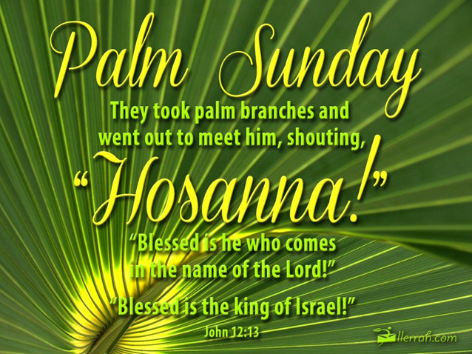

“We welcome you and serve all through faith.”
Worship with us Sundays at 10am

Rev. Jessica Moore, Pastor
Erin Grainger, Music and Choral Director
Stephan Conrady, Organist
Sue Powers, Administrative Assistant
27 Church Street, St. Albans, VT 05478
802-524-4555

info@firstcongregationalstalbans.org
www.firstcongregationalstalbans.org

