First Congregational Church of Saint Albans, Vermont

United Church of Christ

Easter Sunday April 17, 2022

We Gather as God's People

THE PREPARATION
The beginning of the prelude is a call to enter into the spirit of prayer and community.

Prelude Christ the Lord is Risen Again
Welcome and Announcements
Call to Worship:
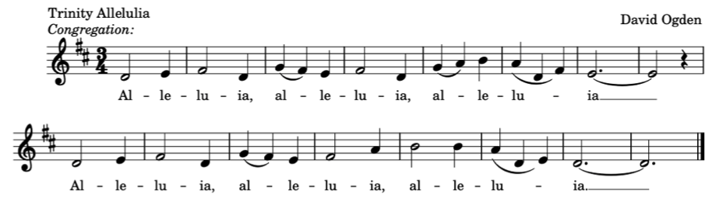

Opening Prayer¹
O, Redeeming God,
Like Mary of Magdala weeping at the tomb,
we, too, have witness the wonders of your work
with our own teary eyes.
In this hour, O God,
Elevate us in Christ and with the power of the Holy Spirit,
so that other may be awakened through our
preaching and proclaiming the good news:
news of healing, peace, justice, and community for all people.
Amen.

Opening Hymn
Christ The Lord Is Risen Today Insert
Prayer of Confession¹
One: God, you call us to step out of the tombs that aim to consume us
and more intentionally into the fullness of life that abounds in your presence.
In stillness and in silence, let us acknowledge the ways we have been separated from
the richness of who you have called us to be.
All: We admit that we have not always remembered the creative power of resurrection.
In a world where dreams and joy have been entombed, and chaos is celebrated and normalized, we have not always considered the divine ingenuity at work that calls us toward the ways of peace, love, and hope. Although we may have strayed from the places where we meet you, we trust that not even death can separate us from you and the creative ways you show your love for us.

A moment for personal reflection
Assurance of God’s Unconditional Love.
Passing of the Easter Peace

THE MESSAGE
Time with Children
Anthem Easter Hodie arr. Donald Hustad
Scripture Reading
John 20:1-18
Morning Reflection
“Three Little Birds”
Hymn
Thine Is The Glory Insert

THE THANKSGIVING
Sharing Our Joys and Concerns
Coral Call to Prayer Hear Our Prayer, O Lord D. Welpton
Prayer of the People ~

Lord’s Prayer
Our Father who art in heaven hallowed be thy name. Thy kingdom come thy will be done on earth as it is in heaven. Give us this day our daily bread. And forgive us our trespasses, as we forgive those who trespass against us. And lead us not into temptation, but deliver us from evil. For thine is the kingdom, and the power and the glory, forever, Amen
Choral Response to Prayer
“Thou wilt keep him in perfect peace, whose mind is stayed on Thee.” Scottish Psalter, 1615
THE DEPARTURE
Hymn
Carry the Light Insert
Benediction
Postlude Victimae Pascali Laudes
No matter who you are or where you are on life's journey, you're welcome here.

Our Church Office Hours and Contact Information
Administrative Office- 8 AM to 11 AM weekdays.
Church Office Phone Number- 1-802-524-4555
Pastor Jessica- Office Hours: T-W-F, 9 AM -12 PM
Email- pastorjessica@firstcongregationalstalbans.org
For urgent, pastoral matters outside of regular office hours, call Pastor Jessica at 207-632-5544

Our Scripture Reader this morning is Nancy Holland.
¹ Worship Ways


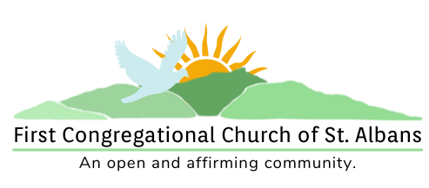

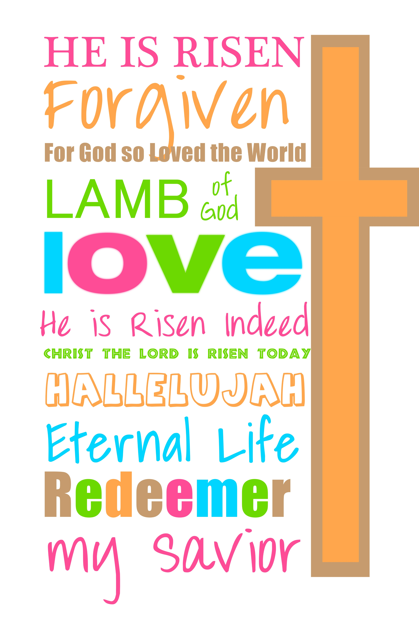

“We welcome you and serve all through faith.”
Worship with us Sundays at 10am

Rev. Jessica Moore, Pastor
Erin Grainger, Music and Choral Director
Stephan Conrady, Organist
Sue Powers, Administrative Assistant
27 Church Street, St. Albans, VT 05478
802-524-4555

info@firstcongregationalstalbans.org
www.firstcongregationalstalbans.org

