First Congregational Church of St. Albans is a welcoming community of spiritual seekers, believers, and doubters.

Please know that no matter who you are or where you are on life's journey, you're welcome here.

FCC Vision Statement
To create an open and loving community that encourages a joyous exploration with God.
To work together to care for and nurture the wider community.

FCC Mission Statement
Our mission as a community resource church is to provide a safe place for spiritual exploration and personal growth. To affirm the value of each person and to meet them where they are.
To connect to the community through personal service, giving, and pastoral care.

Please feel free to contact us:
Administrative Office: 8 AM to 11 AM weekdays.
Church Office Phone Number: 802-524-4555
Pastor Jessica’s Office Hours: T-W-F, 9am-12pm
Email: pastorjessica@firstcongregationalstalbans.org
For urgent, pastoral matters outside of regular office hours,
call Pastor Jessica at 207-632-5544.

Our worship service is broadcast over the local public access channel 1079 on Sundays at 4 PM.

Scripture Reader: Doug Klette



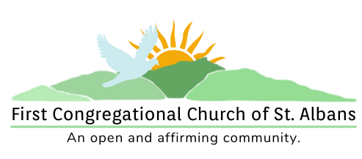

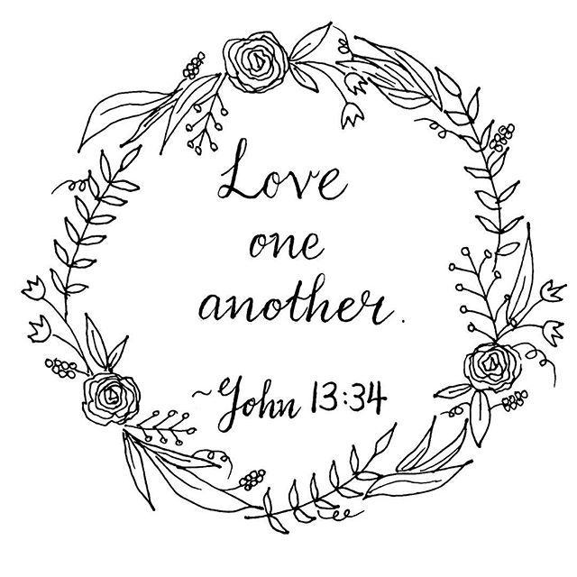

“We welcome you and serve all through faith.”
Rev. Jessica Moore, Pastor
Erin Grainger, Music and Choral Director
Stephan Conrady, Organist
Sue Powers, Administrative Assistant
27 Church Street, St. Albans, VT 05478
802-524-4555

info@firstcongregationalstalbans.org
www.firstcongregationalstalbans.org

First Congregational Church of Saint Albans, Vermont

United Church of Christ

Fifth Sunday of Easter May 15, 2022

We Gather as God's People

CENTERING WORDS:
“Prayer is not asking. Prayer is putting oneself in the hands of God, at His disposition, and listening to His voice in the depth of our hearts.” — Mother Teresa

THE PREPARATION
The beginning of the prelude is a call to enter into the spirit of prayer and community.

Prelude “We gather together” Dutch folk song

Welcome and Announcements

Call To Worship

One: Celebrate our God, from the plains to the mountains!
Many: Celebrate our God, from the waters and hills.
One: Sing to our God who designed creation.
Many: Fill the air with song to the One who painted the world with love.
One: Let us praise our God, the author of grace.
Many: Let us worship our God, the composer of joy.

Welcome to all visitors: We are delighted that you chose to worship with us today and are strengthened by your participation in our service!
If you are new to First Congregational Church of St. Albans, please sign the guest book in the narthex (main entrance of the church).
If you would like more information about our church and its programs or would like to receive our Morning Reflections, and weekly e-newsletter “From the Manse” please fill out a Welcome Card and place it in the Offering tray (be sure to include your email address).

After the service please join us for fellowship, conversation, coffee, and refreshments.

*Please Stand If You Are Able

¹Worship Ways, UCC

Music, Copyright permissions: CCLI #4799426 and SJMP #14586

Morning Prayer¹ (Unison)

Spirit of Joy-
Basking in your presence, we dance in the knowledge that your presence dwells with us. We celebrate your name, your grace, your love in this space with our siblings. We proclaim our excitement that we, together, can glorify your name through sharing your love. May this minute be the start of a new chapter of our love for you and our love for our neighbors. Amen.

Hymn*
“All Things Bright and Beautiful” NCH 31

Prayer of Confession

God of Awe and Harmony-
We were given the great commandment to love one another the way you, the Christ, the Spirit loves us. And yet, the way we love becomes conditional. What events have distorted our view of Divine Love? How can we return to a simple but radical way of loving? Transform our hearts as we work to understand one another, creating an earth which reflects God’s heaven. Amen.

Words of Assurance

Passing of the Peace

Morning Prayer¹ (Unison)

Spirit of Joy-
Basking in your presence, we dance in the knowledge that your presence dwells with us. We celebrate your name, your grace, your love in this space with our siblings. We proclaim our excitement that we, together, can glorify your name through sharing your love. May this minute be the start of a new chapter of our love for you and our love for our neighbors. Amen.

Hymn*
“All Things Bright and Beautiful” NCH 31

Prayer of Confession

God of Awe and Harmony-
We were given the great commandment to love one another the way you, the Christ, the Spirit loves us. And yet, the way we love becomes conditional. What events have distorted our view of Divine Love? How can we return to a simple but radical way of loving? Transform our hearts as we work to understand one another, creating an earth which reflects God’s heaven. Amen.

Words of Assurance

Passing of the Peace

THE MESSAGE
Time with Children
Anthem A New Commandment Richard Hubbard
Scripture Reading
John 13:31-35
Morning Reflection
“Easier Said Than Done”

Hymn*
“Help Us Accept Each Other” verses 1 & 4 NCH 23

THE THANKSGIVING
Sharing Our Joys and Concerns
Choral Call to Prayer
Hear Our Prayer, O Lord D. Welpton
Prayer of the People ~

Lord’s Prayer
Our Father who art in heaven hallowed be thy name. Thy kingdom come thy will be done on earth as it is in heaven. Give us this day our daily bread. And forgive us our trespasses, as we forgive those who trespass against us. And lead us not into temptation, but deliver us from evil. For thine is the kingdom, and the power and the glory, forever, Amen

Choral Response to Prayer
“Thou wilt keep him in perfect peace, whose mind is stayed on Thee.” Scottish Psalter, 1615

THE DEPARTURE
Hymn*
“God Be with You” Verses 1&4 NCH 81
Benediction

Postlude “Hope of the World” Genevan psalter

THE MESSAGE
Time with Children
Anthem A New Commandment Richard Hubbard
Scripture Reading
John 13:31-35
Morning Reflection
“Easier Said Than Done”

Hymn*
“Help Us Accept Each Other” verses 1 & 4 NCH 23

THE THANKSGIVING
Sharing Our Joys and Concerns
Choral Call to Prayer
Hear Our Prayer, O Lord D. Welpton
Prayer of the People ~

Lord’s Prayer
Our Father who art in heaven hallowed be thy name. Thy kingdom come thy will be done on earth as it is in heaven. Give us this day our daily bread. And forgive us our trespasses, as we forgive those who trespass against us. And lead us not into temptation, but deliver us from evil. For thine is the kingdom, and the power and the glory, forever, Amen

Choral Response to Prayer
“Thou wilt keep him in perfect peace, whose mind is stayed on Thee.” Scottish Psalter, 1615

THE DEPARTURE
Hymn*
“God Be with You” Verses 1&4 NCH 81
Benediction

Postlude “Hope of the World” Genevan psalter

