First Congregational Church of St. Albans (FCC) is a welcoming community of spiritual seekers, believers, and doubters.

Please know that no matter who you are or where you are on life's journey, you're welcome here.

First Congregational Church Vision Statement
To create an open and loving community that encourages a joyous exploration with God.
To work together to care for and nurture the wider community.

First Congregational Church Mission Statement
Our mission as a community resource church is to provide a safe place for spiritual exploration and personal growth. To affirm the value of each person and to meet them where they are.
To connect to the community through personal service, giving, and pastoral care.

Please feel free to contact us:
Administrative Office: 8 AM to 11 AM weekdays.
Church Office Phone Number: 802-524-4555
Pastor Jessica’s Office Hours: T-W-F, 9am-12pm
Email: pastorjessica@firstcongregationalstalbans.org
For urgent, pastoral matters outside of regular office hours,
call Pastor Jessica at 207-632-5544.

Our worship service is broadcast over the local public access channel 1079 on Sundays at 4 PM.

Scripture Reader: Nancy Holland



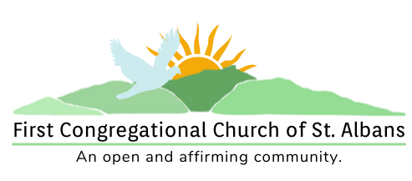

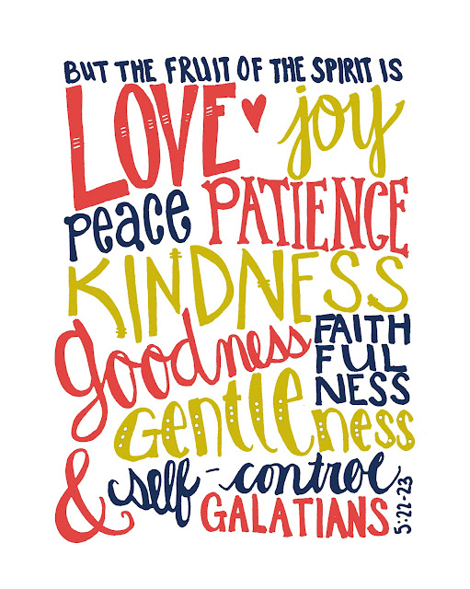

“We welcome you and serve all through faith.”
Worship with us:
June 26, 2022
10am
Rev. Jessica Moore, Pastor
Erin Grainger, Music and Choral Director
Stephan Conrady, Organist
Sue Powers, Administrative Assistant
27 Church Street, St. Albans, VT 05478
802-524-4555

info@firstcongregationalstalbans.org
www.firstcongregationalstalbans.org

Third Sunday after Pentecost June 26, 2022

We Gather as God's People

CENTERING WORDS:
“I am no bird; and no net ensnares me: I am a free human being with an independent will.” ― Charlotte Brontë, Jane Eyre

THE PREPARATION
The beginning of the prelude is a call to enter into the spirit of prayer and community.

Prelude Catherine's call

Welcome and Announcements

Call To Worship¹

One: The way of our God is holy.
Many: Holy One, we seek your presence in our midst.
One: The way of our God is wondrous.
Many: Wondrous God, we marvel at your works and marvelous deeds.
One: The way of our God is awesome.
Many: Awesome God, we call out to you in hope.

Morning Prayer¹ (Unison)
Liberating One, we keep you before us. Our souls rejoice and our hearts are gladdened. Our very beings find safety and security in your presence. We approach you with thanksgiving and anticipation. Enliven us to be your people in the world. Embolden us to live in freedom. Empower us to be your good news. Stand up in us and show us the path of life. Amen.

Welcome to all visitors: We are delighted that you chose to worship with us today and are strengthened by your participation in our service!
If you are new to First Congregational Church of St. Albans, please sign the guest book in the narthex (main entrance of the church).
If you would like more information about our church and its programs or would like to receive our Morning Reflections, and weekly e-newsletter, “From the Manse,” please fill out a Welcome Card and place it in the Offering tray (be sure to include your email address).

After the service please join us for fellowship, conversation, coffee, and refreshments.

*Please Stand If You Are Able

¹UCC, Worship Ways

Music, Copyright permissions: CCLI #4799426 and SJMP #14586

Church Street Sounds Of The Seasons
Donna Costes and Erin Grainger, Co-Artistic Directors
Presents
Royal Towne Brass
Sunday, June 26 at 3:00 PM
Admission: by donation ($10 suggested) – Wheelchair Accessible
Where: St. Luke’s Episcopal Church
8 Bishop Street, St. Albans
For more information:
www.churchstreetsoundsoftheseason.org
______________________________________________________

JUSTICE – and Poetry – FOR ALL
CELEBRATING
Indigenous Poetry of New England

People of the Dawnland:
Voice of Today and Tomorrow
Featuring Poet
Suzanne Rancourt

When: Friday, July 22nd at 5:30 PM food and music. Main event at 6:30 PM.
Where: Pavilion, Kill Kare State Park, St. Albans
Sundog Poetry Center invites you to join us to hear featured indigenous writer Suzanne Rancourt, as well as local poets, storytellers, musicians, and visual artists, including Abenacki writings and stories. For more details go to www.sundogpoetry.org or call 802-585-8502.

Hymn*
“Immortal, Invisible, God Only Wise” vs 1, 3, 4 NCH 1

Prayer of Confession¹ (Unison)

Restoring God, too often we accept the conditions of the world around us and impose limitations on what is possible. We bind ourselves to societal conventions, norms, and pressure rather than follow you and your way. We conform to the values of this world rather than pursue the fruit of the Spirit. Show us the path of life and freedom in you. Teach us to plant seeds of love, joy, peace, patience, kindness, generosity, faithfulness, gentleness, and self-control. May we perennially bear that fruit.

Pause for Reflection

Words of Assurance

Passing of the Peace

THE MESSAGE
Time with Children
Special Music Accordion
Scripture Reading
Luke 9:51-62
Morning Reflection
“Yes, but . . .”
Hymn*
“There’s a Wideness in God’s Mercy” NCH 23

THE THANKSGIVING
Sharing Our Joys and Concerns
Choral Call to Prayer
Hear Our Prayer, O Lord D. Welpton
Prayer of the People ~

Lord’s Prayer
Our Father who art in heaven hallowed be thy name. Thy kingdom come thy will be done on earth as it is in heaven. Give us this day our daily bread. And forgive us our trespasses, as we forgive those who trespass against us. And lead us not into temptation, but deliver us from evil. For thine is the kingdom, and the power and the glory, forever, Amen

Choral Response to Prayer
“Thou wilt keep him in perfect peace, whose mind is stayed on Thee.” Scottish Psalter, 1615

THE DEPARTURE
Hymn*
“I Love to Tell the Story” vs. 1, 4 (refrain after each) NCH 522

Benediction
Postlude Danny Boy

Announcements:

A Special Note of Gratitude From All of Us At FCC:
- Sue and Ray Brown Thank You for helping clean, weed, prune the Manse’s Gardens!
- Greg Beeman Thank You for helping to dispose of the brush from the garden!

The office will not be open until 9 AM on June 28 & 29.

Videographers wanted: We really need your help to live stream the service. We will train you, and you get to sit in the balcony!

Music Notes:
Summer is a-comin’! This is the choir’s last Sunday performing until the Sunday after Labor Day.
Do you, or a friend, sing or play an instrument? You are invited to “pray twice” and share music during Sunday worship! Contact Erin during coffee hour or during the week through the office or firstcongregationalmusic@gmail.com

Bible Study is on Thursday at 6:45 PM.
We’ve moved Bible Study to Thursday nights until August—so that we can all enjoy the summer music in Taylor Park!
Everyone is welcome to join our weekly on-line bible study. We use Zoom as our platform. Please call the office to let Sue or Jessica know you are interested and Jessica will send you the link with instructions.

