First Congregational Church of St. Albans (FCC) is a welcoming community of spiritual seekers, believers, and doubters.

Please know that no matter who you are or where you are on life's journey, you're welcome here.

First Congregational Church Vision Statement
To create an open and loving community that encourages a joyous exploration with God.
To work together to care for and nurture the wider community.

First Congregational Church Mission Statement
Our mission as a community resource church is to provide a safe place for spiritual exploration and personal growth. To affirm the value of each person and to meet them where they are.
To connect to the community through personal service, giving, and pastoral care.

Please feel free to contact us:
Administrative Office: 8 AM to 11 AM weekdays.
Church Office Phone Number: 802-524-4555
Pastor Jessica’s Office Hours: T-W-F, 9am-12pm
Email: pastorjessica@firstcongregationalstalbans.org
For urgent, pastoral matters outside of regular office hours,
call Pastor Jessica at 207-632-5544.

Our worship service is broadcast over the local public access channel 1079 on Sundays at 4 PM.

Scripture Reader: Toni Gray



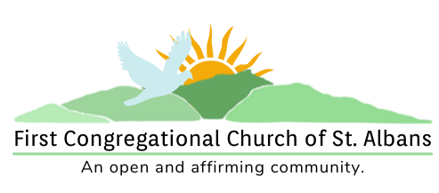

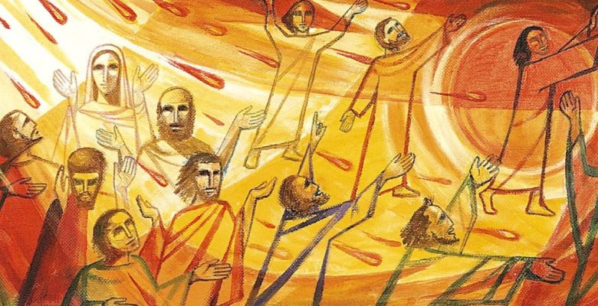

“We welcome you and serve all through faith.”
Worship with us:
June 5, 2022
10am
Rev. Jessica Moore, Pastor
Erin Grainger, Music and Choral Director
Stephan Conrady, Organist
Sue Powers, Administrative Assistant
27 Church Street, St. Albans, VT 05478
802-524-4555

info@firstcongregationalstalbans.org
www.firstcongregationalstalbans.org

We Gather as God's People

CENTERING WORDS:
“If you stumble about believability, what are you living for? Love is hard to believe, ask any lover. Life is hard to believe, ask any scientist. God is hard to believe, ask any believer. What is your problem with hard to believe?” — Yann Martel

THE PREPARATION
The beginning of the prelude is a call to enter into the spirit of prayer and community.

Prelude Under a Tree S. Conrady

Welcome and Announcements

Call To Worship¹

One: Divine Teacher, whirl around us with your wisdom,
Many: Divine Comforter, encircle us with the peace that comes only from you.
One: As the Holy Winds fill our lives with dreams, empower us to live God’s hope in this world.
Many: As the Holy Fire fills our hearts with visions, empower us to create a world of justice and peace.
One: May the Divine Gales of this day move us to know the love of God.

Morning Prayer¹ (Unison)

Holy Winds of Mystery,
As the dawn breaks forth, your Spirit exhales your intentions for our world. As new chapters and eras arise in our lives, your Spirit invites us to wisdom that only comes from you. Open our souls to the wonders of your being. Settle our hearts when questions surround us. Fill our minds with the knowledge that your Spirit will lead us forward. Amen.

Welcome to all visitors: We are delighted that you chose to worship with us today and are strengthened by your participation in our service!
If you are new to First Congregational Church of St. Albans, please sign the guest book in the narthex (main entrance of the church).
If you would like more information about our church and its programs or would like to receive our Morning Reflections, and weekly e-newsletter “From the Manse” please fill out a Welcome Card and place it in the Offering tray (be sure to include your email address).

After the service please join us for fellowship, conversation, coffee, and refreshments.

*Please Stand If You Are Able

¹Worship Ways, UCC

Music, Copyright permissions: CCLI #4799426 and SJMP #14586

Announcements:

A Special Note of Gratitude From All of Us At FCC:
- Greg Beeman Thank You for risking life and limb as you worked with Jim on immediate repairs to the clock tower and assessed the church building for further repairs.

Women’s Breakfast – The last Women’s Breakfast for the season will be held at Maple City Diner on Saturday, June 11 at 9 AM. Please call Sue Brown (802-527-6336) to RSVP.

Sunday, June 12
11:30am
Special Guest Speaker Steven Tendo
Steven Tendo, a Ugandan pastor now living in Vermont, will share his story of defending human rights, being held in the U.S. detention and deportation system, and seeking freedom. Pastor Steven will also share his new vision for ELOI Ministries, the youth focused ministry he created in Uganda.

Bible Study is on Wednesdays at 6:45 PM. Everyone is welcome to join our weekly on-line bible study. We use the Zoom as our platform. Please call the office to let Sue or Jessica know you are interested and Jessica will send you the link with instructions.

Music Notes: You may recognize the anthem tune as “Skye Boat Song”, a traditional Scots tune, that has been been given Pentecostal lyrics by Richard Irwin.

Hymn*
“God Is Here” NCH 70

Prayer of Confession¹ (Unison)

Loving God, Divine Comforter,
Peace is absent from our hearts. From pain to grief, and from turmoil to frustrations, we yearn for what we lack. We ache for the pains and injustices of this world to cease. What we forget is to pause and voice our concerns to you. How can we better integrate your presence in our lives? When have we forgotten to include you in our joys and heartaches? Move us to seek you and speak the burdens of our hearts to you. May your Spirit refill our souls with peace. Amen.

Words of Assurance

Passing of the Peace

THE MESSAGE

Anthem Spirit of God, Unseen as the Wind — Trad. Scottish, arr. A. D. Miller

Scripture Reading
Acts 2:1-21
Morning Reflection
“Everyone Knows It’s Windy”
Hymn*
“Spirit, Spirit of Gentleness” vs 1, 3, 4 NCH 286

THE COMMUNION
Celebration of Holy Communion

ONE: God be with you.
ALL: And with your spirit
ONE: Lift up your hearts
ALL: We lift them up to God.
ONE: Give thanks to God.
ALL: It is right to give God thanks and praise.

We remember that on the night of betrayal and desertion, and on the eve of his death, Jesus gathered his disciples for the Passover feast.
Jesus took the bread, and after giving thanks to you, broke it and gave it to the disciples saying: “Take and eat. This is my body broken for you. Do this in remembrance of me.”
In a similar way, after supper, he took the cup saying: “Drink this, all of you: this is the blood of the new covenant, which is poured out for you and many for the forgiveness of sins. Do this as often as you drink in remembrance of me.

DISTRIBUTION OF HOLY COMMUNION

In one hand, we embrace a piece of one common loaf.
Sharing one cup, we drink of the Christ’s new covenant of unity. With one voice, we lift up our prayers
to you, the one great God, who embraces our differences
yet rejoices in our unity in this one communion act. Amen.

*Sharing of the bread and cup*

Hymn "Let Us Break Bread Together" NCH 330

Words of thanksgiving:

One: May the presence of Christ, Body and Spirit, keep and preserve you to everlasting life. Let us pray.
All: Thank you most Holy God, for meeting us in this simple meal. May your presence within us ripple beyond us, ever expanding, until the day when you gather all your saints from the four winds to share in your eternal banquet.
THE THANKSGIVING
Sharing Our Joys and Concerns
Choral Call to Prayer
Hear Our Prayer, O Lord D. Welpton
Prayer of the People ~

Lord’s Prayer
Our Father who art in heaven hallowed be thy name. Thy kingdom come thy will be done on earth as it is in heaven. Give us this day our daily bread. And forgive us our trespasses, as we forgive those who trespass against us. And lead us not into temptation, but deliver us from evil. For thine is the kingdom, and the power and the glory, forever, Amen

Choral Response to Prayer
“Thou wilt keep him in perfect peace, whose mind is stayed on Thee.” Scottish Psalter, 1615

THE DEPARTURE
Hymn*
“On Pentecost They Gathered” vs 1, 2, 4 NCH 272
Benediction
Choral Benediction
Go Light Your World Chris Rice

Postlude Salve festa dies R. Vaughan-Williams

