## **Project 1: In-door Localization through WLAN**

### **Objective:**

To conduct research on in-door localization through WLAN, specifically through Wi-Fi. To estimate pathloss factor and based on estimated pathloss factor and RSSI, calculate the distance of receiver from Anchor nodes. To perform localization through multidimensional scaling and find out the localization error.

### **Alpha Calculation:**

To estimate path loss factor(alpha), we place a receiver (a laptop with Acrylic Wi-Fi home software) and move the router (Linksys EA4500) at different locations inside the classroom and recorded the RSSI and distance between the router and the receiver. Below is the set for alpha calculation. We used total 12 location to observe the RSSI levels.

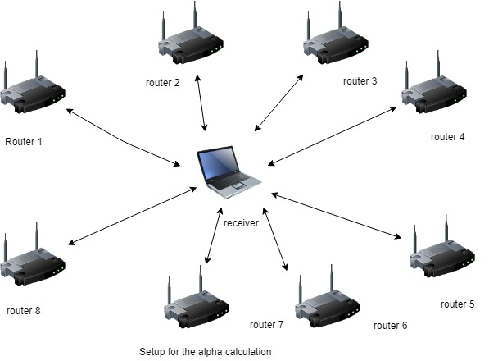

To calculate the alpha value we used following formula:

Alpha = [(log(Ps/Pr))/log(d)]

Where,

Ps = Transmitted power level in milli Watt(28 mW for Linksys EA4500).

Pr = Received power level in milli Watt.

|  |  |  |  |  |  |  |  |  |  |
| --- | --- | --- | --- | --- | --- | --- | --- | --- | --- |
| count | RSSI | Distance | Meters | mW | millimeters | Ps/Pr | log(Ps/Pr) | log (d) in mm | Alpha = log(Ps/Pr) / log (d) |
| 1 | -51 | 23'11" | 7.2898 | 7.9E-06 | 7289.8 | 3524991 | 6.547158 | 3.862715613 | 1.694962479 |
| 2 | -46 | 29'2" | 8.89 | 2.5E-05 | 8890 | 1114700 | 6.047158 | 3.948901761 | 1.531351854 |
| 3 | -38 | 18' | 5.4864 | 0.00016 | 5486.4 | 176668 | 5.247158 | 3.739287468 | 1.403250773 |
| 4 | -45 | 22'10" | 6.9596 | 3.2E-05 | 6959.6 | 885438 | 5.947158 | 3.842584279 | 1.547697487 |
| 5 | -31 | 4'8" | 1.4224 | 0.00079 | 1422.4 | 35249.9 | 4.547158 | 3.153021744 | 1.442158793 |
| 6 | -40 | 15'10" | 4.826 | 0.0001 | 4826 | 280000 | 5.447158 | 3.683587318 | 1.478764466 |
| 7 | -41 | 18'3" | 5.5626 | 7.9E-05 | 5562.6 | 352499 | 5.547158 | 3.745277831 | 1.481107218 |
| 8 | -39 | 10'2" | 3.0988 | 0.00013 | 3098.8 | 222412 | 5.347158 | 3.491193547 | 1.531613174 |
| 9 | -37 | 8'9" | 2.667 | 0.0002 | 2667 | 140332 | 5.147158 | 3.426023016 | 1.502371119 |
| 10 | -42 | 17'4" | 5.2832 | 6.3E-05 | 5283.2 | 443770 | 5.647158 | 3.722897052 | 1.516871929 |
| 11 | -34 | 3'5" | 1.0414 | 0.0004 | 1041.4 | 70332.8 | 4.847158 | 3.017617573 | 1.606286388 |
| 12 | -38 | 13'1" | 3.9878 | 0.00016 | 3987.8 | 176668 | 5.247158 | 3.600733369 | 1.457247037 |

d = Distance in milli-meter

Above is the table showing the calculated alpha values for the 12 locations. We selected the average value of alpha for the localization experiment. The average value of alpha we got is **1.52**.

### **Localization:**

To perform localization experiment, we placed 4 anchor nodes(Linksys EA4500 routers) and receiver(a Laptop with Acrylic Wi-Fi home software) as shown in below diagram. We, then, measured distance from each anchor node to receiver and distance between each anchor nodes. Also, we recorded RSSI level for each anchor node at receiver end. From the estimated alpha value from the previous step and RSSI values, we calculated the distance between anchor nodes and receiver from the below formula:

d = Antilog[ (log(Ps/Pr))/alpha]

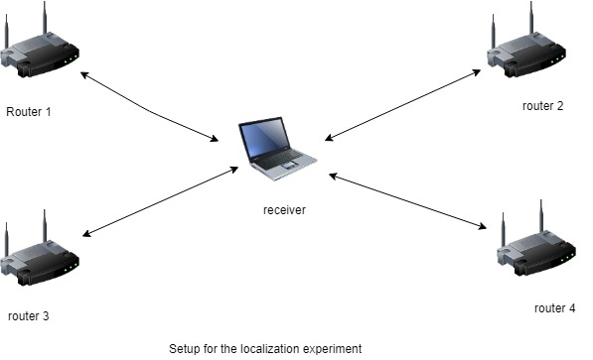

Below is the table to measure distances and calculated distances from the RSSI values.



Where d = measured distance.

d’ = calculated distance from RSSI.

### **Multidimensional Scaling:**

**Multidimensional scaling** (MDS) is a technique that creates a map displaying the relative positions of a number of objects, given only a table of the distances between them. The map may consist of one, two, three, or even more dimensions.

We used MATLAB for multidimensional scaling and function *cmdscale* is used. This function takes N*N matrix as a input and provides co-ordinates of N nodes on x and y axis as output. Output of the MDS is plotted for both measured and calculated distance matrix and compared.

### **Matlab Code:**

clc;

clear;

locations = ...

{'receiver','router1','router2','router3','router4'};

D = [ 0.00 6.32 4.37 6.12 5.26;

6.32 0.00 8.05 9.29 11.35;

4.37 8.05 0.00 10.43 7.79;

6.12 9.29 10.43 0.00 5.68;

5.26 11.35 7.79 5.68 0.00];

[Y,eigvals] = cmdscale(D);

D1 = [ 0.00 2.09 3.29 3.29 5.19;

2.09 0.00 8.05 9.29 11.35;

3.29 8.05 0.00 10.43 7.79;

3.29 9.29 10.43 0.00 5.68;

5.19 11.35 7.79 5.68 0.00];

[Y1,eigvals1] = cmdscale(D1);

format short g;

[eigvals eigvals/max(abs(eigvals))]

Dtriu = D(find(tril(ones(5),-1)))';

maxrelerr = max(abs(Dtriu-pdist(Y(:,1:2))))./max(Dtriu)

figure(1),plot(Y(:,1),Y(:,2),'*');

[eigvals1 eigvals1/max(abs(eigvals1))]

Dtriu1 = D1(find(tril(ones(5),-1)))';

maxrelerr1 = max(abs(Dtriu1-pdist(Y1(:,1:2))))./max(Dtriu1)

figure(1),plot(Y(:,1),Y(:,2),'*');

text(Y(:,1),Y(:,2),locations);

title('measured distance');

xlabel('Meters');

ylabel('Meters');

figure(2),plot(Y1(:,1),Y1(:,2),'*');

text(Y1(:,1),Y1(:,2),locations);

title('calculated distance form RSSI');

xlabel('Meters');

ylabel('Meters');

Below are the two output of the multi-dimensional scaling .

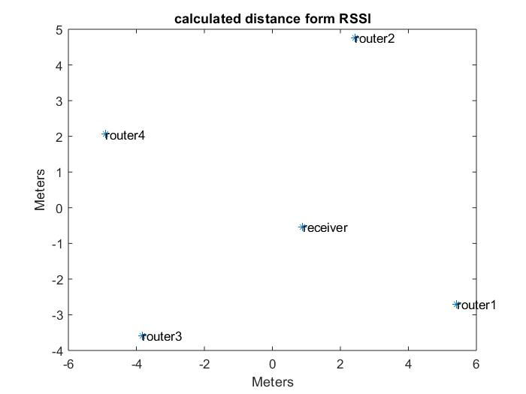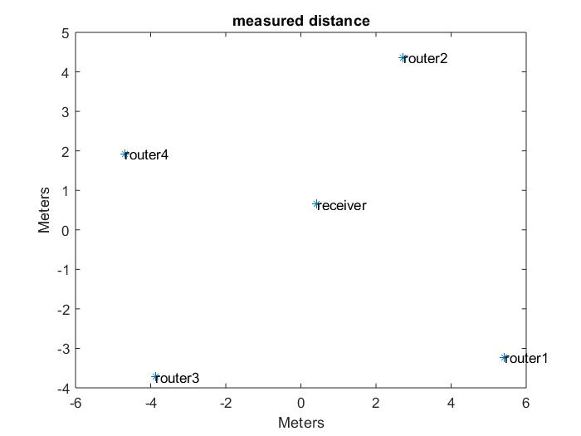

This Multidimensional scaling graph gives the co-ordinates of 4 anchor nodes and receiver node.

### **Localization Error Calculation:**



From the co-ordinates of the receiver and anchor node, we calculated the distance between receiver and each anchor node by following formula.

Di = squareroot(((x – xi)^2) + ((y – y1)^2))

Where,

x and y are co-ordinate of receiver node.

Xi and yi are co-ordinates of corresponding anchor nodes.

We calculated distances for both measured and calculated cases and took difference of corresponding distance values. Average of the difference values is the localization error.

Below is the table of calculated and measured distance .

|  |  |  |  |
| --- | --- | --- | --- |
|  | measured distance | calculated distance | difference |
| R1 to R | 6.307 | 5.02 | 1.28 |
| R2 to R | 4.37 | 5.5 | 1.13 |
| R3 to R | 6.12 | 5.61 | 0.49 |
| R4 to R | 5.26 | 6.34 | 1.08 |
|  |  | Total = | 3.98 |

Localizationa error = total difference/number of measurements

= 3.98/4

= **0.99 meter**

### **Conclusion:**

Based on the various readings of **Received Power** levels, we calculated the path loss factor (alpha) as **1.52**. This path loss factor value is used to calculate the distance of receiver from the Anchor nodes. Using the Multidimensional scaling, the positions of Anchor nodes and receiver are plotted to measure the **localization error** which we observed is **0.99 meter.**