Title of Capstone Here

Author's Full Name, including middle initial, Here

Western Governors University

**Table of Contents**

Summary 4

Review of Other Work 4

Project Rationale is not used in the final capstone report. Do not copy from the proposal. 5

Changes to the Project Environment 5

Methodology 6

Project Goals and Objectives 6

Project Timeline 6

Unanticipated Requirements 7

Conclusions 7

Project Deliverables 8

References 9

References 9

Appendix A 11

Title of Appendix 11

Appendix B 12

Title of Appendix 12

Appendix C 13

Title of Appendix 13

Watch: [**Writing the Final Capstone Report**](https://wgu.hosted.panopto.com/Panopto/Pages/Viewer.aspx?id=5286bdf6-43c4-479e-8135-72922ac3f6bf).

Note: On the pages that follow, keep the bolded main heading but delete the prompt material once you've reviewed and made the necessary additions and adjustments. Also, update the running head and title page. Remove this note as well

# Summary

In this section, include a logical overview the project's client, setting, problem, proposed solution, and how the solution was carried out. The details should include a description of the flow of the project, including all the major aspects that were accomplished.

**From the Proposal:** Proposal Overview including the following:

1. Problem Summary

2. IT Solution

3. Implementation Plan

**What to Adjust:** Remove the subheadings (e.g. Problem Summary). Convert the material to past tense where necessary and provide additional details as to how the project was implemented in the last part of this section.

Note: Be sure that your entire capstone report is written in past tense so it reflects a completed project.

# Review of Other Work

In this section, provide a Review of Other Work section similar to that in task 2, except that you need *three new works*. Two options: 1. Using the sources from the proposal but adding three new ones. 2. Starting from scratch with three new sources. The new sources must deal with how the project was implemented.

**From the Proposal:** You may insert your entire Review of Other Work from the proposal but be sure it reads in the past tense. If you wish, you may leave out that material and start from scratch to meet the section's requirements. Either approach is acceptable so consider how relevant your proposal material is to the final report when deciding to keep or start from scratch.

**What to Adjust:** Provide a review of **three** additional works on your topic (not referenced in Task 2) that relate to the development of this project. Look for sources that provide guidance, answer questions, or include technical material that was helpful.

Note: These other works may include interviews, white papers, research studies, best practices, configuration/implementation guides, migration paths, case studies, or other types of work that are publicly accessible.

# Project Rationale is not used in the final capstone report. Do not copy from the proposal.

# Changes to the Project Environment

In this section, describe and detail changes to the project environment made by the implementation of the project after its completion. Analyze the systems and describe the status of the project environment after the project implementation.

**From the Proposal:** Move your Current Project Environment material from the proposal. Label this as the "original" environment before the project was completed.

**What to Adjust:** Add new material (another paragraph works) that describes how the original environment changed once the project was completed. What's new and what did it improve?

# Methodology

In this section, describe and detail how your completed project was governed by a specific methodology. Explain how a standard methodology was applied for the implementation of the project.

**From the Proposal:** Move your proposal's Methodology section to this report.

**What to Adjust:** You'll want to make the old material read in past tense. You'll also want to add specific project details or examples to the phases of your methodology to emphasize what you actually accomplished.

# Project Goals and Objectives

This section provides a detailed explanation of how project goals and objectives were met. If goals or objectives were not met, that's fine as long as you explain why.

**From the Proposal:** Copy your Goals, Objectives, and Deliverables section. You may also copy the Goals table as it helps the evaluator more clearly understand the hierarchy.

**What to Adjust:** Make sure this reads in the past tense. You may remove the deliverables. You must include a clear, obvious statement with each goal and objective about how it was successfully completed. If you decide to leave the deliverable, connecting them with your objective's success statement is effective.

# Project Timeline

This section creates a timeline that deals with planned and actual durations and the final project's start and end dates. Include a paragraph after the timeline that compares the durations and provides information about where times did or did not work out as planned.

**From the Proposal**: Copy the timeline table.

**What to Adjust**: Create new headings that include: Planned Duration, Actual Duration, Actual Start Date, and Actual End Date. Keep the Deliverables column. Remove or rename the proposal's date columns. **(Don’t miss thisà)** **After the updated timeline, add a narrative discussing how you met the timeline and any changes from task 2. If they were no variances, explain why.**

Note: Because the project is now completed, all the dates must be in the recent past. The evaluator will not compare them to the dates in task 2.

# Unanticipated Requirements

In this section, describe the requirements that emerged during implementation. These are not timing-related (those go in the timeline) but relate to hardware, software, or personnel-type issues that arose during the project's implementation. Additionally, be sure to explain how they were resolved or why they were not solved. If there were no unanticipated requirements, explain why. This is a new section. DO NOT LEAVE IT BLANK.

# Conclusions

In this section, explain the actual project accomplishments and immediate and potential future effects of the completed project. Include at least one measurable metric that was used to prove the project's success.

**From the Proposal:** Copy the Outcome section.

**What to Adjust:** Change your Outcome to past tense. Include information about immediate and potential effects of the completed project. Provide specific examples where relevant. Update the measurable metric information from the proposal. If there is none, add new material that specifies what was measured and what measurement indicated success.

# Project Deliverables

This section describes at least three project artifacts (examples) that appear in the appendices. The artifacts should provide a logical display to substantiate the described successes and benefits of the completed project. Refer to each appendix item (included after the References section as Appendix A, Appendix B, etc.) and describe how it demonstrates evidence of the project's completion. Artifacts may include code samples, screenshots, photos, flowcharts, process diagrams, tables, graphs, network diagrams (before and after), training materials or related documents (e.g., policies), etc. This is a new Section.

# References

List all the outside sources that the narrative refers to in-text. For in-text and reference list citations, please refer to the web link in the Course of Study or visit the WGU Writing Center.

Note: Ensure you have an **in-text citation for each full citation and vice versa**. Those citation pairs must match up according to APA formatting. For example:

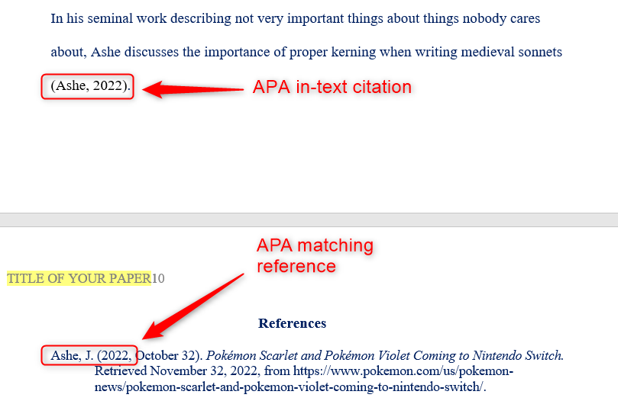

Use [MS Word's 'reference' feature](https://support.microsoft.com/en-us/office/create-a-bibliography-citations-and-references-17686589-4824-4940-9c69-342c289fa2a5) to manage citations and your reference page. Use this [APA Quick Reference](https://drive.google.com/open?id=1cA2sMO-VCODKjnqDwvVWfO_wiHgigLVe), follow the style of this [Task 2 Proposal Example](https://drive.google.com/file/d/1g9hN5GC3n5dqKM4BeFSitJ5R12I8aJSJ/view?usp=sharing), and these formatting guidelines:

* For *B. Other Works* have at least **three different** works referenced using in-text citations.
* For every reference listed, have at least one in-text citation in APA style.
* Use consistent formatting.
* Use hanging Indent.
* Right-click to remove hyperlinks.

Your references should follow this style:

Smyth, A. M., Parker, A. L., & Pease, D. L. (2002). A study of enjoyment of peas. Journal of Abnormal Eating, 8(3), 120-125. Retrieved from http://www.articlehomepage.com/full/url/

Bell, T., & Phillips, T. (2008, May 6). A solar flare. Science @ NASA Podcast. Podcast retrieved from http://science.nasa.gov/podcast.html

OLPC Peru/Arahuay. (n.d.). Retrieved April 29, 2011, from the OLPC Wiki: http://wiki.laptop. org/go/OLPC_Peru/Arahuay

# Appendix A

# Title of Appendix

Typically, the examples of deliverables are included here. Add additional or delete superfluous appendices as needed.

# Appendix B

# Title of Appendix

Put any supporting material in these appendices. Add additional or delete superfluous appendices as needed.

# Appendix C

# Title of Appendix

Put any supporting material in these appendices. Add additional or delete superfluous appendices as needed.