**Sample: Annual Relationship Survey**

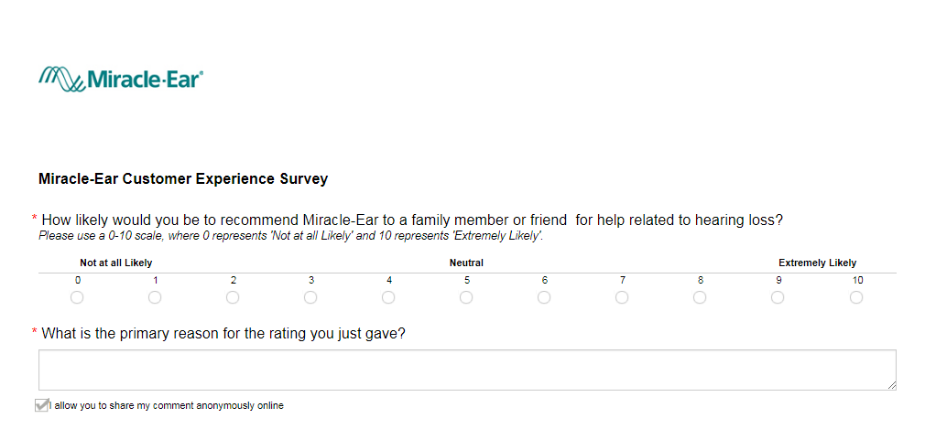

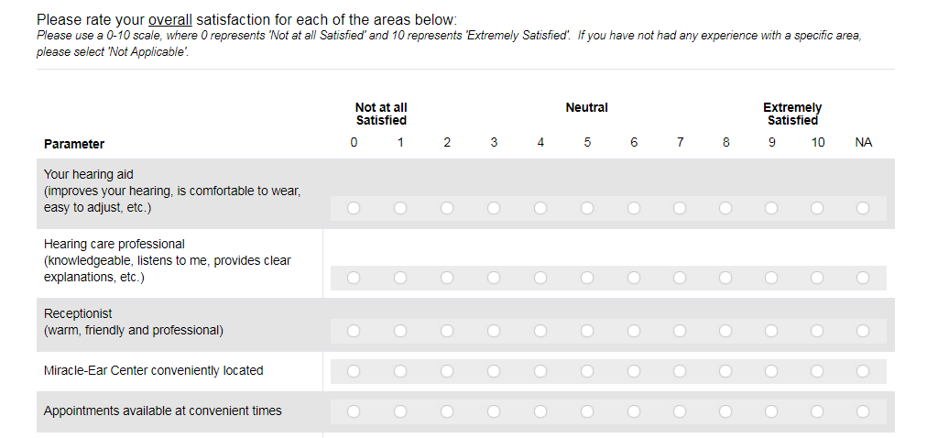

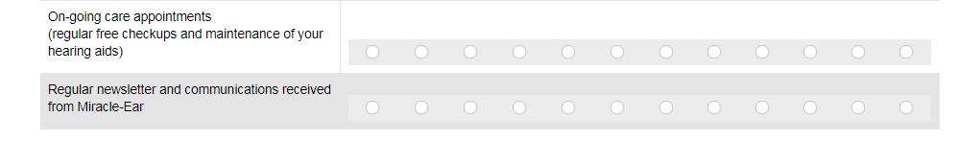

The following questions are triggered by customer response to hearing aid question 0-6 (Detractor).

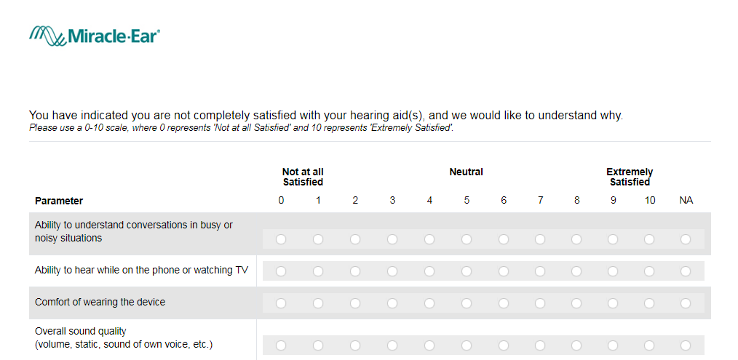

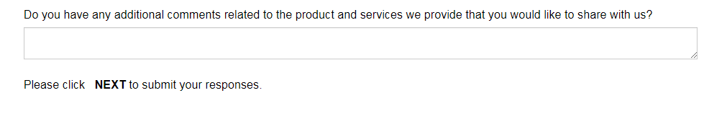

The request to submit a review is currently only available to customers providing a 9 or 10 response to the LTR question.

