Quick Guide to Increasing your NPS Score!

**Frequently Asked Questions**

*1)What is NPS?*

It stands for Net Promoter Score

*2) How does this work?*

It is based off of 1 question on the **Annual Relationship Survey** which is: “Would you recommend Miracle Ear to your Friends and Family?” It’s a numeric scale from 0-10 but only 9’s and 10’s will get you a 100 score.

3) *How are these scores calculated?*

The scale is as follows:

9-10= 100 points “Promoter”

7-8= 0 points “Passive”

0-6=-100 points “Detractor”

Example- If your location has 3 Annual Surveys come in, two of them are 10’s and one of them is a 7. Let’s see what you’re score would be.

10=100

10=100

7=0

100+100+0=200 200/3(surveys)=66.66 Score

4) *How does this survey go out?*

This survey is sent to your patients each year on the **anniversary month of the delivery date via email only!** This survey stays open for 30 days after the initial email is sent. Each patient will receive this survey each year on their delivery date for the next 4 consecutive years. **These emails cannot be resent and we cannot change the email address once the emails has been sent. It is important to verify the patients email before they get the survey.**

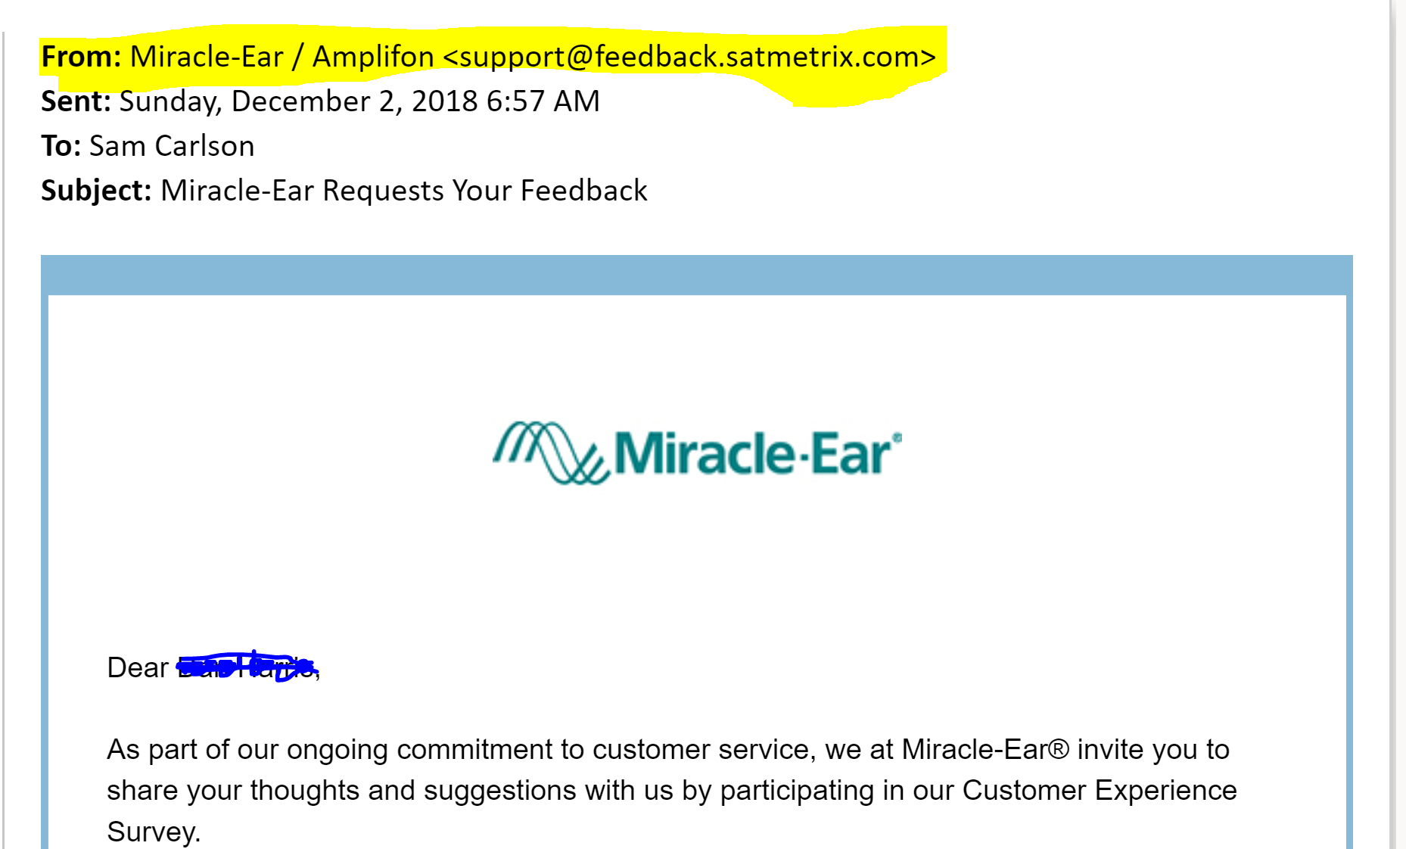

**\*\*\*Note:** This means that when you are figuring out who the surveys are going out, you must look back further than 1 year.

Example- You might run the HA report for September 2017, but patients who also bought in 2016 and 2015 will be better surveys too if they have an email on file.

*5) How do I get prepare myself for these patients who are about to get surveys?*

I would run the HA Sales report each month and **pre-schedule** each of these patients 2 weeks before they should be getting their surveys. You should have a system set up with your consultant where you have a laminated copy of the survey available so that the consultant knows this person will be getting an Annual Survey soon.

*6) How do I make sure that I get a Promoter score?*

When discussing the survey with your patients, make sure that you ask for a 10 because sometimes they get confused how the grading scale works.

Make sure you explain they will be getting a survey via email and you would love their feedback.

*Script:*

“You should be receiving a survey in your email inbox soon, this is like **my** report card. The first question will be asking you if you would refer Miracle Ear to your friends and family and that is what tells my boss I’m doing a good job for you. If I have not given you a 9 or 10 service, let me know how I can be better for you so that I can earn that 9 or 10 score.”

*7) How can I be proactive about getting a good NPS score for my location?*

Step 1:Go into “Marketing” In your Sycle.net and select “Sent Email”

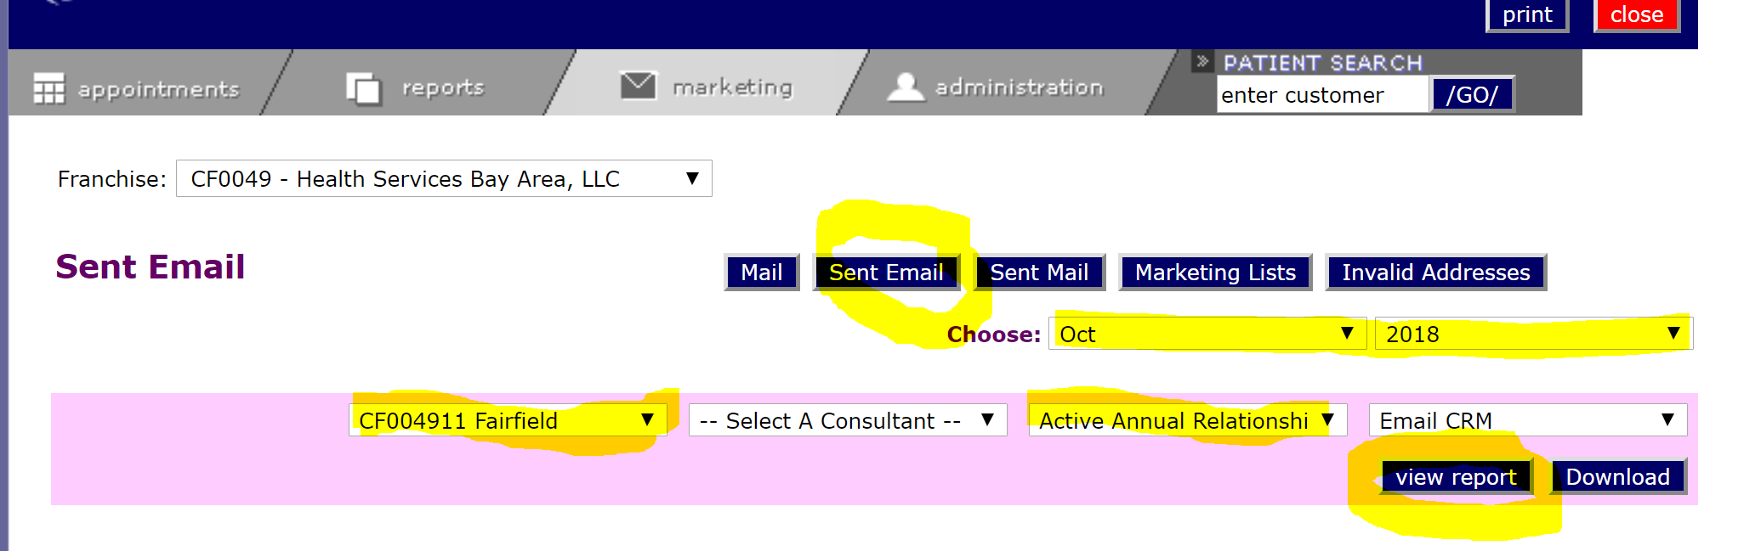

Step 2: Select your store, and in the “Choose” drop down, select “Active Annual Relationship Survey”

This will give you a list of everyone who is receiving their survey and when it was sent!

*8) How can I increase the number of surveys that go out?*

The more emails you collect and the more ACCURATE emails you collect, the more opportunity you will have to increase your score.

LET’S BE PROACTIVE!

1. Go to Reports and Select HA Sales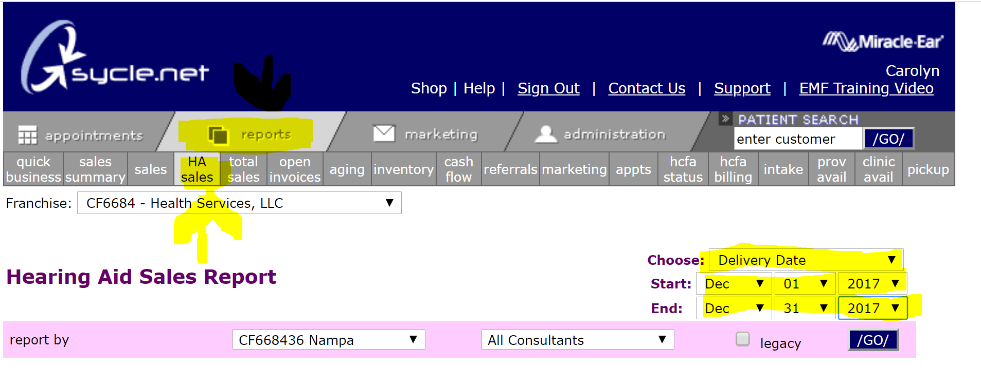

Run this report for the past 4 years to ensure that you have the proper information for your patients and that you are also seeing them regularly.