[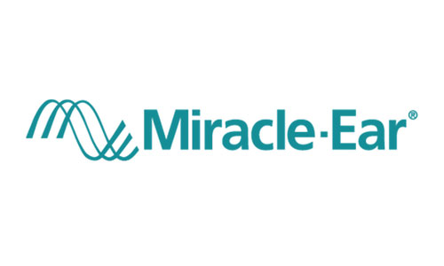](http://www.google.com/url?sa=i&rct=j&q=&esrc=s&source=images&cd=&ved=2ahUKEwiH2qOe09PaAhWMGnwKHdPtAWkQjRx6BAgAEAU&url=http://www.saveon.com/coupons/mi/chesterfield/health-beauty/hearing-aids/miracle-ear-michigan/356205&psig=AOvVaw0n_CsK3SFN2MtcPk0lz4Y4&ust=1524684690515060)

RECORDS RELEASE REQUEST

Date:_________

Name:_______________________ Phone:_____________

Address:_____________________

City:_________________________ State: _____ Zip:___________

I authorize the release of medical records relevant to my treatment, or copies of such

including the following

• Audiometric Evaluations

• Chart Notes

• Warranty Information

• Packing Slip of current hearing instruments

Records to be transferred to:

Miracle-Ear

7974 W. Fairview Ave

Boise, ID 83704

P: 208-377-3179

F: 208-377-3598

E: Veronicak@miracle-earnw.com

______________________________ ________________________________

Print Patient Name Signature (Patient, Parent, or Guardian)