Chess Manuel Testing Plan

-Ajay Shekar (ashekar2)

In order to test the functionality of the GUI, please follow the following steps and ensure that each produce the desired output.

1. Execute the file BoardGUI.java located in the chess project and ensure that the following screen is seen:

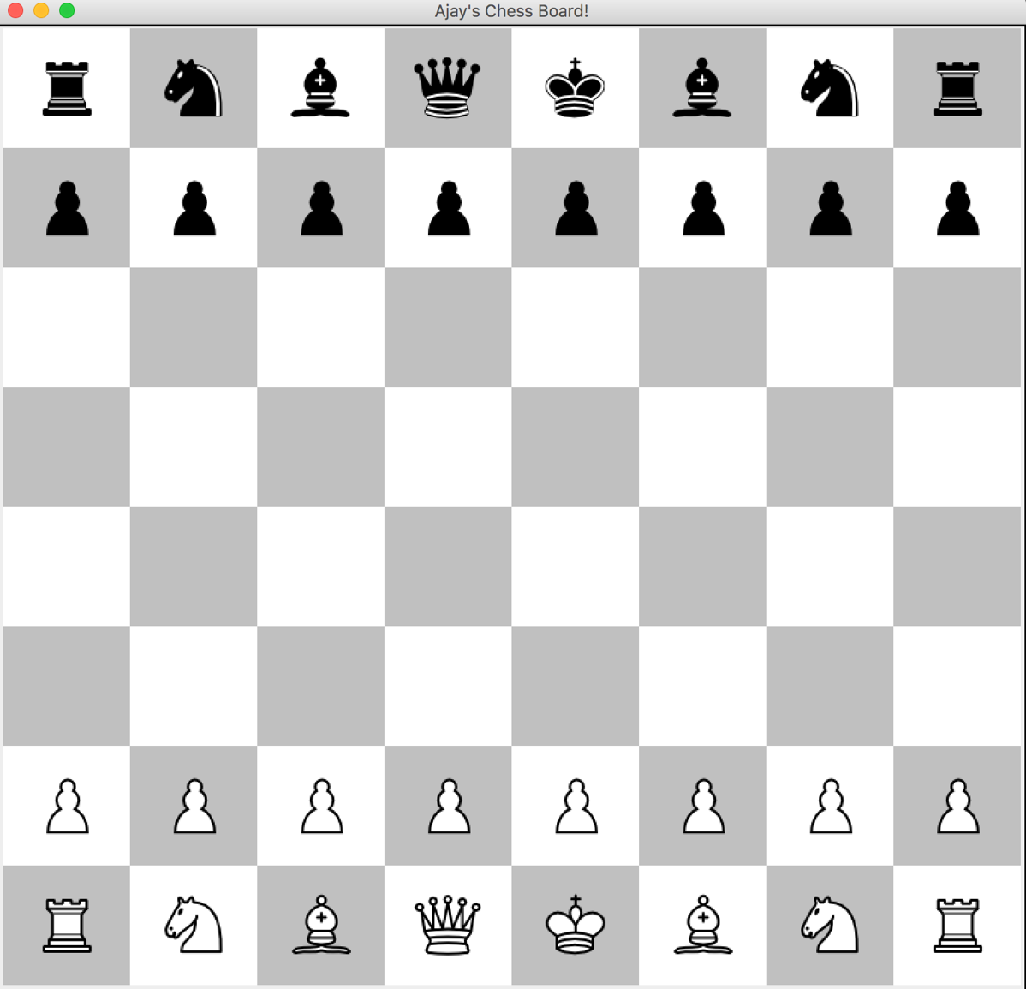

1. Make sure that the pieces are in the correct position as seen above.
2. Ensure that the frame is the center of the screen
3. Click on the white pieces to ensure that the animation of the button click is visible. (this feature will be used in the dynamic version of the GUI.)
4. Ensure that when the close button is clicked, the screen completely closes and the java program is no longer running.