Manual Test Plan

Ajay Shekar

Please follow the following steps in order to ensure that the interaction between the Social Graph and the backend neo4j database is working correctly.

* Log into your account from the login page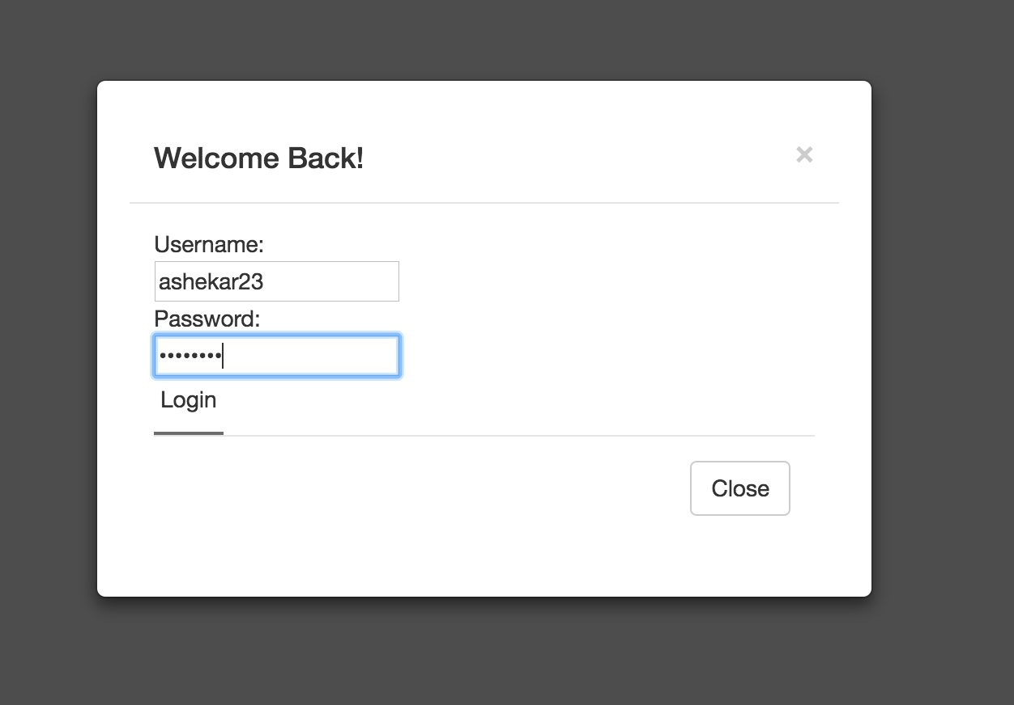
* Ensure that the details you see on your home page are correct

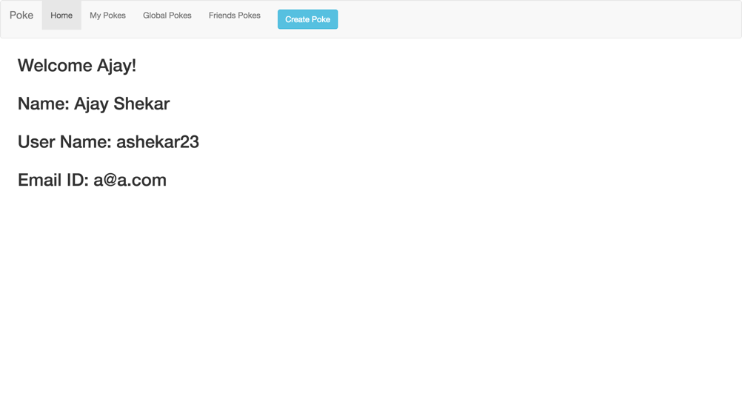

* Create a new Poke. Specify users as global.

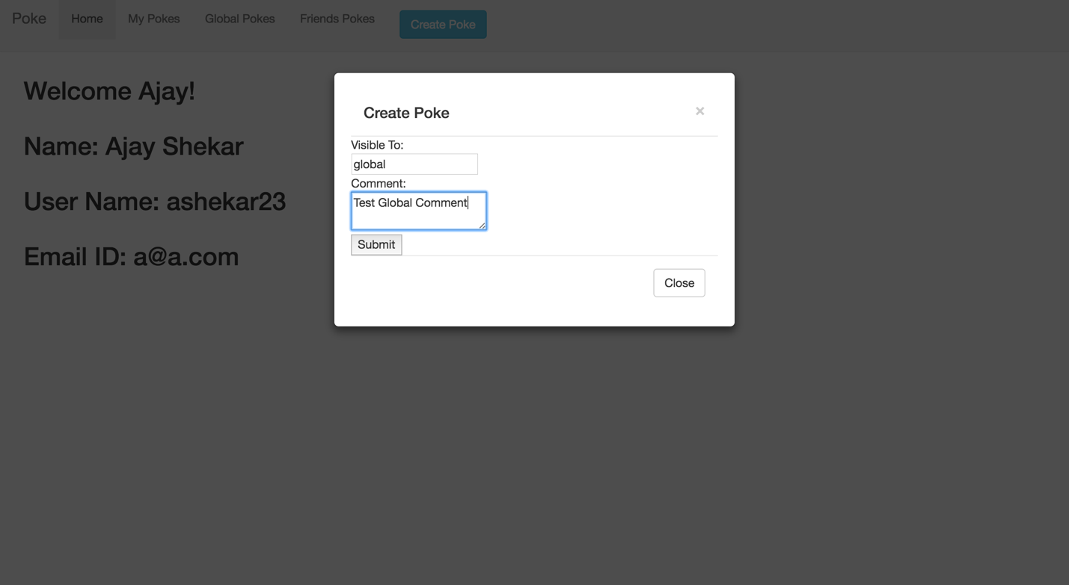

* Go to the global Pokes tab and ensure that you see the comment present.

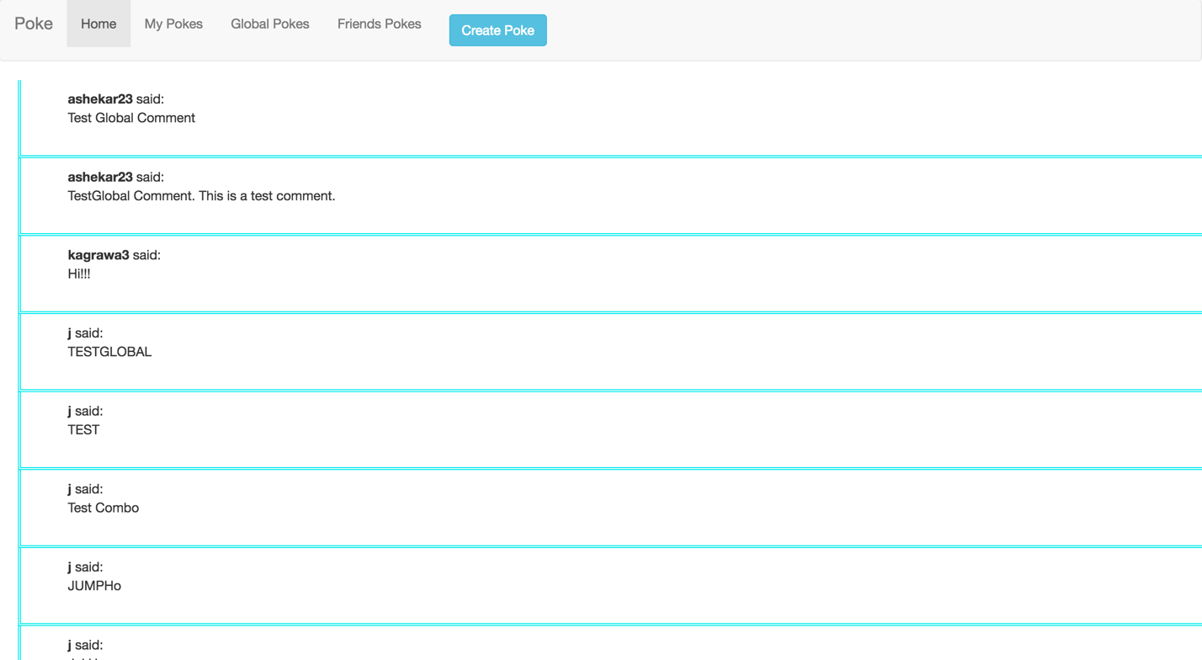

* Go to my Pokes and ensure that you see the same comment

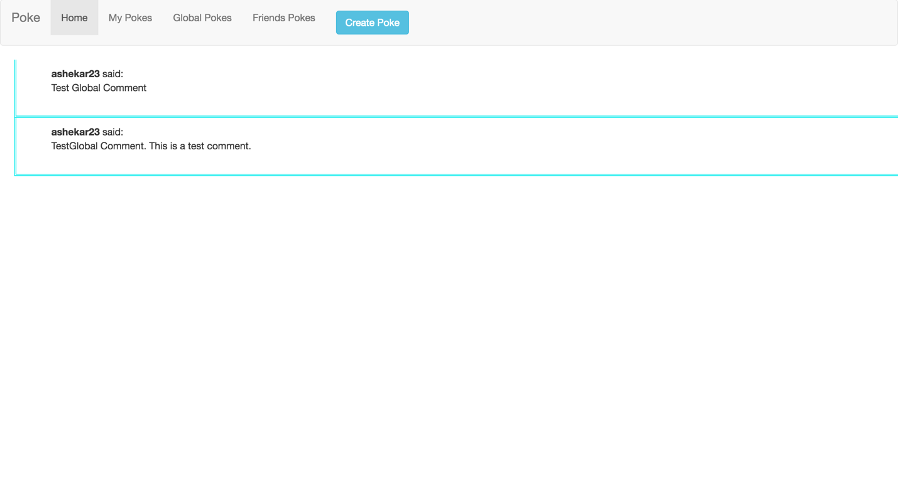

* Create a new Poke. This time add another username in the ‘visible to’ section.

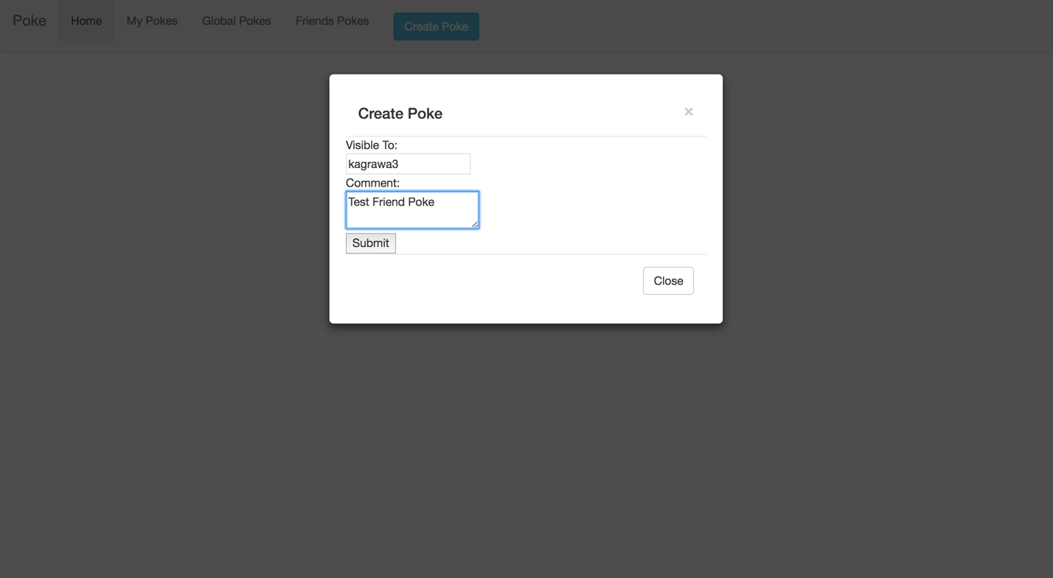

* Submit the Poke and ensure that you see the poke in Personal Pokes only.

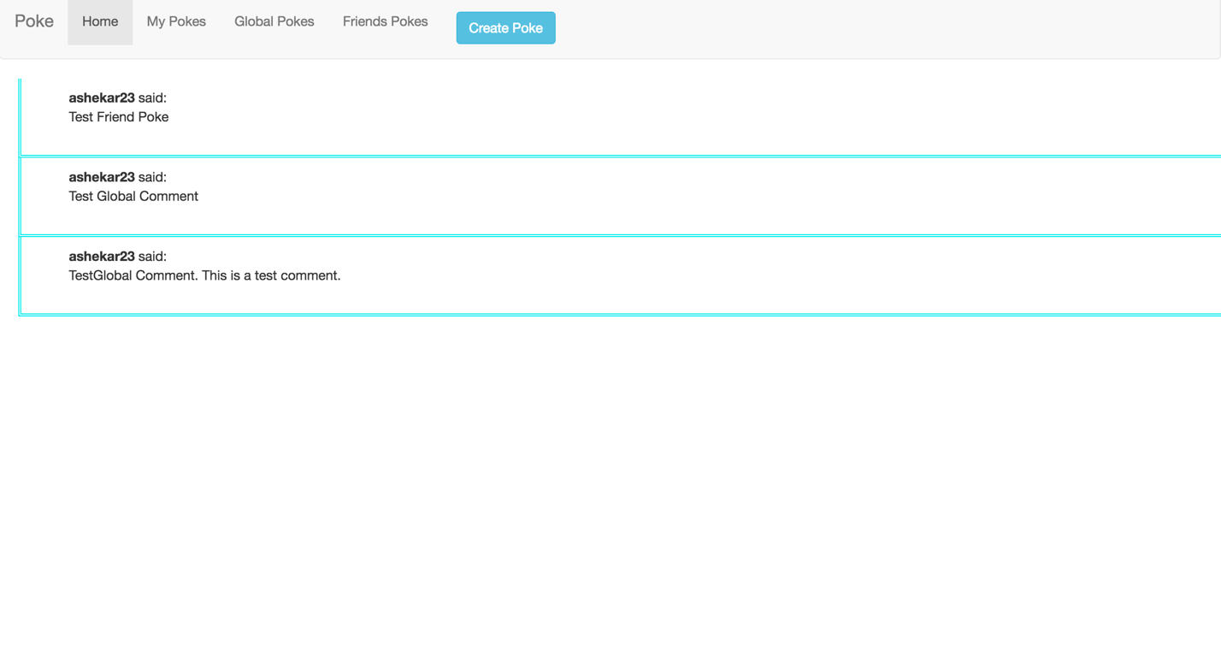

* Log into the account for the user you specified. Ensure that under friends Pokes, the above message is seen.

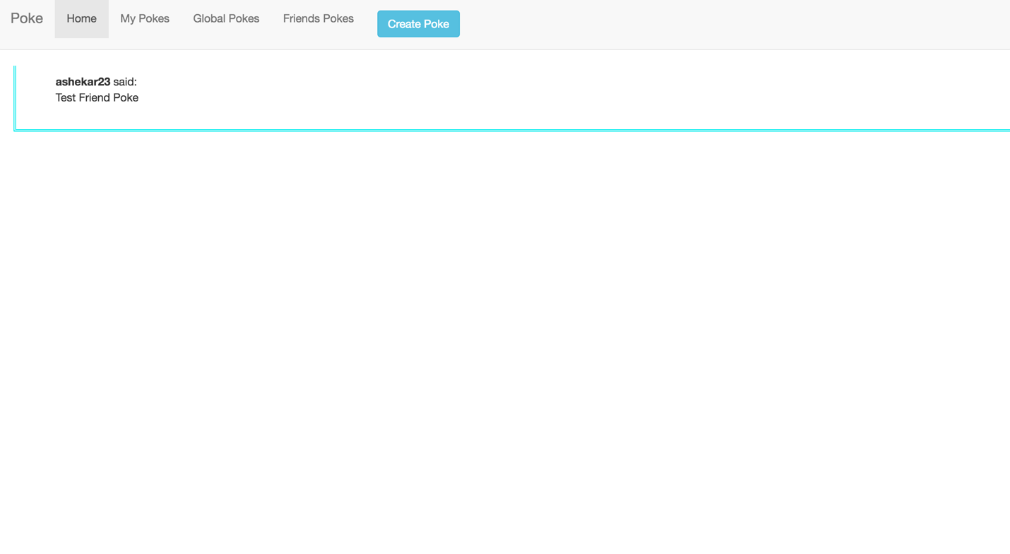

* Apart from these steps, you can also use the neo4j visualization tool in order to ensure the proper interaction with the database

**Test for checking correct functioning of Follow Button:**

* After logging into your account. You should see the following screen:

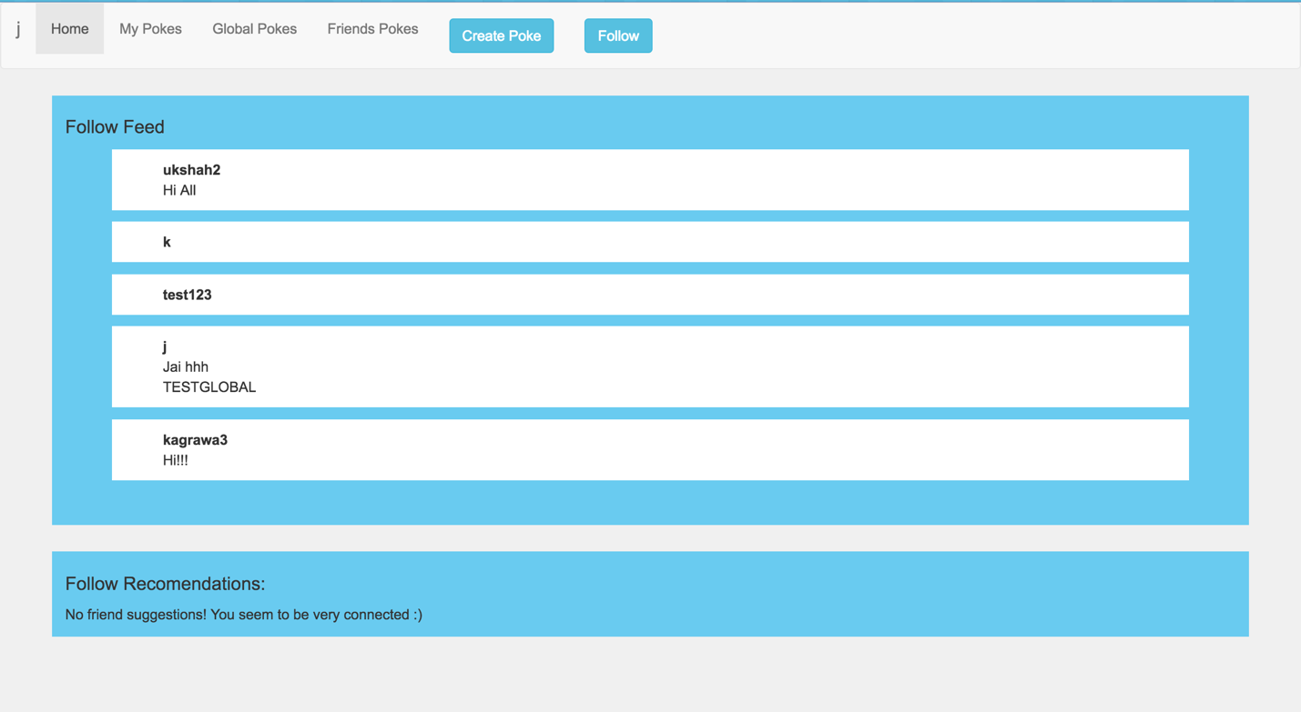

* Click on the follow button and enter a valid username. Click submit.

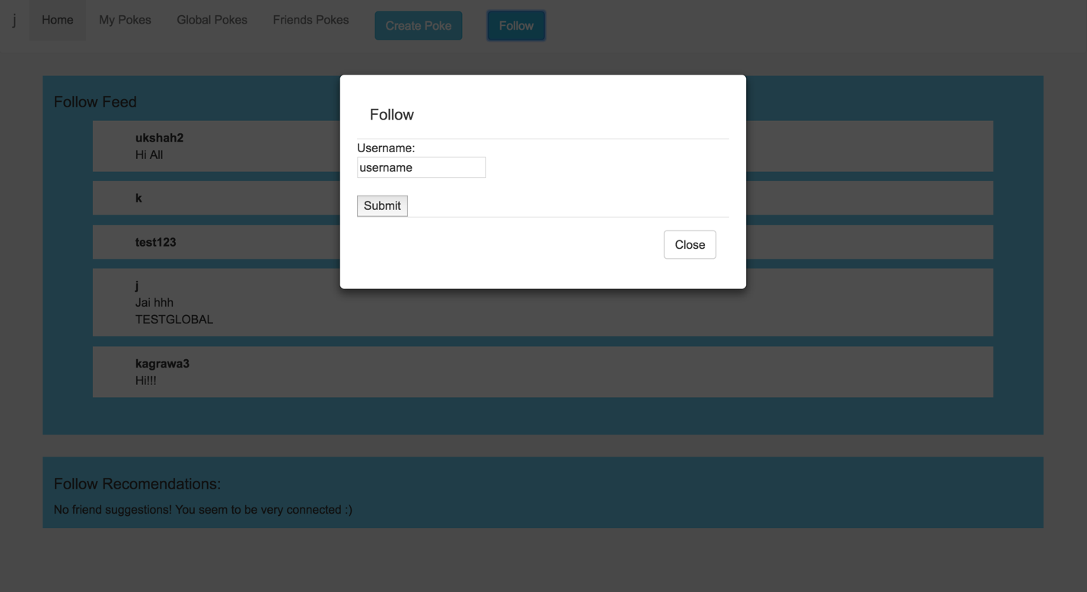

* You should see the following screen after the page reloads. It should contain the name of the person you are now following with the top 2 feed stories they have posted. If there are no posts made by the user, you will simply see him as one the people you are now following. In this case j is not following ashekar23

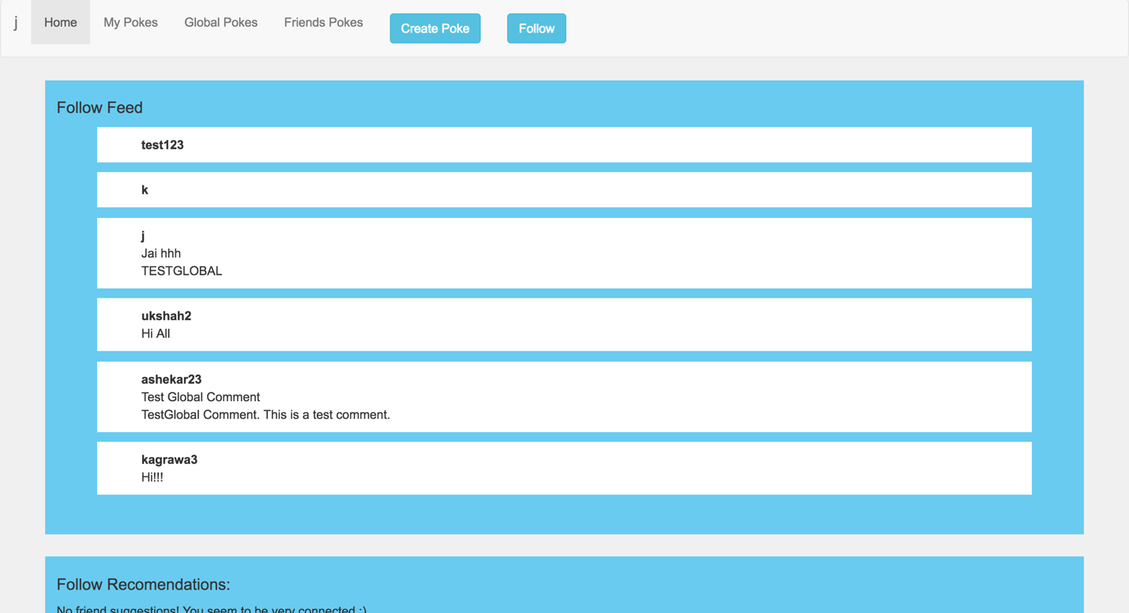

**Test for checking the correct functioning of shortest path algorithms:**

* Create users name user1, user2, user3.
* Make user1 follow user2. Make user2 follow user3.
* Now navigate to user1’s homepage and enter the name of user3 in textbox for shortest path.

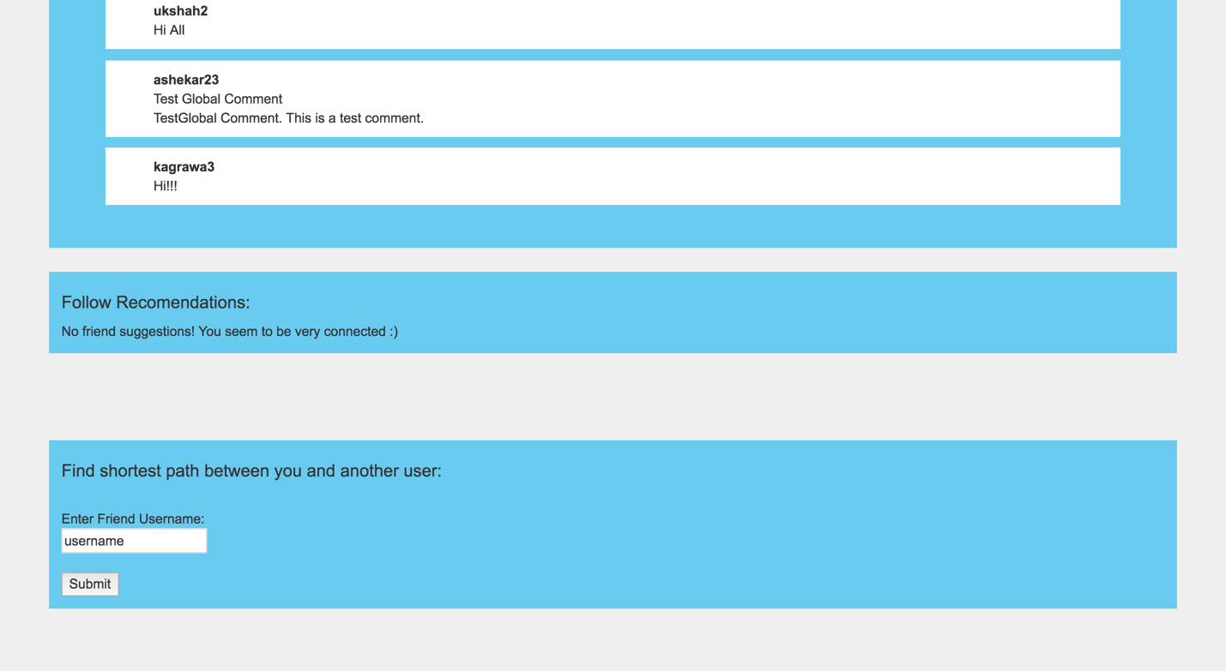

* You should see user1 -> user2 -> user3 indicating that there is a path from user1 to user3 through user2.

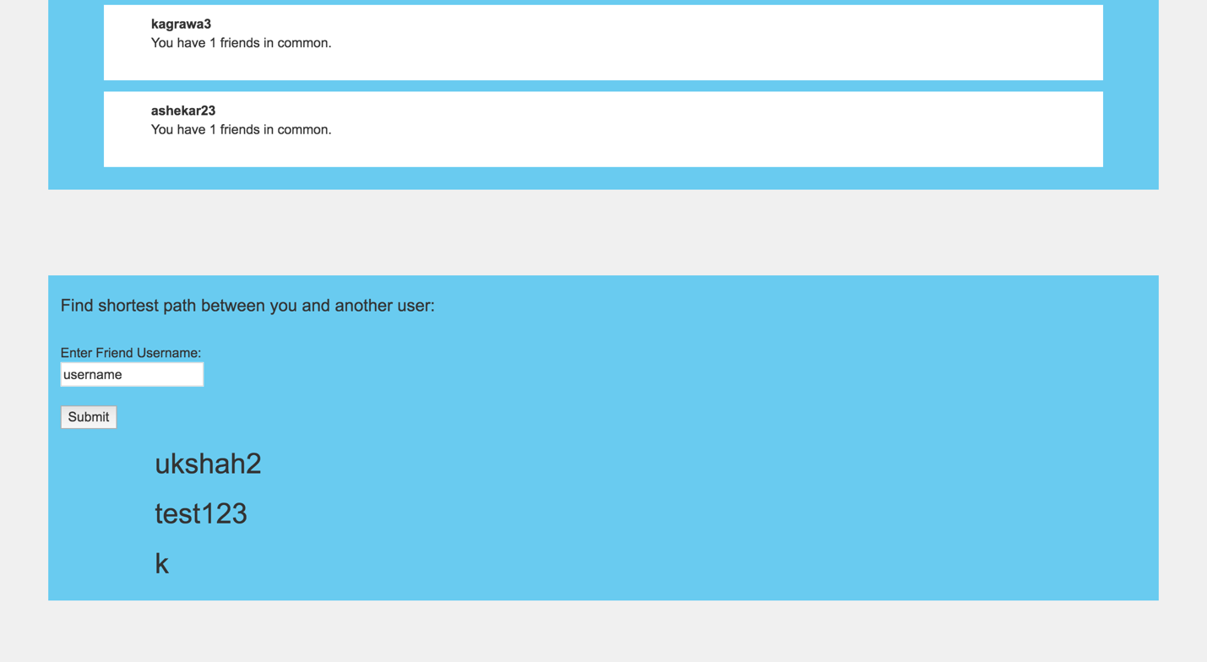

* The following example is shows for user1 = ukshah2 user2 = test123 and user3 = k