Ashley Landin

CSD310

Module 5.2 Assignment

November 7, 2023

TIME_TO_SEC

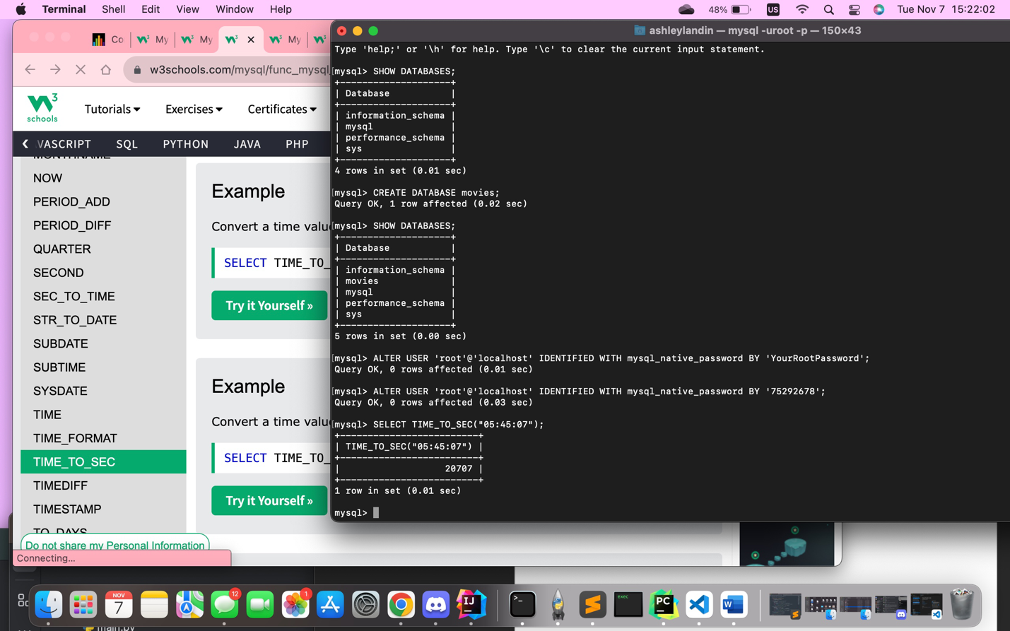The TIME_TO_SEC function in MySQL lets you enter a time stamp and have it automatically converted into seconds. If a project or data requirement specifically asks for time to be accounted for in seconds, this function can be useful to convert it within MySQL automatically in the case that it isn’t already converted.

TIMEDIFF

The TIMEDIFF function can be used to return the time difference between two dates entered into the function. With this function, you can keep it to only calculating the differences between timestamps, or you can add a date alongside the times tap as another parameter to measure the time difference for. As you can see in my example below, the order of the dates and times is significant, if the later date is placed after the earlier date, the function will return a negative value. That is something to keep in mind when using this function. This function is useful for calculating the time difference between two occurrences, and can be used to add an additional form of data.

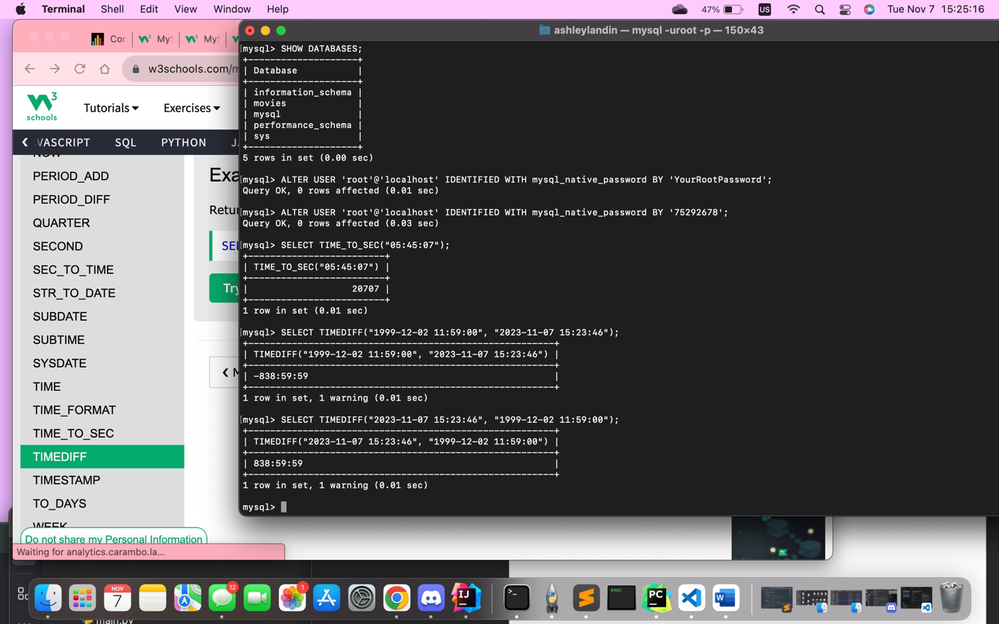

SUBTIME

The SUBTIME function in MySQL is used to subtract a specific time interval from an initial value that contains a time stamp and date. For the function, you would enter the time and date that you want to be modified, and then afterwards you enter the time interval that will subtracted from the initial value. Once you run the function, MySQL will display the information in a table with the command line in one tab and below it will be the new time and date that was pulled from the function. This function is really convenient for just calculating the difference of a time interval and having that data displayed with the date and new time. This could be useful for accounting for time zone differences that cause time intervals and even dates to be modified at times.

