1 Classification of Components

1.1 Define all components

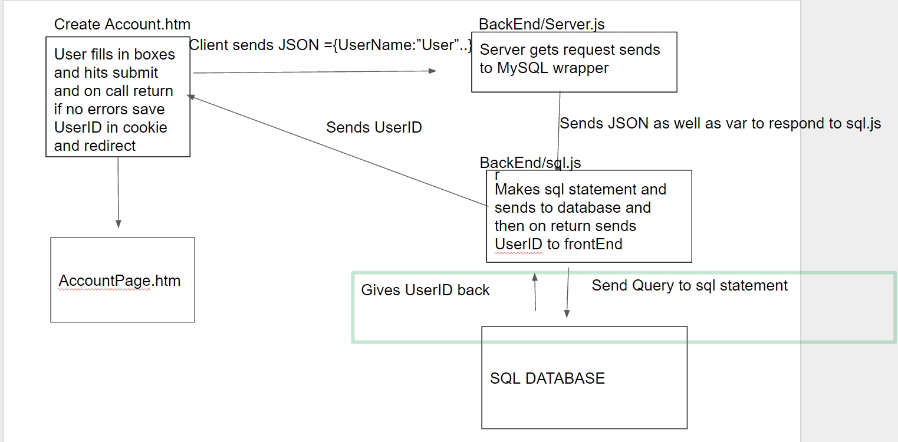

B.

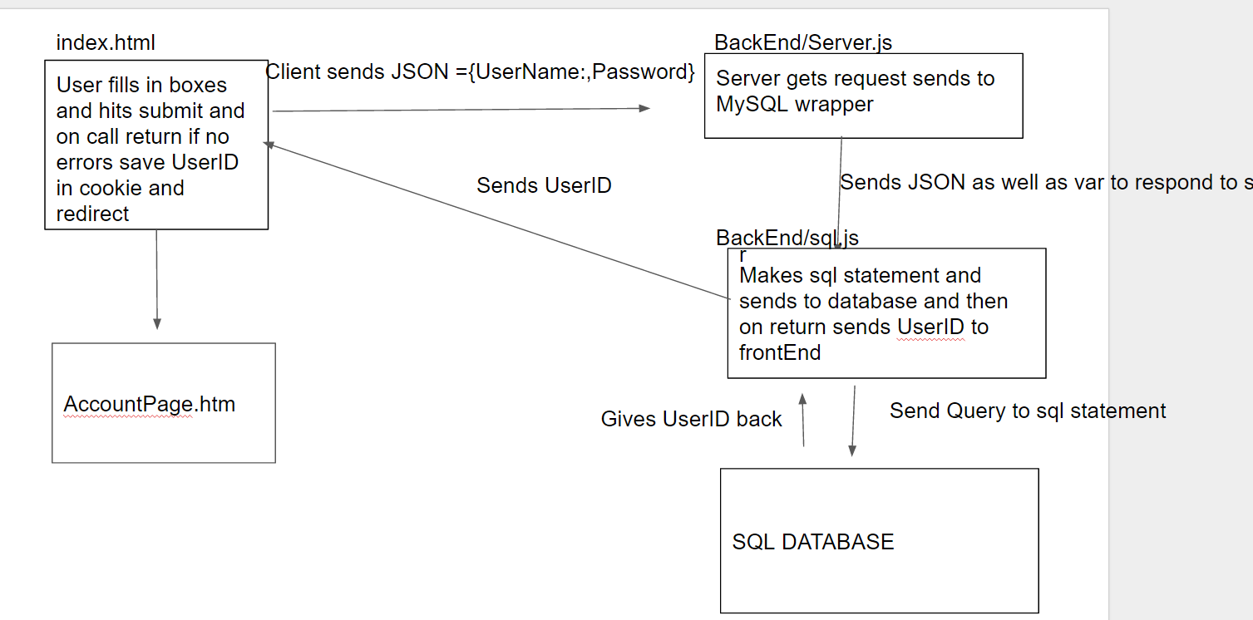

C.

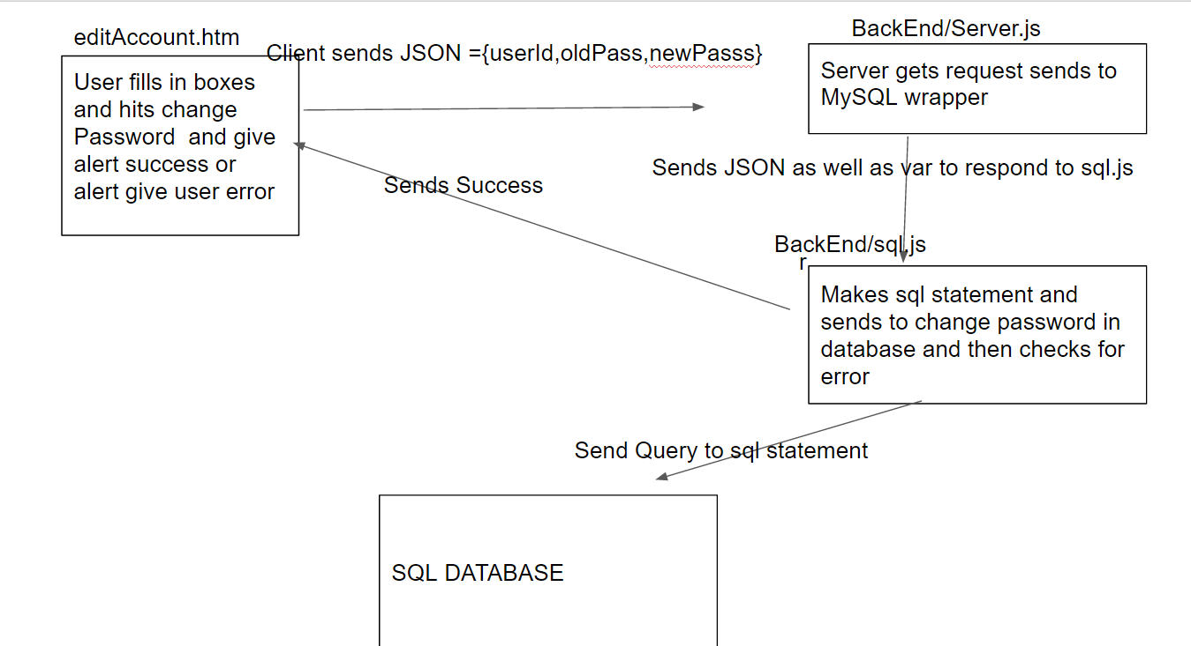

D.

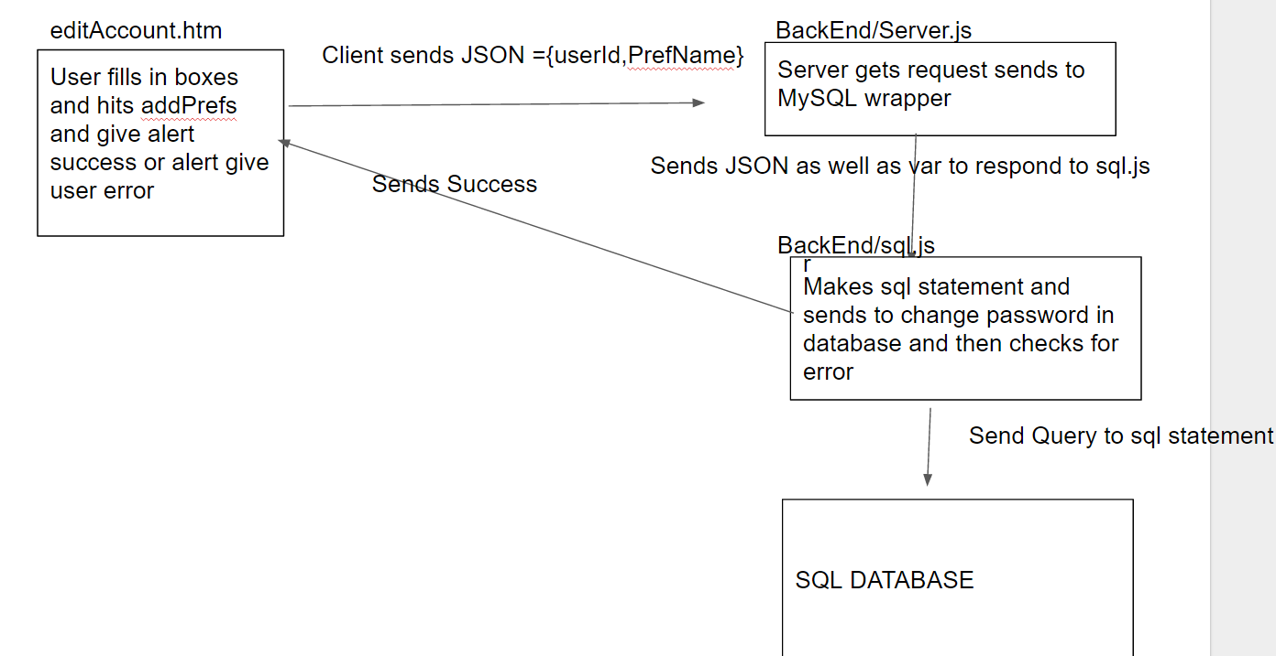

1.2

We did bottom up testing. We tested our SQL statements in javascript and then tested our node.js server running those sql statements;

2.1 Automation

We made our tests run automatically by running /cs408/BackEnd/test/

We used a Module Based Testing Framework where each test runs a different module and then had another test case that runs module test cases on top of those functions. We used a Data Driven Testing Framework, by pointing data in the database and running tests on different data to make sure it can read it right.

## Defect Log

|  |  |
| --- | --- |
| Module | Component A - Division |

Incremental Testing

|  |  |  |  |
| --- | --- | --- | --- |
| Defect # | Description | Severity | How Corrected |
|  | Did not find any errors in incremental testing |  |  |

Regression Testing

|  |  |  |  |
| --- | --- | --- | --- |
| Defect # | Description | Severity | How Corrected |
|  | Did not find any errors in incremental testing |  |  |

## 

|  |  |
| --- | --- |
| Module | Component B - Division |

Incremental Testing

|  |  |  |  |
| --- | --- | --- | --- |
| Defect # | Description | Severity | How Corrected |
|  | Did not find any errors in incremental testing |  |  |

Regression Testing

|  |  |  |  |
| --- | --- | --- | --- |
| Defect # | Description | Severity | How Corrected |
| 1 | Res was null in many cases -causing timeout erros | 1 | Change function to pass res along |

## 

|  |  |
| --- | --- |
| Module | Component C - Division |

Incremental Testing

|  |  |  |  |
| --- | --- | --- | --- |
| Defect # | Description | Severity | How Corrected |
| 1 | Change name to fit sql on editPassword | 2 | Ask for USerName when needed UserID |
| 2 | Res was null in many cases -causing timeout erros | 1 | Change function to pass res along |

Regression Testing

|  |  |  |  |
| --- | --- | --- | --- |
| Defect # | Description | Severity | How Corrected |
| 1 | editPassword call the wrong the function | 2 | Changed function that editUser called to send back proper response to client |

## 

|  |  |
| --- | --- |
| Module | Component D - Division |

Incremental Testing

|  |  |  |  |
| --- | --- | --- | --- |
| Defect # | Description | Severity | How Corrected |
| 1 | test case 37 failed  { Error: ER_NO_REFERENCED_ROW_2: Cannot add or update a child row: a foreign key constraint fails (`cs408`.`user_intere  sts`, CONSTRAINT `user_interests_ibfk_2` FOREIGN KEY (`InterestID`) REFERENCES `interests` (`InterestID`)) | 2 | Added a check for id to make sure it wasn’t -1. |
| 2 | Test 38 failed  Error should not have passed | 2 | Fixed itself |
|  | test case 40 failed  { Error: ER_BAD_FIELD_ERROR: Unknown column 'UserID' in 'where clause' | 2 | Added a check to make sure userid was greater than 0. |
|  |  |  |  |

Regression Testing

|  |  |  |  |
| --- | --- | --- | --- |
| Defect # | Description | Severity | How Corrected |
| 1 | Error: Can’t set header after it has been sent(from running testClient.js), send res more than once | 1 | After sending res return to stop next calls from having |
|  |  |  |  |
|  |  |  |  |
|  |  |  |  |

## 