**Travel Insurance System**

Django python framework based Travel Insurance System

**Setup project**

Install Virtual Environment (recommended)

Installing python packages in virtual environment is recommended

Featured

* User management
  + Create ,edit and view operation/staff
  + Create edit and view Manager
  + Create edit and view client
* Insurance request
  + Client add request, search request, edit request, and print policy
  + Staff check client request and insert policy no
  + Manager check user request and confirm request
* Login session
  + Login and logout

**Migration**

After installing python run bellow command

Python manage.py makemigration

Python manage.py migrate

**Create Admin User**

Run below command

Python manage.py Createsuperuser

**Run server**

Python manage.py runserver

Now,open <http://127.0.0.1:8000/>

**Screenshot**

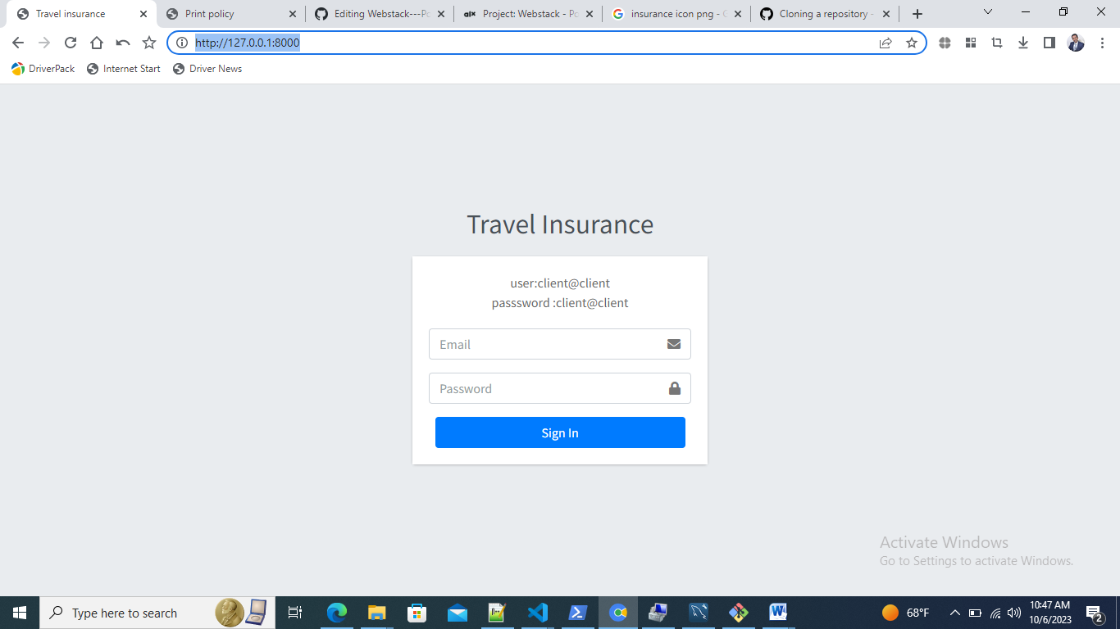

**Admin /dashboard**

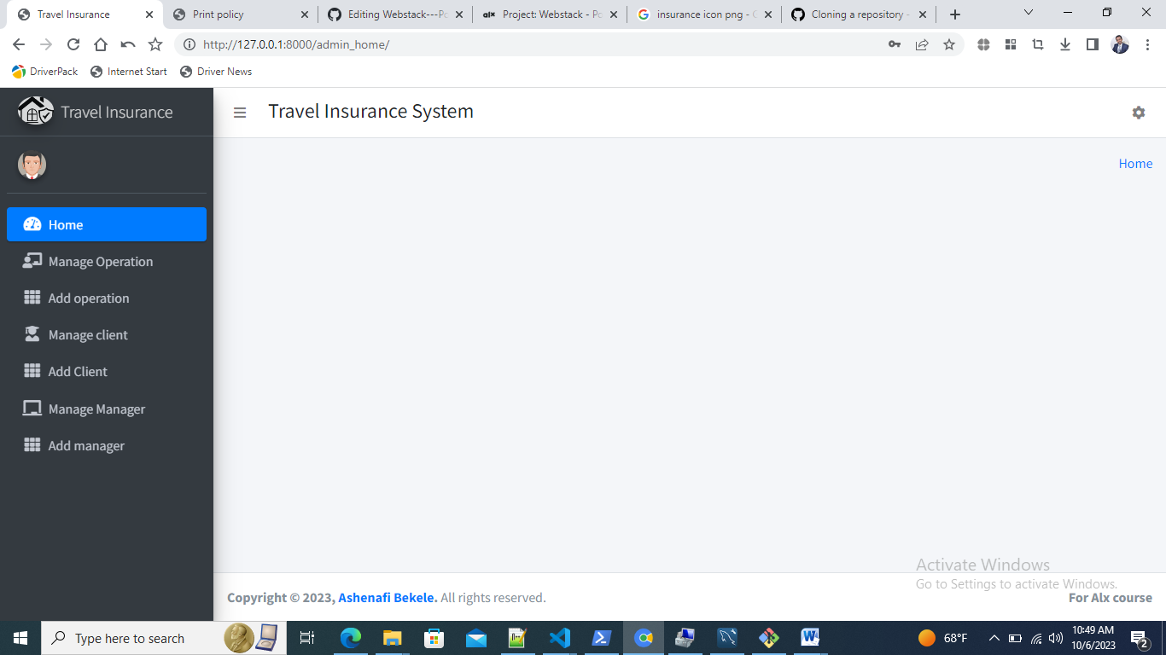

Use registration

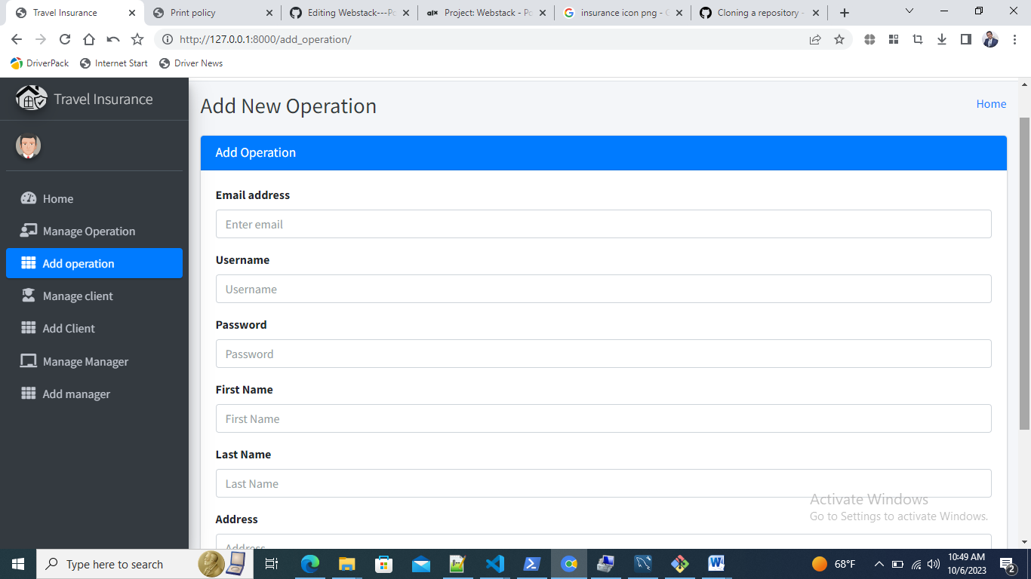

Client dashboard

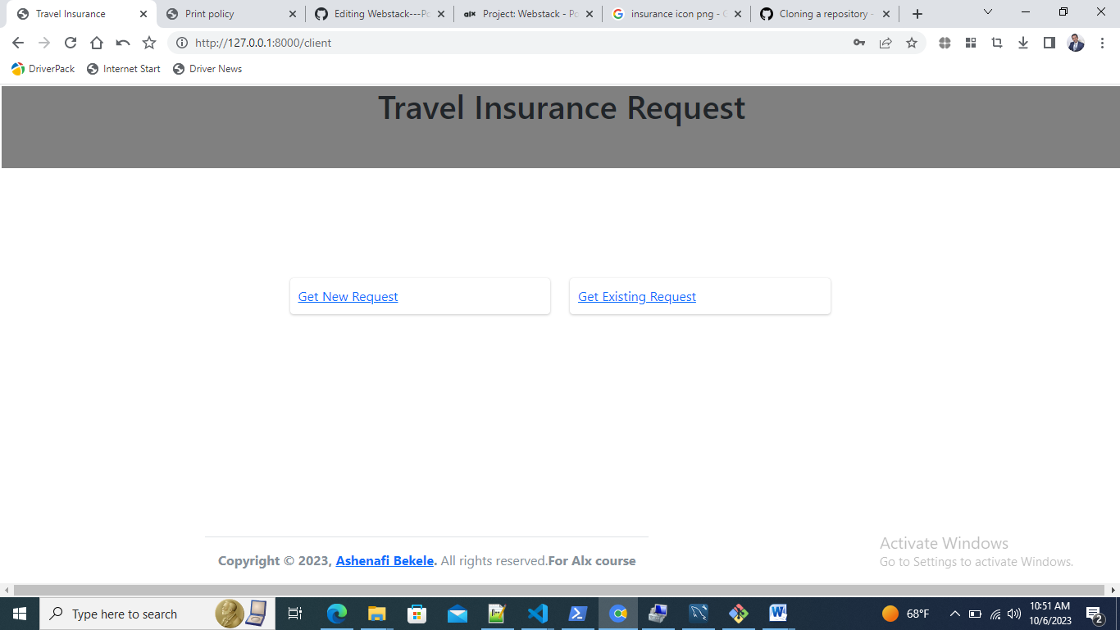

Insurance request form

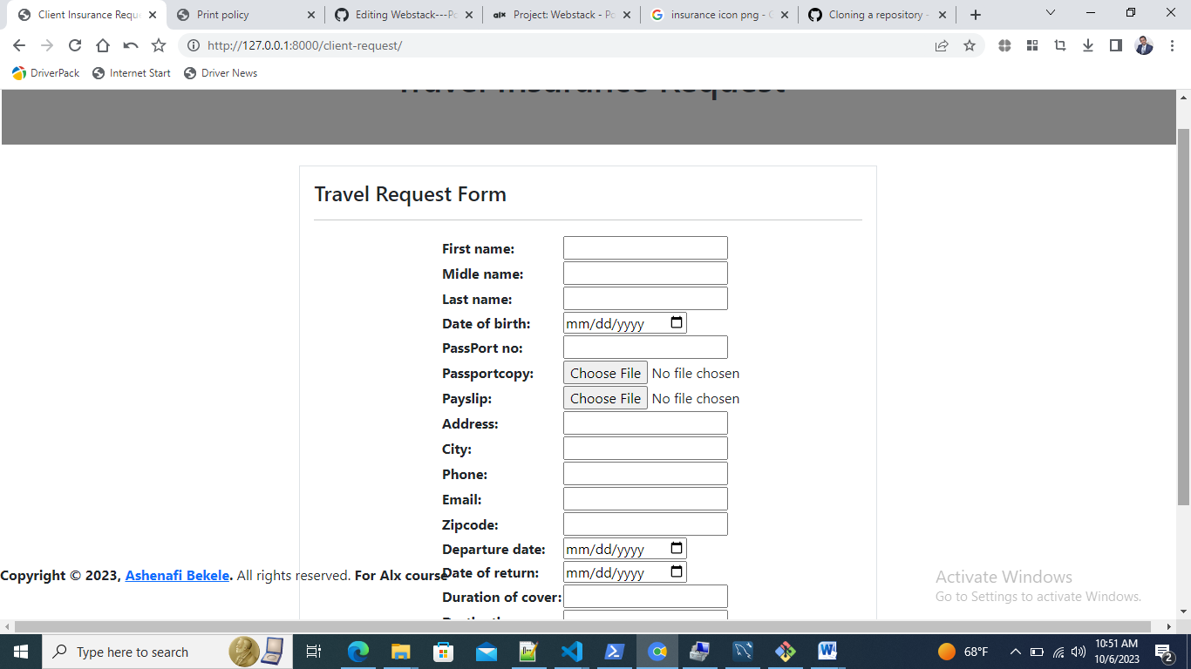

Search Request

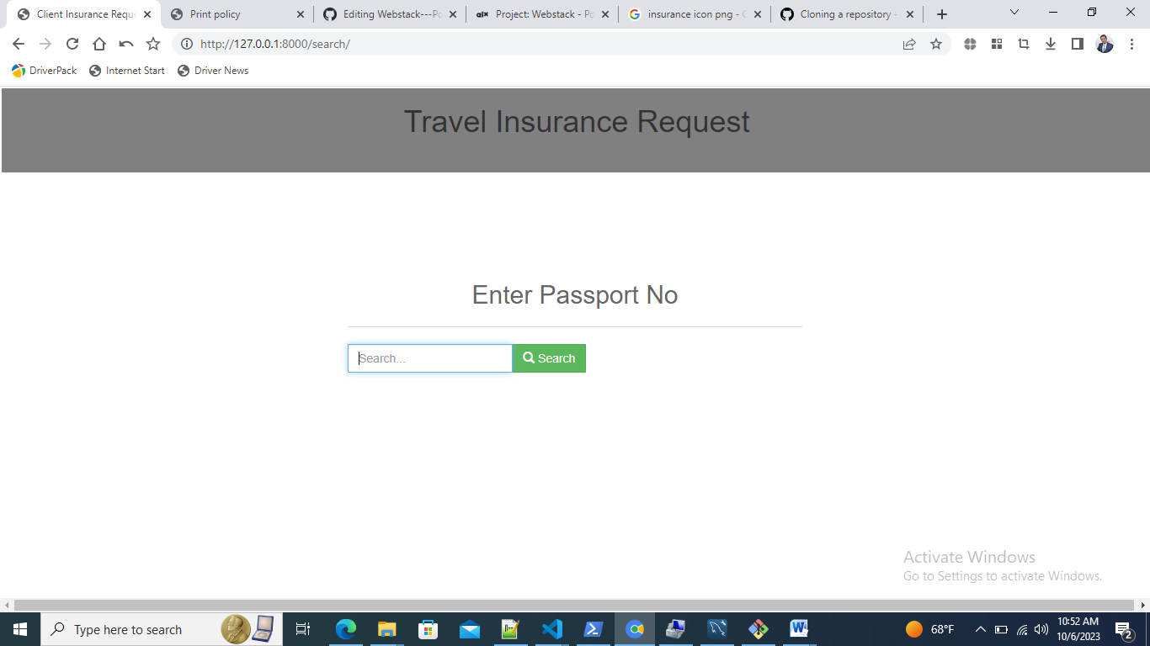

Result

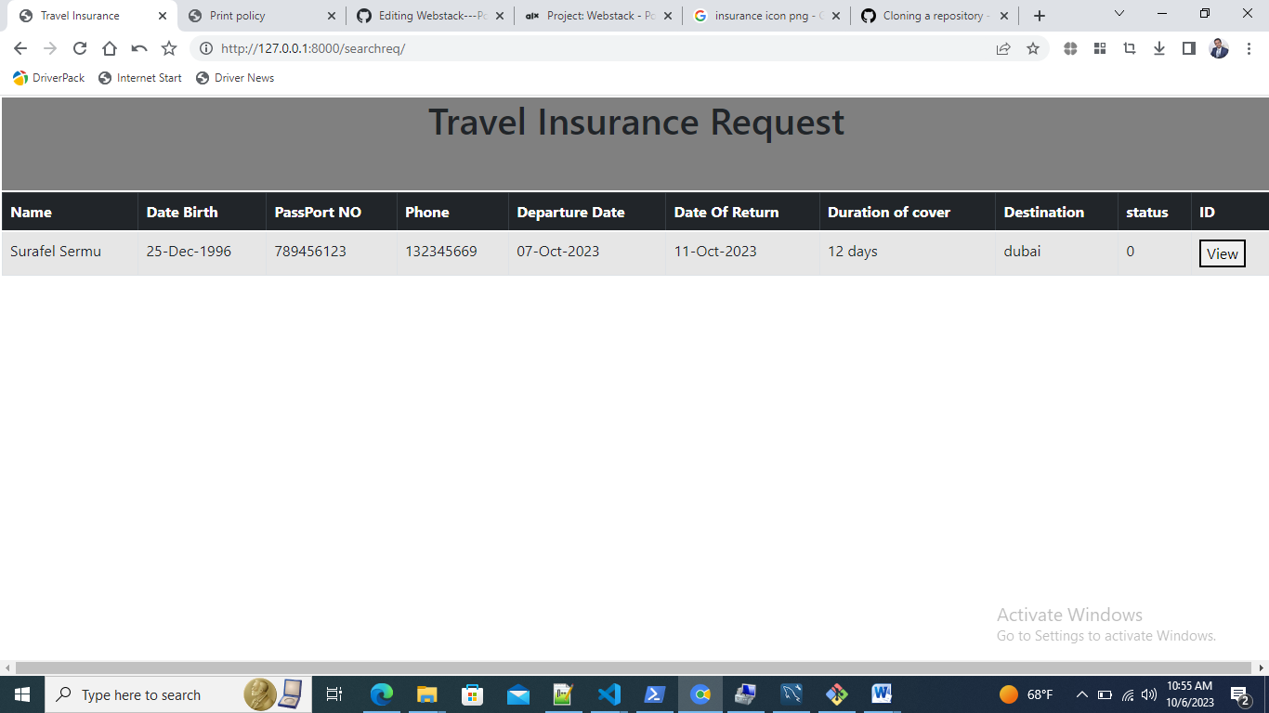

Details

