**Project 3 Style Guide**

[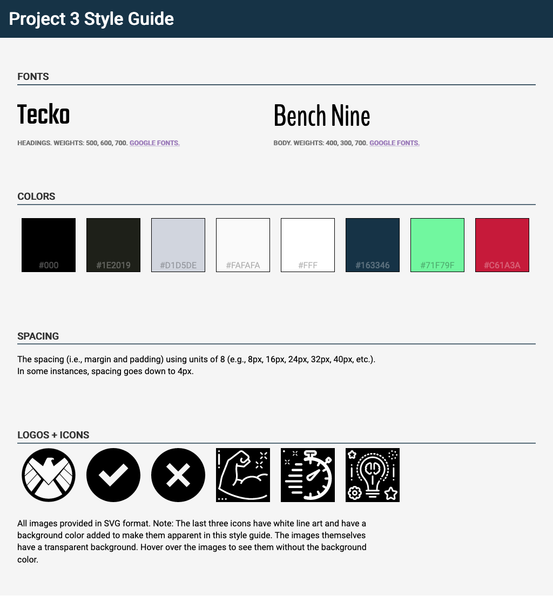](https://cdpn.io/angeliquejw/debug/55b400902bf4fe7e7c2249f24903d2b1)

I’ve created a detailed interactive styleguide via CodePen here:

<https://cdpn.io/angeliquejw/debug/55b400902bf4fe7e7c2249f24903d2b1>

Want to see the code behind this styleguide? 👀

<https://codepen.io/angeliquejw/pen/55b400902bf4fe7e7c2249f24903d2b1>