How to install and Use Scripts   
for Prepare Site Archive   
and for Post Clear Site processing.

# PART I. Installing Drivers and prepare Credentials for access to Sharepoint Server.

## Install CSOM (Sharepoint Client Side Object Model)drivers on Computer

* 1. To Install CSOM Drivers to Access SharePoint From Client (not a Server) computer, first click following link:  
     \\ekekfls00\sharetwo$\ekcc_pub\codeRepository\Asher\sharepointclientcomponents_16-6906-1200_x64-en-us.msi
  2. 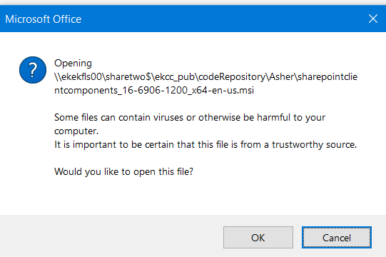
  3. **Click OK.**
  4. 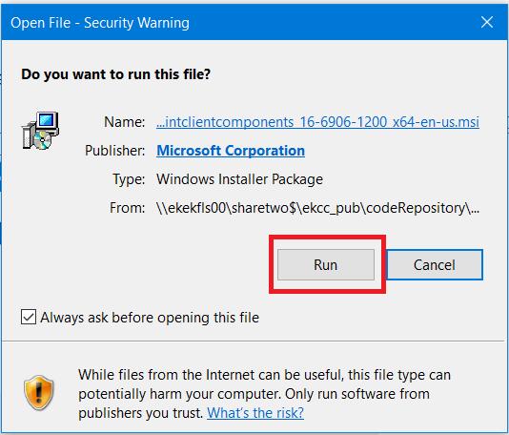
  5. Click Run
  6. 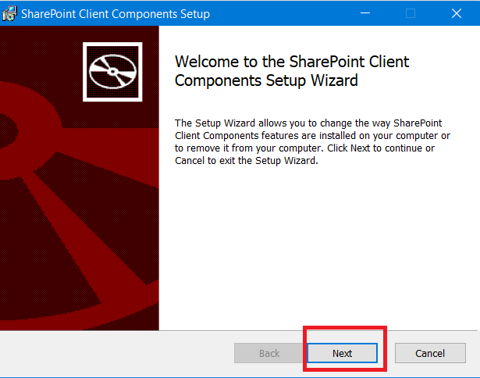
  7. Click Next and finish process of installation

## Copy Initial Files to Local Drive

* 1. Open folder c:\
  2. Create folder AS-SCRIPTS on local drive
  3. 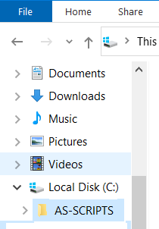
  4. Open Folder \\ekekfls00\sharetwo$\ekcc_pub\codeRepository\Asher\AS-SPPS\  
     **(Source Folder)**
  5. Open Folder c:\AS-SCRIPTS  
     **(Destination Folder)**
  6. Copy all files from Source Folder to Destination Folder
  7. 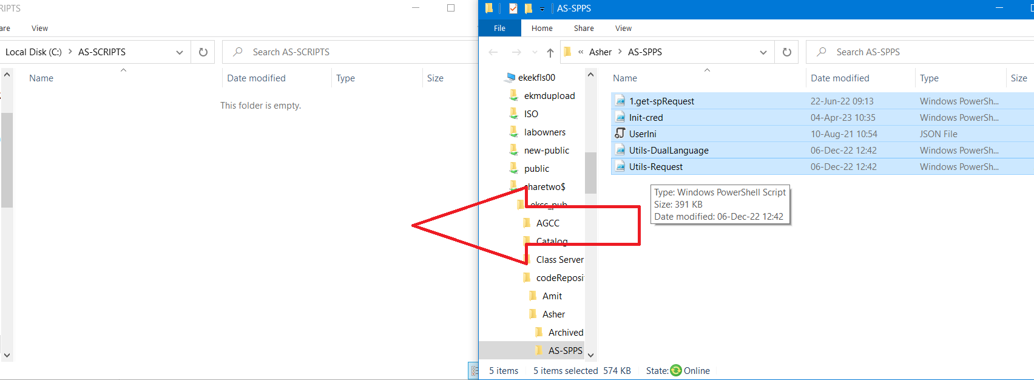
  8. 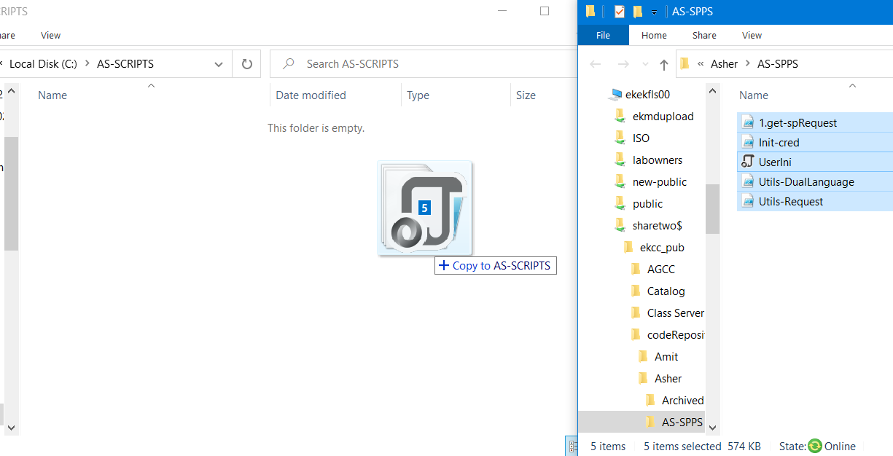
  9. 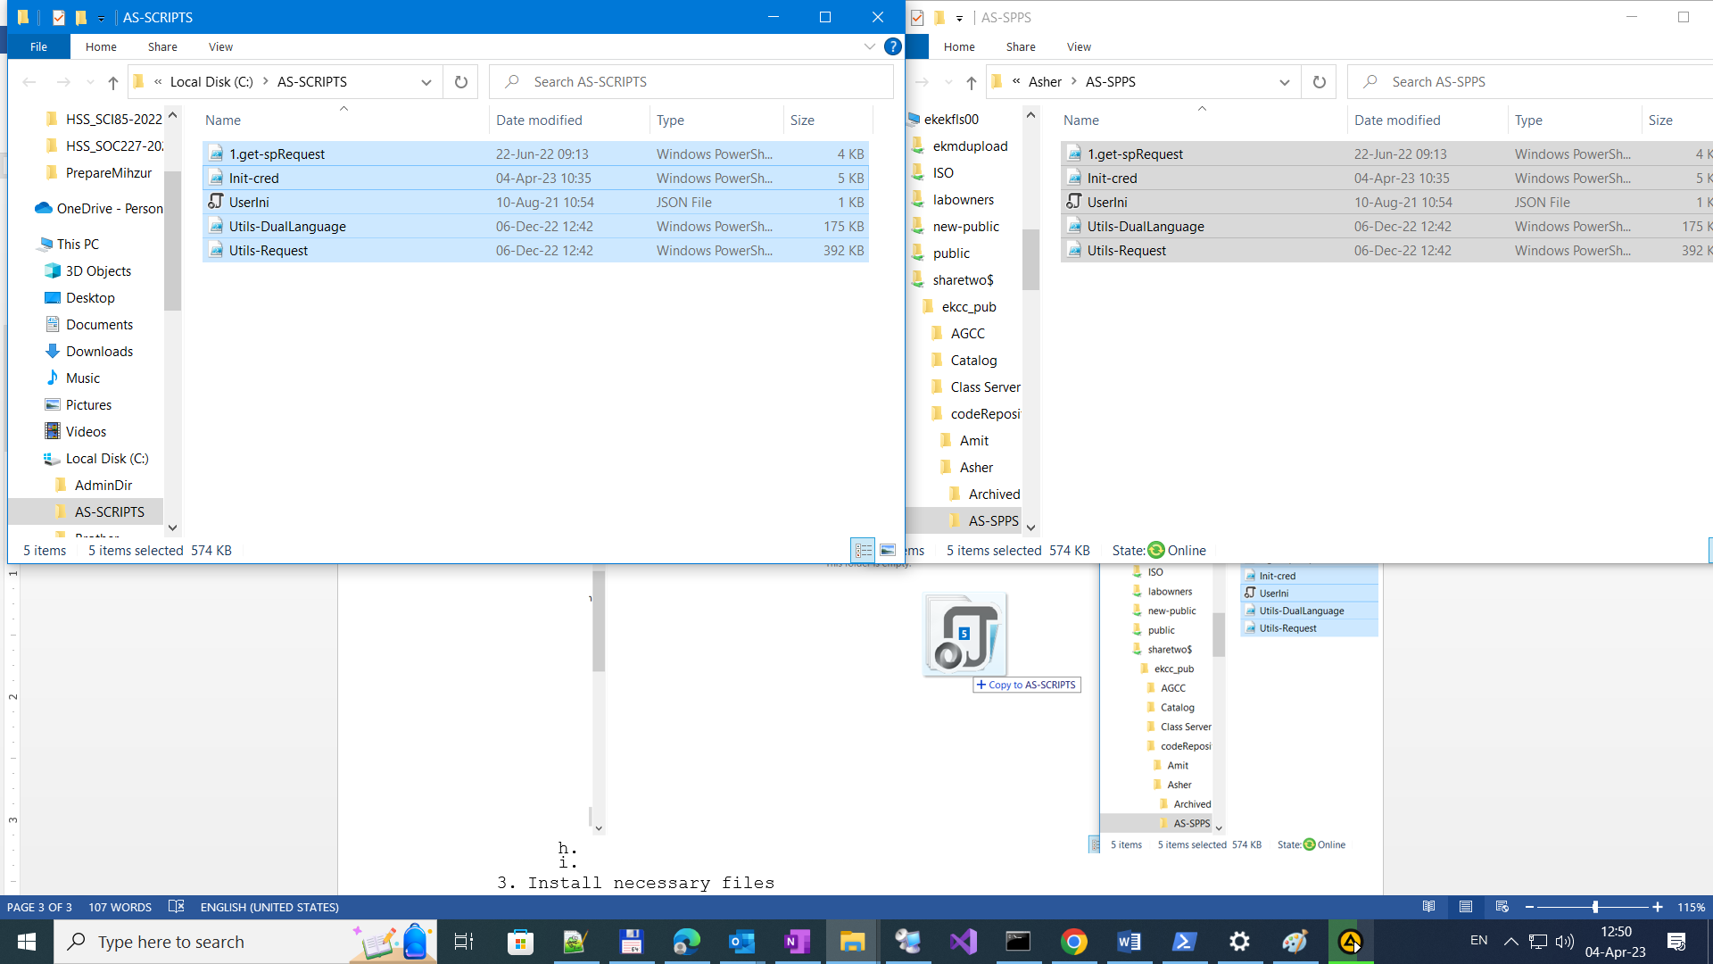

Run File for Store Initial Credentials.

Notes: Initial credentials Store in Local registry in Hidden (encrypted) form.  
This need, that you will not enter Username and Password every time you run a script. Script contains of hundreds little utilities and every time you access to SharePoint Script use this credentials you entered. Other, you were need to enter credentials lot of times.

* 1. Open PowerShell
  2. Change drive to c:
  3. Open directory c:\AS-SCRIPTS  
     PS S:\> **c:**
  4. PS C:\> **cd .\AS-SCRIPTS\**

PS C:\AS-SCRIPTS> **.\Init-cred.ps1  
Enter Username and Password in domain EKMD**

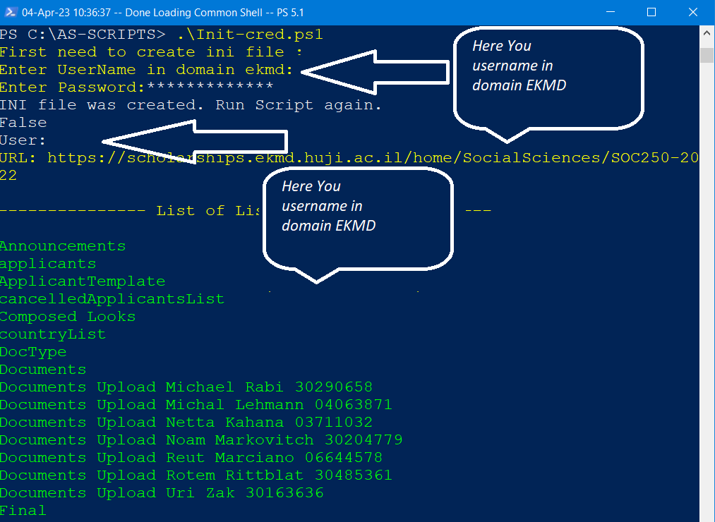

* 1. If you have got list of Libraries (color green), that means you Credentials is OK and you have access to SharePoint.

PART II

1. Prepare to archive  
   When on site <https://portals2.ekmd.huji.ac.il/home/huca/spSupport> exists new request on List **spRequestsList** and you understand that it request requires create new Archive (Mihzur) the **Best way** to prepare use script **.\14.Prepare-Archive.ps1**
2. Insert Command **.\14.Prepare-Archive.ps1** and press key ↵ Enter.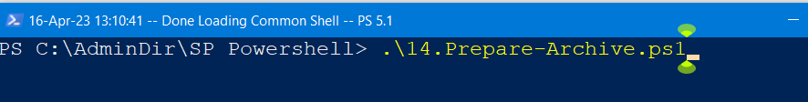
3. Script shows list of sites of **spRequestsList** with following **status**es **: 0 – חדש /1 – בביצוע /1.1 - ארכיון תוכנן   
   (new, in process, archive is planned).**May be a list of sites. Each shown item have **Index**   
   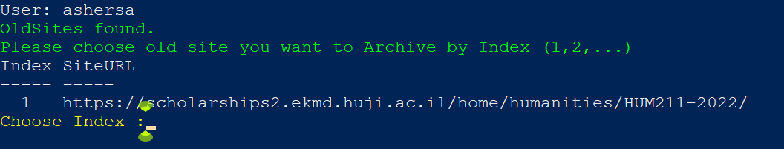  
     
   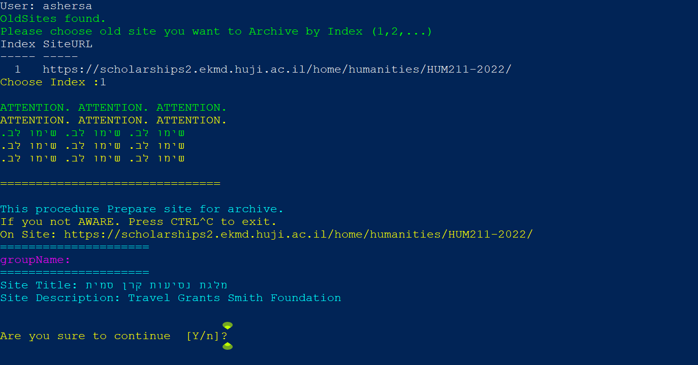  
     
   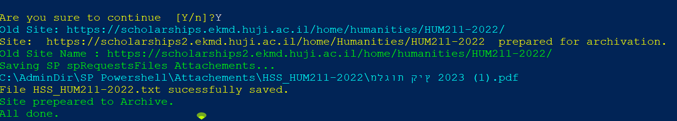  
     
   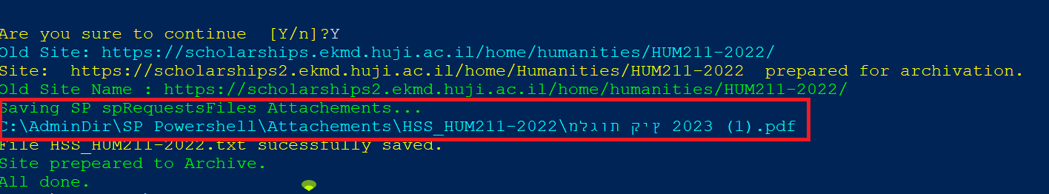  
     
   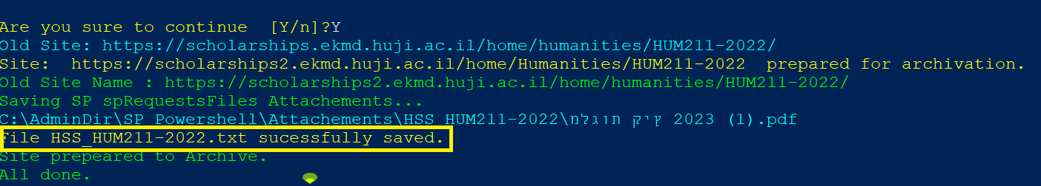  
     
   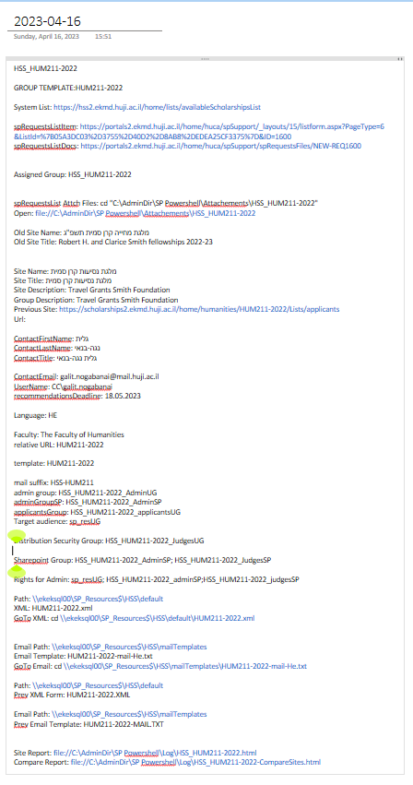  
   <https://portals2.ekmd.huji.ac.il/home/huca/spSupport/Lists/spRequestsList/applicationin%20progress.aspx>  
   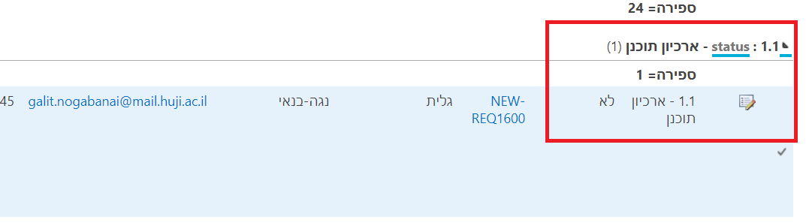  
     
     
     
     
   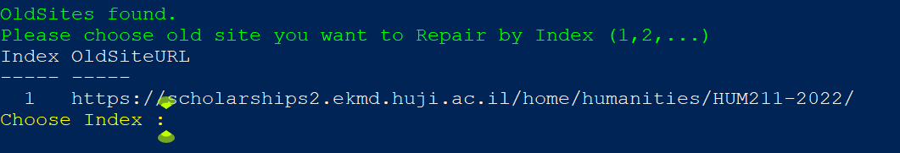  
     
   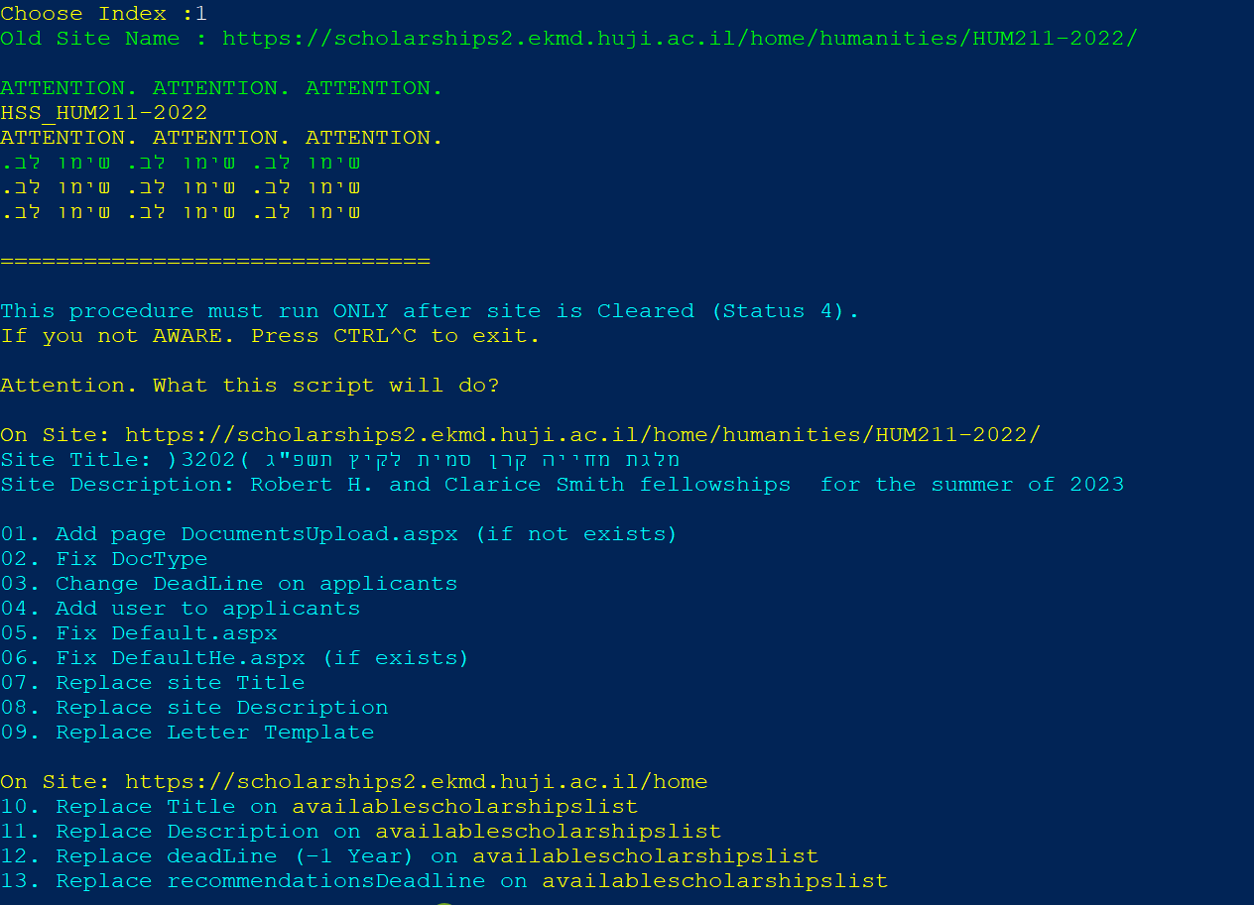  
     
   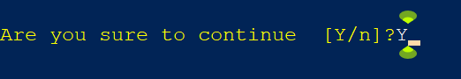  
     
   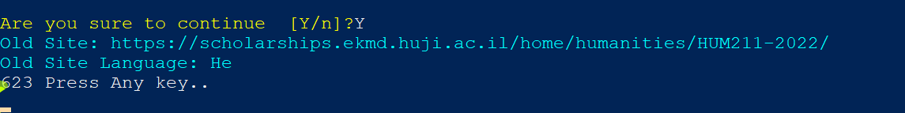  
     
   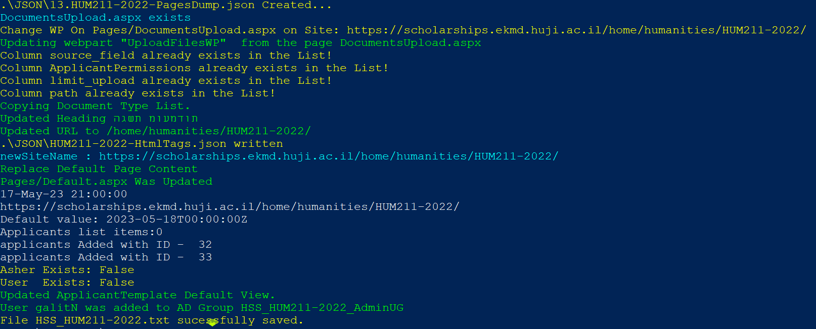  
     
     
     
   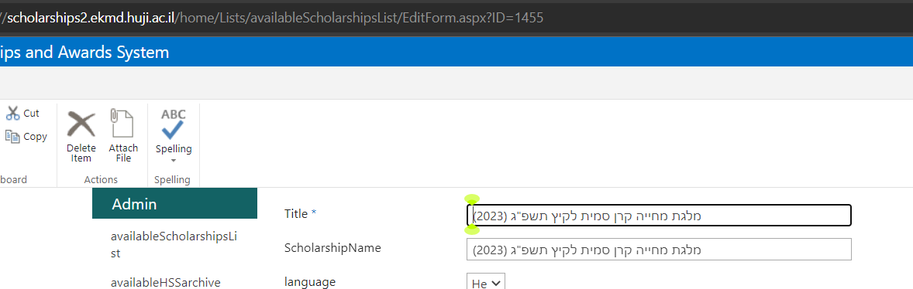  
     
   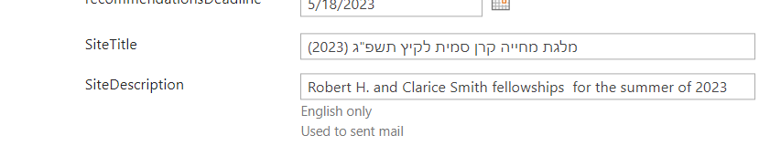  
   1. Output of the Script
4. Check for TXT file
5. Insert TXT File to OneNote
6. Get HTML support file