# Script AS-fillFinal-01.ps1

## Script AS-fillFinal-01.ps1 running on server SharePoint under administrative rights.

1. Script reads source list Applicants on site [**https://grs.ekmd.huji.ac.il/home/Education/EDU63-2022/**](https://grs.ekmd.huji.ac.il/home/Education/EDU63-2022/)

If field **Export_Files** on applicants list is ON and Field **[סטאטוס טיפול בתיק] eq [קבלה] or [קבלה עם השלמות]**

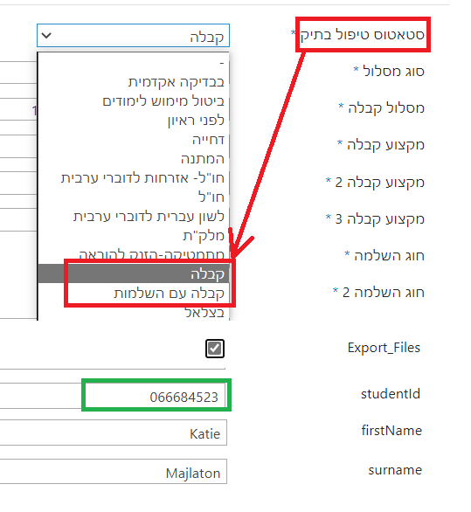

Scripts Looks in Document Library **ResponseLetters** on Site <https://grs.ekmd.huji.ac.il/home/Education/EDU63-2022/ResponseLetters/Forms/AllItems.aspx> File with value from field **studentID**, and if file with this name exists in document library copy it to temporary folder on server.

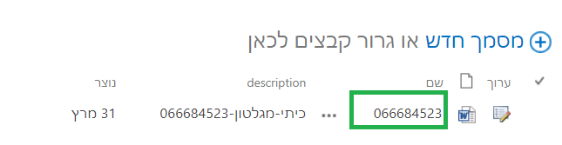

1. Script opens target site <https://portals.ekmd.huji.ac.il/home/EDU/stdFolders>  
   Looks if exists Document Library with internal name of **studentID**, if not exists Create it with internal name form **studentID** value and renames it to user notation Document Library. 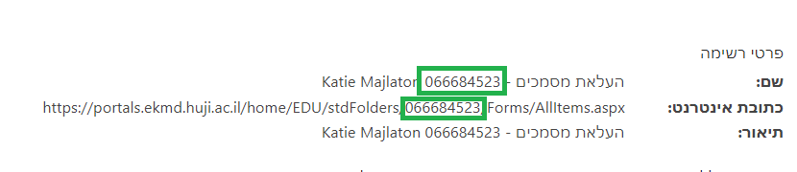
2. Then script adds folder hierarchy to user document library, if hierarchy does not exists.  
   **Graphical user interface, application

   Description automatically generated**

And copy file from temporary folder to תיק מועמדות hierarchy.

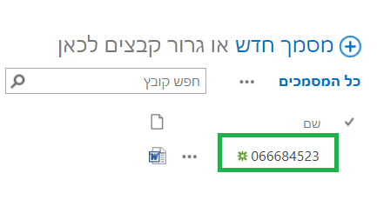

1. After script open list **TeachCert** on Site <https://portals.ekmd.huji.ac.il/home/EDU/stdFolders> and looks if exists record with **studentID** in **תעודת זהות** field. ****if no record add it and change field **folderLink** to Document library link and name **תיק אישי**  
   Edit fields of list with values from source applicant list.  
   **Graphical user interface, text, application, email

   Description automatically generated**
2. After script clears Flag **Export_Files** in Applicants List.  
   Background pattern

   Description automatically generated with low confidence