Project 4 – Degradation of Data Integrity

Austin Chandler

College of Science, Engineering, and Technology, Grand Canyon University

CST-305: Principles of Modeling and Simulation Lecture & Lab

Dr. Ricardo Citro

March 1st, 2021

**Project 4 – Degradation of Data Integrity**

This project consists of two-parts where a system of ODEs is built to model the loss or corruption of data in a digital storage system. Then a computer simulation is implemented to visualize the data degradation.

**Responsibilities**

Responsibilities and tasks that were completed during this project were as follows. For part 1, factors that lead to the degradation of data over time were identified, defined, and described. Mathematics were used to back up the model, the system of ODEs, and the quantification of the outcome. For part 2, the chosen scenario was detailed and appropriate techniques and tools were found to visualize changes in the quality of the data over time, and the appropriate mathematical and scientific notion of the model was explained in detail. Additionally, graphic models were generated to provide clear visuals for the equations and stages of degradation.

**System performance context description**

System performance is not applicable because the system is only graphing the result, not solving for it.

**Specific problem solved**

For part 1, a mathematical model was constructed that describes the I/O and data transfer speeds in processors A, B, and C, respectively, at a time t. This mathematical model was then solved to find the eigenvalues. The graphic model the mathematical model was based on is shown below:

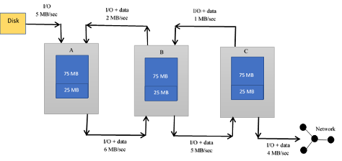

For part 2, a mathematical model was constructed from the figure shown below to find the I/O data at a time t in processors A and B respectively. A mathematical model was then created in the standard order of differential equations. $e^{At}$ was then calculated. Solutions for $x(0) = 1$ and $x’(0) = -1$ were then found using the matrix method, and appropriate software was used to generate graphs for the solution.

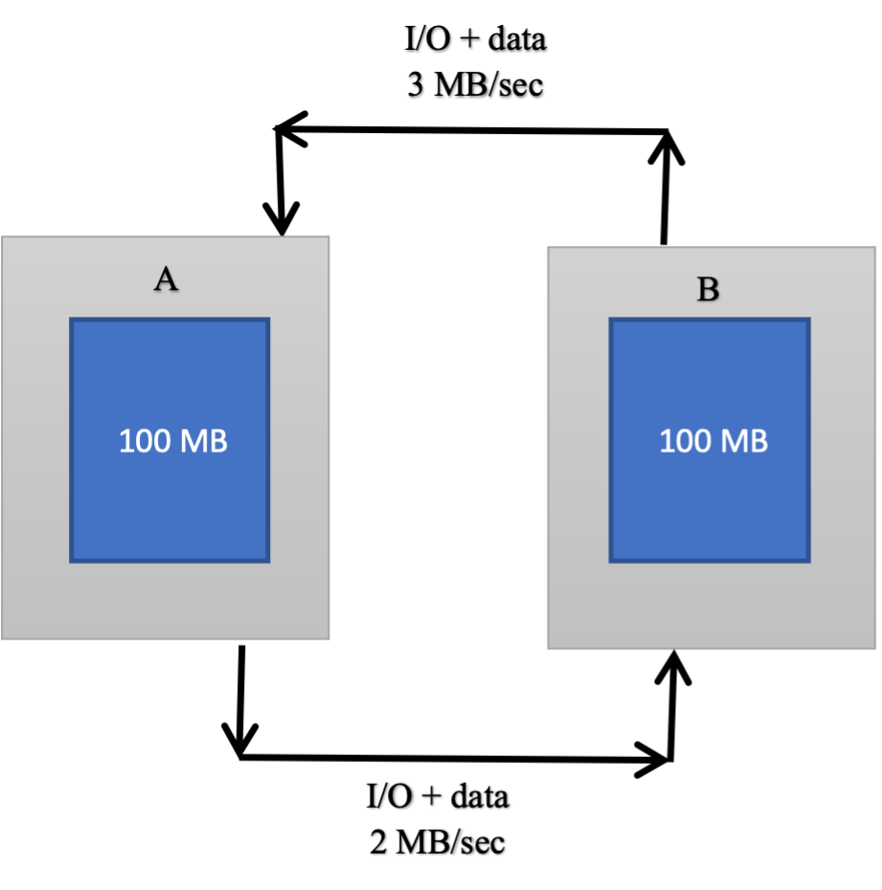

**Mathematical Approach**

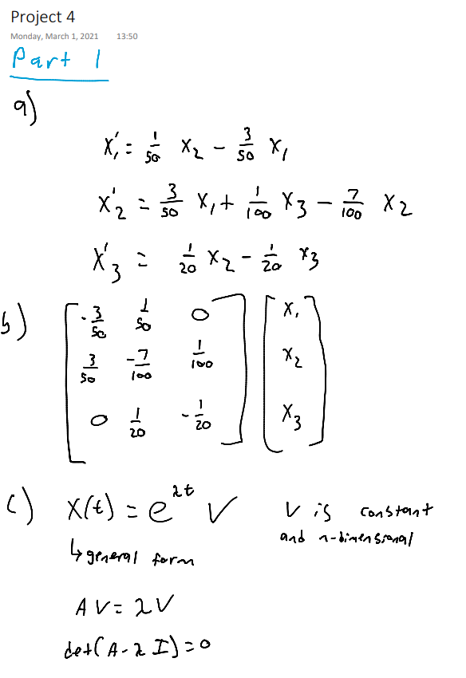

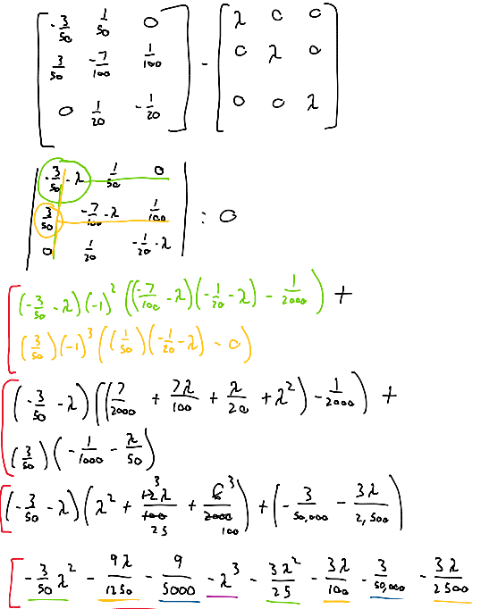

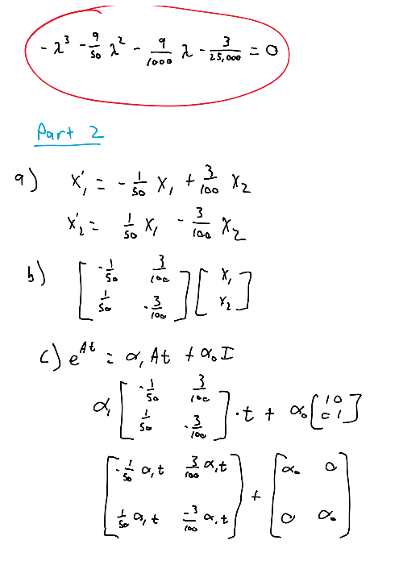

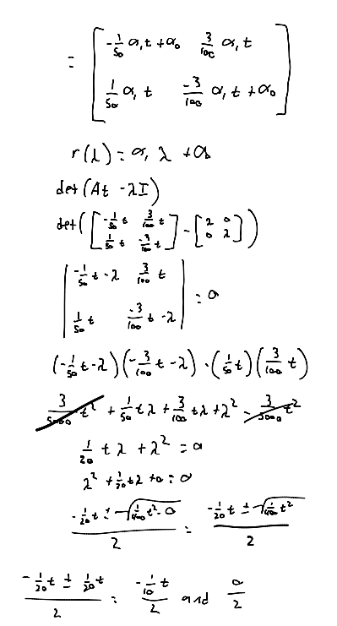

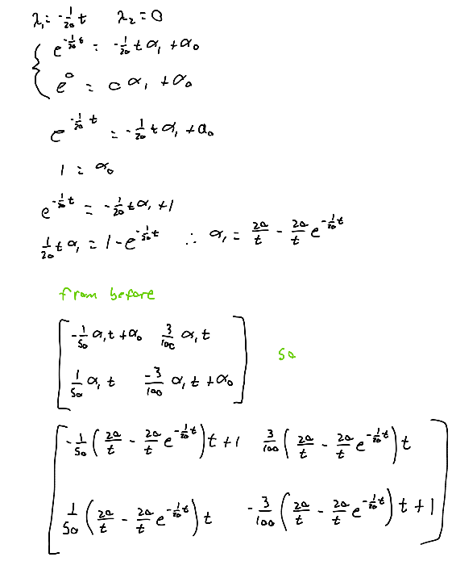

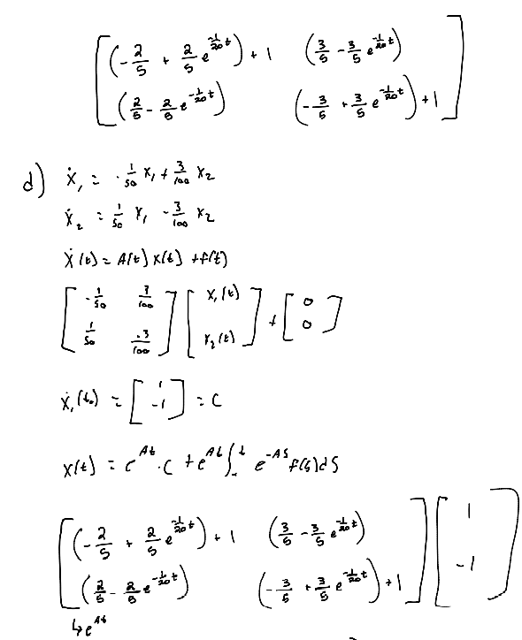

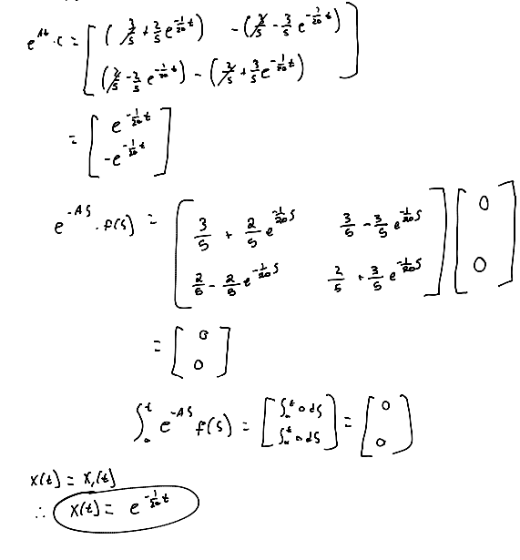

**Approach for implementation in code (e.g., algorithm, flowchart)**

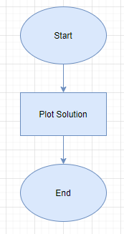

**Screenshots depicting key phases in the program execution**

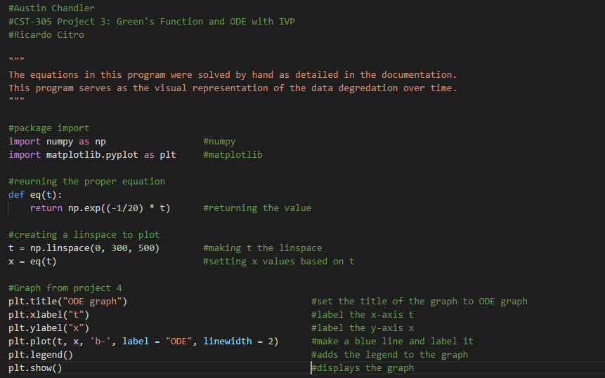

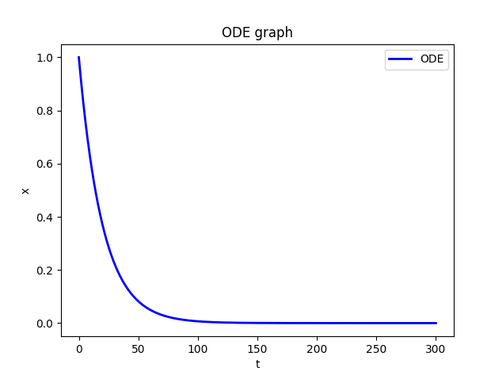

**References for theory and code sources**

<http://www.math.utah.edu/~gustafso/2250systems-de.pdf>