Project 5 – Self-Organized Criticality

Asher Shores

College of Science, Engineering, and Technology, Grand Canyon University

CST-305: Principles of Modeling and Simulation Lecture & Lab

Dr. Ricardo Citro

November 14, 2021

**Project 5 – Self-Organized Criticality**

In this project a dynamical system is used to model deterministic, chaotic behavior inherent of file systems.

**Responsibilities and completed**

In this project, a model was constructed to display the deterministic chaotic behavior of dynamic systems, demonstrating self-organized criticality that is a phenomenon of the given file system. This project implements previously used concepts as well as new ones to model things such as file sizes, file loads, file access times, storage sizes, files save times, fragmentation times, fragment assembly time and

In this project a model for the dynamic system that illustrates the deterministic chaos phenomenon and the self-organized criticality characteristics of a file system was created. Variables for storage size, file sizes, file load time, file access time, file save time, fragmentation time, fragments assembly time and a critical threshold that triggers a “system too slow” alert were defined. The model was implemented as a computer program where the program displays a visualization of the fragmentation process.

**Specific problem solved**

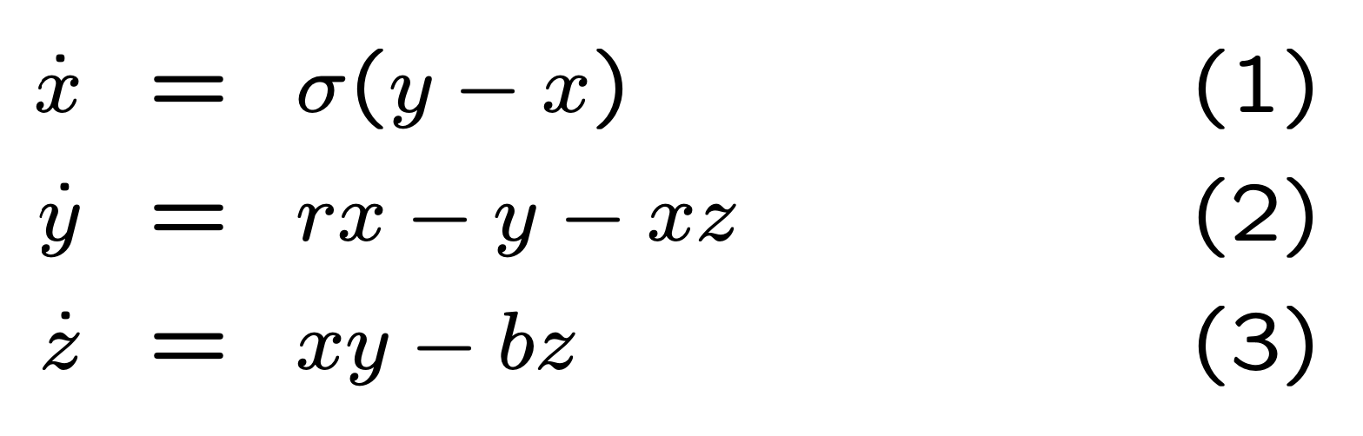

The above set of equations were provided to be used for this project as a demonstration of the Lorenz system.

**The mathematical approach for solving it**

It was not required to solve this system by hand for this project.

**The approach for implementation in code (e.g., algorithm, flowchart)**

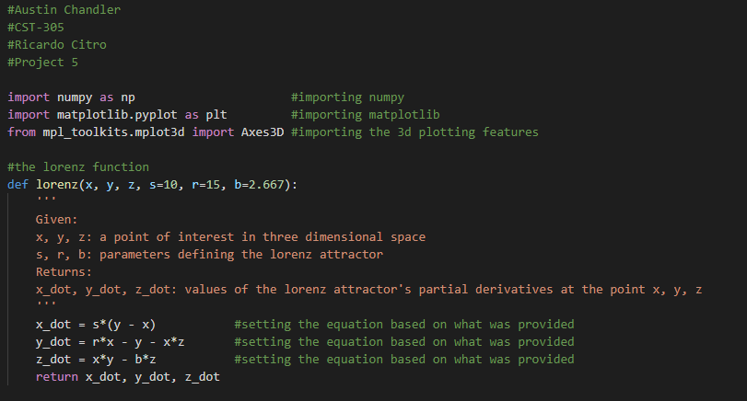

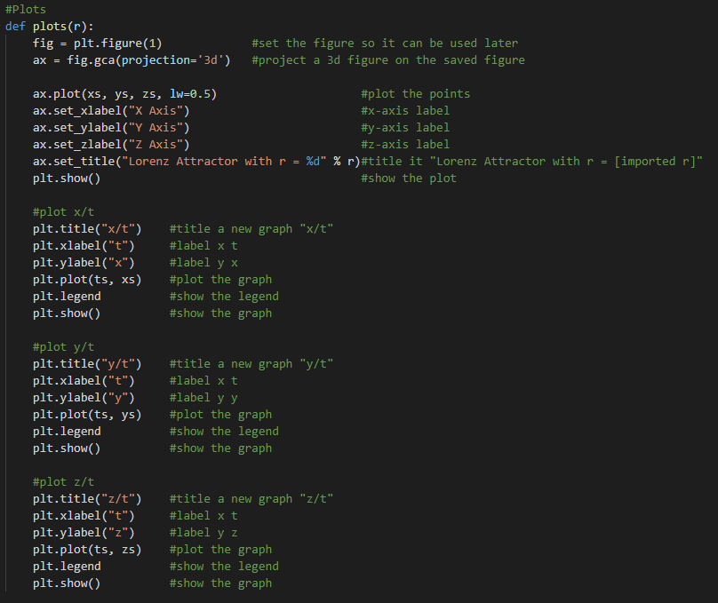

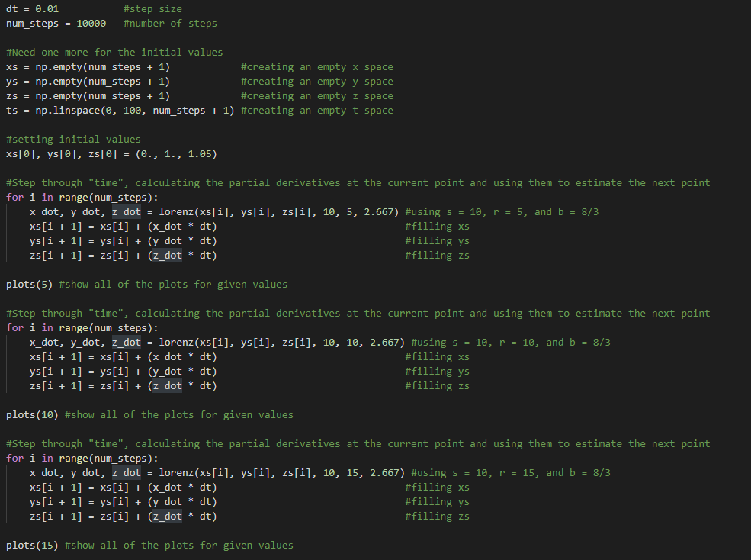

**Screenshots depicting key phases in the program execution**

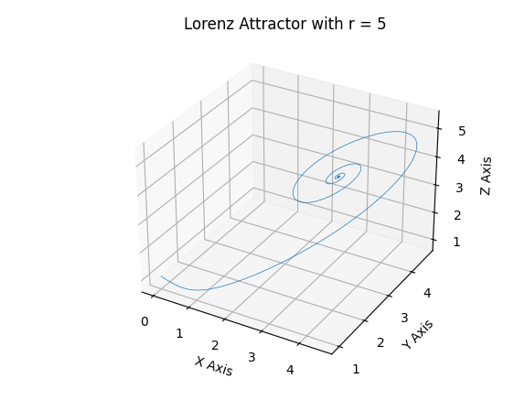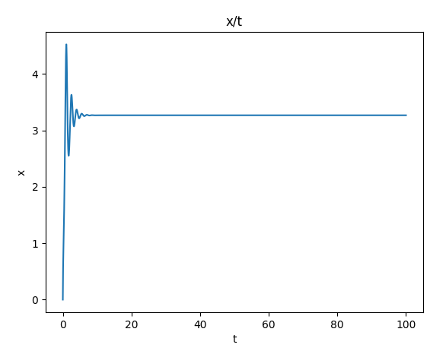

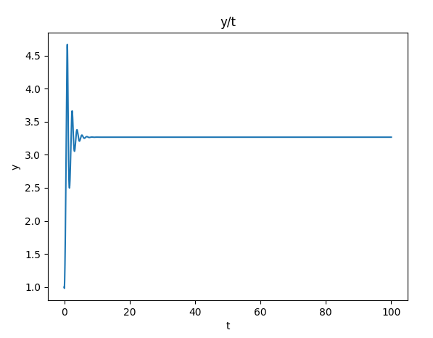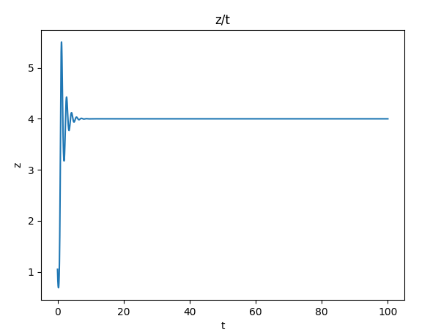

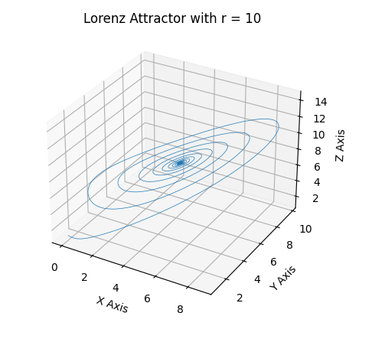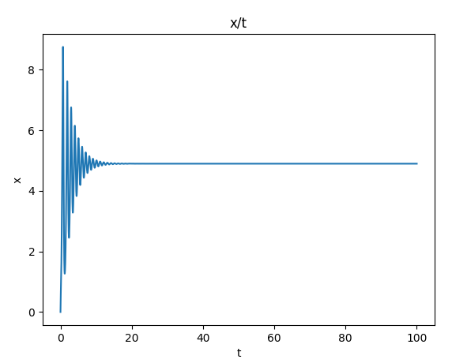

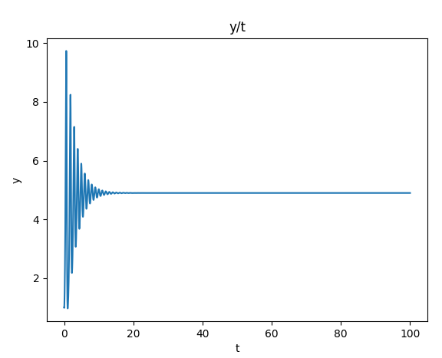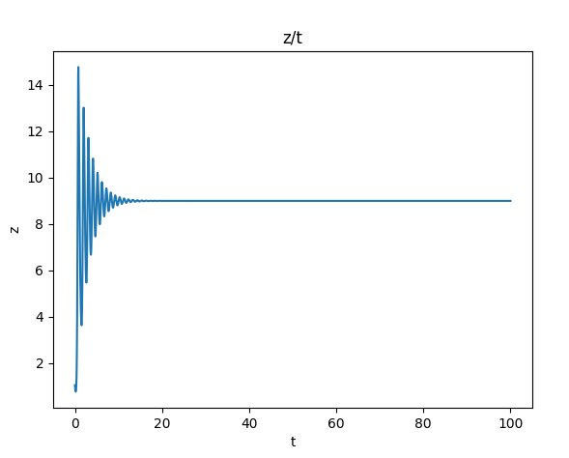

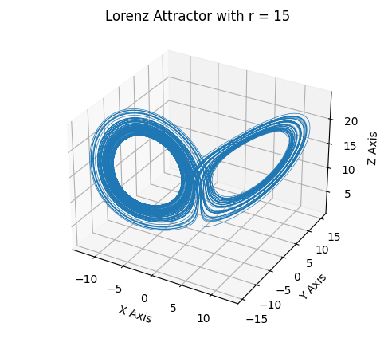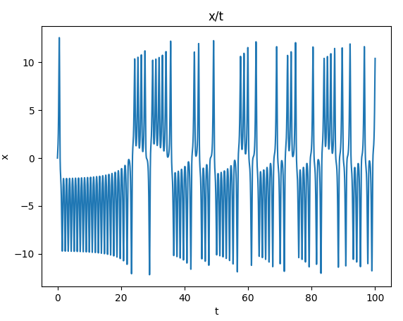

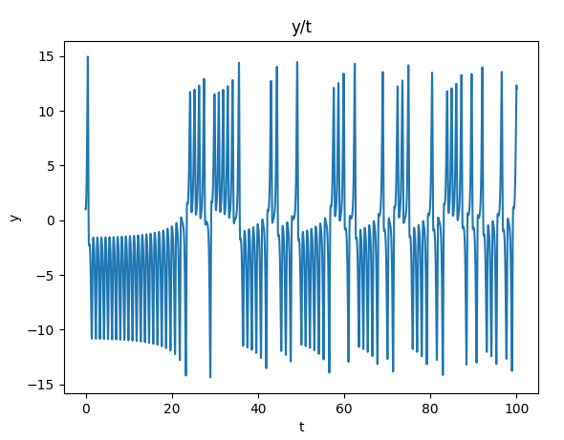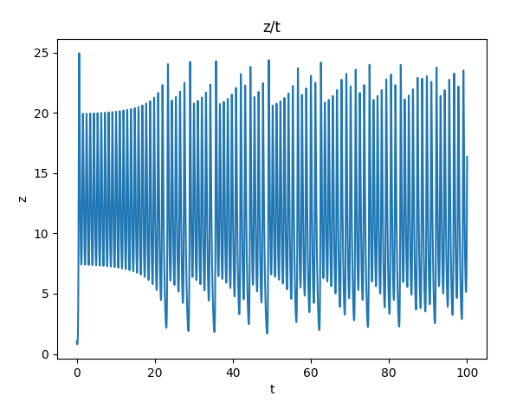

As demonstrated by the above illustrations the system becomes chaotic at r = 15.

**References for theory and code sources**

*Three Dimensional Systems*. Lecture 6: The Lorenz Equations. <https://www2.physics.ox.ac.uk/sites/default/files/profiles/read/lect6-43147.pdf>.