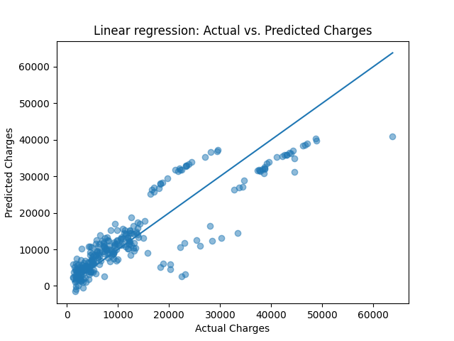
Report Task 1: Model summaries
Linear regression
Learned Coefficients:
Feature | Coefficient
sex_male | -18.592
smoker_yes | 23651.129
region_northwest | -370.677
region_southeast | -657.864
region_southwest | -809.799
age | 3614.975
bmi | 2036.228
children | 516.890

Root Mean Squared Error:
Training Set: 6105.545
Test Set: 5796.285
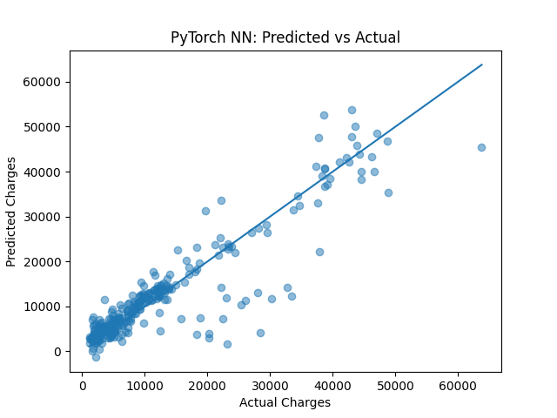
Neural network
Root Mean Squared Error:
Training Set: 3668.89
Test Set: 5039.16 OVERFITTING???
New Training RMSE: 4075.14
New Test RMSE: 4483.49
(after dropout and L2 regularisation)

Bayesian linear regression
Posterior means for coefficients:
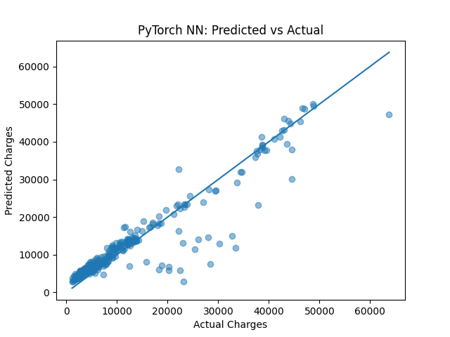  Feature | Mean Est.
Intercept | -0.348
sex_male | -0.011
smoker_yes | 1.968
region_northwest | -0.030
region_southeast | -0.085
region_southwest | -0.079
age | 0.298
bmi | 0.171
children | 0.047
Noise mean: 0.501

Report Task 2: Model comparison
1. RMSE Comparison on the Test Set
The Root Mean Squared Error (RMSE) measures the
average magnitude of the error. A lower value indicates
a better fit.
Neural Network: 5039.16
Linear Regression: 5796.285
Result: The Neural Network achieved the lowest error on the test set, ^^^This is new data after dropout etc. outperforming the Linear Regression model by approximately 757 points.

2. Model Complexity and Interpretability
Linear Regression
Complexity: Low. The model fits a straight line (or hyperplane) to the data.
Interpretability: High. The model provides clear coefficients that explain exactly how much each feature contributes to the charges.
Example: Being a smoker (smoker_yes) increases the predicted charge by 23,651.129.
Example: Each year of age adds 3,614.975 to the charge.
Neural Network
Complexity: High. The model uses hidden layers and non-linear activation functions to capture complex patterns.
Interpretability: Low. It acts as a "black box." While it produces predictions, it does not offer a simple table of coefficients to explain why a specific prediction was made.

3. Which Model Performs Better?
The Neural Network performs better in terms of raw predictive accuracy, but with a caveat regarding stability.
Accuracy: The Neural Network is the superior predictor, achieving a Test RMSE of 5039.16 compared to Linear Regression's 5796.285.
The Neural Network's Training RMSE (3668.89) is significantly lower than its Test RMSE (5039.16). This large gap indicates the model memorized the training data somewhat and struggled to generalize as effectively to new data. There is overfitting, and as such I did this……
In contrast, the Linear Regression model was very stable, with Training RMSE (6105.545) and Test RMSE (5796.285) being very close.
Conclusion: If the primary goal is minimizing prediction error, the Neural Network is the better choice. However, if the goal is to explain the cost drivers to a stakeholder (interpretability) or ensure a robust model that isn't overfitted, Linear Regression is the preferable option.

