**Issue with RDP connecting to DSVM**

If you cannot RDP to  VMs from your patched client, we can consider changing the policy settings **on the client** to temporarily gain RDP access to the servers.

You can change the settings in Local Group Policy Editor by following these steps:

1. Execute **gpedit.msc** and browse to **Computer Configuration / Administrative Templates / System / Credentials Delegation** in the left pane:

https://blogs.technet.microsoft.com/mckittrick/unable-to-rdp-to-virtual-machine-credssp-encryption-oracle-remediation/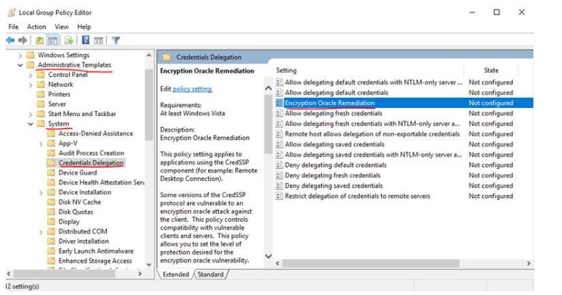

1. Change the **Encryption Oracle Remediation** policy to **Enabled**
2. Change the **Protection Level** to **Vulnerable**.
3. Select OK and re-try to connect to your remote machine.

**Issue when creating cluster environment (Exercise 3, Task 2)**

When you run the **az ml env setup -c -n <environment name> --location <e.g. eastus2>** command, the prompt tells you the subscription is set to XYZ. If you select “N” to continue with the subscription, you may encounter a UnicodeEncodeError when it attempts to parse your subscription list. If this happens, manually set the subscription first using the following command:

**az account set –subscription <Subscription Id>**

Then rerun the **az ml env setup** command.