Terminal Assessment 2 Verified Testing and Benchmark Report
Project: University Student Service & Queue System
Section: BSIT 2.4
Members: Maguigad, William; Protacio, Santino Adelrey; Artista, Ashanti P.

1. Scope and evidence standard
This report records observed behavior from VS Code screenshots supplied during manual testing. A pass means the displayed result matched the stated test expectation, not that the entire module is formally proven correct. Benchmark timings below are transcribed from the provided terminal screenshot; no timings have been invented.

2. Manual test-case execution log
# | Module | Input / action | Actual observed output | Result
1 | Add student | ID 1001 entered | Record added | PASS
2 | Display registry | Choice 4 | ID 1001 shown | PASS
3 | Update record | Edit 1001 | Name, service, priority updated | PASS
4 | Undo update | Undo then display | Prior values restored | PASS
5 | FIFO enqueue | Enqueue ID 1001 | Regular queue contains 1001 | PASS
6 | FIFO dequeue | Process queue | 1001 served; queues empty | PASS
7 | Priority enqueue | Enqueue ID 1002 (priority 2) | Priority queue contains 1002 | PASS
8 | Priority dequeue | Process queue | 1002 served; queues empty | PASS
9 | Search existing ID | Search ID 1002 | Linear and binary found; 2 comparisons each | PASS
10 | Bubble sort, sorted | IDs 1001,1002 | 1 comparison, 0 swaps | PASS
11 | Selection sort, sorted | IDs 1001,1002 | 1 comparison, 0 swaps | PASS
12 | Insertion sort, sorted | IDs 1001,1002 | 1 comparison, 0 swaps | PASS
13 | Bubble sort, unsorted | IDs 1001,1002,999 | 999,1001,1002; 3 comparisons; 2 swaps | PASS
14 | Selection sort, unsorted | IDs 1001,1002,999 | 999,1001,1002; 3 comparisons; 2 swaps | PASS
15 | Insertion sort, unsorted | IDs 1001,1002,999 | 999,1001,1002; 3 comparisons; 2 swaps | PASS
16 | Benchmark execution | Choice 11 | Displayed data through N=50,000 | PASS (observed)
17 | Delete record | Delete ID 999 | 999 absent from registry | PASS
18 | Undo deletion | Undo then display | 999 restored with original fields | PASS
19 | Duplicate ID | Add existing ID 1001 | Duplicate ID message | PASS (rejection)
20 | Invalid menu type | abc | Invalid entry; menu remained active | PASS
21 | Empty queue underflow | Process with empty queues | Both queues empty; no crash | PASS

3. Benchmark results from terminal screenshot
N = 50,000. These are single-run wall-clock timings in milliseconds. Timing is hardware- and workload-dependent.
Algorithm | Profile | Comparisons | Swaps | Time (ms)
Bubble | Random | 1,249,992,947 | 623,335,740 | 18,295.2049
Selection | Random | 1,249,975,000 | 49,992 | 5,628.6681
Insertion | Random | 623,385,731 | 623,335,740 | 8,496.1613
Bubble | Sorted | 49,999 | 0 | 0.7156
Selection | Sorted | 1,249,975,000 | 0 | 6,051.3598
Insertion | Sorted | 49,999 | 0 | 0.6127
Bubble | Reverse | 1,249,975,000 | 1,249,975,000 | 22,955.7692
Selection | Reverse | 1,249,975,000 | 25,000 | 5,036.0409
Insertion | Reverse | 1,249,975,000 | 1,249,975,000 | 21,975.2099
Search observations at N=50,000: sorted profile linear search 25,000 comparisons (0.7814 ms); reverse profile linear search 25,001 comparisons (0.2029 ms). Binary search reports 1 comparison for the displayed profiles because the selected key lies at the first midpoint; binary timings exclude preparation sorting.

4. Interpretation and qualifications
Selection Sort performs a fixed n(n−1)/2 comparisons in this implementation and relatively few swaps. Bubble and insertion sorting are adaptive on already sorted data. For reverse data, the 50,000-item bubble and insertion runs each counted 1,249,975,000 swaps. Random-profile values depend on the generated permutation. For tiny measured times, noise and timer resolution make speed comparisons unreliable. Binary search preparation is excluded from its displayed timing, so those timings cannot be used to compare total end-to-end lookup cost.

5. Evidence screenshots

Compilation and running menu
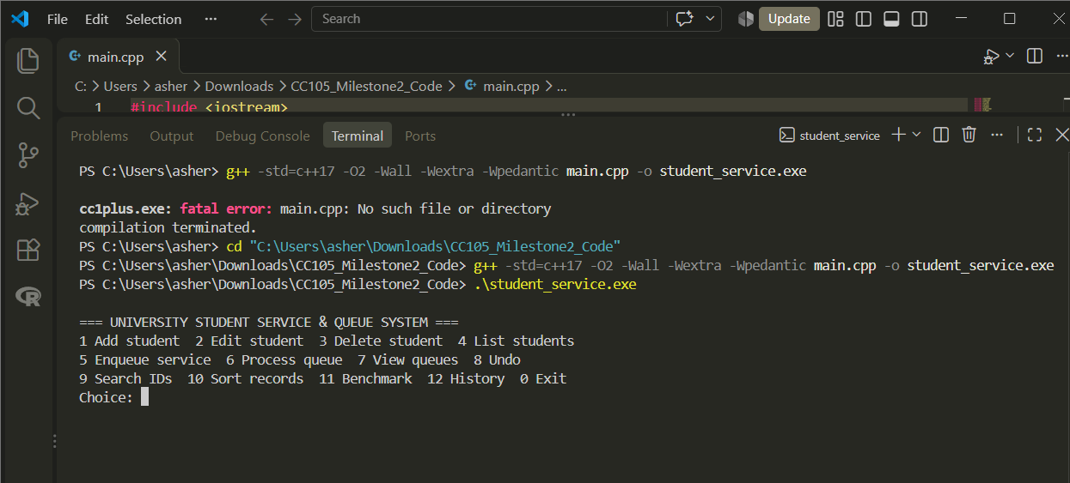

Student edit and updated record
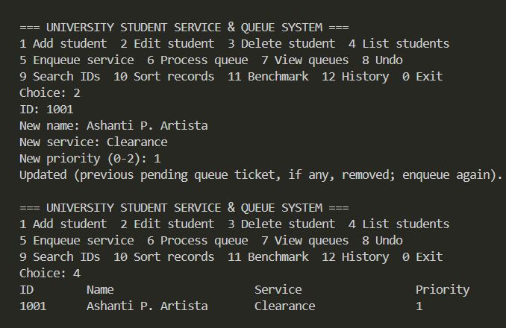

Undo restores earlier record
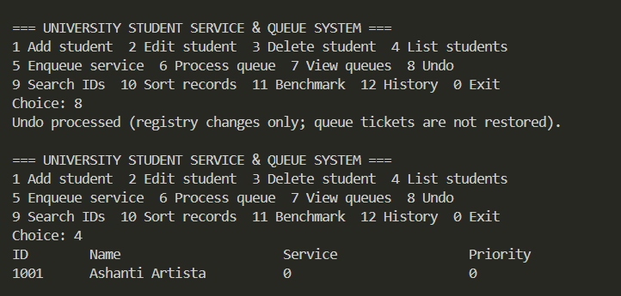

FIFO enqueue
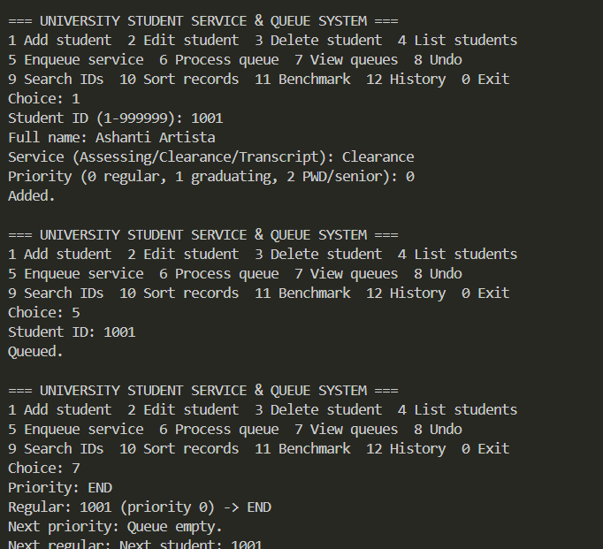

Priority queue enqueue
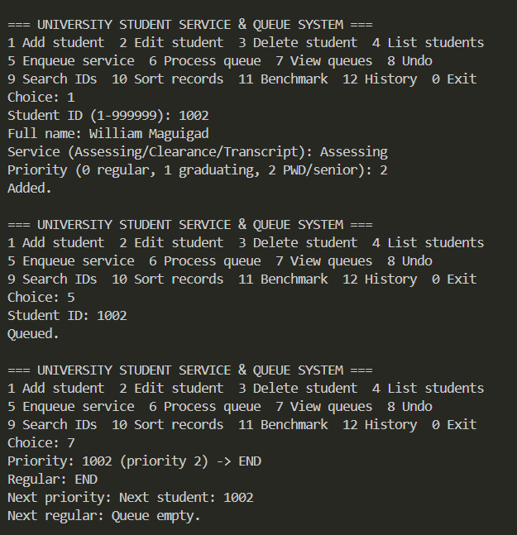

Linear and binary search
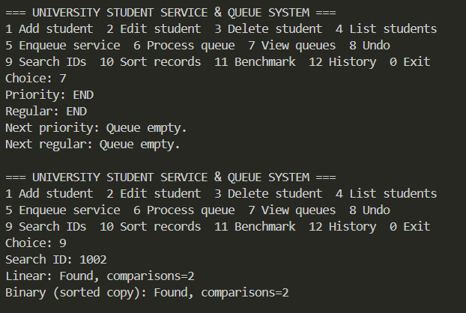

Bubble sort unsorted dataset
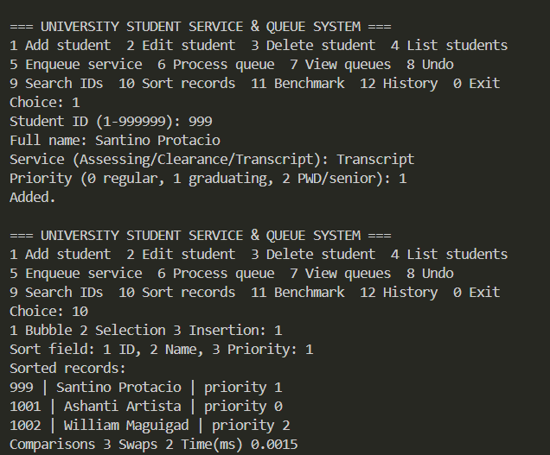

Selection sort unsorted dataset
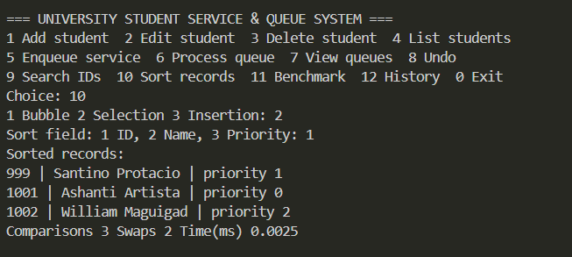

Insertion sort unsorted dataset
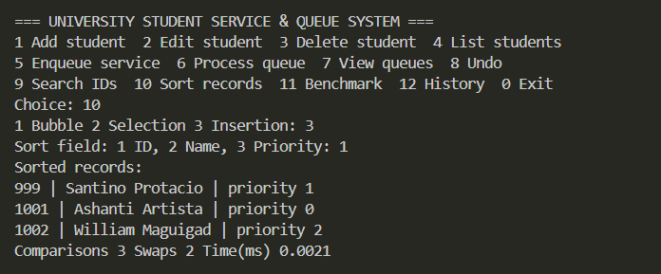

Benchmark N=10,000 and N=50,000
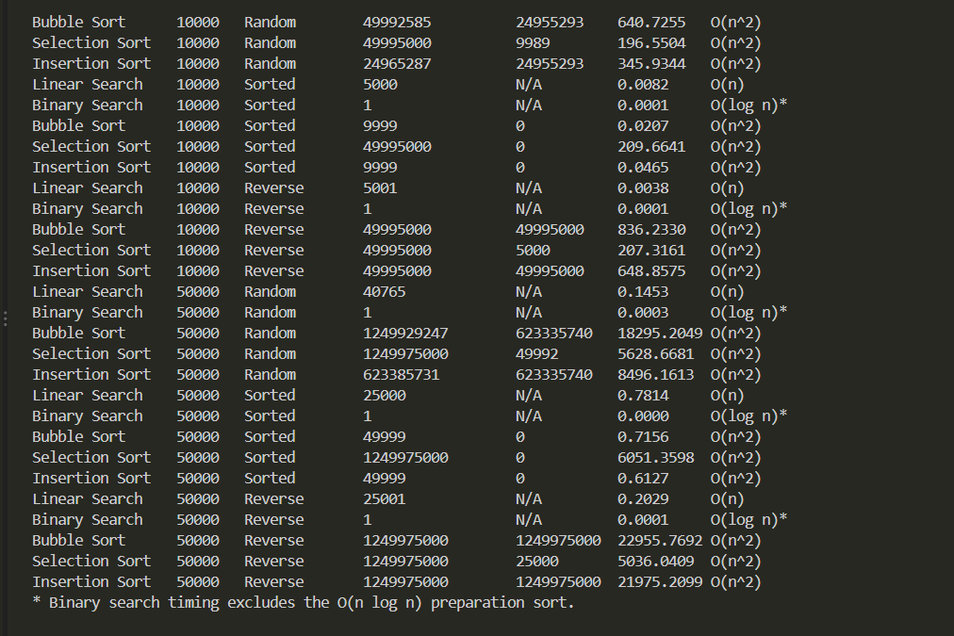

Delete and registry
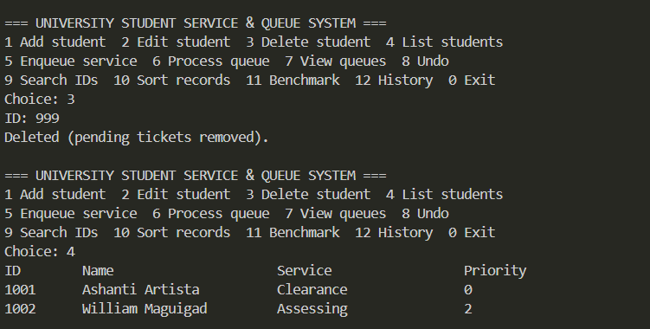

Undo deletion
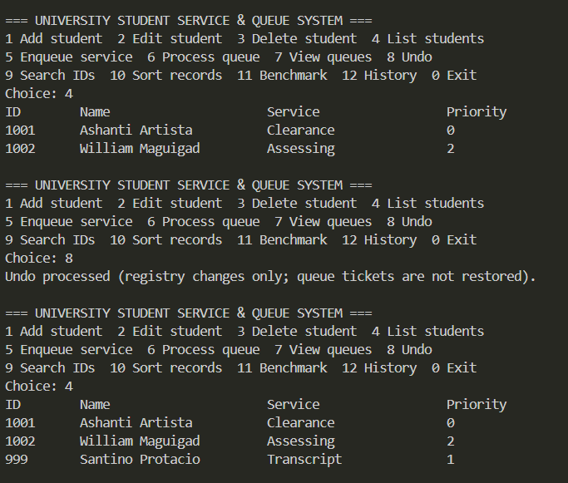

Duplicate ID validation
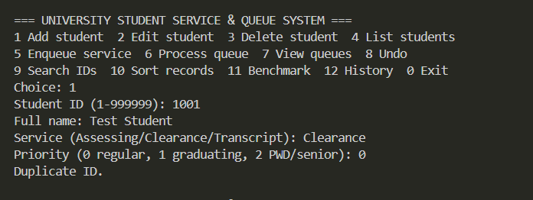

Invalid type validation
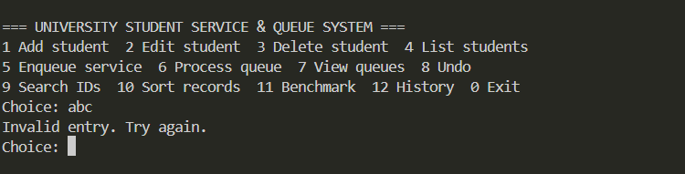

Empty queue handling
