Shader-First Neo-Glass UI
Engineering design document for a React + Three.js component system with stained-glass refraction, luminous transmission, and production-grade fallbacks
Target outcome  A tactile UI material where light appears to live inside the surface instead of sitting on top of it. | Principle  Render material in WebGL, keep copy and controls in the DOM, and use CSS only for layout and fallback polish.

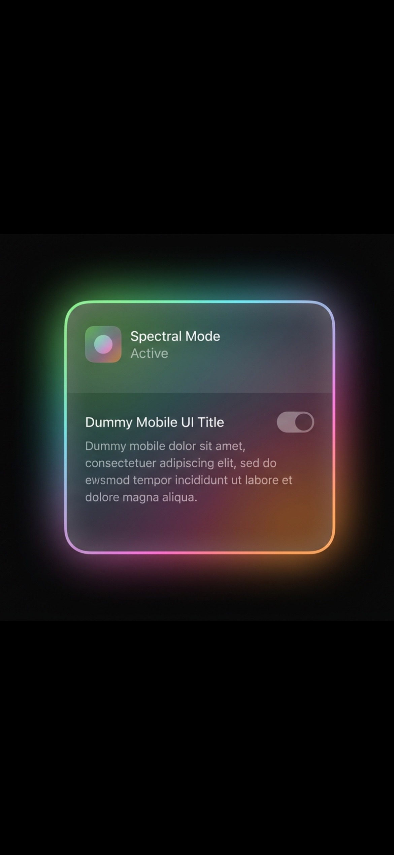
Current direction: glass card UI that feels too flat.

1. Product Intent
• This system is not a normal card component with gradients and blur layered on top. It is a transmissive material system with UI semantics attached to it. The material should feel premium, dimensional, slightly sculpted, and responsive to light.
• The visual reference combines three families of behavior: modern iOS glass surfaces, product-render quality volumetric highlights, and stained-glass-like color transmission. The correct target is not maximal noise or a literal cathedral motif; it is controlled spectral richness with physical plausibility.
• Success criteria: the component reads as immediately interactive, remains legible, performs smoothly on modern hardware, and degrades gracefully when GPU features are limited.

2. Visual Language
• Neo-glass: rounded transmissive panels, frosted blur, curved edge highlights, and tactile depth.
• Stained-glass optics: segmented internal color zones, localized glow, spectral splitting, and slight thickness-driven distortion.
• Material realism: internal reflections, soft refraction, edge brightening, micro-surface waviness, and restrained bloom.
• Modern UI hierarchy: crisp typography above the material, strong content grouping, and deliberate spacing so the interface remains usable instead of becoming decorative.
Must have  Transmission, spectral split, edge energy, tactile depth | Must avoid  Flat uniform gradients, global glow wash, muddy blur | Nice to have  Caustic pulse, subtle noise, reactive highlights

3. System Architecture
• Use React for layout, state, keyboard handling, and accessibility semantics. Use react-three-fiber and Three.js for material rendering. Use CSS for sizing, spacing, typography, and the fallback path.
• Keep all text, labels, and interaction hit targets in the DOM. The card shell and toggle material live in WebGL behind or beneath DOM layers. Pointer input is captured by semantic HTML controls and forwarded to the visual layer only when needed for hover and active effects.
• This separation preserves crisp text, browser accessibility, SSR compatibility, and easier responsive layout while still enabling high-end material rendering.

4. Core Components
• GlassCardShell: owns bounds, corner radius, hover state, active state, and shared uniforms for panel illumination.
• SpectralMaterialPlane: fragment shader for transmission, blur sampling, spectral split, cell segmentation, edge glow, and imperfection noise.
• RefractiveToggle: separate mesh for the track and knob, with knob magnification, color dispersion, and luminous contact shadow.
• LightFieldController: computes pointer-driven parallax, animated caustic drift, time-based shimmer, and energy pulses when state changes.
• ForegroundContent: plain React content layer with icon, title, status, description, and the semantic switch control.

5. Shader Model
• Transmission pass samples the scene or background texture behind the card. UVs are perturbed by signed noise and curvature so the background bends through the surface.
• Spectral dispersion offsets red, green, and blue channels by slightly different amounts based on local normal direction, thickness, and edge proximity. This creates stained-glass-like refraction without becoming rainbow fog.
• Segmentation introduces softly bounded cells inside the material. Each cell modulates tint, luminance, and scatter intensity so the panel feels internally structured rather than uniformly gradient-filled.
• Glow is generated from internal energy maps and edge Fresnel behavior. The brightest zones should hug edges, seams, and curvature transitions instead of washing over the entire surface.
• Imperfection noise adds hand-made subtlety: minute waviness, density variance, and anisotropic striations. This must remain low amplitude so the UI still feels engineered.

6. Uniforms and Runtime Inputs
• uTime drives slow caustic motion and gentle breathing of internal luminance.
• uPointer stores normalized local pointer position for hover distortion and highlight steering.
• uVelocity stores smoothed pointer delta or toggle interaction energy to produce elastic light response.
• uIntensity, uDispersion, uScatter, and uFrost control the material family and allow product tuning.
• uThemePalette carries a constrained spectral palette so the stained effect stays premium and not random.
• uReducedMotion and uQualityTier gate expensive animation and sampling counts for accessibility and performance.

7. Interaction Design
• Hover should feel like light reorienting through the material, not like the whole card simply brightening. The highlight follows the pointer with slight lag while the internal colors shift subtly under the surface.
• Press states compress the apparent depth slightly, tighten highlights, and increase edge brightness for a tactile response.
• Toggle on-state should not be a plain green fill. The track should gain internal transmitted color, and the knob should behave like a glass orb that refracts whatever sits behind it.
• State changes may emit a short caustic pulse and micro-bloom, but they should resolve quickly to avoid distraction.

8. Accessibility and UX Guardrails
• Use a native button or input type=checkbox role=switch for semantics, focus handling, and assistive technology support.
• Never place essential copy inside the WebGL canvas. Text contrast must remain compliant on top of all visual states.
• Respect prefers-reduced-motion by disabling shimmer drift, reducing hover lag, and shortening state pulses.
• Provide a no-WebGL or low-end fallback using CSS glass, static gradients, and reduced glow while preserving layout and meaning.

9. Performance Strategy
Quality tiers should be implemented as product configuration rather than design forks: High = full dispersion and motion field; Medium = reduced samples and simplified noise; Fallback = CSS glass with the same DOM semantics and layout.
• Keep geometry simple. Most richness should come from the fragment shader, not dense meshes.
• Use a small number of samples for transmission blur and upscale carefully. Prefer half-resolution offscreen buffers on mobile if needed.
• Cap bloom intensity and postprocessing passes. Jaw-dropping should come from material quality, not from overexposed effects.
• Batch uniform updates, avoid unnecessary React rerenders, and use damped interpolation in the render loop for smooth motion.
• Define quality tiers: high for desktop, medium for capable phones, and fallback for constrained GPUs or battery-saving scenarios.

10. Suggested Project Structure
• src/components/glass-card/GlassCard.tsx for the semantic shell and public API.
• src/components/glass-card/GlassCardScene.tsx for react-three-fiber scene orchestration.
• src/components/glass-card/materials/SpectralGlassMaterial.ts for shader material creation.
• src/components/glass-card/shaders/spectralGlass.frag and spectralGlass.vert for GLSL sources.
• src/components/glass-card/hooks/useLightField.ts and useQualityTier.ts for interaction and adaptive rendering.
• src/components/glass-card/styles.css for DOM layout, typography, focus rings, and fallback visuals.

11. Public API Recommendation
• Expose a compact API: title, status, description, checked, disabled, onCheckedChange, palette, intensity, quality, and className.
• Allow a preset-based design system, for example prism, aurora, opal, and stained. Presets should tune shader uniforms without changing layout semantics.
• Keep advanced material knobs behind an expert prop object or theme registry so product teams cannot accidentally create inconsistent or gaudy variants.

12. Delivery Phases
• Phase 1: baseline DOM card and switch with exact layout, accessibility, and CSS fallback.
• Phase 2: WebGL plane behind the card with frosted transmission, Fresnel edge, and pointer-driven highlight.
• Phase 3: stained spectral segmentation, glass orb knob, and state pulse.
• Phase 4: performance tuning, reduced-motion path, visual QA across devices, and design-token integration.
• Phase 5: packaging as a reusable component library unit with Storybook demos and screenshot regression coverage.

13. Risks and Mitigations
• Risk: the effect becomes noisy or gaudy. Mitigation: constrain palette, clamp bloom, and design presets around a narrow art direction.
• Risk: text readability suffers against animated backgrounds. Mitigation: keep copy in DOM, add localized backdrop darkening, and test worst-case states.
• Risk: mobile GPUs struggle. Mitigation: quality tiers, half-resolution buffers, disabled postprocessing on low tier, and CSS fallback.
• Risk: implementation couples design too tightly to a single card. Mitigation: separate material primitives from component semantics so the system can scale to toggles, pills, chips, and sheets.

14. Final Recommendation
• Prioritize shader realism over CSS cleverness. The right architecture is a DOM-first component with a WebGL-driven material layer.
• Aim for disciplined spectacle: strong light behavior, restrained palette control, crisp typography, and physically believable depth.
• The component should feel like a manufactured interface material with stained luminous transmission, not an effect stack pasted onto a card.

Appendix: Visual Reference Signals
These images define the material ambition more clearly than the original flat glass card. They should guide light behavior, not literal ornamentation.
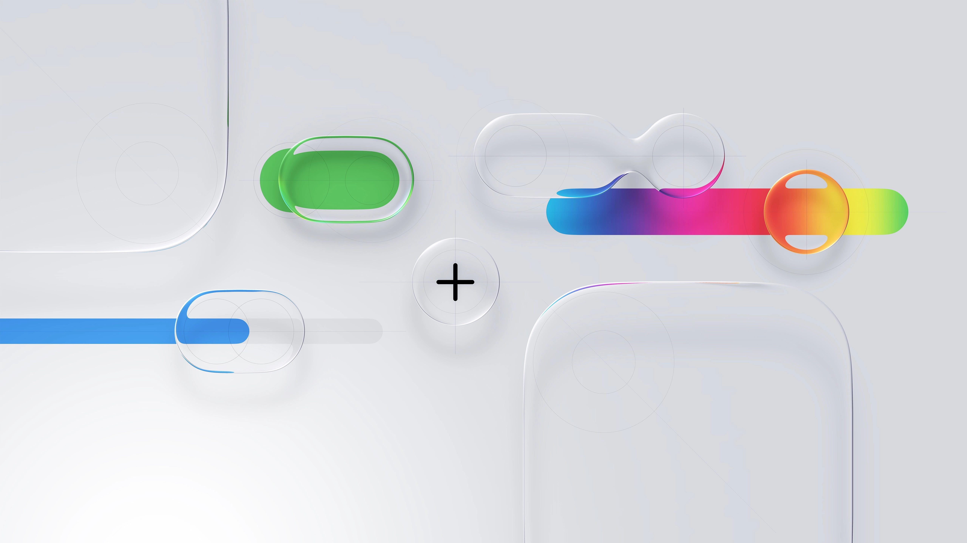
Reference A: volumetric iOS-like controls with sculpted surfaces and luminous color transmission.
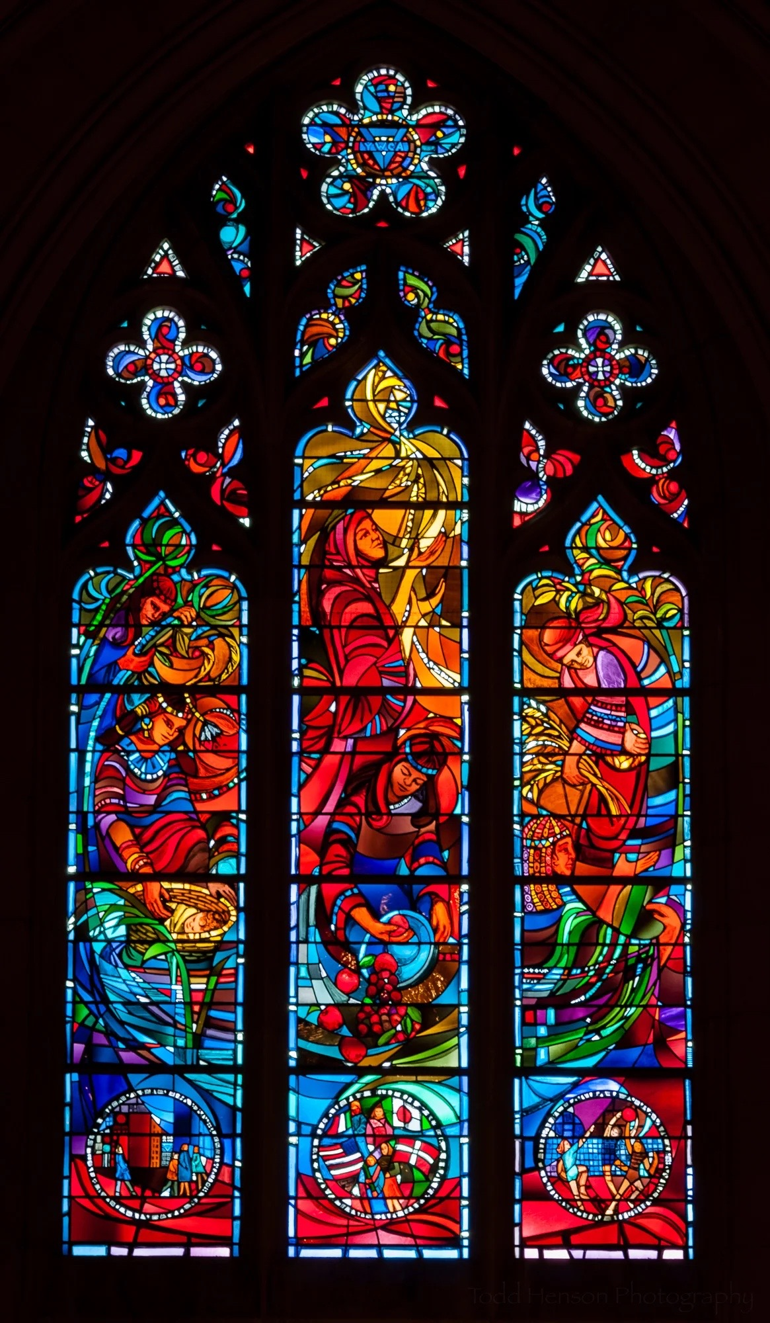
Reference B: stained glass light behavior - segmented color, transmitted radiance, and dark structural boundaries.
Prepared from the design direction established in the conversation. This document is implementation-focused and intended to guide a production-ready build.

