Hello & thank you for testing Elevate! A few things to keep in mind:

* **Beta Testing:** This is a “beta” test version of the app. As with all beta software, bugs and quirks are to be expected.
* **Your Feedback:** When you come across bugs or things that are confusing, please let us know so we can take a look and fix them!
* **Your Ideas:** Since we’re trying to get the app from beta to final, we won’t be able to add new features to this version, but we would love to hear your ideas for future versions. Please use the same process for submitting feedback to send us your ideas.

Let’s get started!

-------------------------------------------------------------------------------------------------------------------------------

# Step 1. Download Two Apps

Since Elevate’s Beta app is for testing only, it’s not publicly available & you can’t download it from the App Store. You’ll get it through the free TestFlight app, so let’s download TestFlight first.

1. **On your iPhone**, find the EMAIL **“Convene has invited you to test ‘Convene Elev8’.”** Open it, and tap the “**View in Testflight**” button.

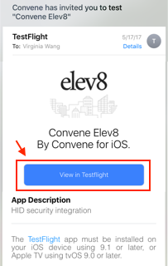

1. Safari will open a page like this. Tap the **blue words**… Do NOT close this page!   
   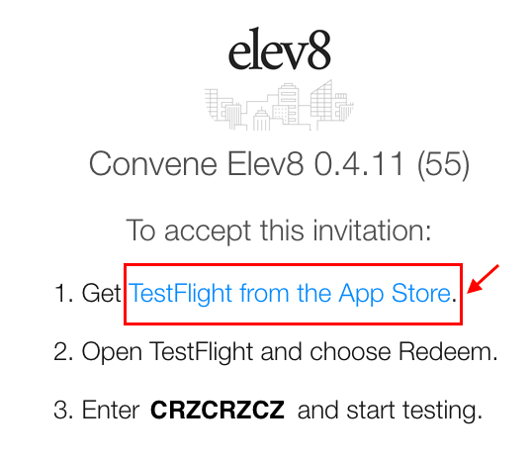
2. Apple’s App Store will launch.  
   Tap **“Get**” to download the free **TestFlight app**.

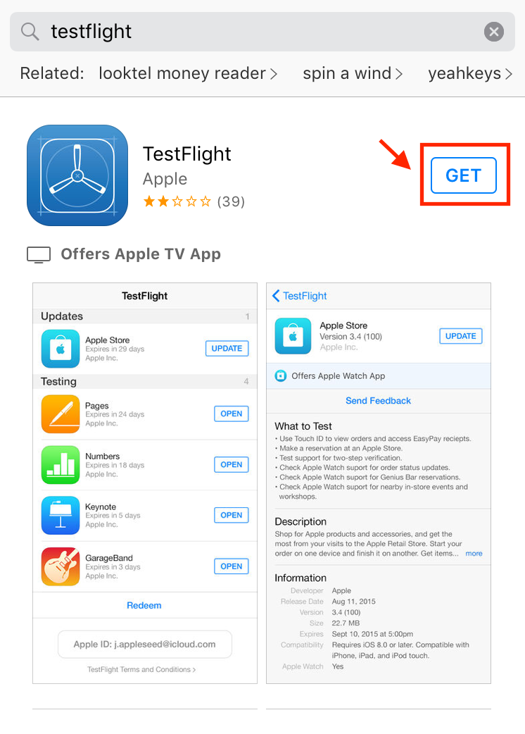

1. Now you can download the Elevate app through TestFlight. You’ll need your unique permission code to do this. **Copy your** **code** from this page (in Safari).  
     
   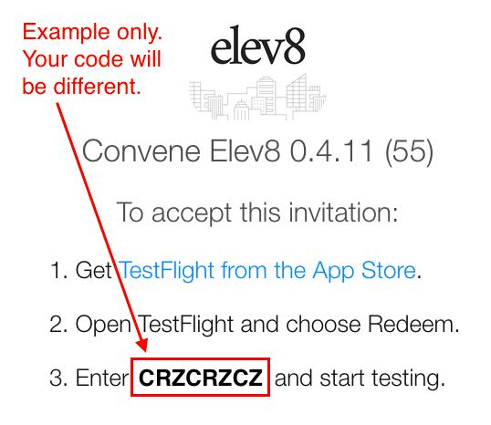
2. Open the TestFlight app and tap “**Redeem**.”

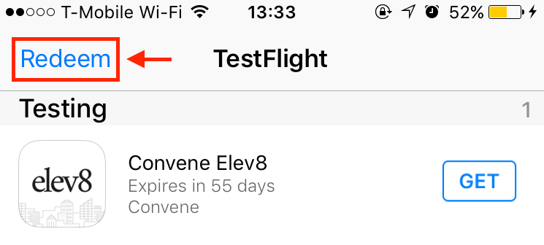

1. **Paste the CODE** here… ... then tap **“Redeem.”**  
   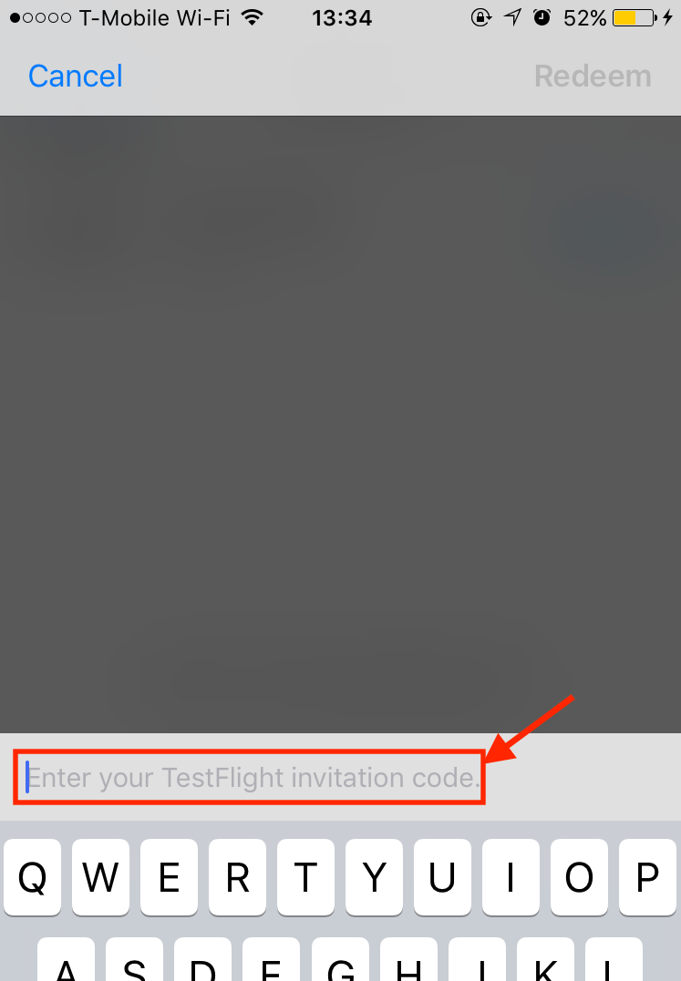 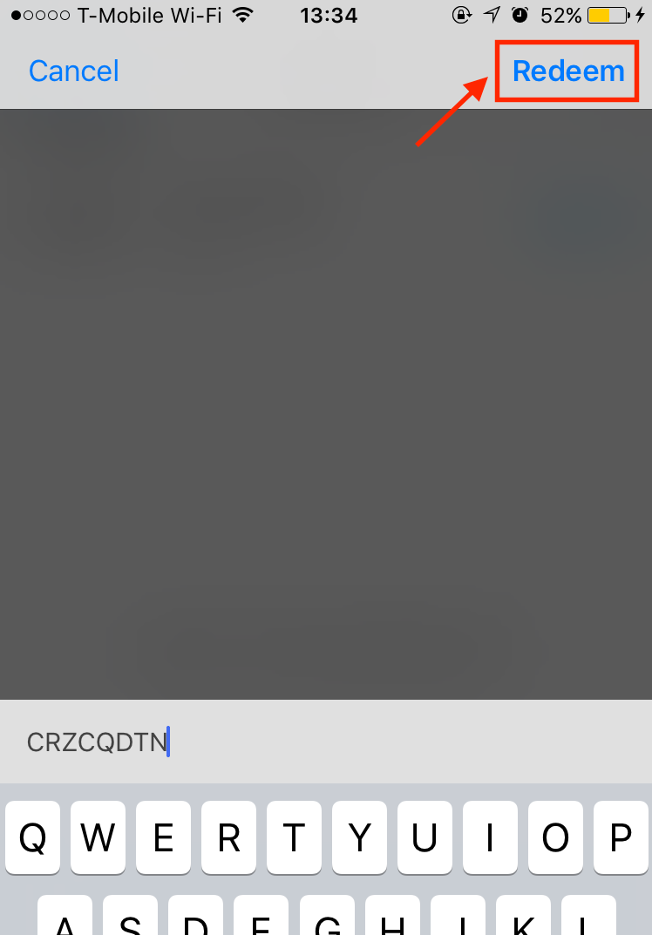
2. Elevate’s app should download automatically. If not, tap **“Get”** to start the download. When the app finishes downloading, it will open to the Welcome screen.  
      
   ***Do Not Sign Up Yet! Please go straight to Step 2.***  
   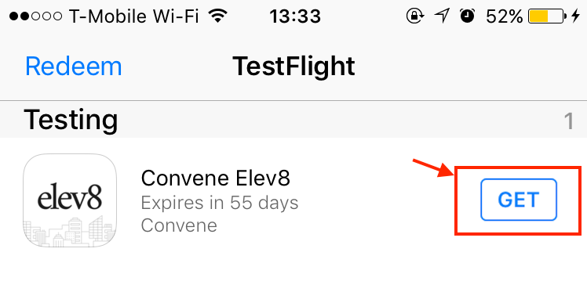

# Step 2. Sign up via Email Link

1. **On your iPhone**, find the **“Welcome to Elev8” Email**.   
   Tap the **link** in the email to launch the Elevate app.

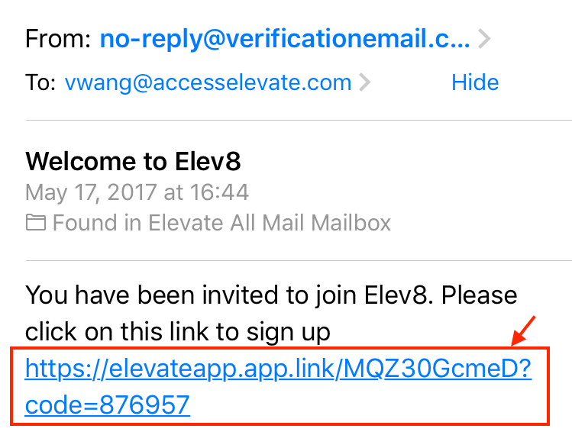

1. Enter a **Password** for your new Elevate account, then submit it.  
   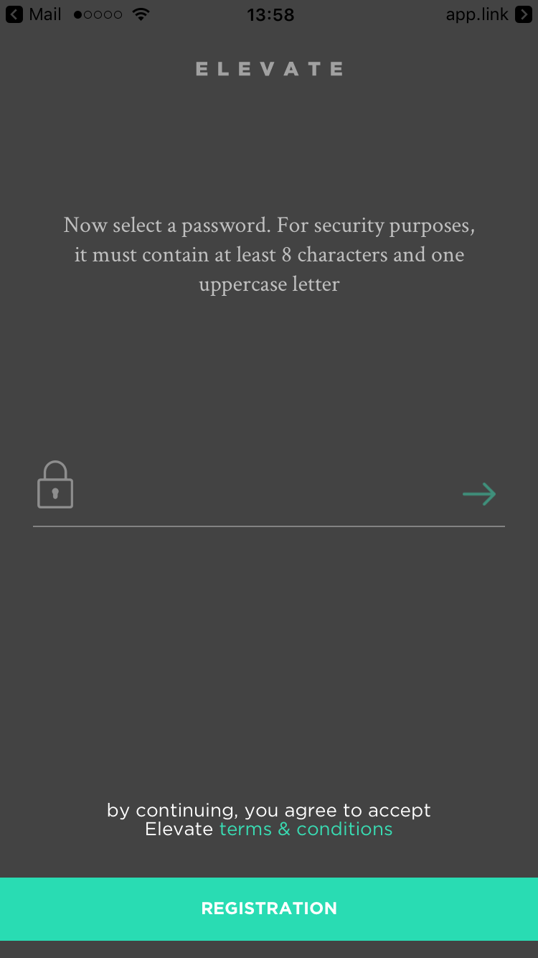  
     
   You’re almost there! Just one more step -- Step 3!

# Step 3. Contact Building Management or Security

The last step is done by yourBuilding Management or Security Team. They’ll update the Security system to grant you the appropriate building access through the Elevate app.

1. For this step, you’ll need your Mobile Key. Tap on **Security / Access** at the bottom of the Home Screen.  
     
   *A red exclamation mark should not appear. If it does, see TROUBLESHOOTING below.*  
     
   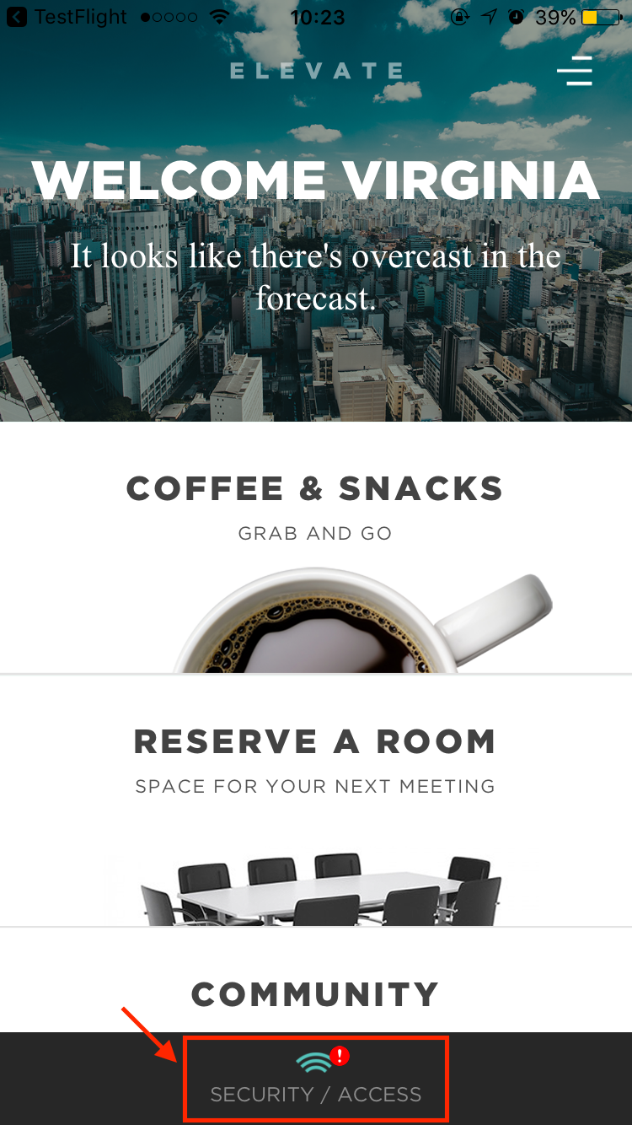
2. On the next screen is your **Mobile Key** (see below). Write it down or screenshot it.
   1. Give this # to your Building Management or Security Team.
   2. Let them know you need to be set up in the ACS for building access using the Elevate App and this Mobile Key.

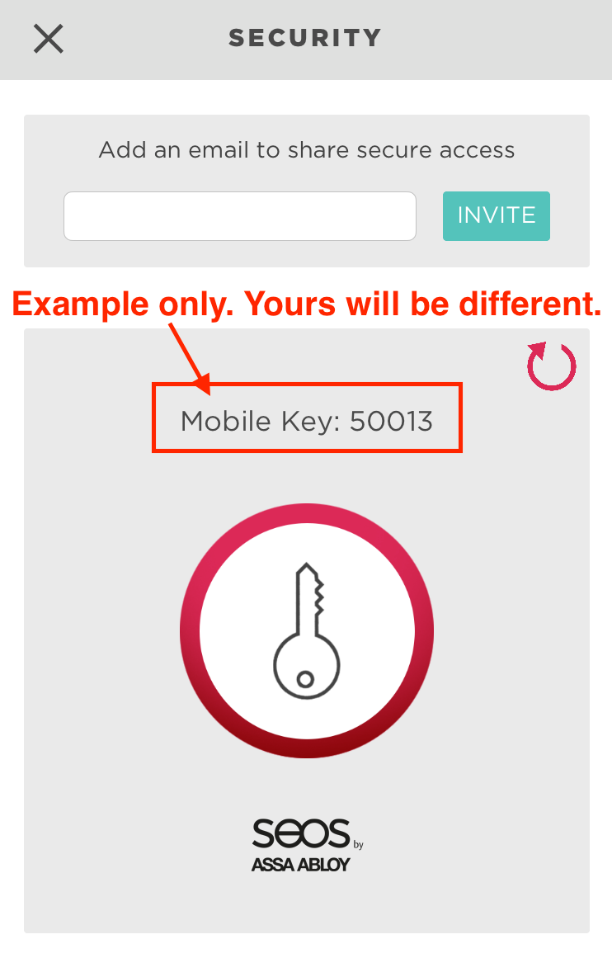

TROUBLESHOOTING

If you see a red exclamation mark by **Security / Access**, tap it & you’ll see a screen like this.

|  |  |
| --- | --- |
|  | Wherever there is a red line, you’ll need to do something so the app can work properly*.* For example, you might need to:Connect to **Wifi** or an **LTE Cellular Data network**. Enable **Bluetooth**. You can do this from the “Swipe Up” menu on your iPhone. Enable Location Services for the Elevate App. You can do this under **Settings** > **Privacy** > **Location Services** on your iPhone. |

# Step 4. Send Us Your Feedback

Let us know when you encounter bugs, have questions or ideas. To send us feedback:

1. Go to the Elevate app & tap the 3 lines in the **Upper Right**.  
   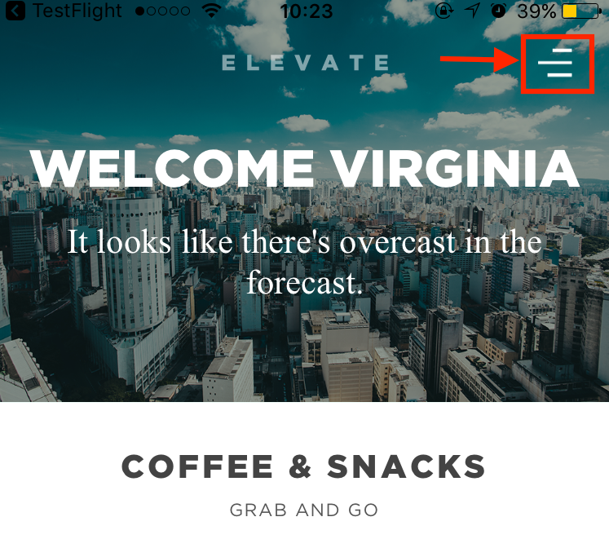
2. Then tap “**Contact Us**” and send us your thoughts!

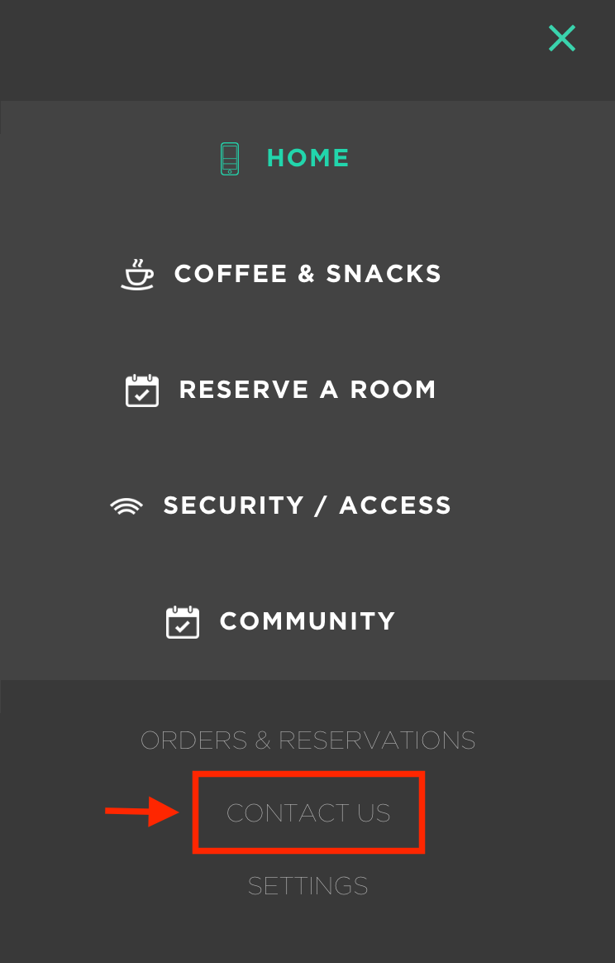

Thanks & happy testing!

The Elevate Team