**Lab 1: Learning Basic Linux Commands**

**OS Used:** Ubuntu

**1.1.** **Command Name:** ls

**Syntax:** ls [options] [file]

**Usage:** It is used for listing files and directories within the file system.

**Commands Used:**

ls -> It lists all the unhidden files and directories within current directory

ls Documents -> It lists all the files and directories of documents directory

ls -l documents -> It lists files in long listing format which includes:

* + - The file type.
    - The file permissions.
    - Number of hard links to the file.
    - File owner.
    - File group.
    - File size.
    - Date and Time.
    - File name.

**Output:**

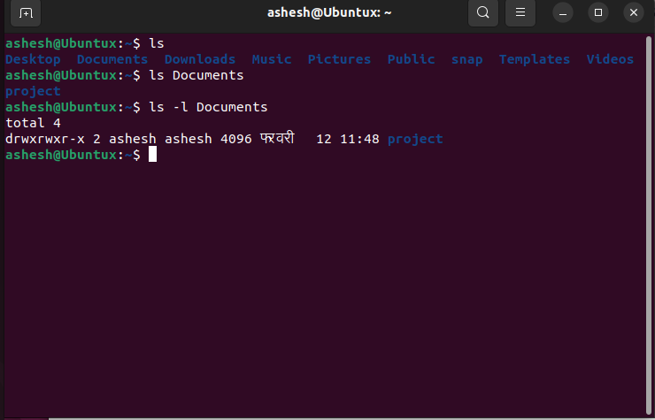

**1.2. Command Name:** cd

**Syntax:** cd [Options] [Directory]

**Usage:** It is used to change the current directory of the terminal.

**Commands Used:**

cd -> It changes working directory to users home directory.

cd Documents-> It changes directory to documents.

**Output:**

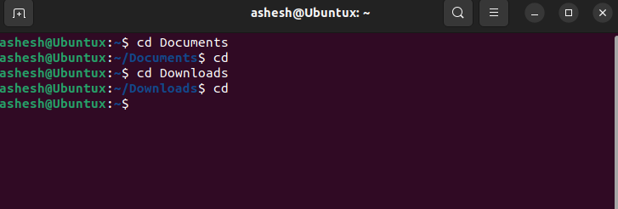

**1.3. Command Name:** grep

**Syntax:** grep [options] patterns [files]

**Usage:** It searches a file for a particular pattern of characters and displays all lines that contain that pattern.

**Commands Used:**

grep 'pattern'file.txt -> Searches for the pattern in the specified file.

grep -r 'pattern' -> Recursively searches for the pattern in the specified file.

**Output:**

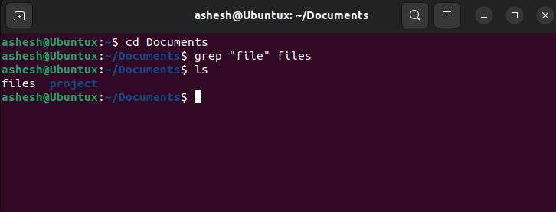

**1.4. Command Name:** sudo / su

**Syntax:** sudo [option]

**Usage:** It is used for executing commands with special rights as a super user.

**Commands Used:**

$ sudo mkdir /example: Creates a directory named example.

$ sudo rmdir /example: Removes a directory named example

**Output:**

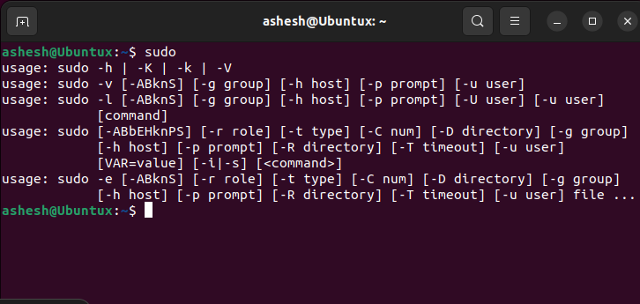

**1.5. Command Name:** pwd

**Syntax:** pwd [Options]

**Usage:** It is used for printing the name of current working directory.

**Commands Used:**

pwd -> It prints current working directory

pwd –L -> It prints the logical path of the current working directory

pwd -P -> It prints the physical directory without symbolic links

**Output:**

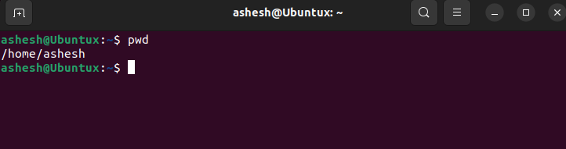

**1.6. Command Name:** mv

**Syntax:** mv [Option] [Source_File] [Destination_File]

**Usage:** It is used for moving and renaming files and directories.

**Commands Used:**

mv files ./project/: Moves files to the project.

**Output:**

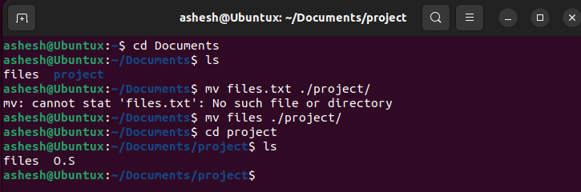

**1.7. Command Name:** cp

**Syntax:** cp [Option] [Source_File] [Destination_File]

**Usage:** It is used for copying files and directories from one location to another.

**Commands Used:**

cp this.txt that.txt -> It copies contents of this.txt to that.txt

cp files O.S

**Output:**

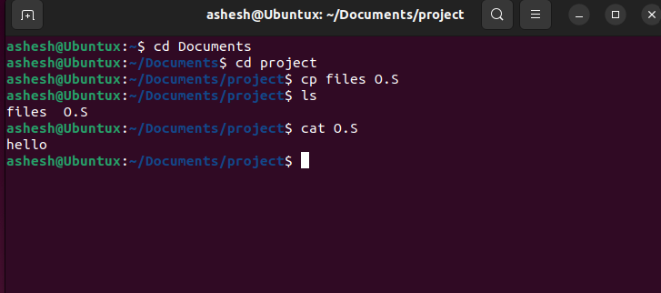

**1.8. Command Name:** rm

**Syntax**: rm [Option] [File]

**Usage:** It is used for removing files and directories.

**Commands Used:**

rm files-> It removes "files" file.

**Output:**

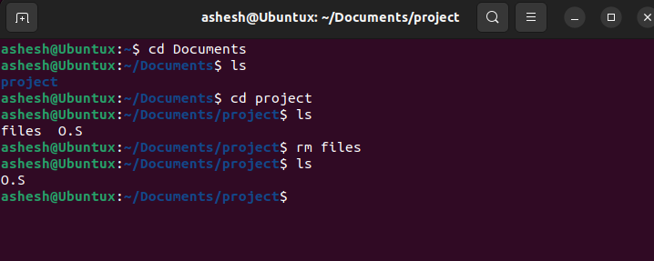

**1.9. Command Name:** mkdir

**Syntax:** mkdir [option] [Directory_name]

**Usage:** It is used for making directories.

**Commands Used:**

mkdir folder -> It creates folder directory.

**Output:**

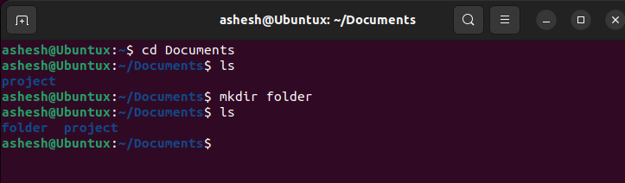

**1.10. Command Name:** rmdir

**Syntax:** rmdir [option] [Directory_name]

**Usage:** It is used for removing empty directory.

**Commands Used:**

rmdir folder -> It removes folder directory(must be empty)

**Output:**

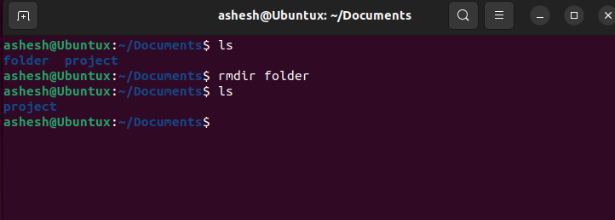

**1.11. Command Name:** chmod

**Syntax:** chmod [Option] [Mode] [File]

**Usage:** It is used for changing file and directories mode/permissions.

**Commands Used:**

chmod 755 next: Changes the permissions of next to read, write, and execute for the owner, and read and execute for group and others.

**Output:**

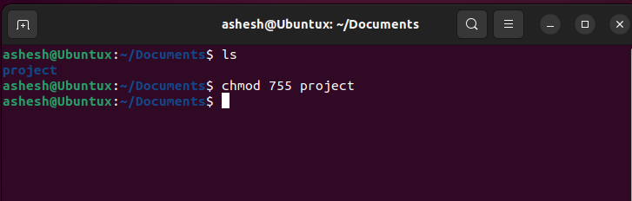

**1.12. Command Name:** cat

**Syntax:** cat [Option] [File]

**Usage:** It is used for viewing, creating, copying, concatenating, merging and

manipulating file contents.

**Commands Used:**

cat O.S -> It displays the contents of O.S on the terminal

**Output:**

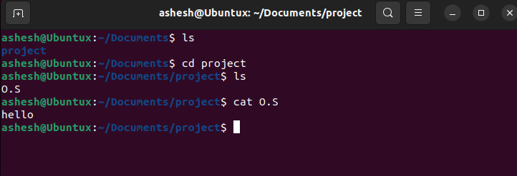

**1.13. Command Name:** chown

**Syntax:** chown [options] user[:group] file(s)

**Usage:** It is used for changing the user and group ownership of file.

**Commands Used:**

chown anon index.html -> It changes ownership of index.html file to anon

**Output:**

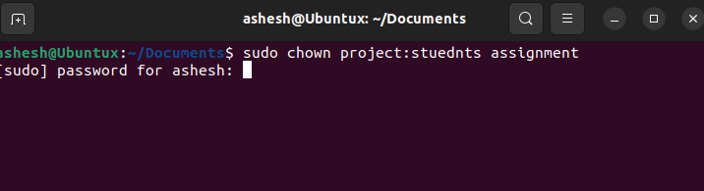

**1.14. Command Name:** echo

**Syntax:** echo [Option] [String]

**Usage:** It is used to display lines of text or strings that are passed as arguments.

**Commands Used:**

echo “Hello World” -> It displays Hello World on the terminal

**Output:**

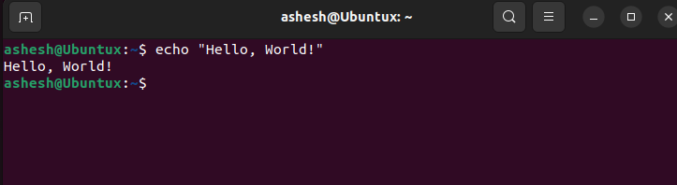

**1.15. Command Name:** wc

**Syntax:** wc [Option] [File]

**Usage:** It is used to find out number of lines, word count, byte and characters count

in a file.

**Commands Used:**

wc O.S -> It prints the number of lines ,word count and characters count

in O.S file

**Output:**

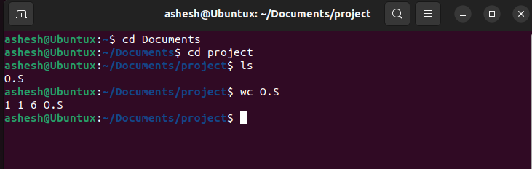

**1.16. Command Name:** man

**Syntax:** man [command]

**Usage:** It is used for displaying manual page for commands.

**Commands Used:**

man echo -> It displays manual page for echo

**Output:**

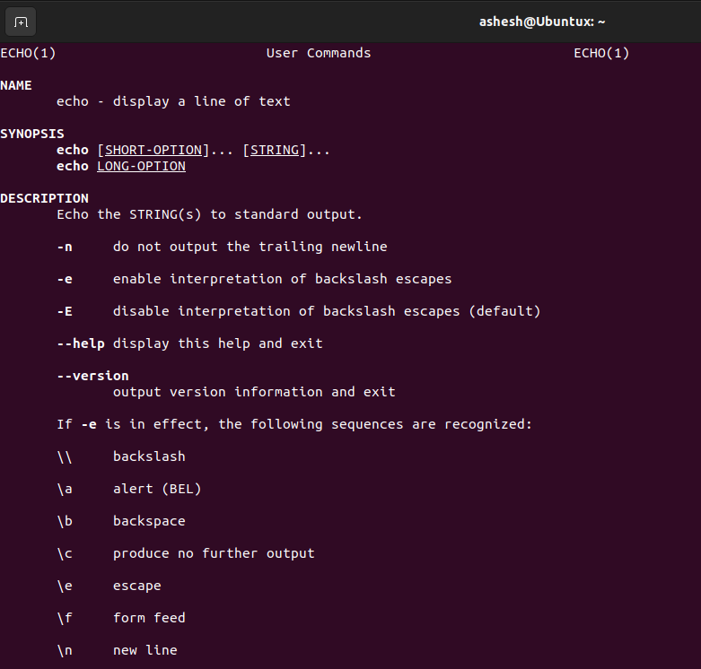

**1.17. Command Name:** history

**Syntax:** history

**Usage:** It allows to view and search through command history.

**Commands Used:**

history -> It lists the previously executed commands from history library

history 5 -> It lists the previous five executed commands

history -c -> It removes the complete history of executed commands

**Output:**

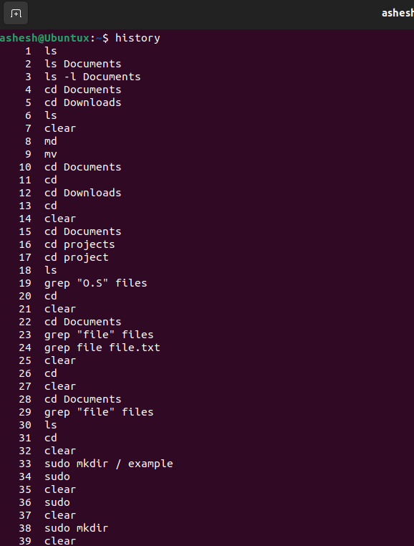

**1.18. Command Name**: clear

**Syntax:** clear

**Usage:** It is used for clearing the terminal screen.

**Commands Used:**

clear -> It cleans the terminal screen

**Output:**

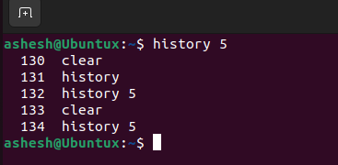

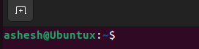

**1.19. Command Name:** touch

**Syntax:** touch [Options] [File­_Name]

**Usage:** It is used to modify the timestamps and create a file without any content.

**Commands Used:**

touch index.txt -> It creates a file named index.txt

touch -a index.txt-> It changes the access time of index.txt

**Output:**

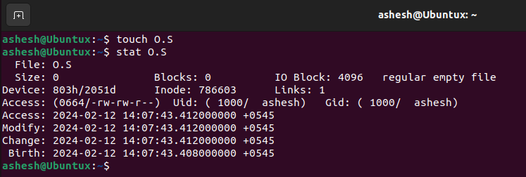

**1.20. Command Name:** locate

**Syntax:** locate [Option] [Pattern]

**Usage:** It is used to find files using the file name.

**Commands Used:**

locate help.txt -> It searches for help.txt in a particular directory.

**Output:**

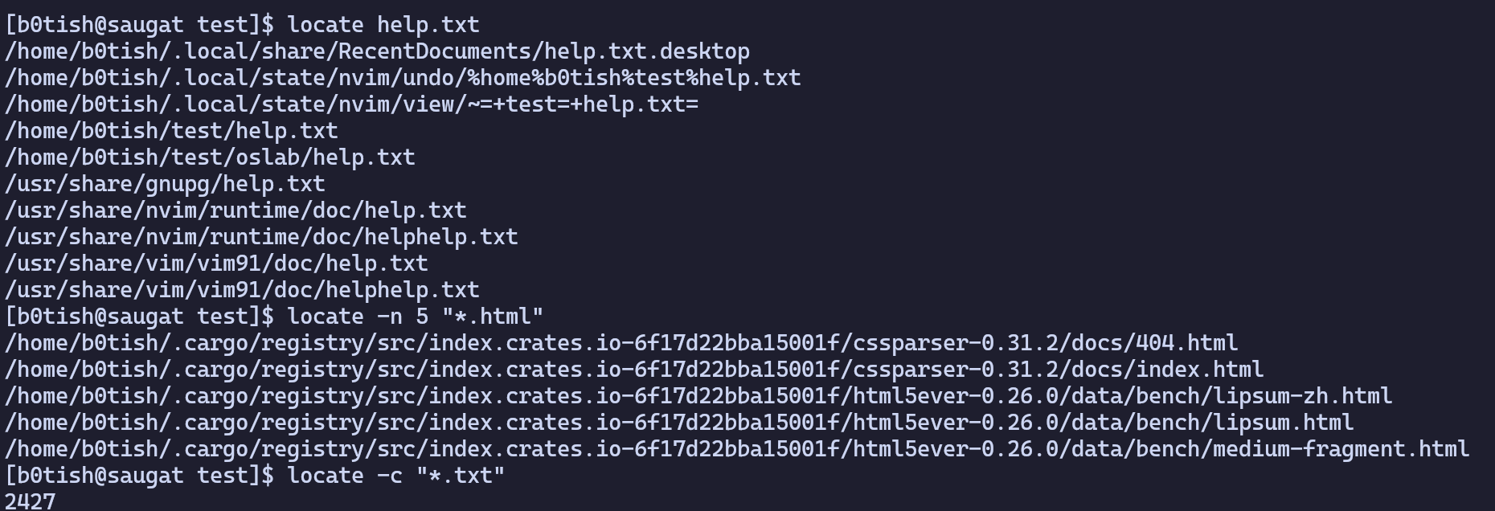

**1.21. Command Name:** netstat

**Syntax:** netstat [Options]

**Usage:** It allows to display network-related information and diagnose various

networking issue.

**Commands Used:**

netstat -a -> It shows both listening and non-listening sockets

netstat -at -> It lists all TCP ports that the system is engaged in

netstat -l -> It lists all the actively listening ports for incoming connections

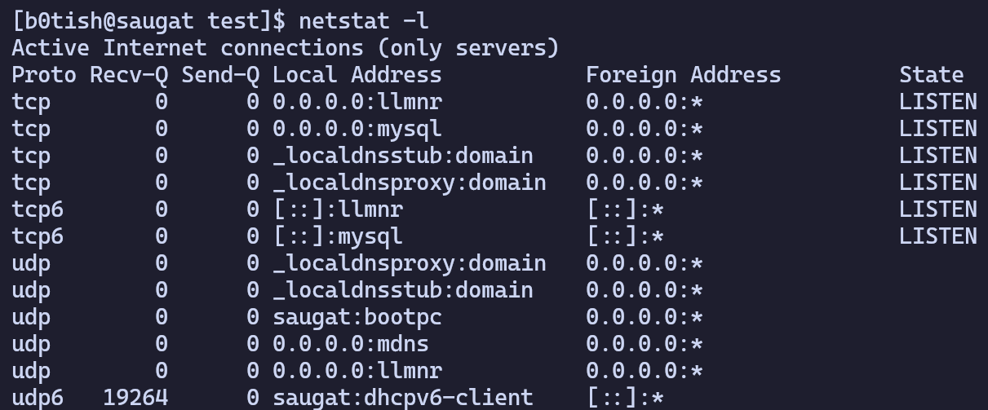**Output:**

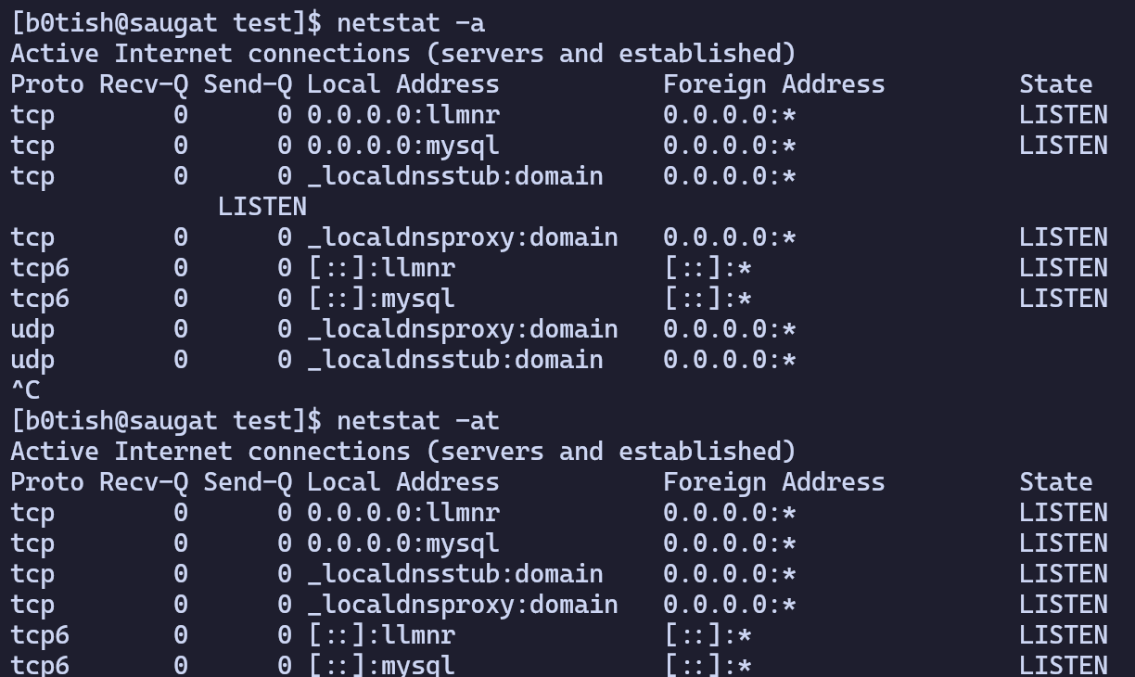**1.22. Command Name:** df

**Syntax:** df [Options] [Filesystem]

**Usage:** It is a utility that provides valuable information on disk space utilization.

**Commands Used:**

df -> It displays all information all the mounted file systems

**Output:**

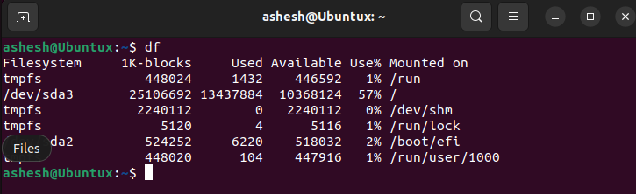

**1.23. Command Name:** du

**Syntax:** du [Options] [File]

**Usage:** It is a utility that analyzes and reports on disk usage within directories and

files.

**Commands Used:**

du -h /home/b0tish/test -> It prints the sizes in human readable format

**Output:**

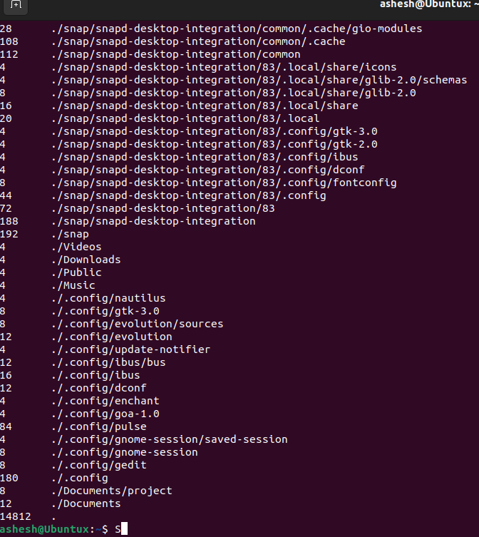

**1.24. Command Name:** uname

**Syntax:** uname [Option]

**Usage:** It is a utility that prints basic information about the operating system name

and system hardware.

**Commands Used:**

uname -s -> It prints the kernel name

uname -n -> It prints the hostname of the current computer

uname -r -> It prints the kernel release date

**Output:**

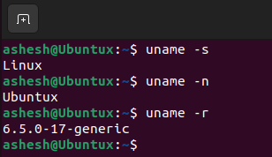

**1.25. Command Name**: passwd

**Syntax:** passwd [Options] [Username]

**Usage:** It is used for changing the user password.

**Commands Used:**

passwd -> It changes current user’s password

**Output:**

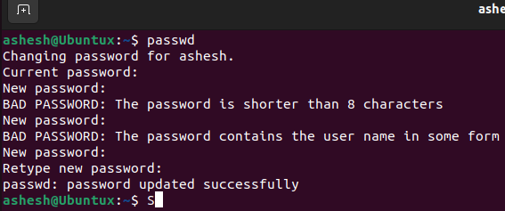

**1.26. Command Name:** useradd

**Syntax:** useradd [options][User_name]

**Usage:** It is used to add user accounts to the system.

**Commands Used:**

sudo useradd -> It creates a new user with the name.

**Output:**

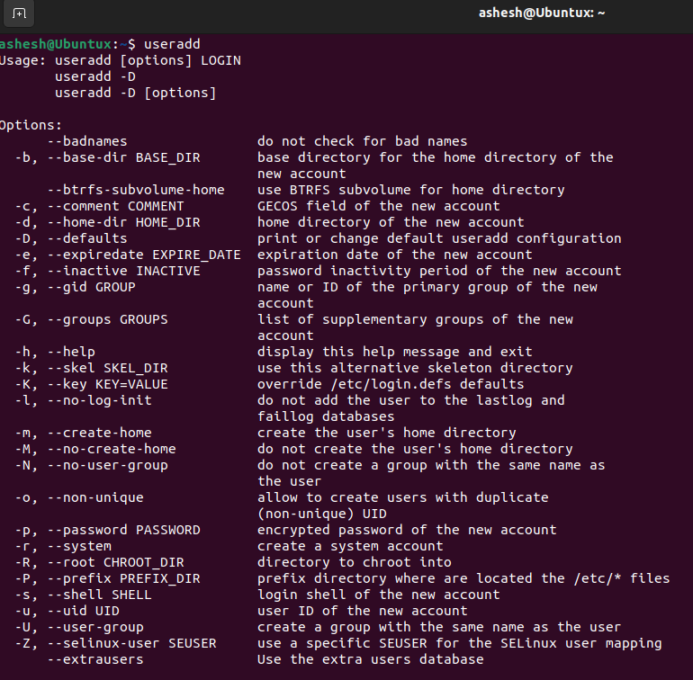

**1.27. Command Name:** userdel

**Syntax:** userdel [options][User_name]

**Usage:** It is used for deleting a user account and related files.

**Commands Used:**

sudo userdel -> It removes user with the name.

sudo userdel -f steven -> It forcefully removes of steven’s account

**Output:**

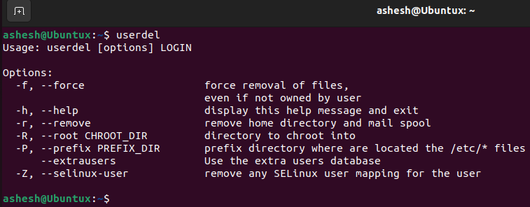

**1.28. Command Name:** apt-get

**Syntax:** apt-get [options]

**Usage:** It is used for handling packages.

(Cannot be done on arch linux as it uses different package manager)

**1.29. Command Name:** ping

**Syntax:** ping [options] [host_or_ip address]

**Usage:** It is used to check the network connectivity between host and server/host.

**Commands Used:**

ping google.com -> It checks whether the host google.com Is up or not

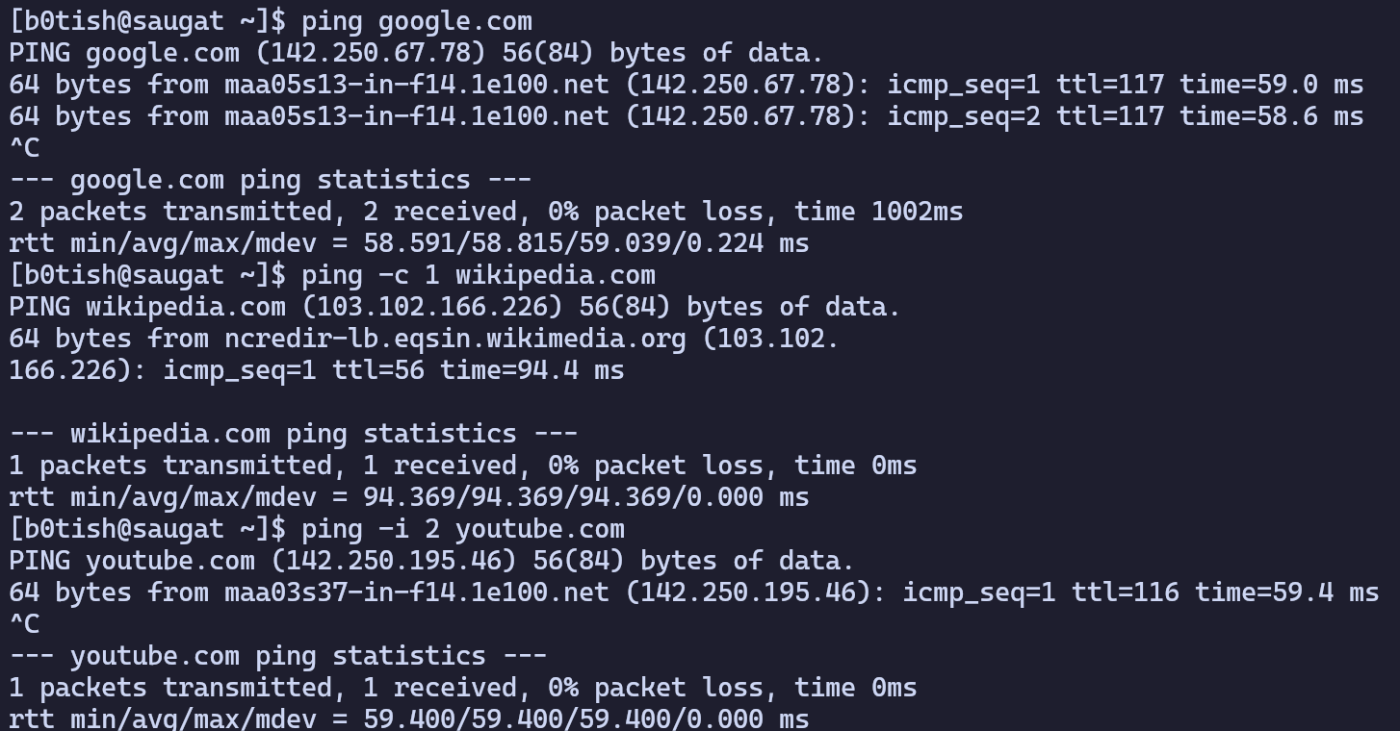**Output:**

**1.30. Command Name:** find

**Syntax:** find [path] [options] [expression]

**Usage:** It is used to search files and directories in a directory hierarchy based on

given expression.

**Commands Used:**

find ./projects -name encry.c -> It searches a file named “encry.c” within

**Output:**

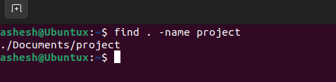

**1.31. Command Name:** head

**Syntax:** head [Option] [File]

**Usage:** It is used to print the top N number of data of the given input.

**Commands Used:**

head secret.txt -> It displays only the first 10 lines of secret.txt file

**Output:**

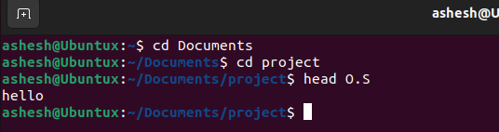

**1.32. Command Name:** rename

**Syntax:** rename [option] [expression] [file]

**Usage:** It is used to change the names of lots of files all at once.

**Commands Used:**

rename -v .html .c *.html -> It shows that all .html files are being renamed

into .c files

**Output:**

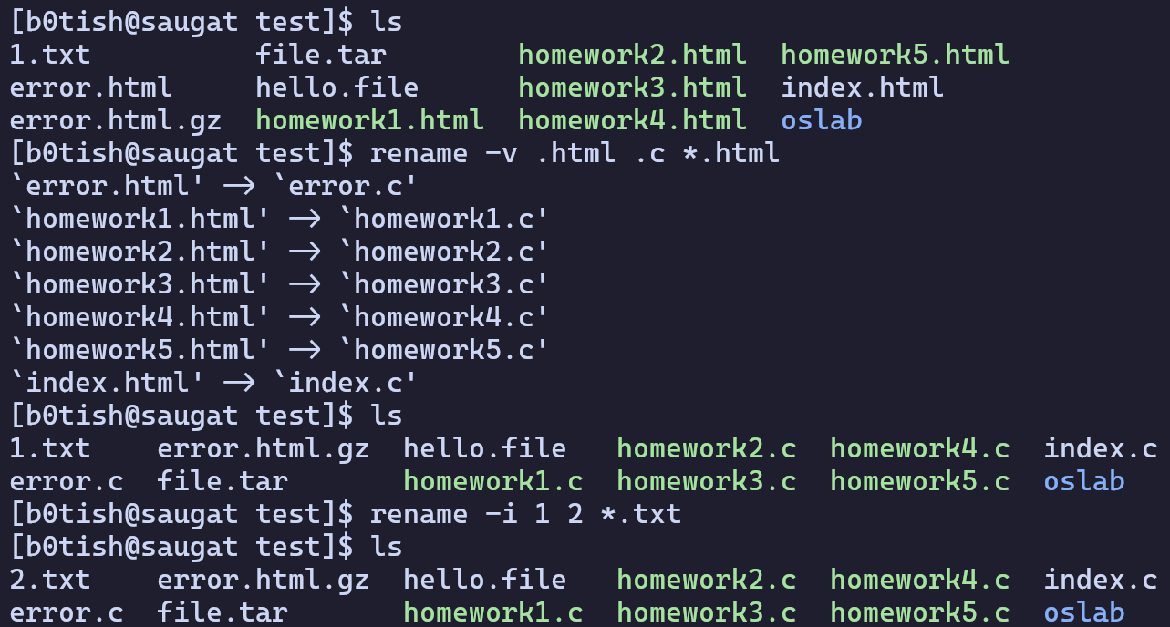

**1.33. Command Name:** tail

**Syntax:** tail [Option] [File]

**Usage:** It is used to print the last N number of data of the given input.

**Commands Used:**

tail secret.txt -> It displays the last 10 lines of secret.txt file

**Output:**

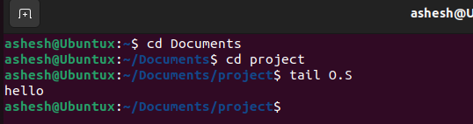

**1.34. Command Name:** tac

**Syntax:** tac [Option] [File]

**Usage:** It is used to concatenate and print files in reverse.

**Commands Used:**

tac O.S.txt -> It prints the contents of the file help.txt in reverse

**Output:**

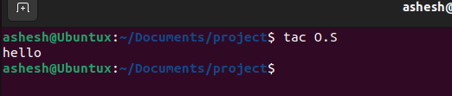

**1.35. Command Name:** comm

**Syntax:** comm [Option] [File]

**Usage:** It is used to compare two sorted files line by line and write to standard

output.

**Commands Used:**

comm file1.txt file2.txt -> It compares file1 and file2 content and displays the

following information :

**Output:**

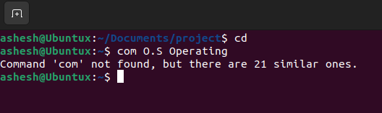

**1.36. Command Name:** cut

**Syntax:** cut [Option] [File]

**Usage:** It is used to cut out the sections from each line of files and write into output.

**Commands Used:**

cut -b 3,5,9 file.txt → It extracts specific bytes given by the list of byte

numbers

cut -c 1,2,4 file.txt → It extracts specific characters given by the list of

numbers

cut -d “ “ -f 1 file.txt → It extracts the text using space as a field separator

**Output:**

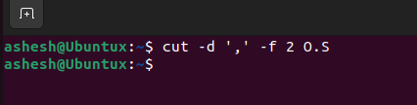

**1.37. Command Name:** sort

**Syntax:** sort [Option][FileName]

**Usage:** It is used to sort the file contents in an alphabetical order.

**Commands Used:**

sort names.txt -> It sorts the content of the names.txt in an alphabetical order

**Output:**

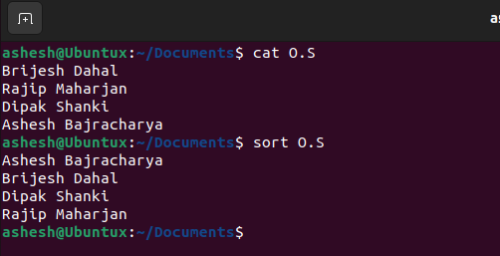

**1.38. Command Name:** date

**Syntax:** date [Option] [Format]

**Usage:** It is used for displaying system date and time in given format.

**Commands Used:**

date -> It prints the current date and time

date -u -> It displays the current time in UTC format

date –-date=”2 days ago” -> It prints the date and time of 2 days ago

date +’%a, %b %d’ -> It prints date in abbreviated weekdays , month and prints day

**Output:**

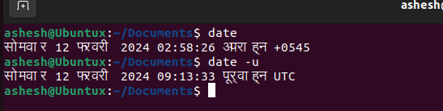

**1.39. Command Name:** cal

**Syntax:** cal [ [month] year]

**Usage:** It is used to print the calendar of a specific month or a whole year.

**Commands Used:**

cal → It shows the current month calendar with current date highlighted

**Output:**

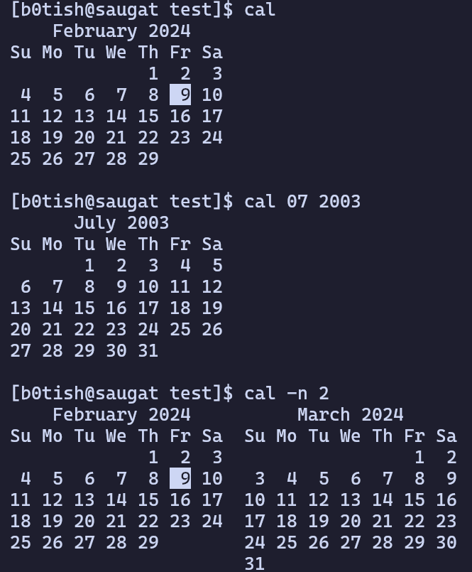

**1.40. Command Name:** time

**Syntax:** time [option] [command]

**Usage:** It is used for printing a summary of system resource usage.

**Commands Used:**

time ls → It displays the time taken by the ls command.\

**Output:**

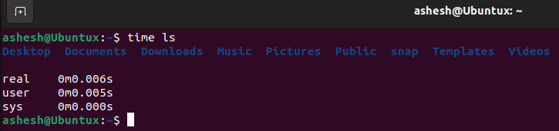

**1.41. Command Name:** host

**Syntax:** host [option] [domain hostname IP address]

**Usage:** It is used to perform DNS lookups I.e to find a hostname when provided with

IP address.

**Commands Used:**

host youtube.com → It prints out the IP address and IPV6 address of

youtube.com

host -C facebook.com → It compares the SOA records on authoritative

nameservers

host -t ns github.com → It is used to specify and print the name server of

github.com

**Output:**

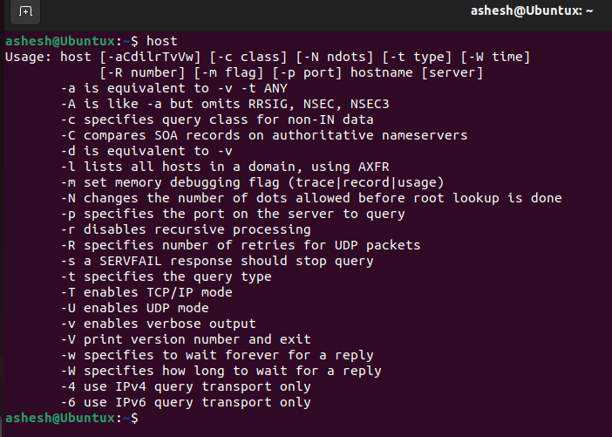

**1.42. Command Name:** wget

**Syntax:** wget [option] [URL]

**Usage:** It is used to download files from the server even when the user has not

logged on to the system.

**Commands Used:**

wget https://pastebin.com/raw/cR41megZ→ It downloads the webpage using

wget

wget -O hello.txt get https://pastebin.com/raw/JMz7ecid → It downloads the

content and saves it under hello.txt

**Output:**

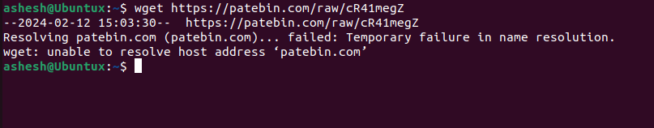

**1.43. Command Name:** id

**Syntax:** id [option] [user]

**Usage:** It is used to find out user and group names and numeric ID’s of the current

user or any other user in the server.

**Commands Used:**

id → It shows the ID of current user UID and GID

**Output:**

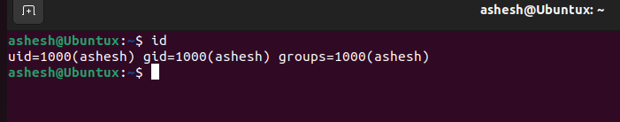

**1.44. Command Name:** ps

**Syntax:** ps [option]

**Usage:** It is used to view information about the processes running on the system.

**Commands Used:**

ps → It lists the running processes in the current shell

**Output:**

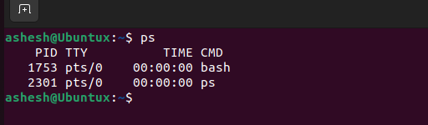

**1.45. Command Name:** top

**Syntax:** top [option]

**Usage:** It shows the summary information of the system and the list of processes or

threads.

**Commands Used:**

top → It shows the following system information :-

**Output:**

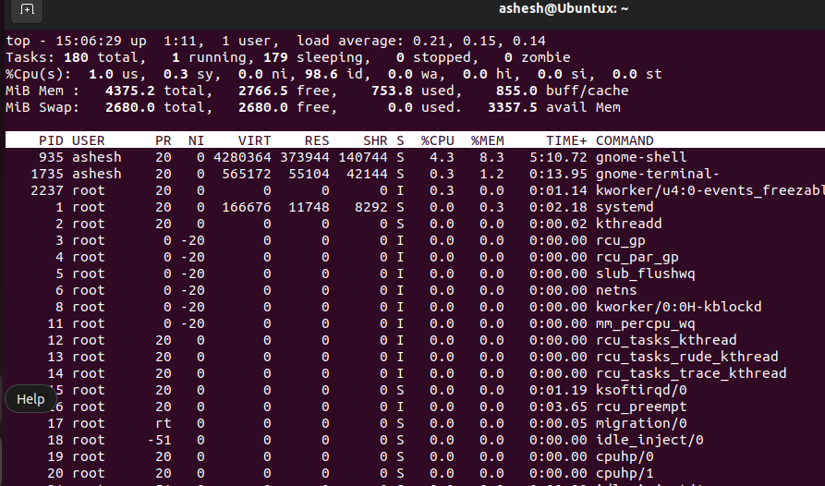

**1.46. Command Name:** kill

**Syntax:** kill [signal] PID

**Usage:** It is used for sending a signal to a process that terminates the process.

**Commands Used:**

kill -9 8740 -> It sends a “SIGKILL” to kill all process of id 8740

kill -l -> It lists all the available signal name

**Output:**

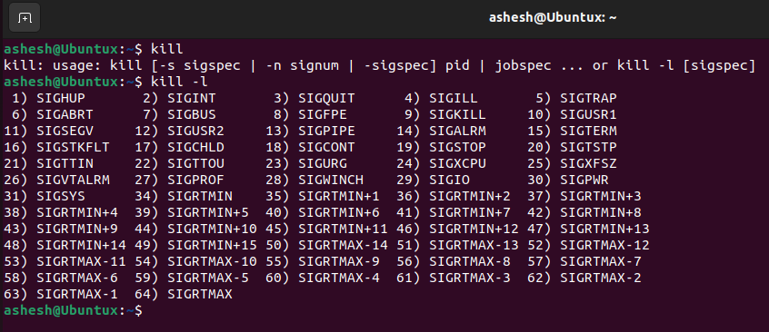

**1.47. Command Name:** pkill

**Syntax:** pkill [options] [pattern]

**Usage:** It is used for sending signals to the processes of a running program based on

given criteria.

**Commands Used:**

pkill nvim -> It terminates all processes named ‘nvim’

**Output:**

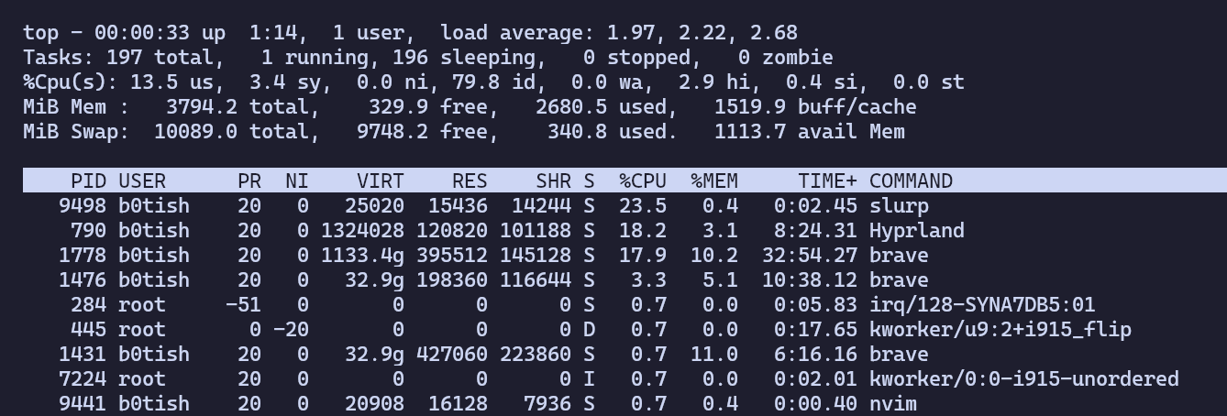

**1.48. Command Name:** killall

**Syntax:** killall [ -Z CONTEXT ] [ -u USER ] [ -y TIME ] [ -o TIME ] [ -eIgiqrvw ] [ -s SIGNAL | -SIGNAL ] NAME...

**Usage:** It is used for killing process by their names and different attributes.

**Commands Used:**

killall nvim -> It kills all process having name nvim

**Output:**

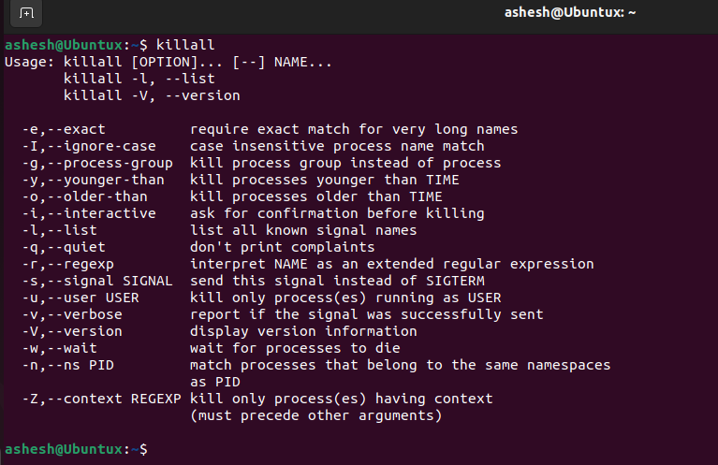

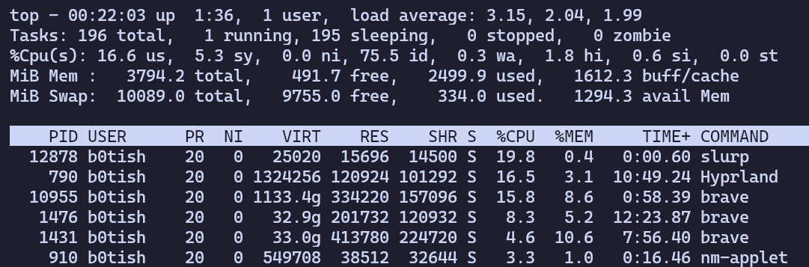

**1.49. Command Name:** bg

**Syntax:** bg [job]

**Usage:** It is used to place foreground jobs in background.

**Commands Used:**

bg %1 → It places the foreground job “sleep” in the background

bg -help → It displays the help information of bg command

**Output:**

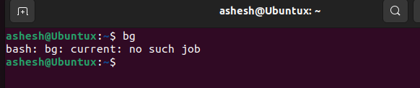

**1.50. Command Name:** fg

**Syntax:** fg [jobs]

**Usage:** It is used to put a background job in foreground.

**Commands Used:**

fg %1 → It places the background job “sleep” into the foreground

fb –help → It displays the help information for fg command

**Output:**

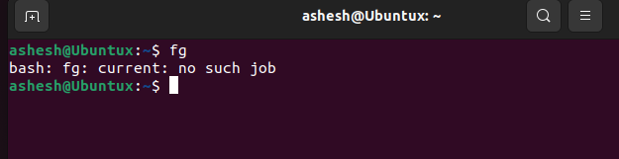

**1.51. Command Name:** tar

**Syntax:** tar [options] [archive-file] [file or directory to be archived]

**Usage:** It is used to create Archive and extract the Archive files.

**Commands Used:**

tar cvf file.tar *.html -> It creates a tar file called `file.tar` which is the Archive

of all .html files in current directory

**Output:**

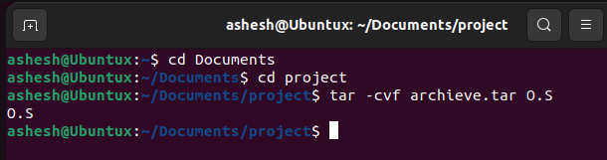

**1.52. Command Name:** gzip

**Syntax:** gzip [options] [filenames]

**Usage:** It is a compressing tool which is used to truncate the file size.

**Commands Used:**

gzip index.html -> It creates a compressed file of index.html named as

**Output:**

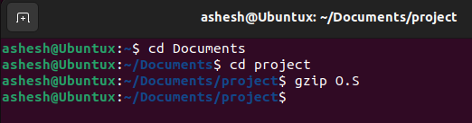

|  |
| --- |
| NAGARJUNA COLLEGE OF INFORMATION TECHNOLOGY  (Tribhuvan University)  Shankhamul, Lalitpur    Lab Sheet: Operating System      Submitted by: Ashesh Bajracharya  Submitted to: Bipin Timalsina Sir  Roll no: 3  Department: CSIT  Semester: IV |

Table Of Content

|  |  |  |  |  |
| --- | --- | --- | --- | --- |
| Lab No. | Title/Question (Command) | Submission  Date | Signature | Remarks |
| 1.1 | ls | 2080/11/1 |  |  |
| 1.2 | cd | 2080/11/1 |  |  |
| 1.3 | grep | 2080/11/1 |  |  |
| 1.4 | su/sudo | 2080/11/1 |  |  |
| 1.5 | pwd | 2080/11/1 |  |  |
| 1.6 | mv | 2080/11/1 |  |  |
| 1.7 | cp | 2080/11/1 |  |  |
| 1.8 | rm | 2080/11/1 |  |  |
| 1.9 | mkdir | 2080/11/1 |  |  |
| 1.10 | rmdir | 2080/11/1 |  |  |
| 1.11 | chmod | 2080/11/1 |  |  |
| 1.12 | cat | 2080/11/1 |  |  |
| 1.13 | chown | 2080/11/1 |  |  |
| 1.14 | echo | 2080/11/1 |  |  |
| 1.15 | wc | 2080/11/1 |  |  |
| 1.16 | man | 2080/11/1 |  |  |
| 1.17 | history | 2080/11/1 |  |  |
| 1.18 | clear | 2080/11/1 |  |  |
| 1.19 | touch | 2080/11/1 |  |  |
| 1.20 | locate | 2080/11/1 |  |  |
| 1.21 | netstat | 2080/11/1 |  |  |
| 1.22 | df | 2080/11/1 |  |  |

|  |  |  |  |  |
| --- | --- | --- | --- | --- |
| 1.23 | du | 2080/11/1 |  |  |
| 1.24 | uname | 2080/11/1 |  |  |
| 1.25 | passwd | 2080/11/1 |  |  |
| 1.26 | useradd | 2080/11/1 |  |  |
| 1.27 | userdel | 2080/11/1 |  |  |
| 1.28 | apt-get | 2080/11/1 |  |  |
| 1.29 | ping | 2080/11/1 |  |  |
| 1.30 | find | 2080/11/1 |  |  |
| 1.31 | head | 2080/11/1 |  |  |
| 1.32 | rename | 2080/11/1 |  |  |
| 1.33 | tail | 2080/11/1 |  |  |
| 1.34 | tac | 2080/11/1 |  |  |
| 1.35 | comm | 2080/11/1 |  |  |
| 1.36 | cut | 2080/11/1 |  |  |
| 1.37 | sort | 2080/11/1 |  |  |
| 1.38 | date | 2080/11/1 |  |  |
| 1.39 | cal | 2080/11/1 |  |  |
| 1.40 | time | 2080/11/1 |  |  |
| 1.41 | host | 2080/11/1 |  |  |
| 1.42 | wget | 2080/11/1 |  |  |
| 1.43 | id | 2080/11/1 |  |  |
| 1.44 | ps | 2080/11/1 |  |  |
| 1.45 | top | 2080/11/1 |  |  |
| 1.46 | kill | 2080/11/1 |  |  |
| 1.47 | pkill | 2080/11/1 |  |  |
| 1.48 | killall | 2080/11/1 |  |  |
| 1.49 | bg | 2080/11/1 |  |  |
| 1.50 | fg | 2080/11/1 |  |  |
| 1.51 | tar | 2080/11/1 |  |  |
| 1.52 | gzip | 2080/11/1 |  |  |

|  |
| --- |
| NAGARJUNA COLLEGE OF INFORMATION TECHNOLOGY  (Tribhuvan University)  Shankhamul, Lalitpur    Lab Sheet: Operating System      Submitted by: Brijesh Dahal  Submitted to: Bipin Timalsina Sir  Roll no: 5  Department: CSIT  Semester: IV |

|  |  |  |  |  |
| --- | --- | --- | --- | --- |
| Lab No. | Title/Question (Command) | Submission  Date | Signature | Remarks |
| 1.1 | ls | 2080/11/1 |  |  |
| 1.2 | cd | 2080/11/1 |  |  |
| 1.3 | grep | 2080/11/1 |  |  |
| 1.4 | su/sudo | 2080/11/1 |  |  |
| 1.5 | pwd | 2080/11/1 |  |  |
| 1.6 | mv | 2080/11/1 |  |  |
| 1.7 | cp | 2080/11/1 |  |  |
| 1.8 | rm | 2080/11/1 |  |  |
| 1.9 | mkdir | 2080/11/1 |  |  |
| 1.10 | rmdir | 2080/11/1 |  |  |
| 1.11 | chmod | 2080/11/1 |  |  |
| 1.12 | cat | 2080/11/1 |  |  |
| 1.13 | chown | 2080/11/1 |  |  |
| 1.14 | echo | 2080/11/1 |  |  |
| 1.15 | wc | 2080/11/1 |  |  |
| 1.16 | man | 2080/11/1 |  |  |
| 1.17 | history | 2080/11/1 |  |  |
| 1.18 | clear | 2080/11/1 |  |  |
| 1.19 | touch | 2080/11/1 |  |  |
| 1.20 | locate | 2080/11/1 |  |  |
| 1.21 | netstat | 2080/11/1 |  |  |
| 1.22 | df | 2080/11/1 |  |  |

|  |  |  |  |  |
| --- | --- | --- | --- | --- |
| 1.23 | du | 2080/11/1 |  |  |
| 1.24 | uname | 2080/11/1 |  |  |
| 1.25 | passwd | 2080/11/1 |  |  |
| 1.26 | useradd | 2080/11/1 |  |  |
| 1.27 | userdel | 2080/11/1 |  |  |
| 1.28 | apt-get | 2080/11/1 |  |  |
| 1.29 | ping | 2080/11/1 |  |  |
| 1.30 | find | 2080/11/1 |  |  |
| 1.31 | head | 2080/11/1 |  |  |
| 1.32 | rename | 2080/11/1 |  |  |
| 1.33 | tail | 2080/11/1 |  |  |
| 1.34 | tac | 2080/11/1 |  |  |
| 1.35 | comm | 2080/11/1 |  |  |
| 1.36 | cut | 2080/11/1 |  |  |
| 1.37 | sort | 2080/11/1 |  |  |
| 1.38 | date | 2080/11/1 |  |  |
| 1.39 | cal | 2080/11/1 |  |  |
| 1.40 | time | 2080/11/1 |  |  |
| 1.41 | host | 2080/11/1 |  |  |
| 1.42 | wget | 2080/11/1 |  |  |
| 1.43 | id | 2080/11/1 |  |  |
| 1.44 | ps | 2080/11/1 |  |  |
| 1.45 | top | 2080/11/1 |  |  |
| 1.46 | kill | 2080/11/1 |  |  |
| 1.47 | pkill | 2080/11/1 |  |  |
| 1.48 | killall | 2080/11/1 |  |  |
| 1.49 | bg | 2080/11/1 |  |  |
| 1.50 | fg | 2080/11/1 |  |  |
| 1.51 | tar | 2080/11/1 |  |  |
| 1.52 | gzip | 2080/11/1 |  |  |