

REPUBLIC OF ALBANIA

FACULTY OF COMPUTER SCIENCES AND IT

Software Engineering Program

**Software Analysis and Design**

Team: Andi Sheta, Oldeso Nikolli, Seli Fuga

Lector: Igli Hakrama

TIRANA 2023

Table of Content   
  
1.1 Short description of the project  
2.1 Requirements of the business  
3.1 Process flow  
4.1 How can the business profit  
5.1 Delivery process and states

6.1 Tracing of orders(from customers point of view)  
7.1 Cost of packages/orders  
8.1 Prerequisites and logistics

9.1 Screenshot of Front Page  
10 Screenshots of Diagrams

Posta 420  
  
1.1 What will this project offer?  
  
The idea of this project is to create a web app for a postal chain, which will make possible an efficient and easy delivery for one time costumers as well as businesses(online shops).  
  
It will mostly cover the state of Albania but also will be able to provide coverage throughout Europe (international transport with the help of third parties).  
  
**2.1** In order for this project to function it will require several departments/Workers:  
  
1) Branch Manger – He will be responsible on managing the workflow on his assigned branch. Also resolving any issues that the branch may face.   
2) Branch worker – Their responsibilities will be communication with costumers, providing information and taking in orders from costumers who come inside the office  
3) Storage worker – Will do the storing/sorting process. And provide the packages to the assigned delivery drivers

4) Delivery driver – Their responsibility will be picking up the packages from the costumer or business. Taking those packages to the branch, transporting them from branch to branch. Delivering the packages.

1. pickupDriver -> pick ups packages and returns the returned ones from the sender
2. transitDriver -> delivers packages from mainBranch to the respective branch and vice-versa.
3. courier ->delivers the package to the reciever

5) Finance department – As the name suggest they will handle the transactions provide invoices and do the liquidation process for the customers  
  
3.1 How will it work?  
  
Posta 420 will be divided into branches, it will have the parent office(main branch) located in Tirana and other branches all over the other cities in Albania.  
  
It will include a sorting algorithm in order to make the delivery of the packages more efficient. They will be divided into categories, depending on location and in some special cases on notes. For example, if the sender or receiver requests the package to be delivered on a specific time.

if(senderState=Albania)

{

if(senderlocation=!MainBranchLocation)

{

if(senderLocation=!recieverLocation)

{send package to Main Branch}

else

{deliver package in respective Branch}

}

else

{deliver package}

}

else

{package=international}

* In case the package need to be delivered to another city, the transitDriver will transport the package from the respective branch to the main branch. From there, the main branch will give the package to the transitDriver, who will send the packages to the recieverLocation branch.   
    
    
  The process can be:

1) Main Branch -> Side branch

2) Side Branch -> Main branch

3) Side Branch -> Main Branch -> Side branch   
  
Sender will be able to pay directly when the package is picked up or though the system(online). Price will be calculated directly by the system and given to the customer before making the pick-up request. As for more info it will be listed below.

If it is a business a direct payment during the pick up process is not required since we will have an agreement with them. They also can do the payment directly through the system  
  
In case it will be an international delivery. The price per package will predetermined from the research done prior by us. The final price including our margin will be provided to the customer. If the customer agrees than the delivery process will be done.

**4.1 The main income will be divided into two groups**  
1) Normal/simple customers – They will be able to send one or more packages. The delivery request can be made on their local branch or through the website. For normal customers it will not be necessary to log in and a guest option will be provided.   
  
For this type of customer the packages can be received by hand from them in the branch or they can make a pick up request for our delivery drivers to pick them up.   
  
2) Business – For this type of customer an account will be required. Each of them will have an SLA(service level agreement) which will determine the flux of the orders which will come to the post and the pricing per package.  
  
Here the packages will be picked up in bulk by the delivery driver and then sent to the branch   
  
**5.1 Delivery process:**   
  
After the packages have been picked up and sorted they will enter the delivery process. During this phase ,the sender will receive an email or notification with a transaction fee and a packageCode ( for example AE30QD) in order to track the order that he created.  
**Statuses will be:**  
1) Picked up – The delivery driver has picked up the package and now is on it way to send the package to the appropriate branch (main Actor= pickupDriver)

2) To be delivered – The package has been picked up from the customer an is sent to the branch. There it will be sorted and selected when to deliver(main Actor= branchWorker)  
  
3) Stored – When the package sent to the branch and is in the storage facility. (main Actor= storageWorker)

4) Transit – Here we have two phases, this status will be put in case that the sender location differs from the receivers location. (main Actor= transitDriver)  
  
 * Main Branch -> Side branch * Side Branch -> Main branch

5) Delivering – Package has been assigned to a driver and it is “on the road” (main Actor= branchWorker)

6) Problematic – While delivering the package we can face some issues on which the costumer must be notified. This status will have some sub categories (main Actor= courier)

7) Delivered – package has been sent do the recipients address and accepted by them(main Actor= courier)  
  
8) International delivery – In this state we will just give an ETA and the client will need to contact branch for an update or just wait for the branch worked to update the system depending on the third parties website. An automates system can also be created to update the website automatically (main Actor= branchManager)  
  
9) Returned- The package was sent to the recipient but for one reason or another it was not accepted and will need to be returned to the original provider(main Actor= pickup driver)

6.1 How will the customer be able to track the package?  
  
On the pick-up request ,as mentioned above the sender received a packageCode. He can use that code to track the package state in two ways. A direct way though the website. There an option will appear “Track package”. Sender will need to insert the packageCode and a recieverName and click Track. They will be redirected to another page, giving them the status of the package. Another way will be by contacting the office through phone.This way, the verification process will be done vocally and an update will be provided by the branchWorker. Sender may as well visit the office directly if they would prefer it. Status of the package will be provided on real time since we can communicate if needed with the delivery driver. The delivery driver can update the status of the delivery themselves directly.  
  
In case the package is an international package the tracking process will differ a bit. Since the delivery is done by a third party deliver company a real time update can slightly difficult. Packages will be updated when a notification was received by the third party or when contacted by the branch worker

**7.1 Cost of package**  
The cost of the package will depend on the packages weight and location of the reciever.   
For example:

*\*values will be decided by mainBranchManager*

UrbanDelivery(avg=200*) (delivery inside the same city)

NationalDelivery(avg=300*)(delivery between 2 cities)

InternationalDelivery(avg=1000*)(delivery between two states)

if (weight<=3*) {price=avg}

else{

price=avg+(weight-3)*50(price/weight)*}

A discount will be made if the customer requests to deliver more packages

*\*values will be decided by mainBranchManager*

if (clientPackageNr>100*/day)

{

urbanDeliv=urbanDeliv-50*

NationalDeliv=nationalDeliv-100*

InternationalDeliv=internationalDeliv- 150*}

Sorting Process

The storage worker will sort the packages depending on recieverLocation for the transitDrivers(if the package is urbanDeliv) or courier(if the package is nationalDeliv) and also weight the packages to compare it to the one that the sender put. If they are different contact the branchWorker.(worker deals with client)BranchWorker makes the necessary changes. Else (label the packages or “mark” them depending on weight as well as dimension).   
  
There will be two types of sorting process

1. Within the same city, the packages will be sorted as mentioned above
2. From branch to branch finding the most efficient way to send the packages to the needed branch

8.1 Prerequisites  
   
1) Sender:

* Must have basic computer knowledge
* Internet access
* A working phone number
* Package made ready

2) Business:

* SLA agreement with us
* Account created
* Existing work flow
* NIPT

1. Branch
2. Staff
3. Manager
4. Worker
5. StorageWorker
6. Driver
7. Transit Driver
8. Courier
9. Pick-up Driver

* Driving license

* Good soft skills

* Basic phone knowledge

1. Finance
2. Logistics
3. Equipment(phone, pc, printer, etc)
4. Transport(vehicle, motorcycle, van)
5. Buildings(BranchBuilding, Storage)
6. Internet access.

9.1 Homepage

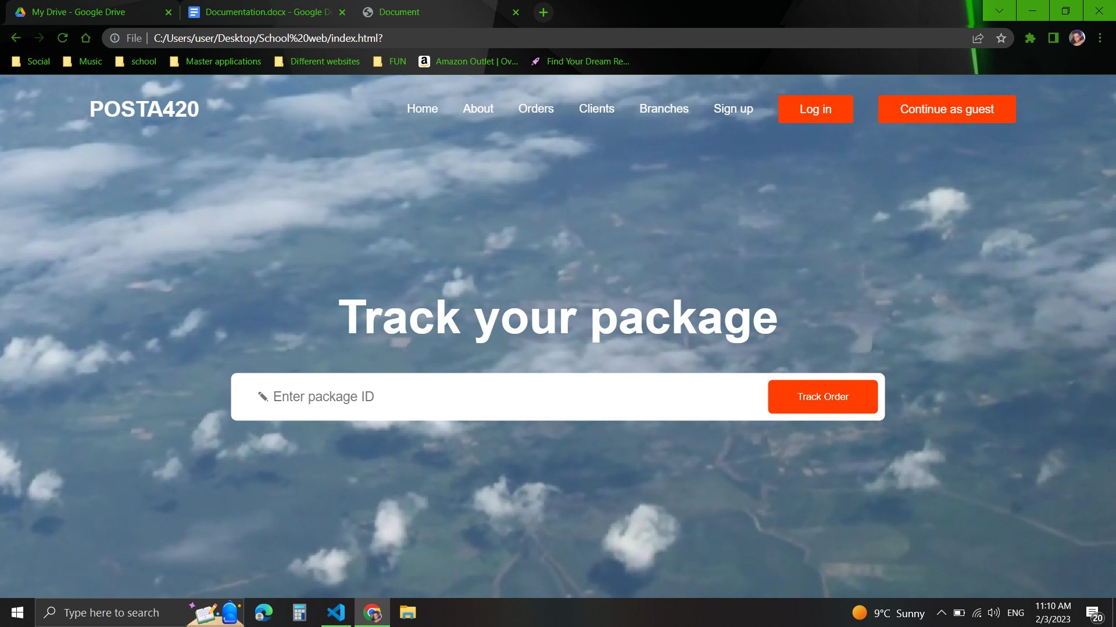

10 Diagrams

10.1 Use cases  
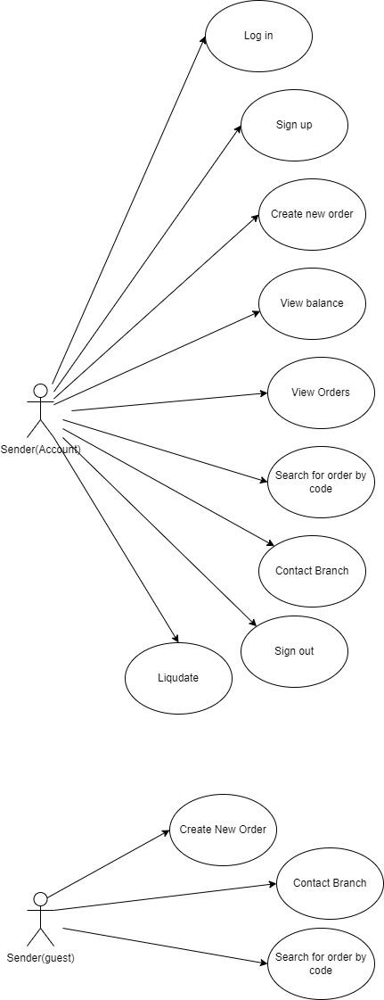  
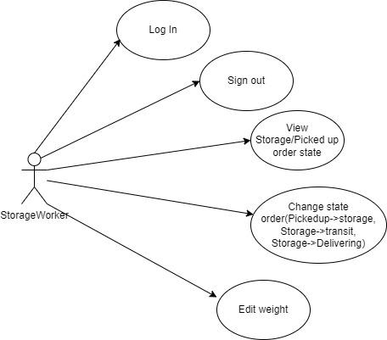  
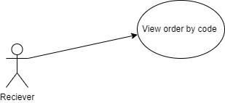  
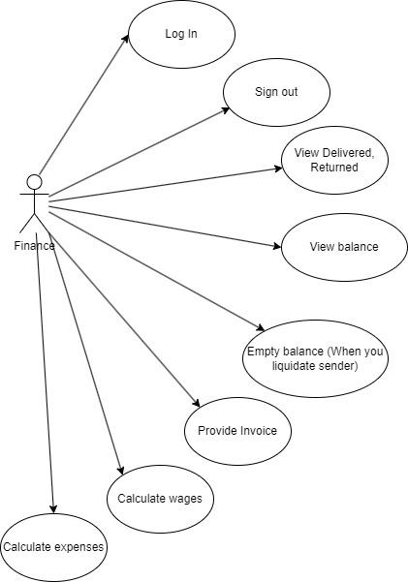  
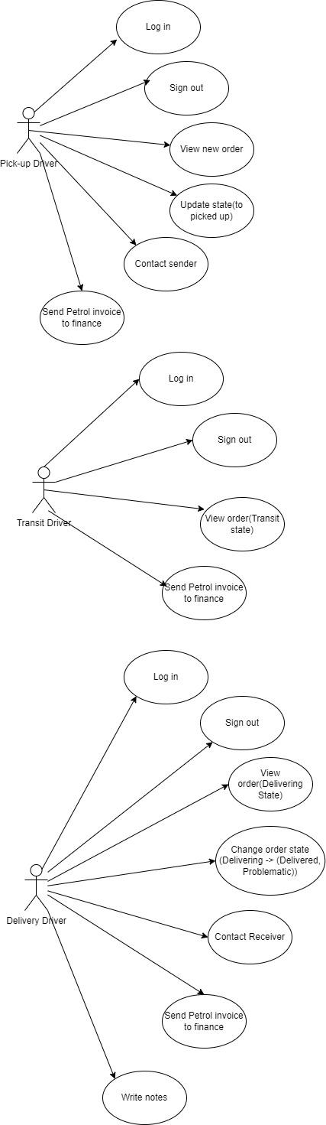  
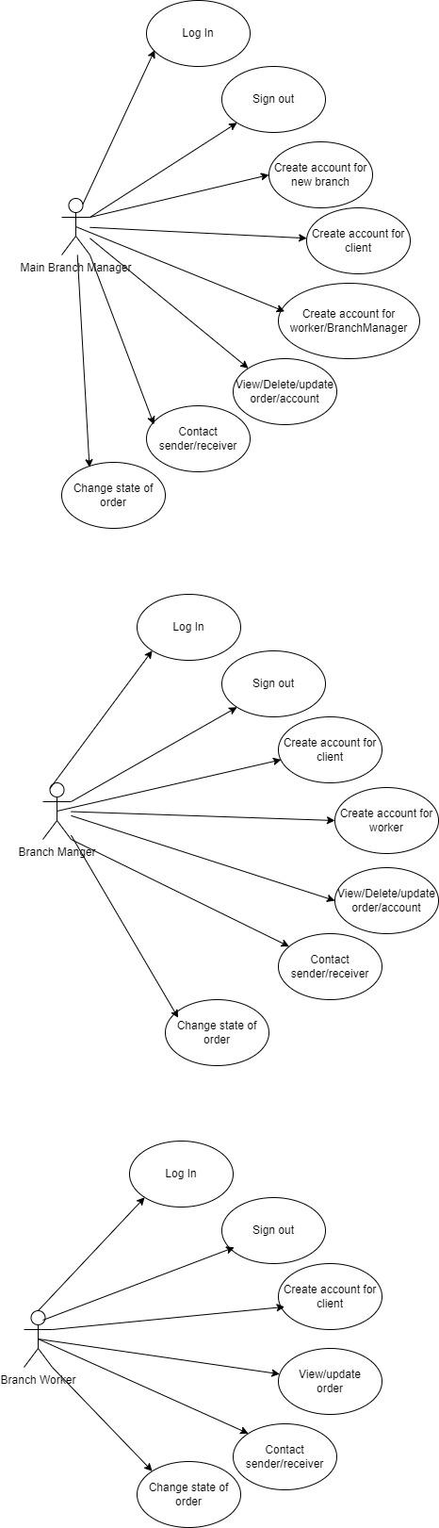  
10.2 Activity Diagram  
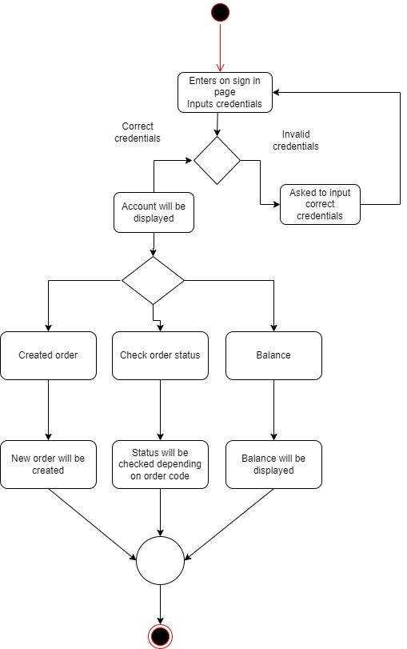  
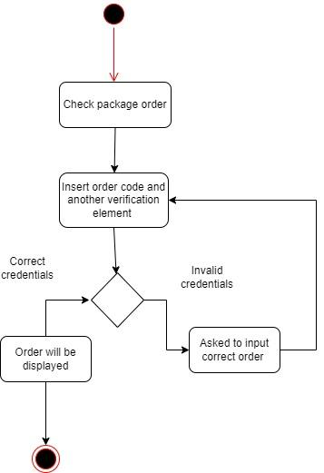  
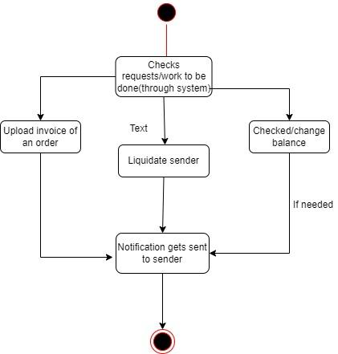  
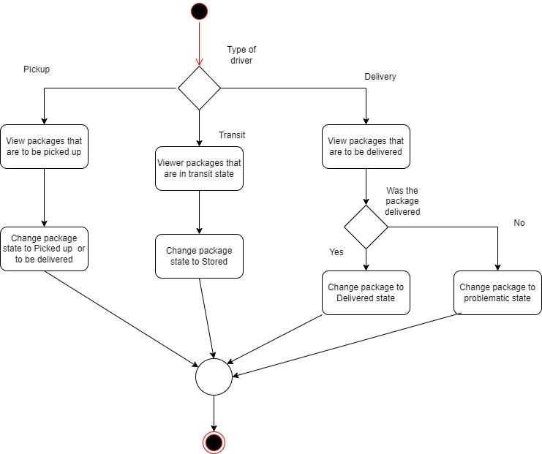  
  
  
  
10.4 ER Diagram  
  
  
  
  
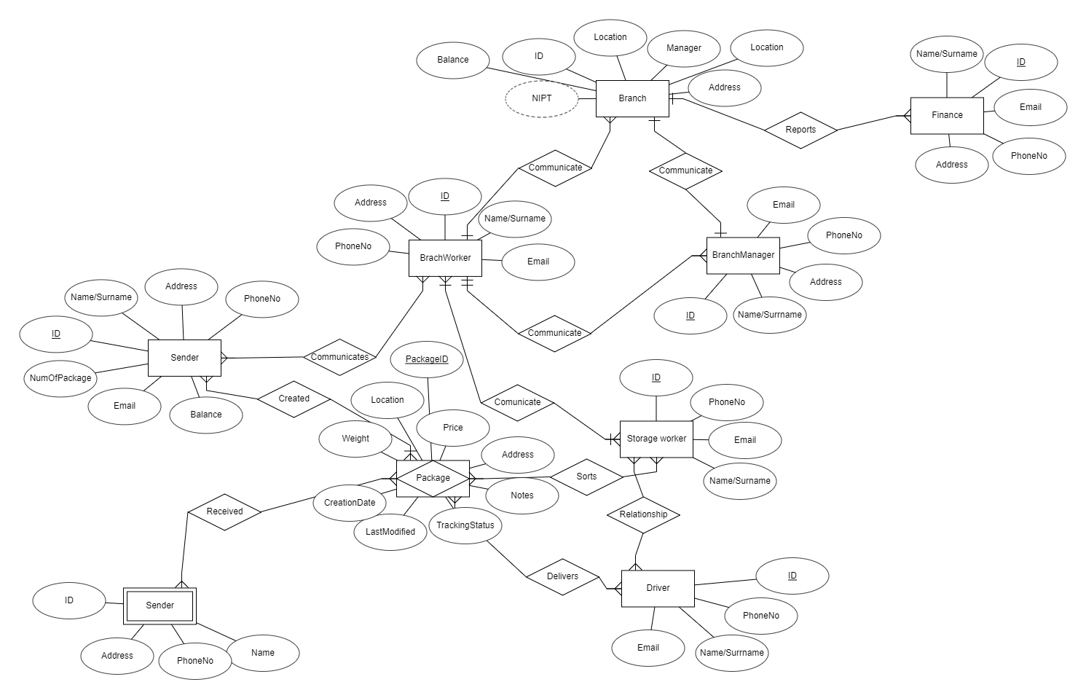

10.5 Class Diagram  
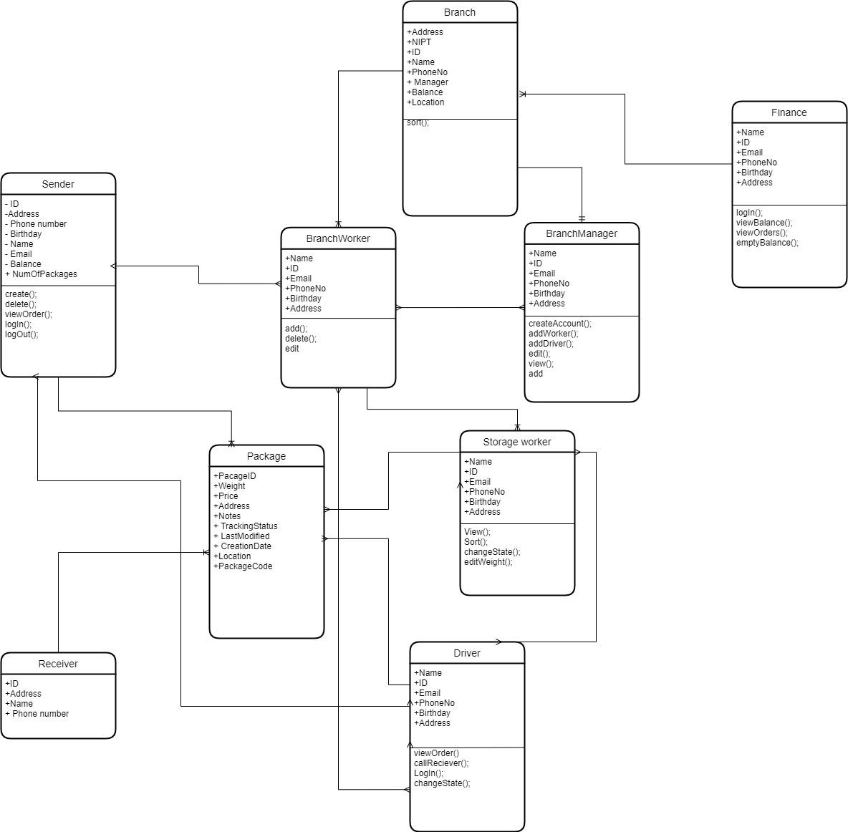

10.6 DFD  
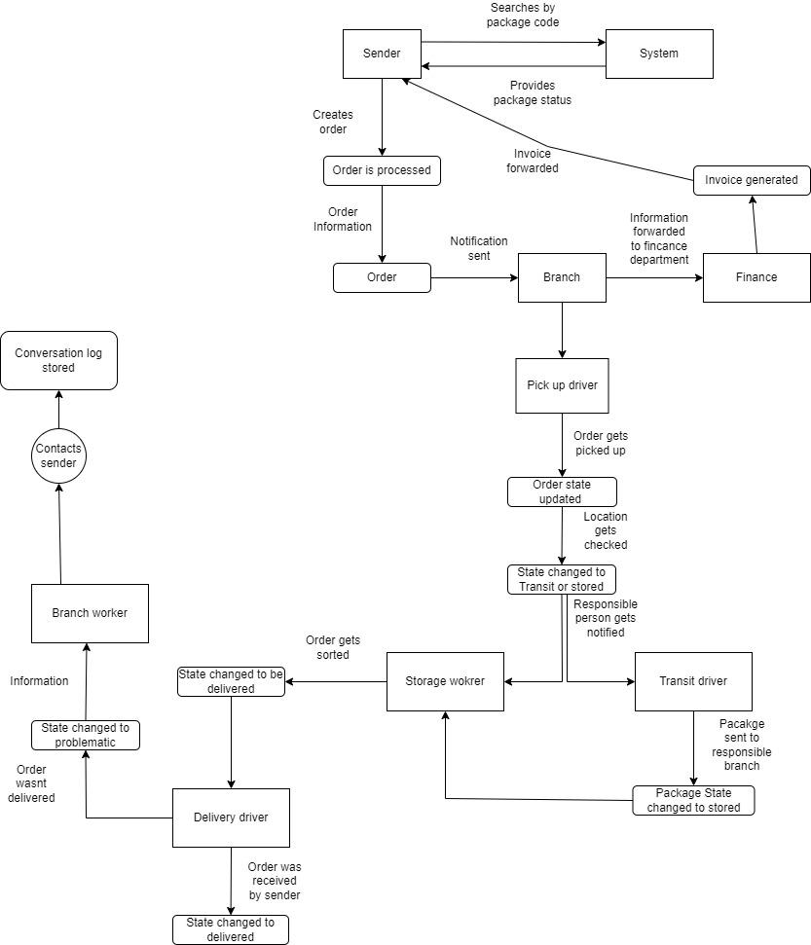  
  
  
  
10.7 Sequence Diagram  
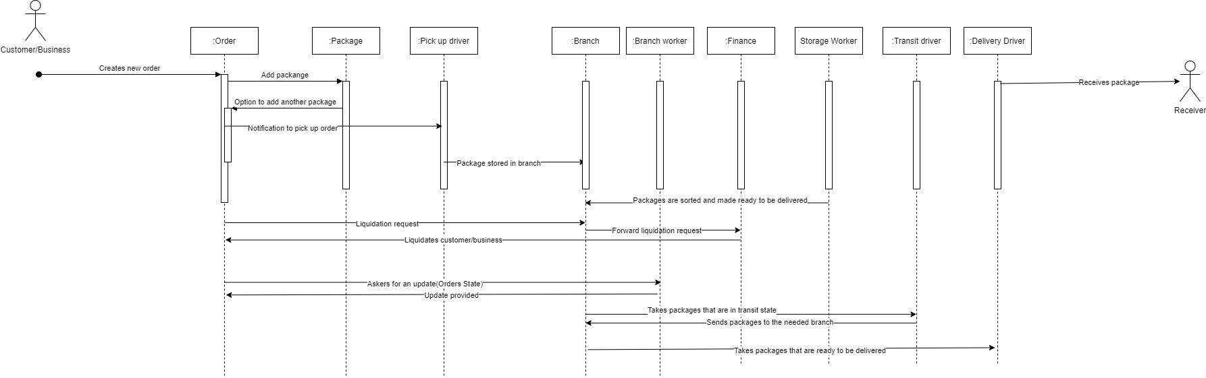  
10.8 Sequence Diagram

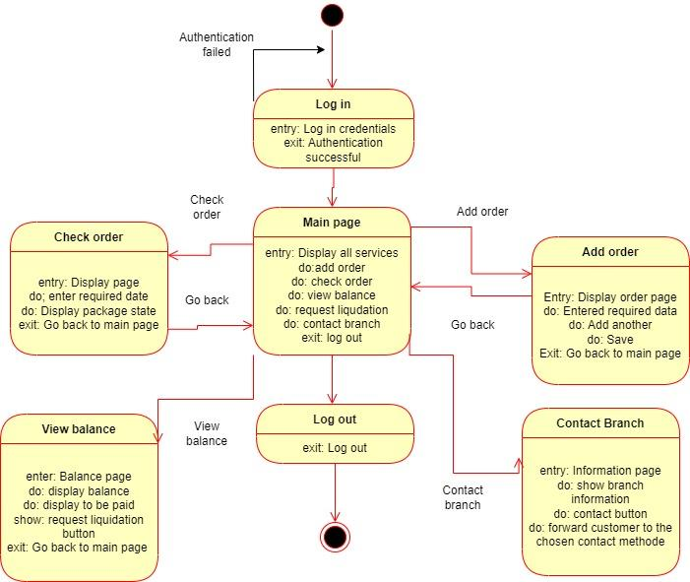  
  
  
10.10 Object Diagram

