**Create an automation account for scheduling the Resource in the given date time scenario.**

Problem Statement:

Create an automation account for scheduling the resources for a custom time

QuickStart’s

Create Automation account

Step1:

You can create an Azure Automation account through Azure, using the Azure portal,

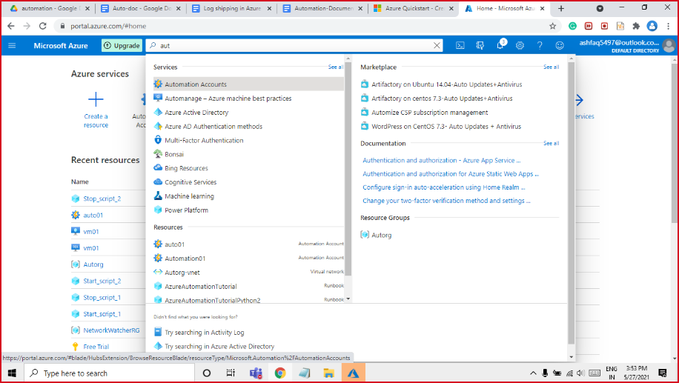

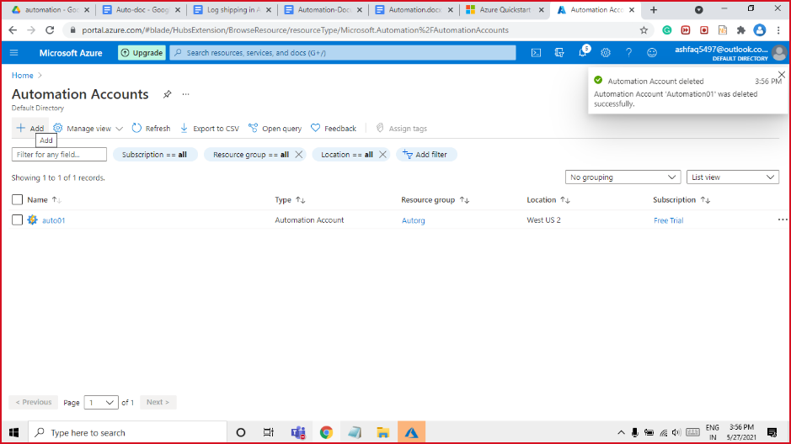

Step2:

Enter the account information, including the selected account name. For **Create Azure Run As account**, choose **Yes** so that the artifacts to simplify authentication to Azure are enabled automatically. When the information is complete, click **Create** to start the Automation account deployment.

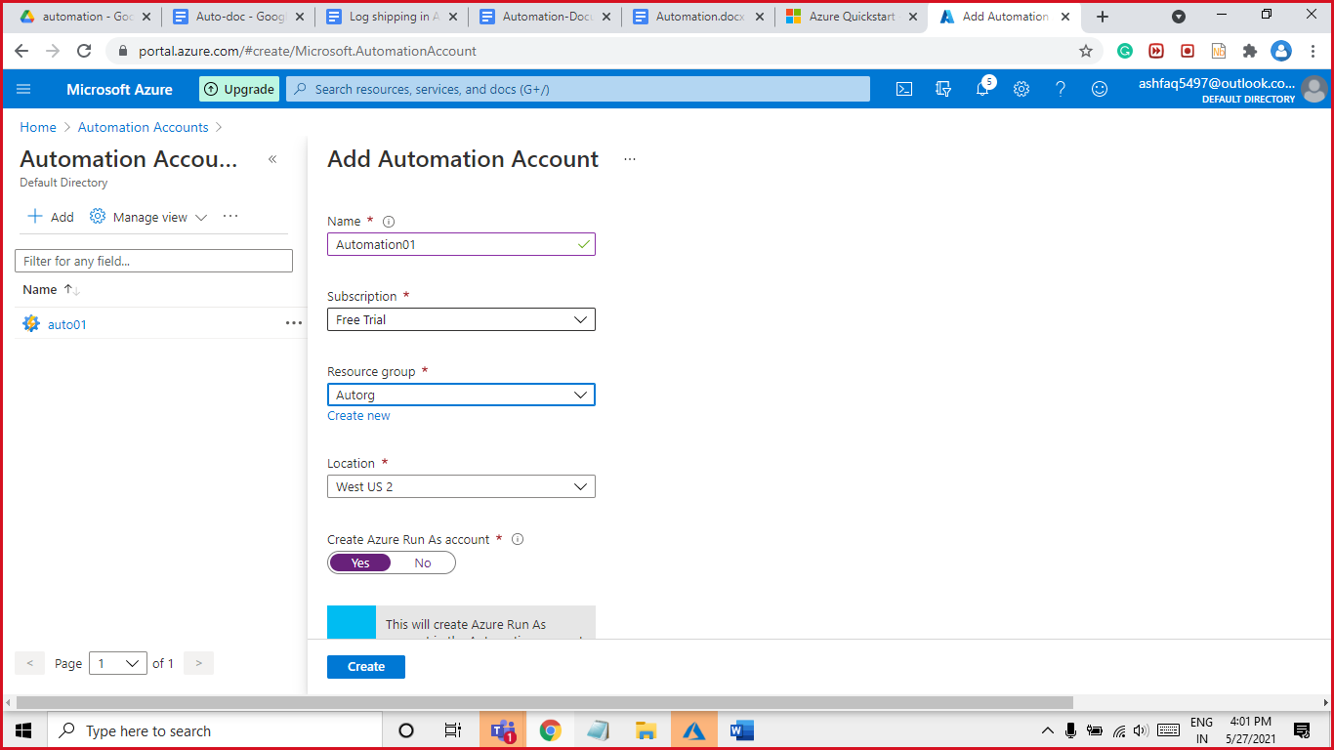

Select **Automation Accounts** and then choose the Automation account you have created.

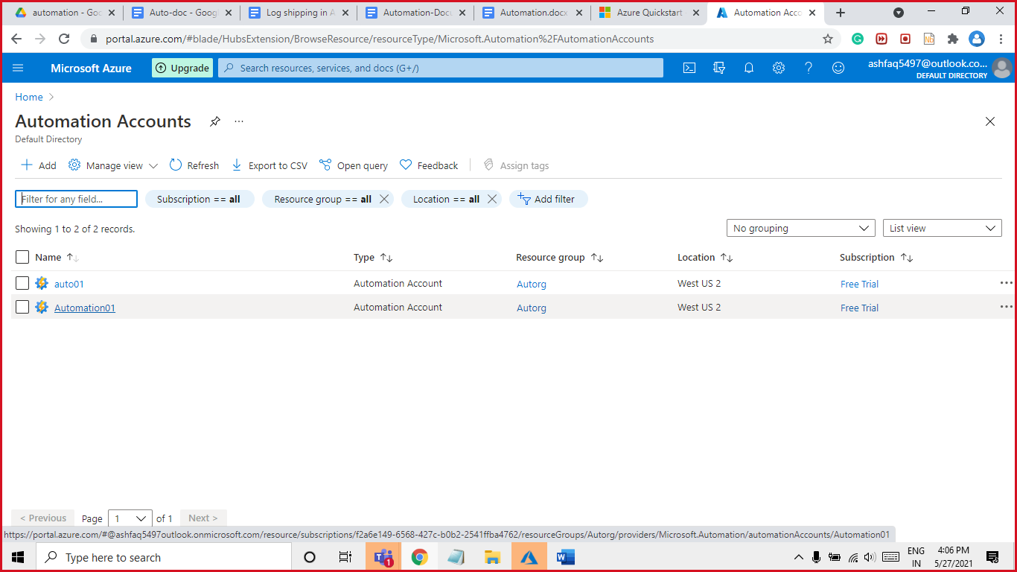

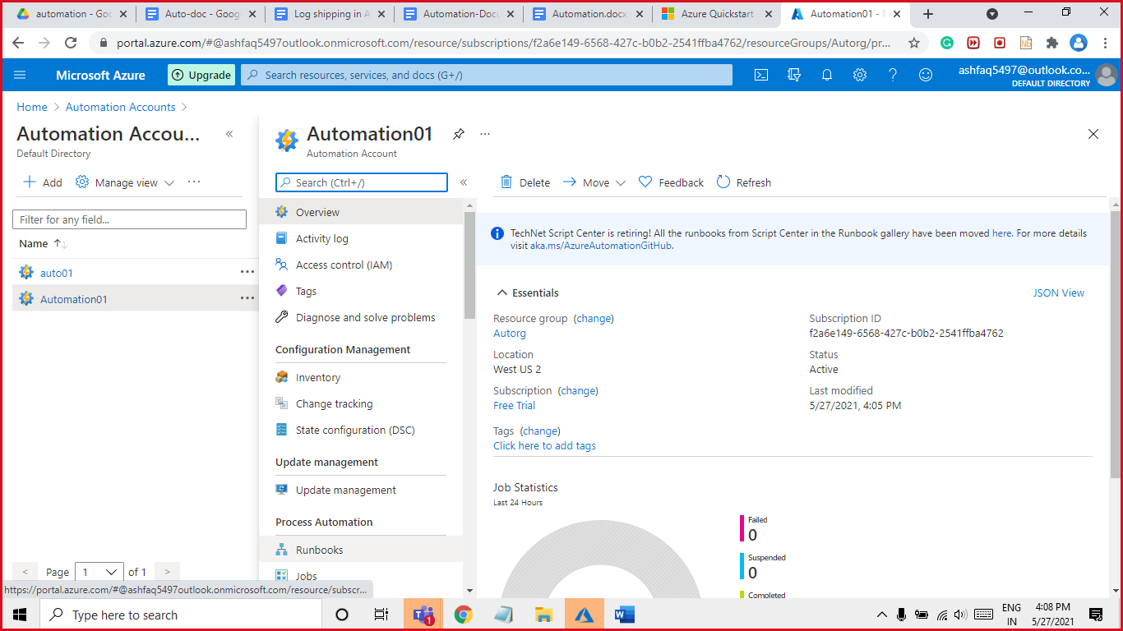

Step3: Create an Azure Automation runbook

# Click **Runbooks** under **Process Automation**. The list of runbooks is displayed. By default, several tutorial runbooks are enabled in the account.

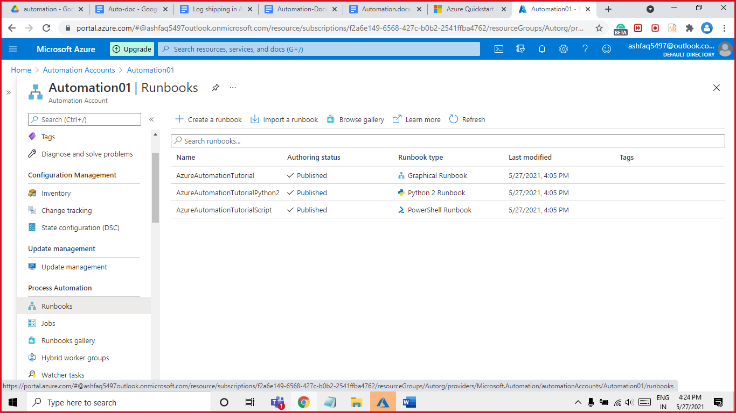

## Create the runbook.

## We Have 3 Options.

## Create a new runbook.

## Write your own custom code

## .

## Import if we have one already.

## Browser gallery and get ready made runbooks.



## Step4: For this demo will get a runbook from Browser gallery.

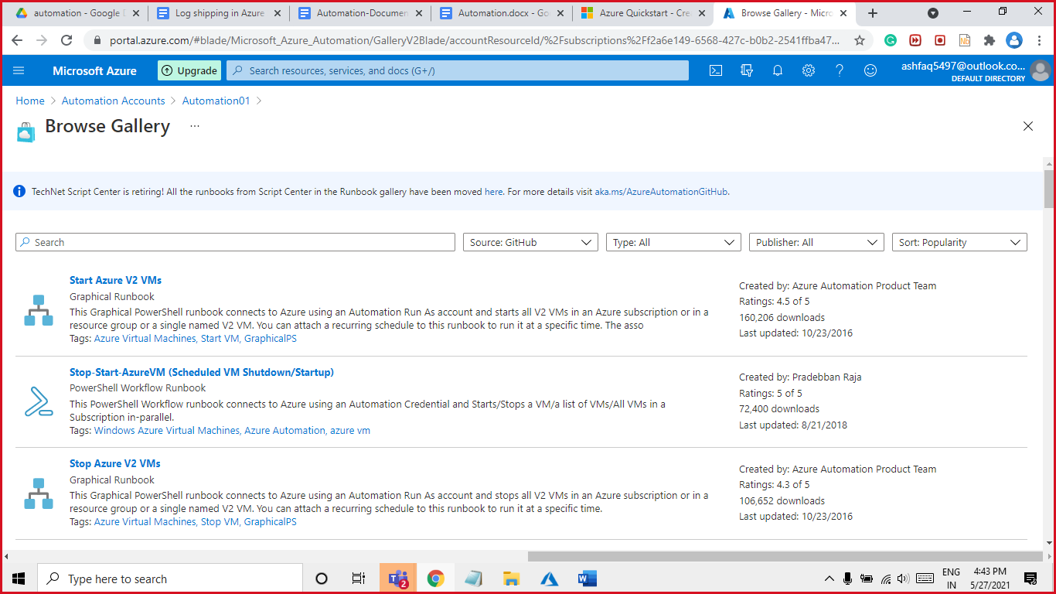

1.In this demo will be test on VM Resource Start & Stop import the Start VM runbook and stop VM runbook

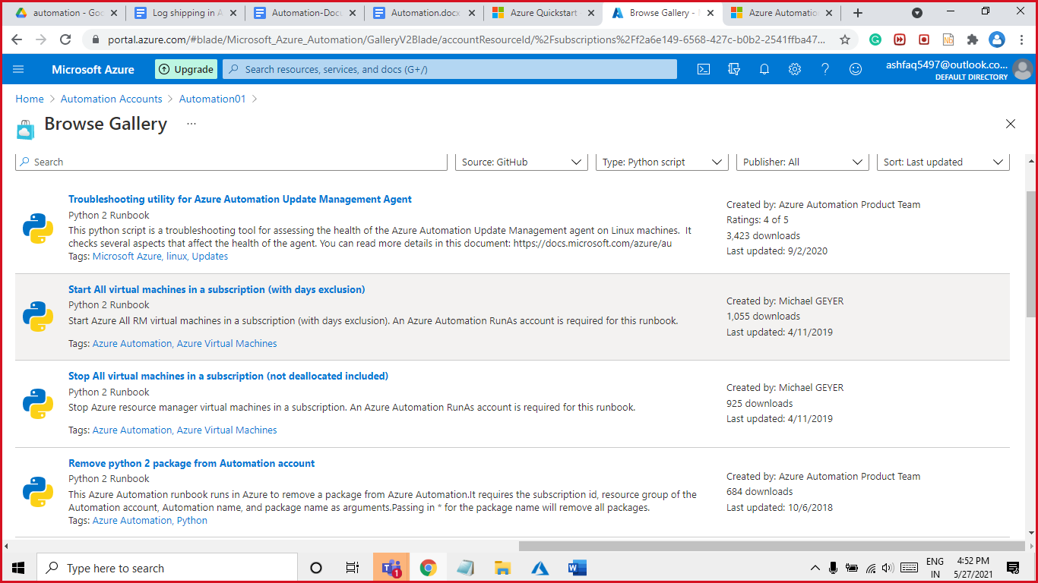

Click on import give a name Start_scrip_1

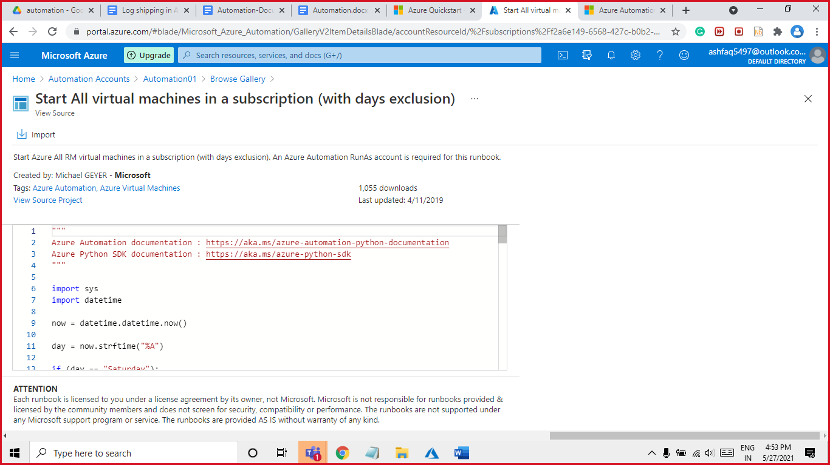

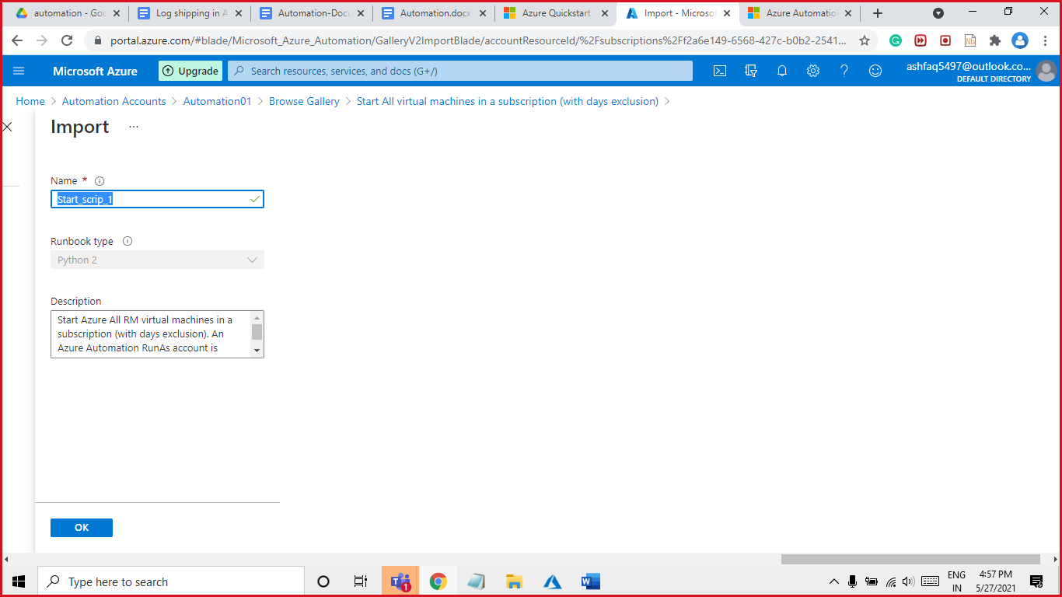

Step5: As we click on ok it will create a runbook Once the runbook is created, you must test the runbook to validate that it works. Open the runbook

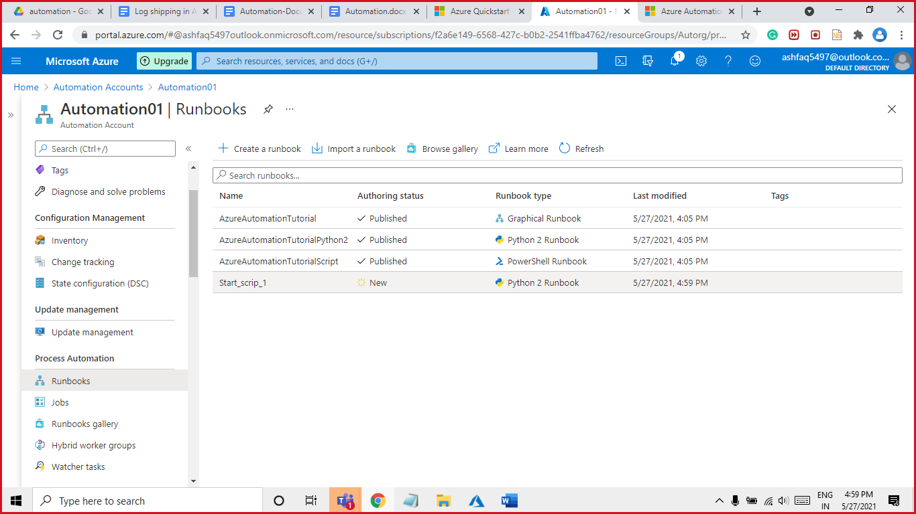

Click on Edit pan in this runbook

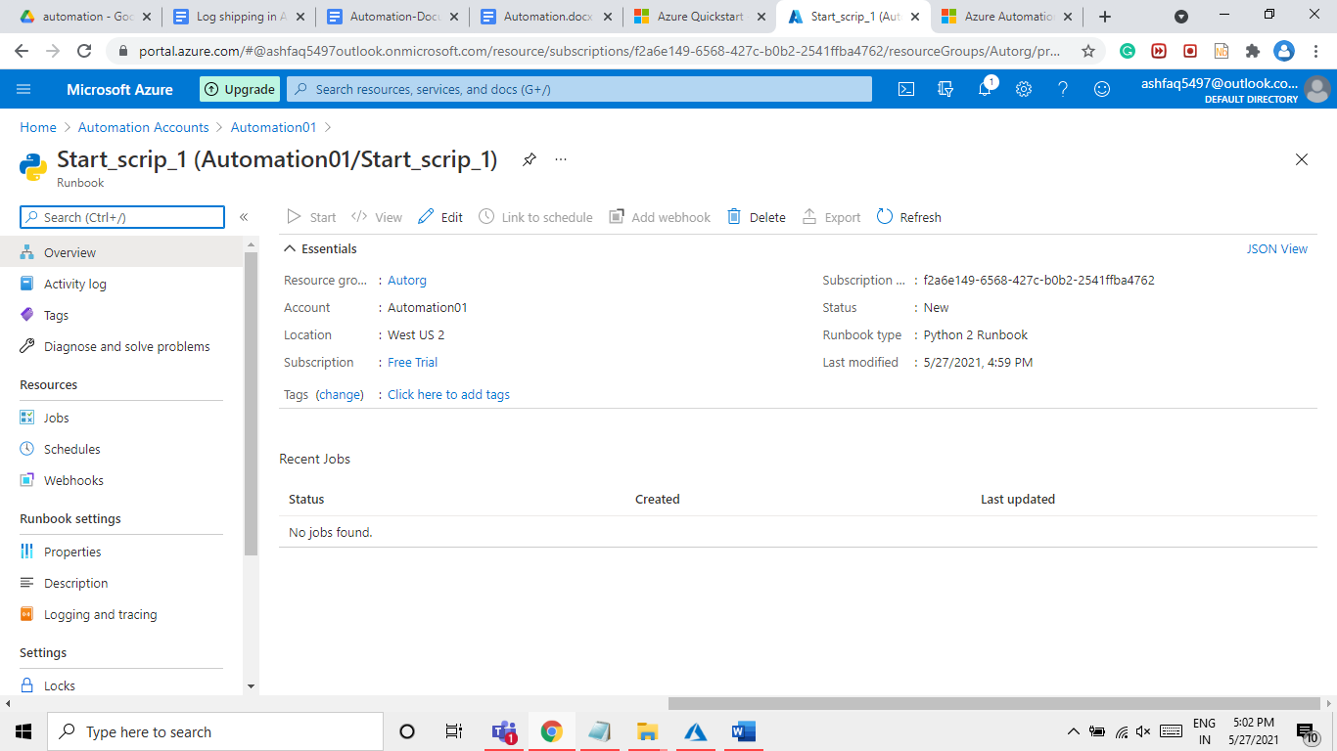

Click **Test pane** to open the Test pane.

. The test job starts and the job status and output display.

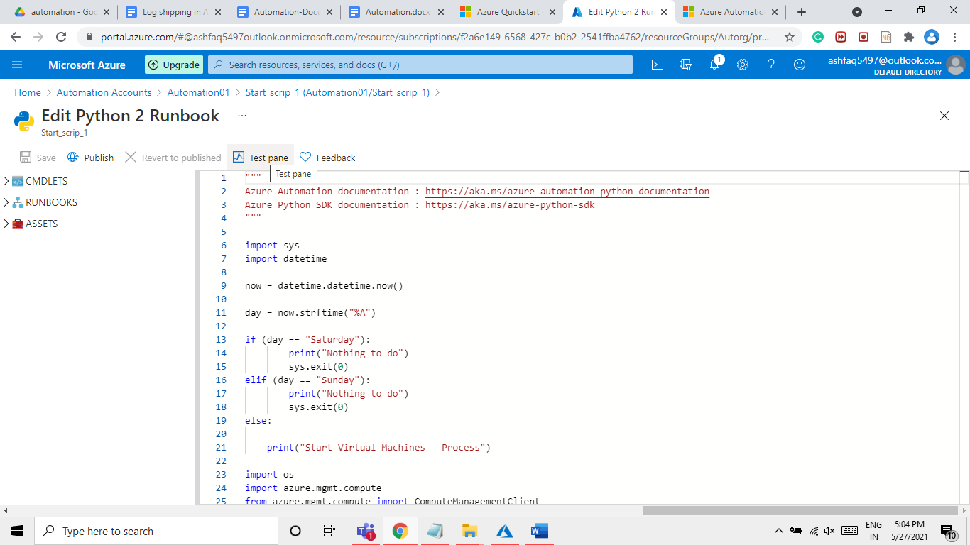

Click on start button.

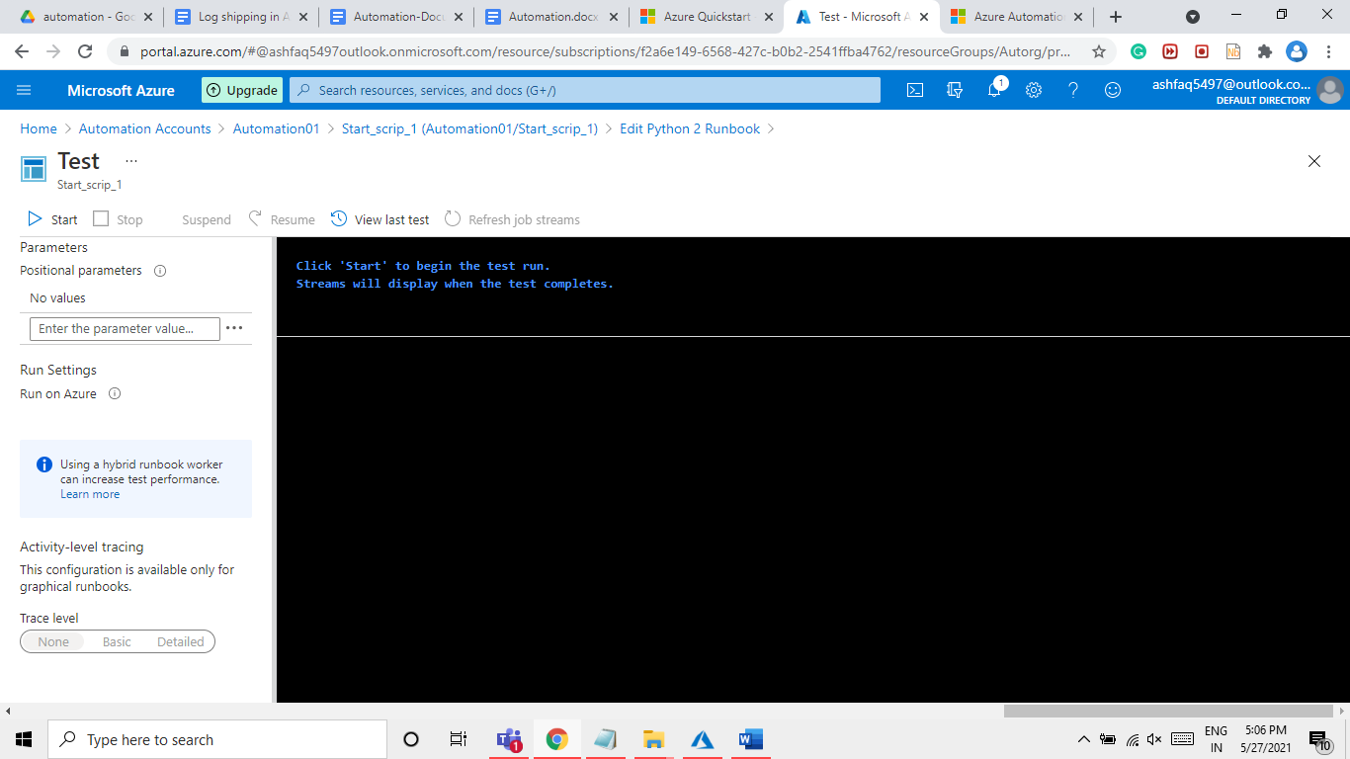

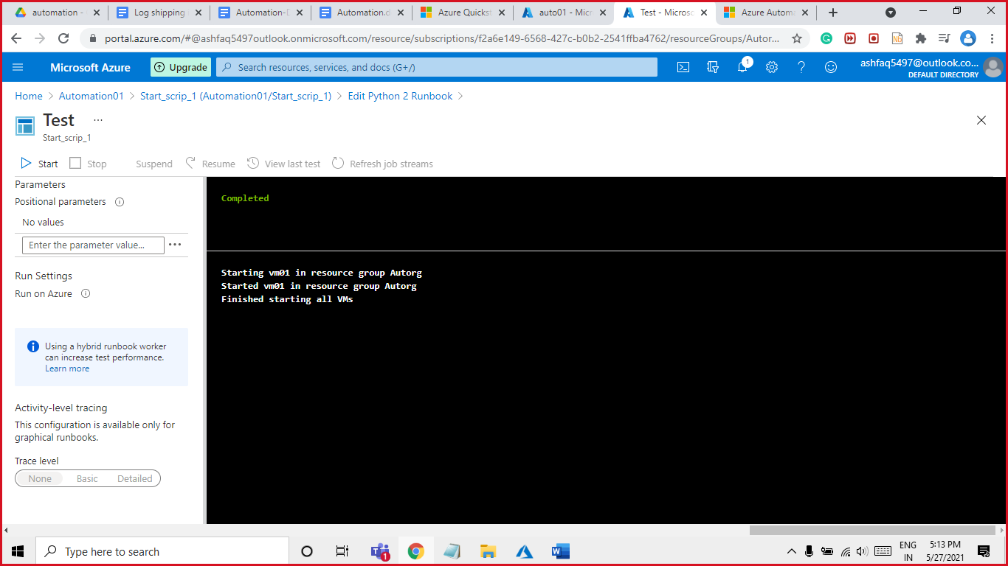

After the test is completed correctly click on publish button

Now we must create four runbooks two runbooks for start and two runbooks for stop.

With this name I have created:

Start_scrip_1, Stop_script_1, Start_scrip_2, Stop_script_2

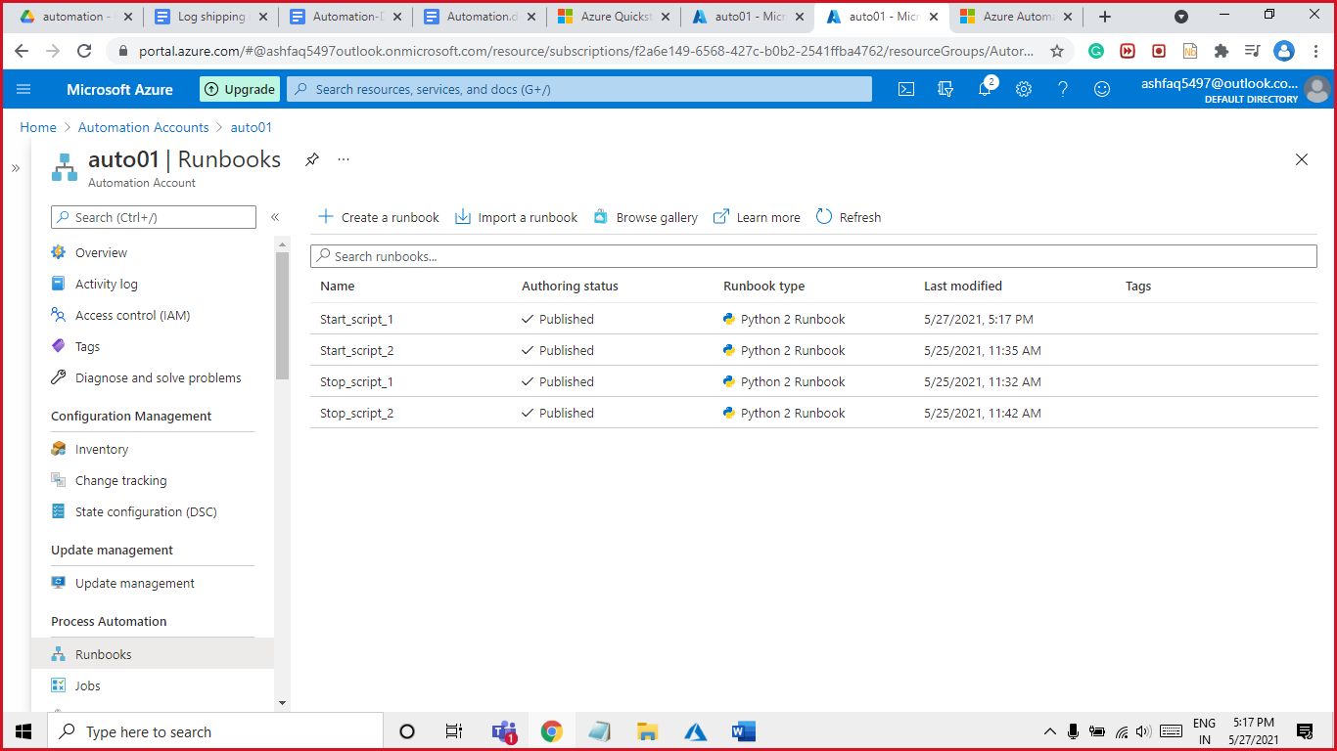

! Test all 4 runbooks before publishing.

Click on publish before scheduling this runbooks

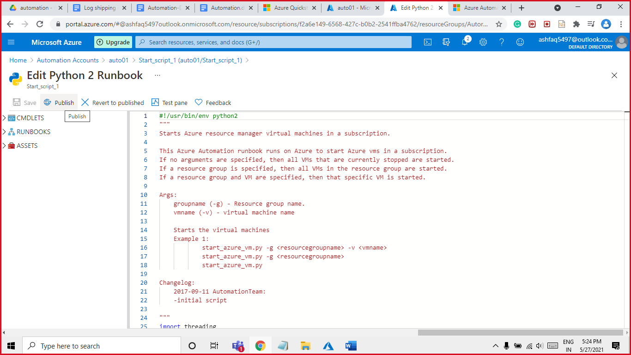

**Schedule Pattern**

Step:6

Start_script_1. Start Time: - 9:00 AM

This script will run at 9:00 Am everyday excluding Sunday & Saturday.

Execution date is from 3 to 28 of every month.

For scheduling a runbook open runbook click on **link to schedule**

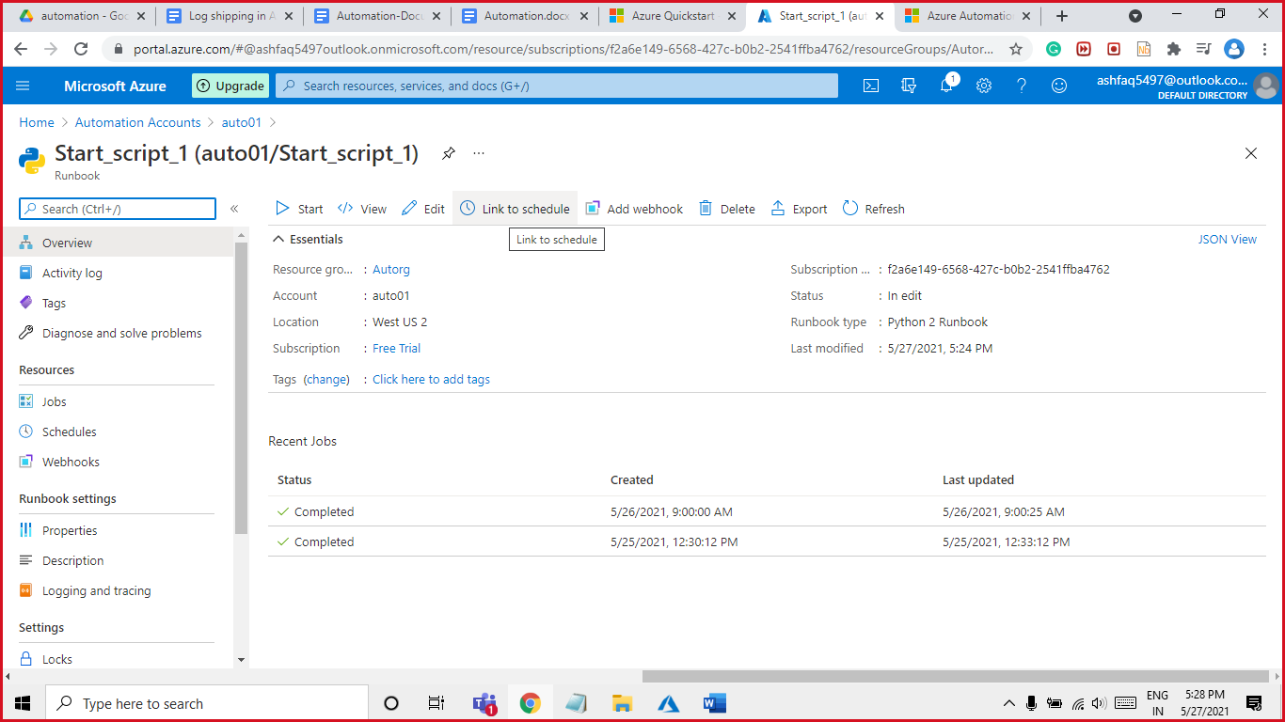

Click on Link a schedule to your runbook

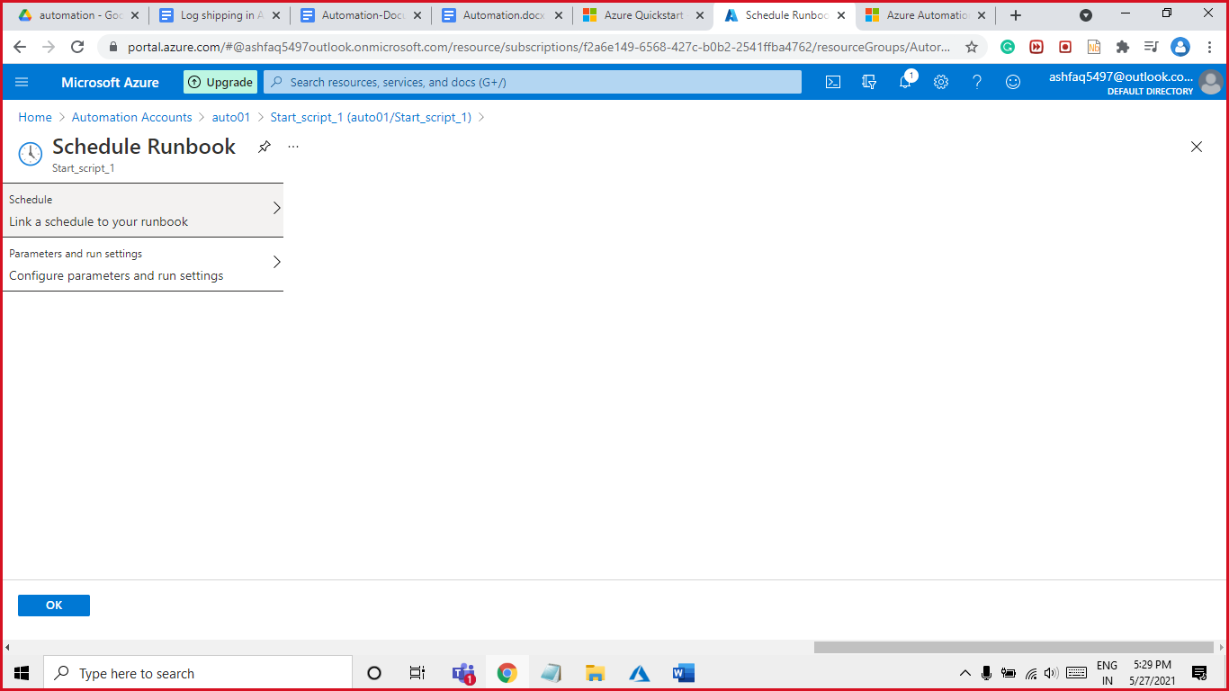

+Add a Schedule

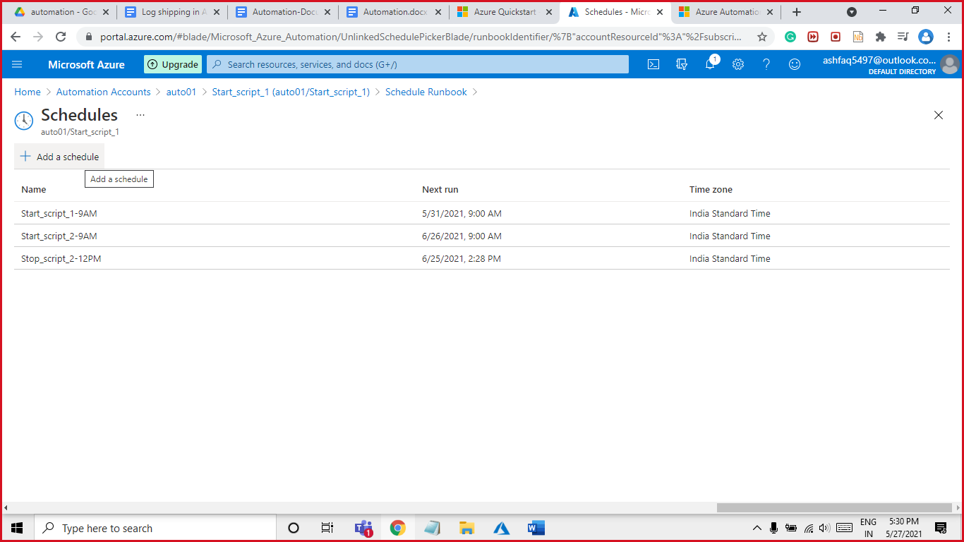

Name: start_scrip_1 Start time will be 9 Am and select Recurring 1 week

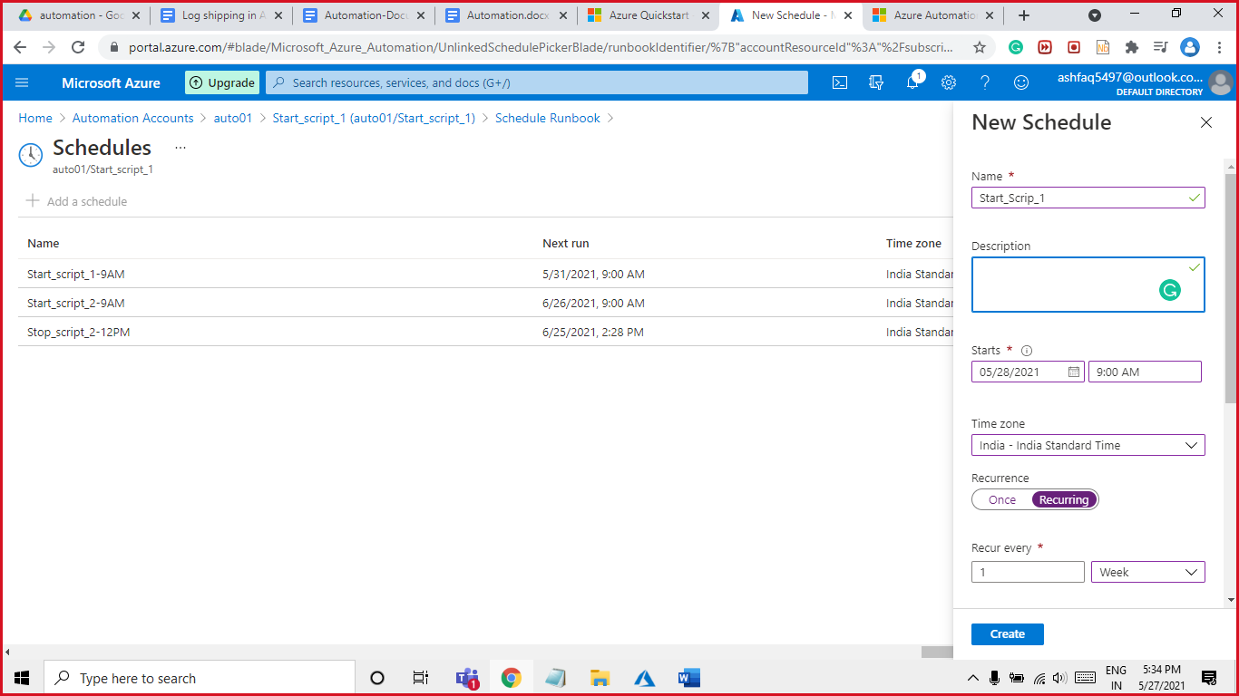

Select weekdays from Monday to Friday and click on create button

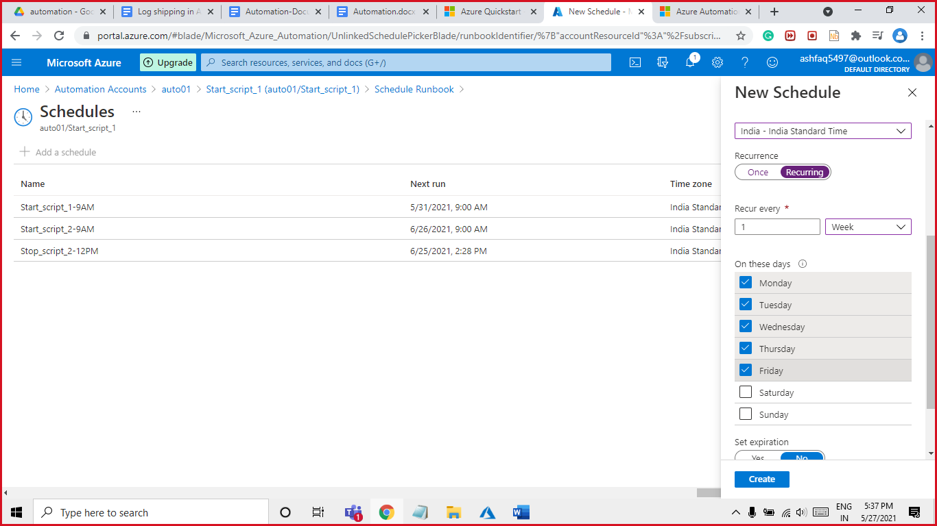

You can see the above schedule from Resources select Schedules.

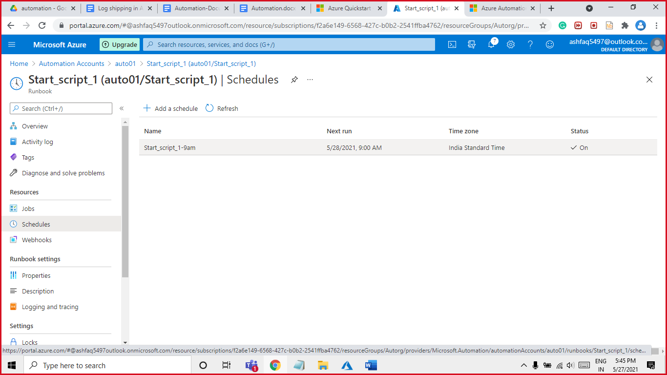

Now that we have created Schedule for start_scrip1 will be creating scheduler for rest 3 more script runbook. Scheduler Recurring will be different for each script

Step7:

Stop_script_1. Stop Time: - 6:00 PM

This script will run at 6:00 Pm everyday excluding Sunday & Saturday.

Execution date is from 3,4, 5…………………28 of every month.

Will Schedule Stop_script_1

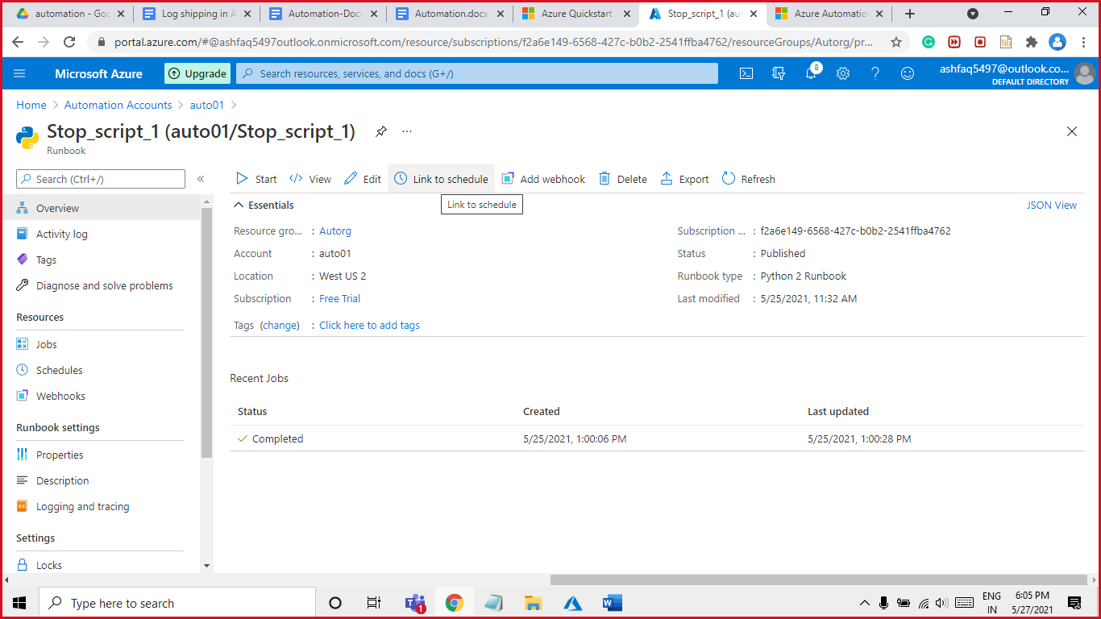

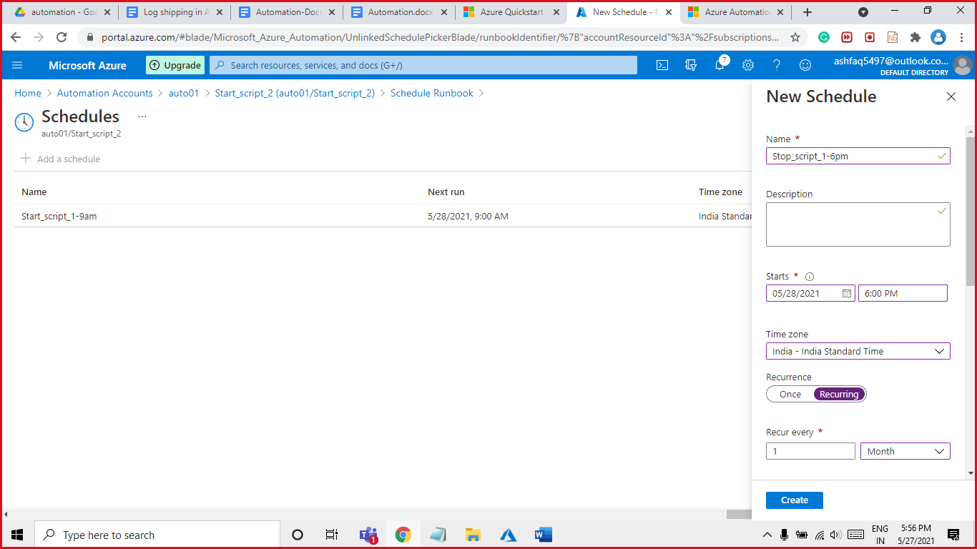

Select Recurring as months and select the days 3 to 28 same as given in picture and create.

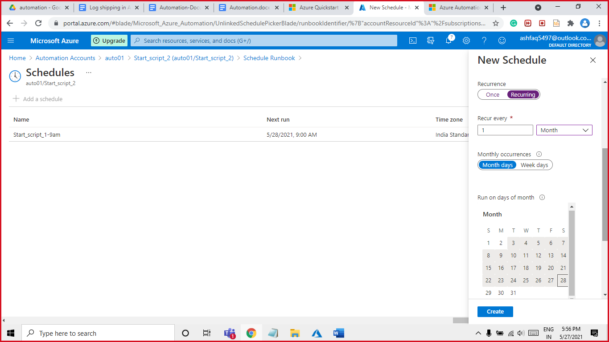

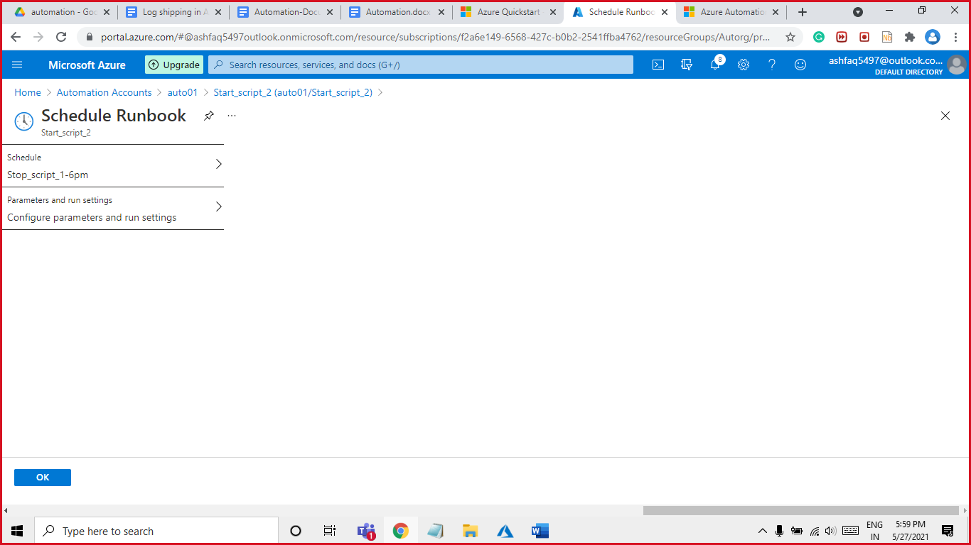

All the Scheduled you can see in the automation account Shared Resources **->** Scheduled.

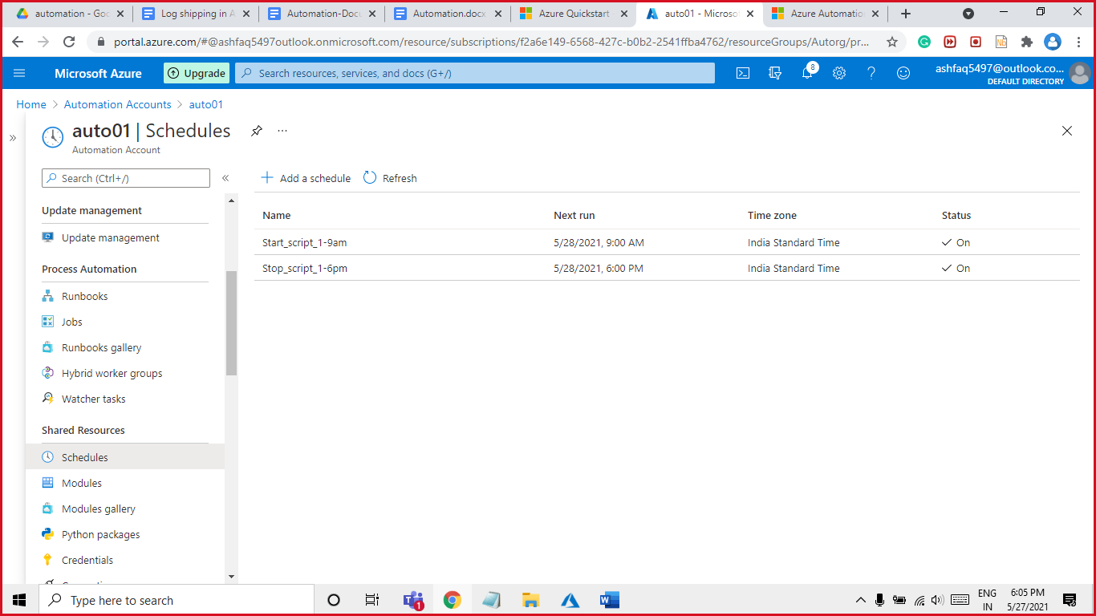

Step8:

Start_script_2. Start Time: - 9:00 AM

This script will run at 9:00 Am on these days (29,30,31,1,2) every month.

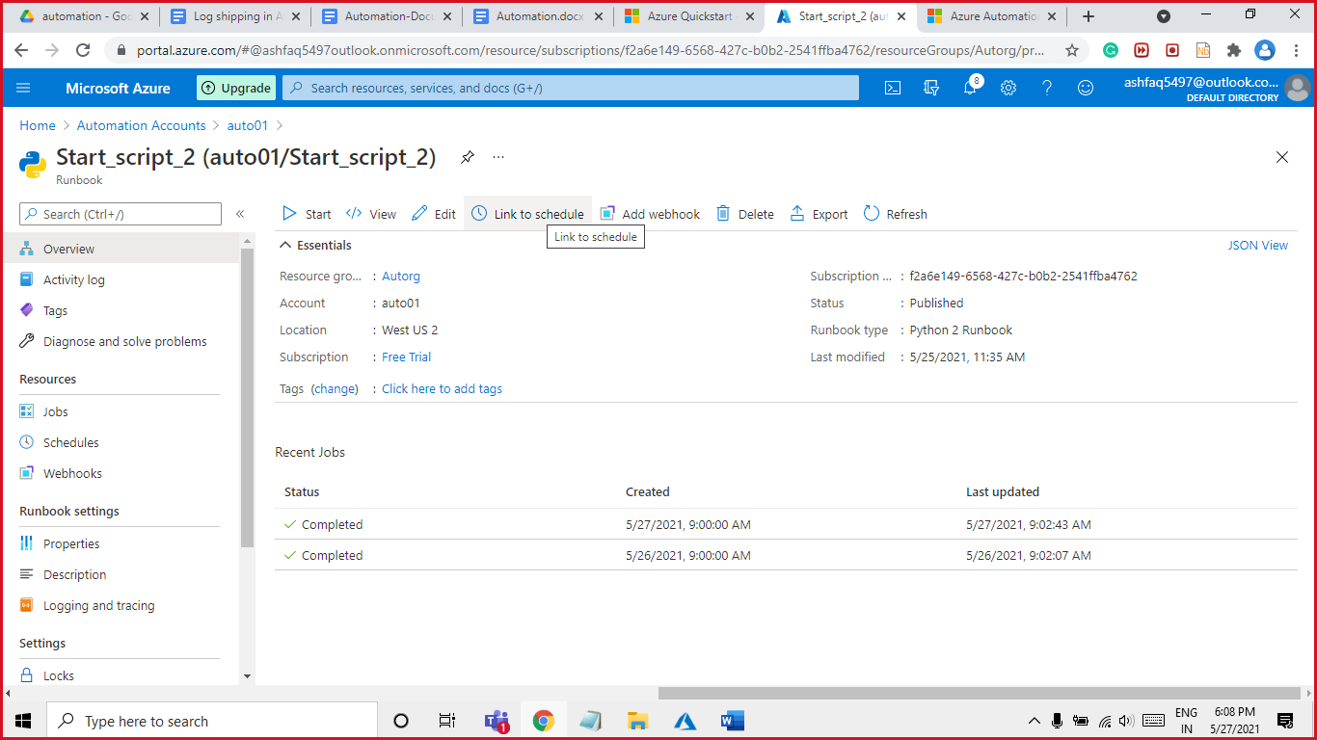

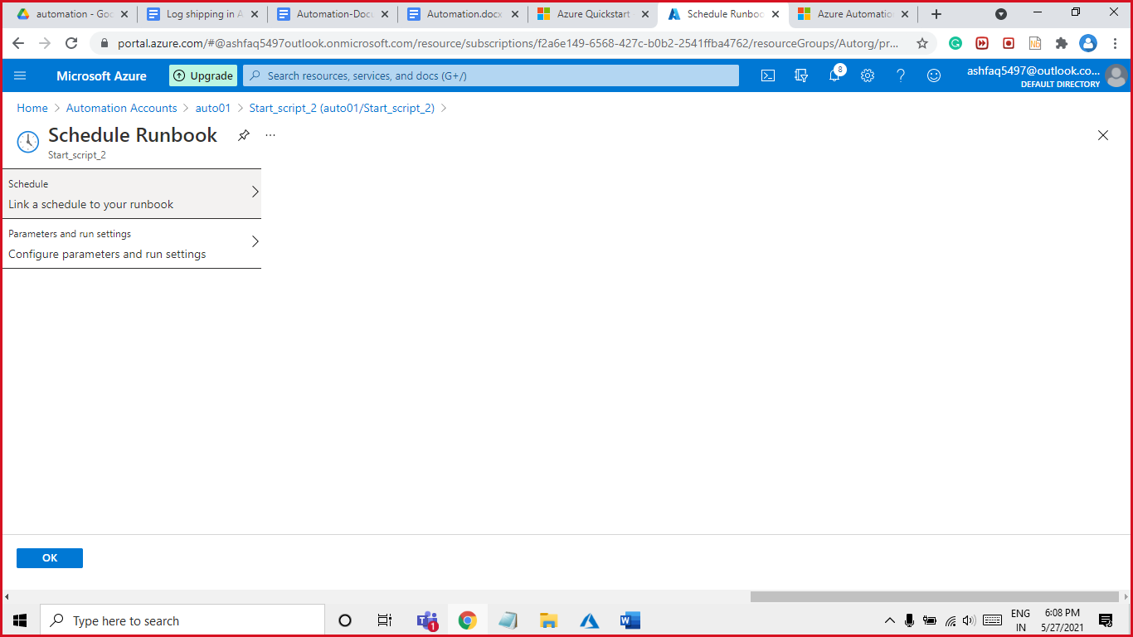

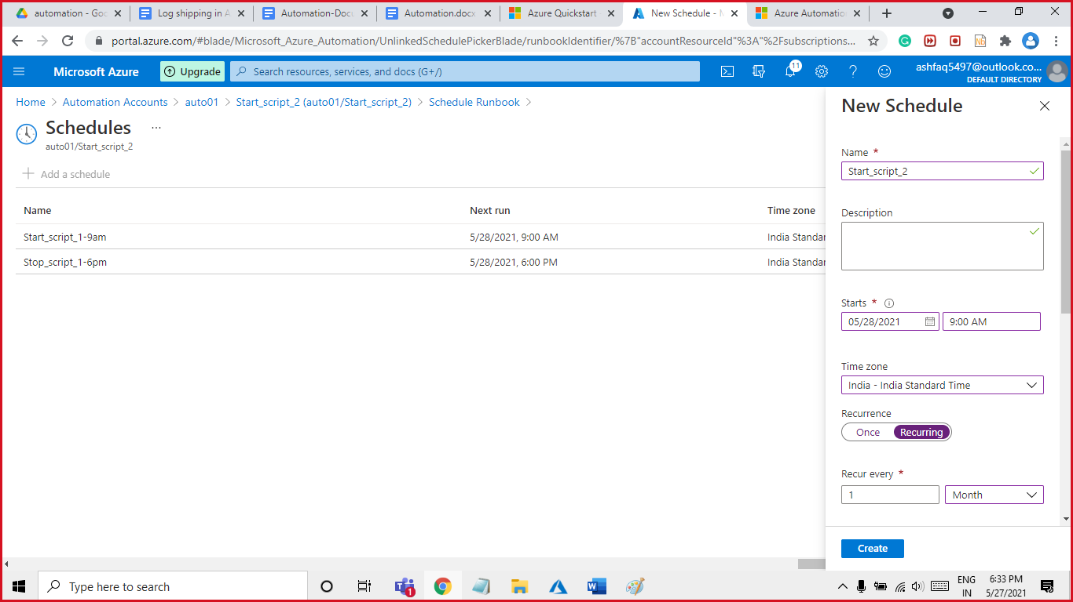

Select Recurring as months and select the days (29,30,31,1,2) same as given in picture and create.

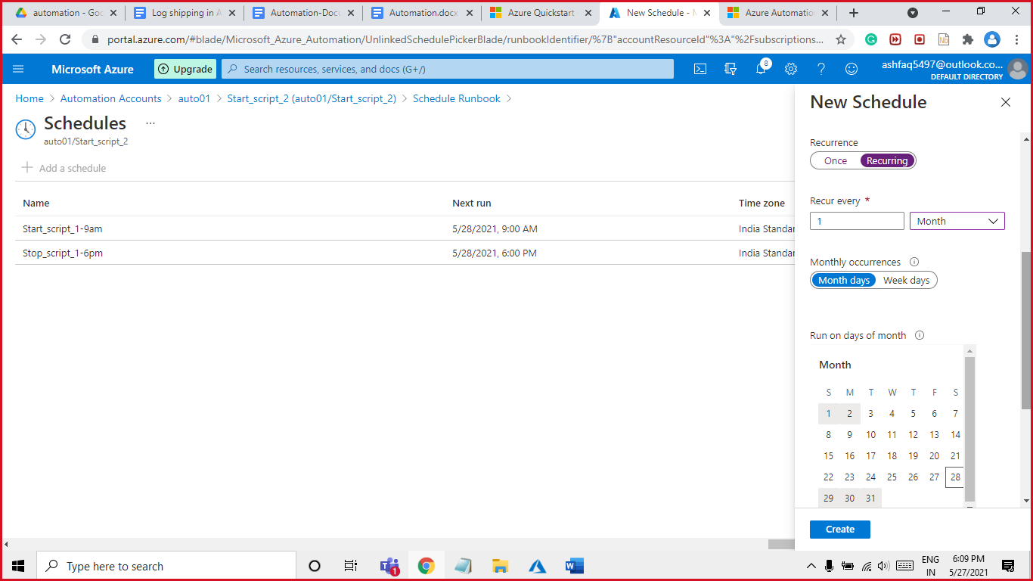

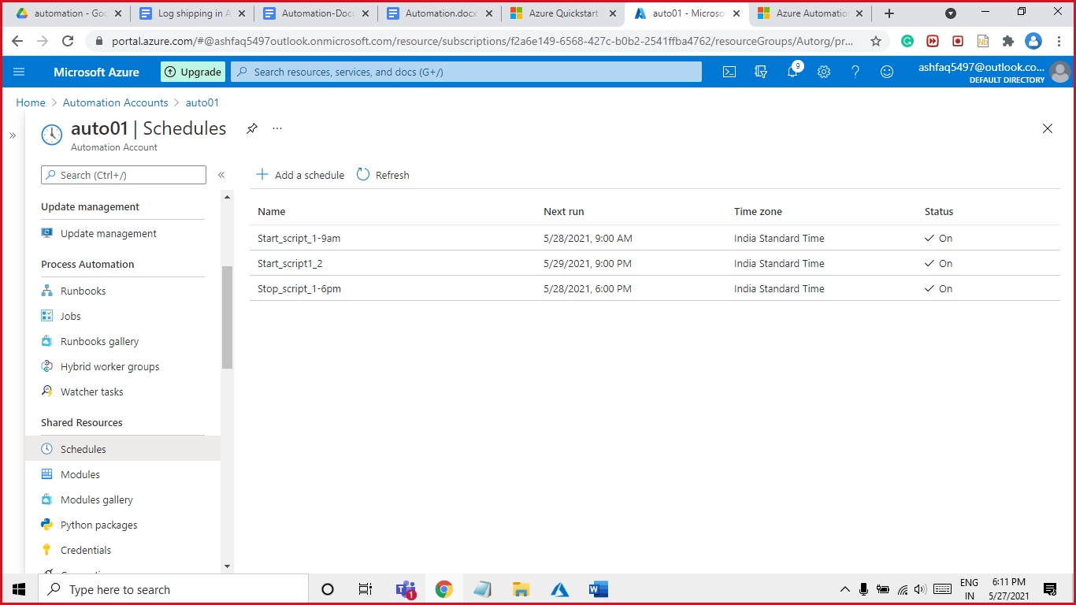

Step9:

Stop_script_2. Stop Time: - 12:00 AM

This script will run at 12:00 Am on these days (29,30,31,1,2) every month.

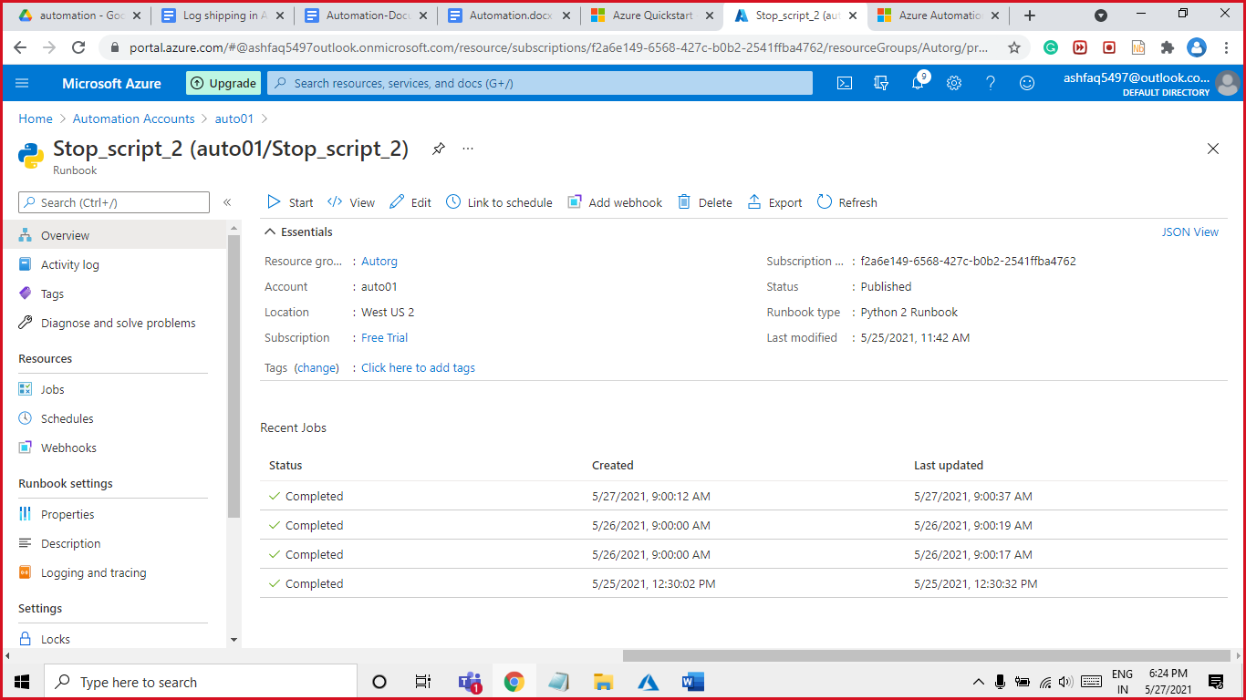

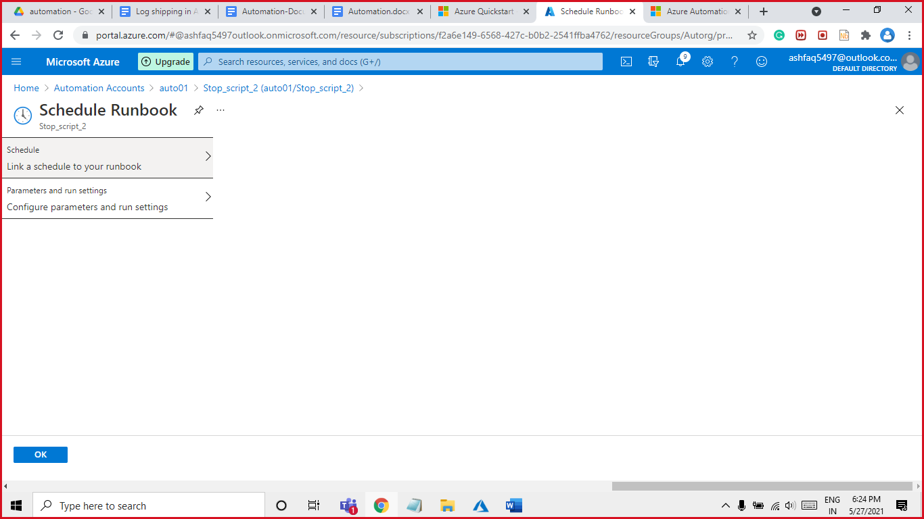

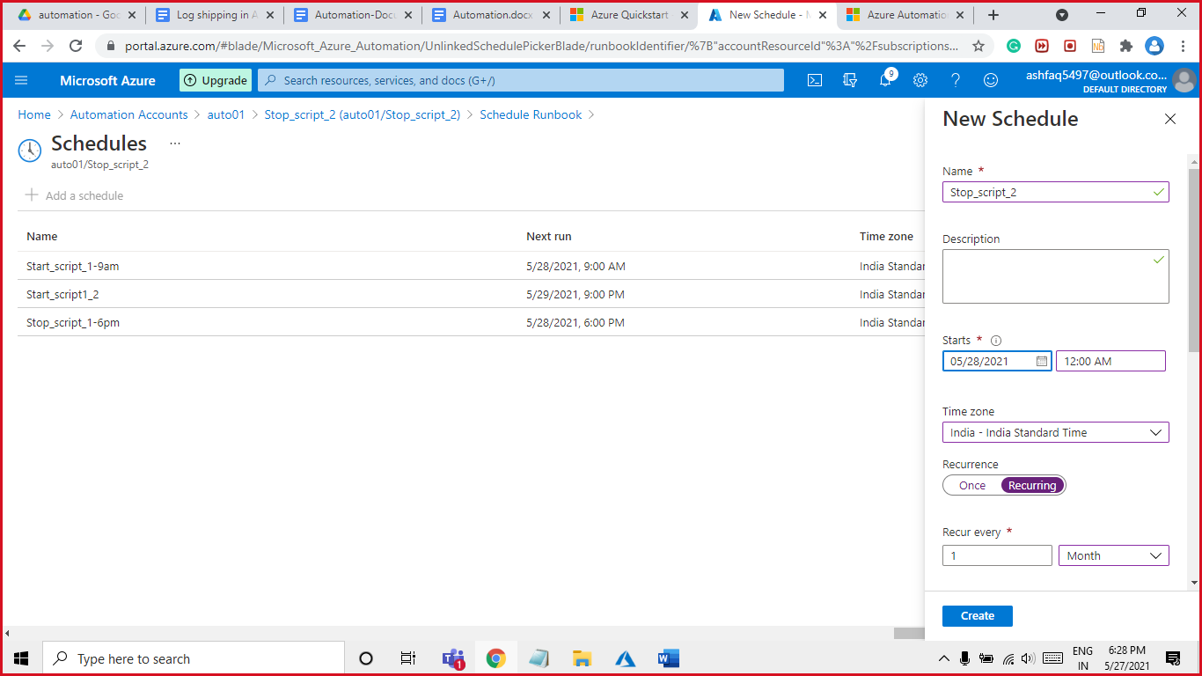

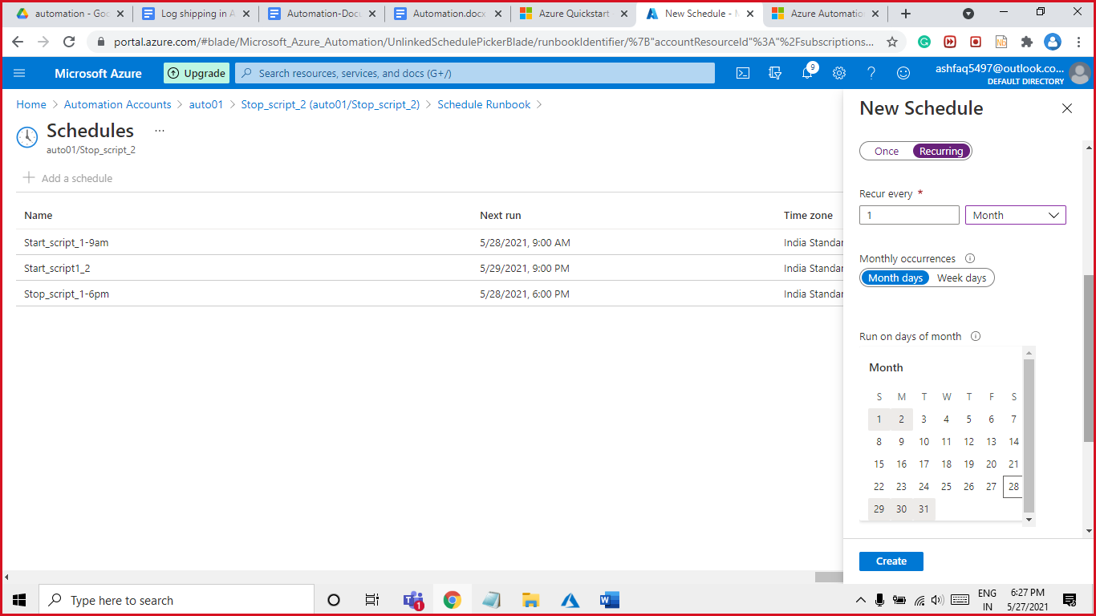

All four Runbook are now scheduled you can seen from automation account left panel go to Shared Resources > scheduler

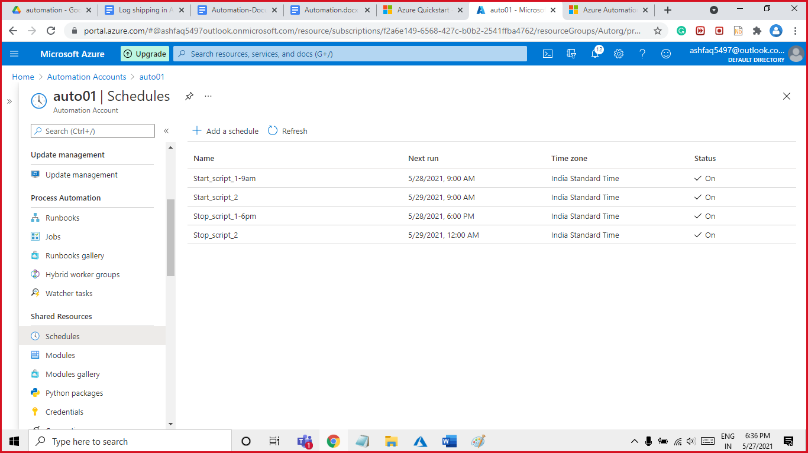

Testing

1. We have run the **two-start** script simultaneously, first will run on the basic of weekdays while second will run based on month’s date, hence there is no chance of clash or failure of script. As shown on below image: -

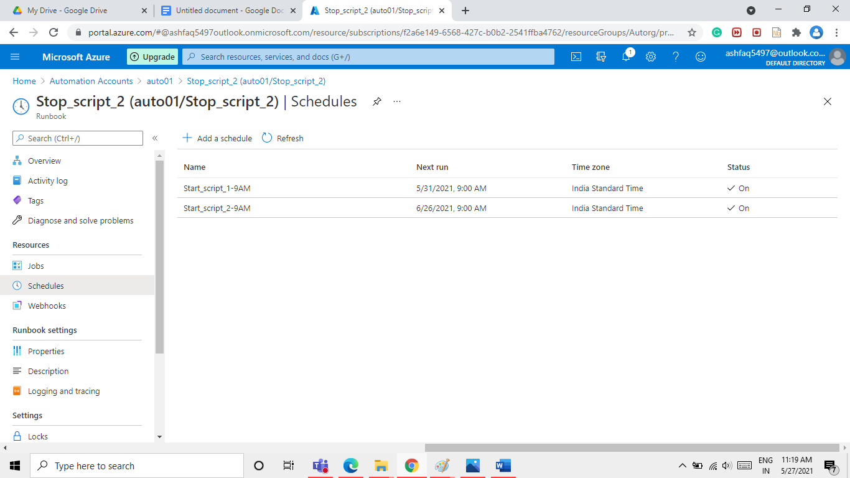

Below image shows the testing result of all the event based on hour as well as based on days.

