Azure Data Factory Copy files of last 7 days

**Statement:** Copy files from a one container to another container based on X days [ex: copy last 7 days data] using ADF pipeline.

**Pre-requisites**

* **Need to have an azure subscription.**
* **Need a storage account create 2** containers with name.

container1 name = ‘input’ adds some files

container2 name = ’output’

* **Create a ADF Resource using azure portal.**

**Following are the Steps.**

Step 1 Open Data factory Select Author & Monitor from Overview! Click on Author & Monitor .

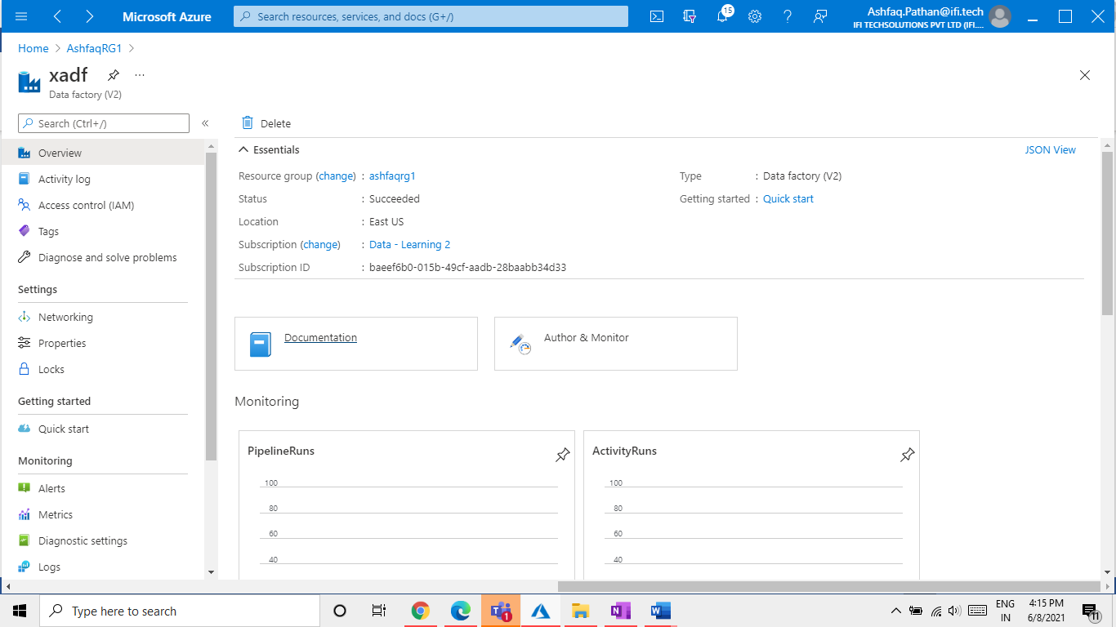

Step 2: Click on Author (Pencil icon).

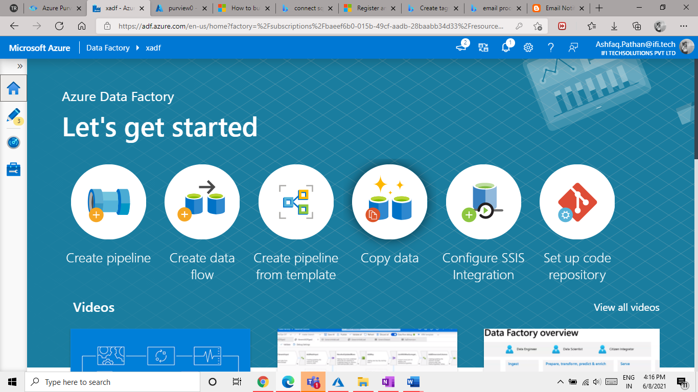

Step 3: Go to Factory Resources > Pipeline > Click on 3 dot .

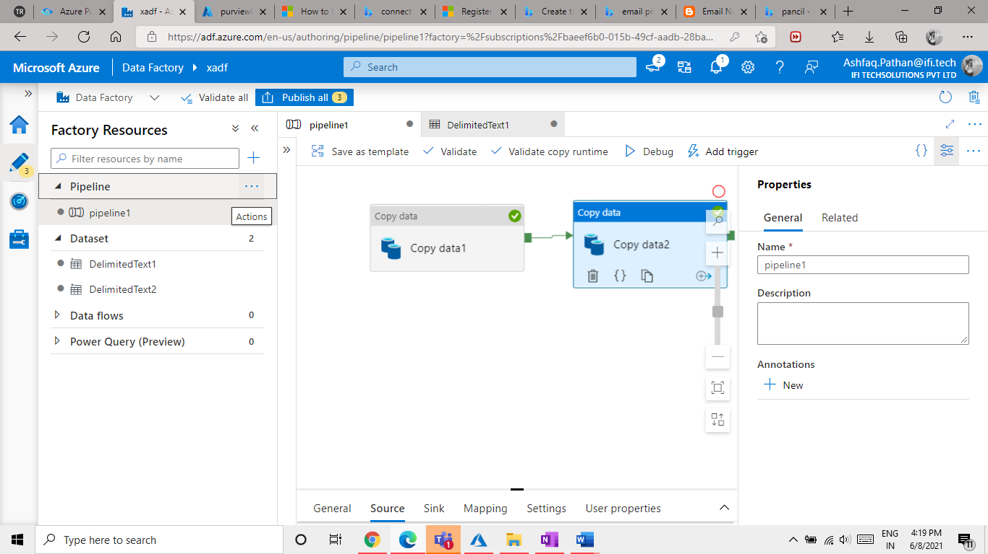

3.1 Create a new pipelin.

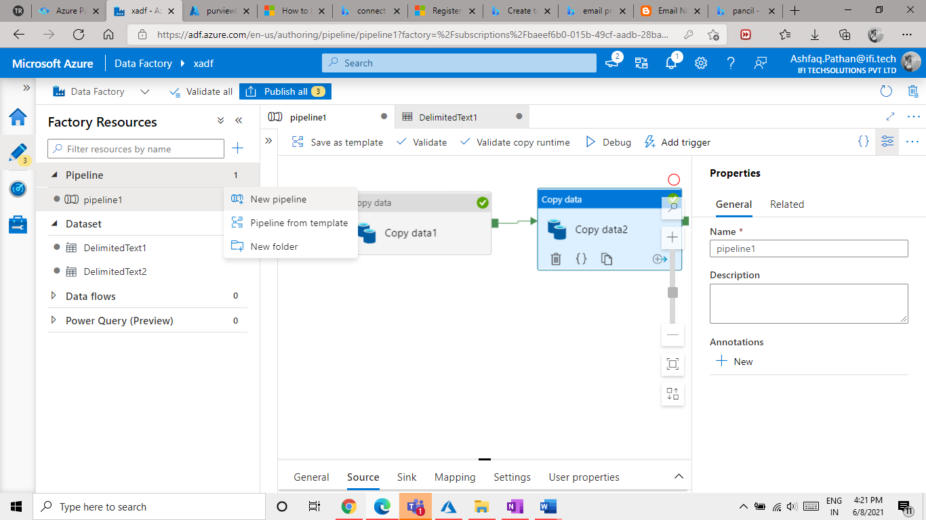

Step 4: Pipeline go to Activities > move & transform > drag and drop copy Activity.

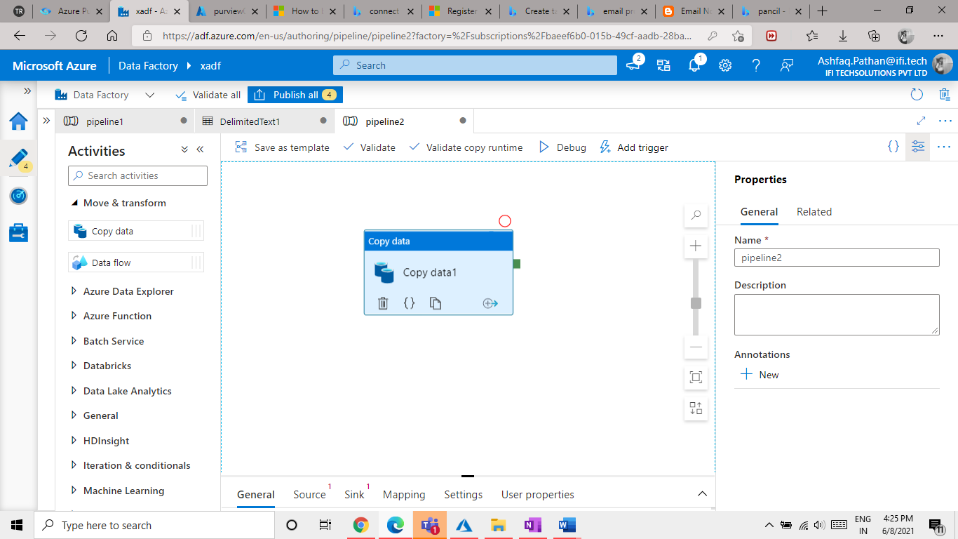

Step 5: Click on **Source** in that add new source data click on **New** option.

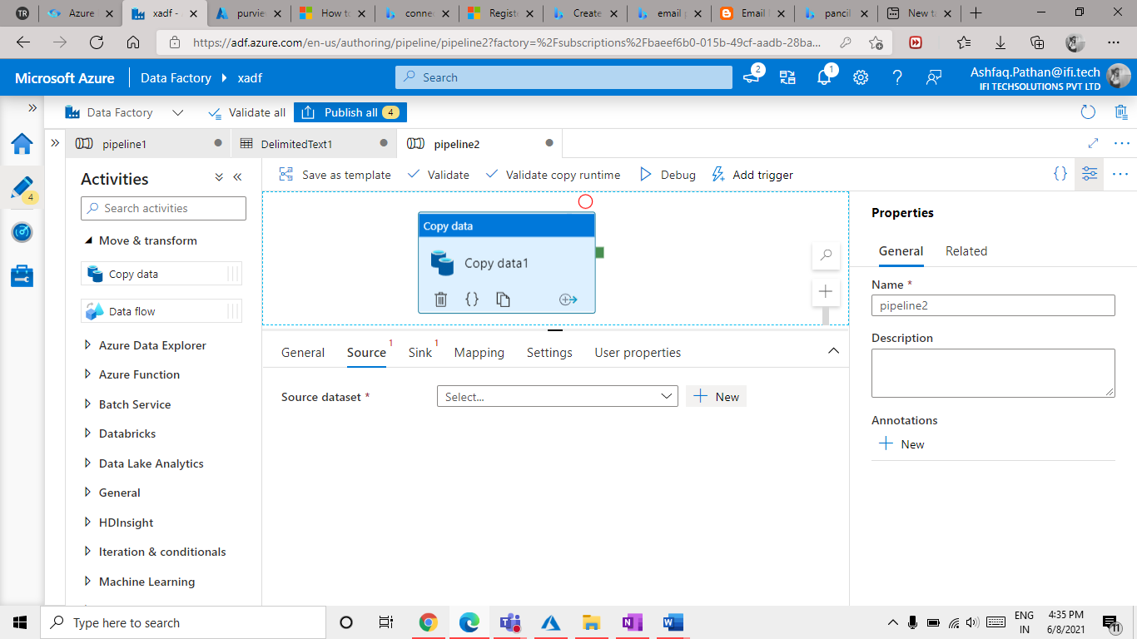

Step 6: Select Azure Blob Storage.

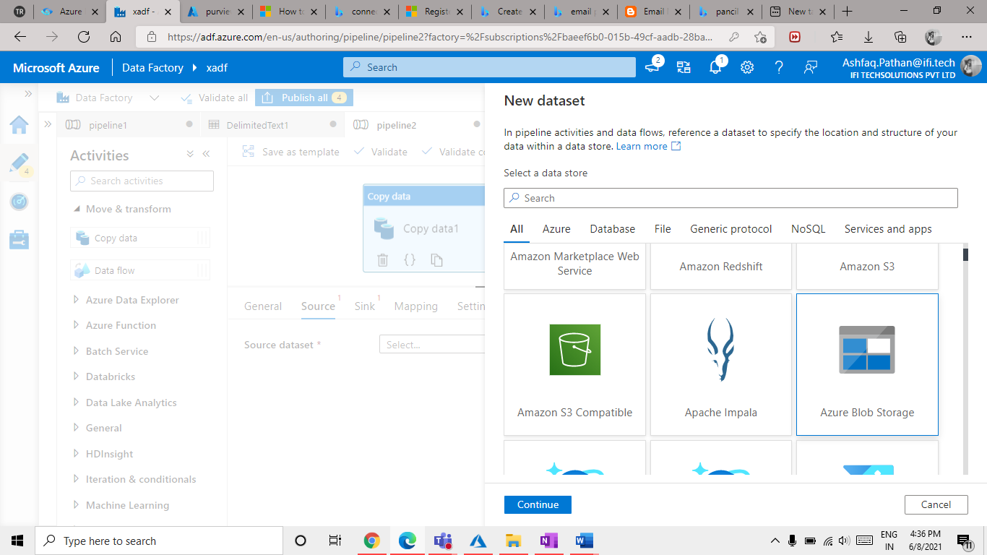

Step 7: Select **DelimitedText.**

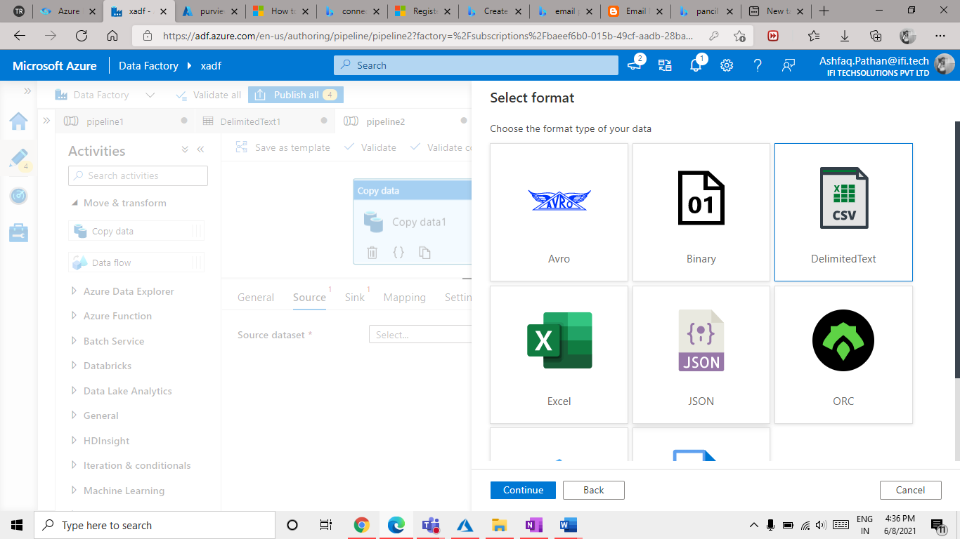

Step 8: Add a **linked service** add a new service.

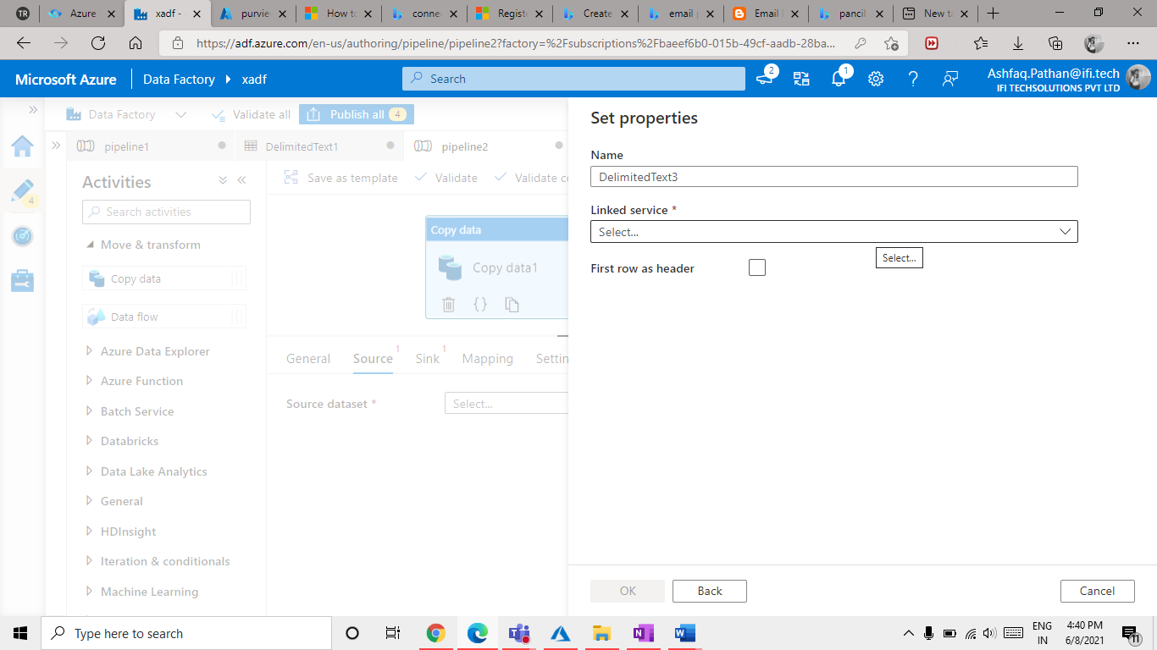

8.1 Click on **NEW.**

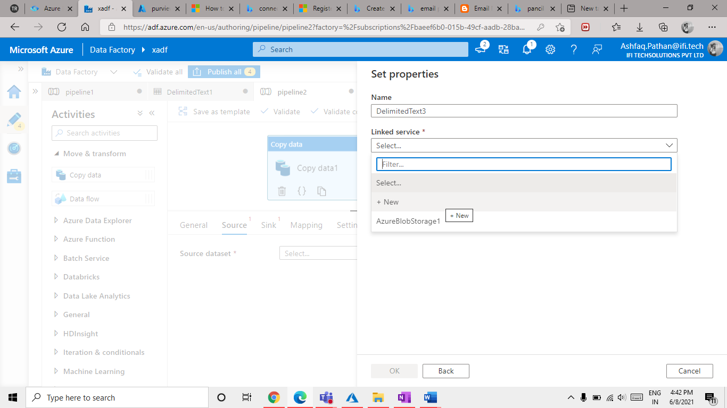

Step 9: In this step only, add.

* + Azure subscription = add your azure subscription in which you have your storage account
  + Storage account name = Storage account we have created using azure portal in a resource group
  + Click on Create Button at bottom of screen.

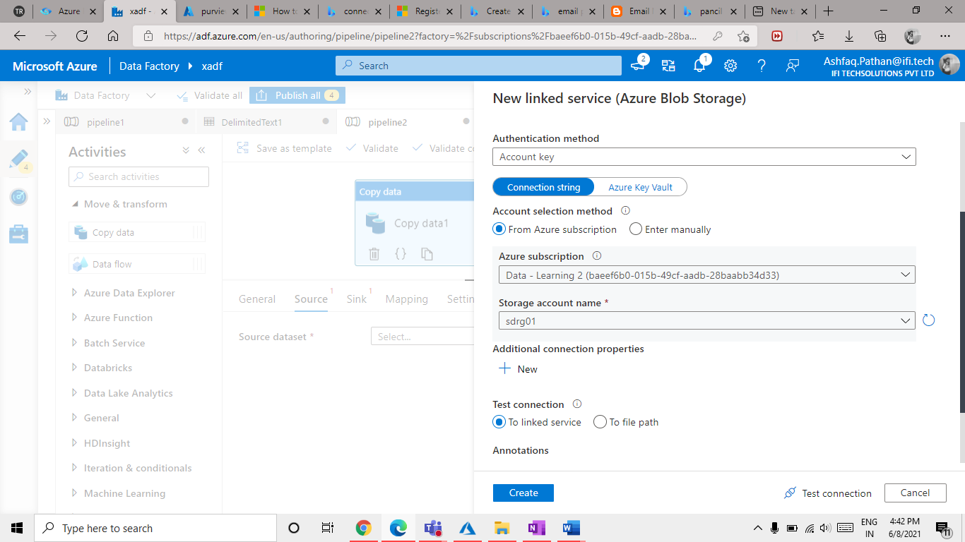

Step 10: Select Container.

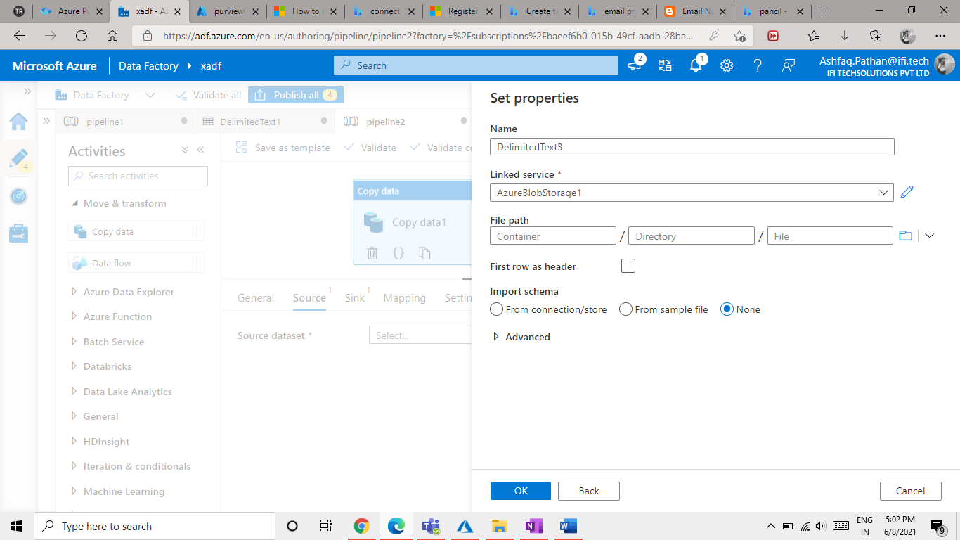

Step 11: Now Configure Source of Copy activity

Select Wildcard path from file path type add extension (* ) This will take all the files in the selected Container.

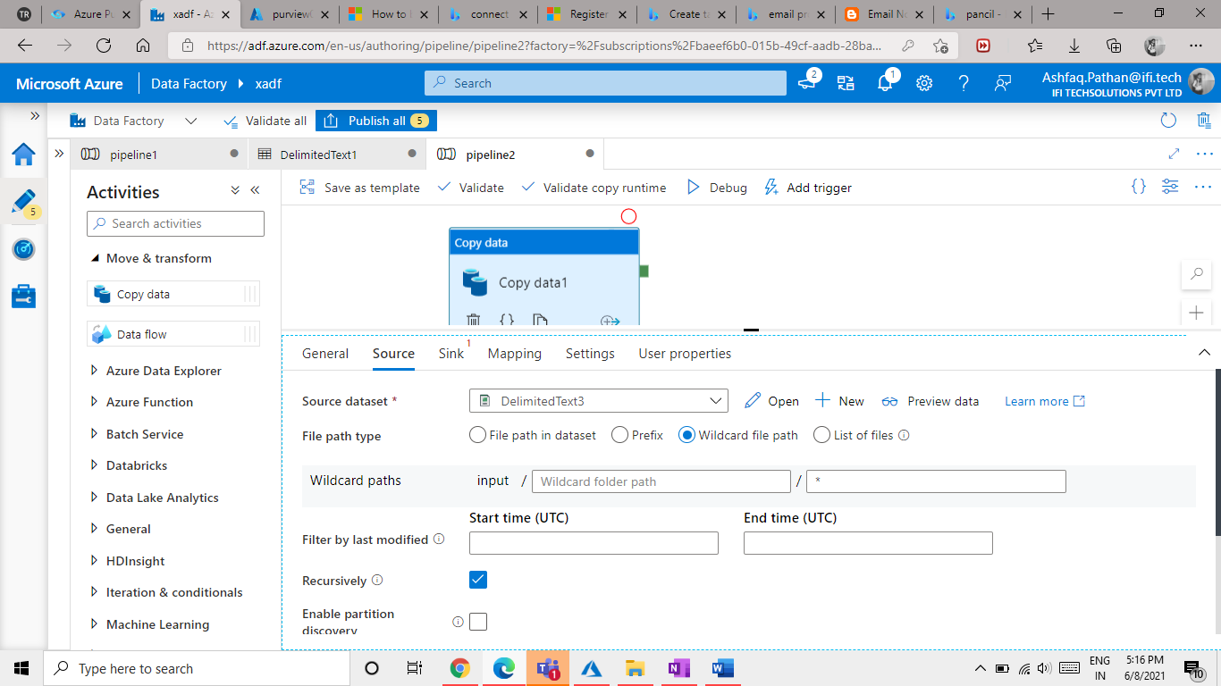

11.1 Now Configure Filter by last modified. Click on Add dynamic content [Alt+Shift+D].

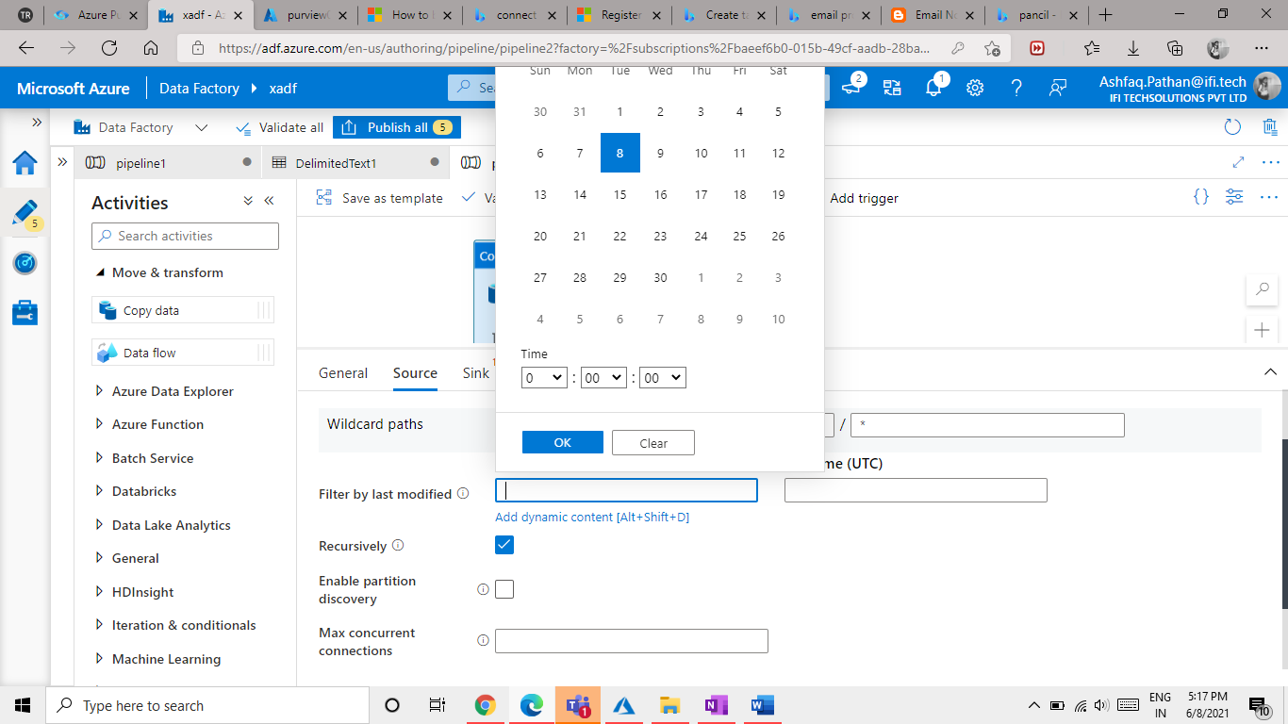

11.2 Add this syntax to the Content. @adddays(utcnow (),-7) Click Finish.

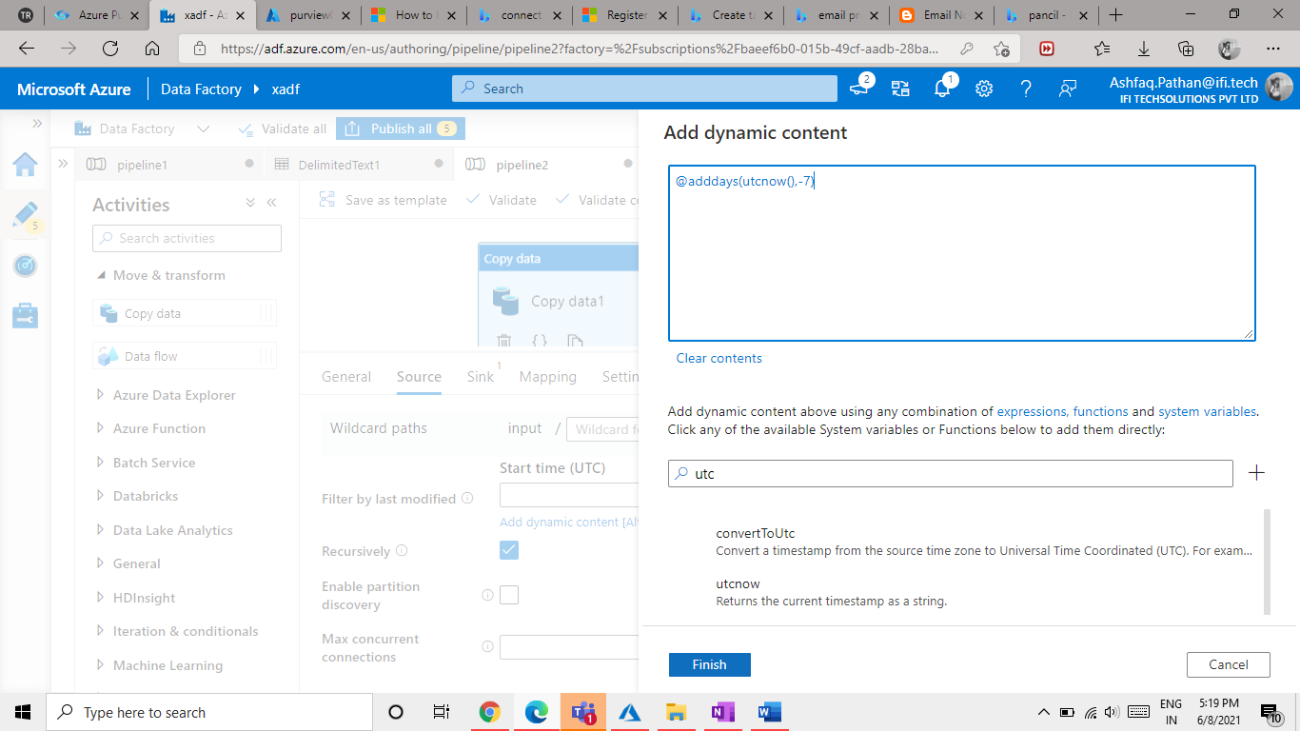

11.3 For the End Time add @utcnow().

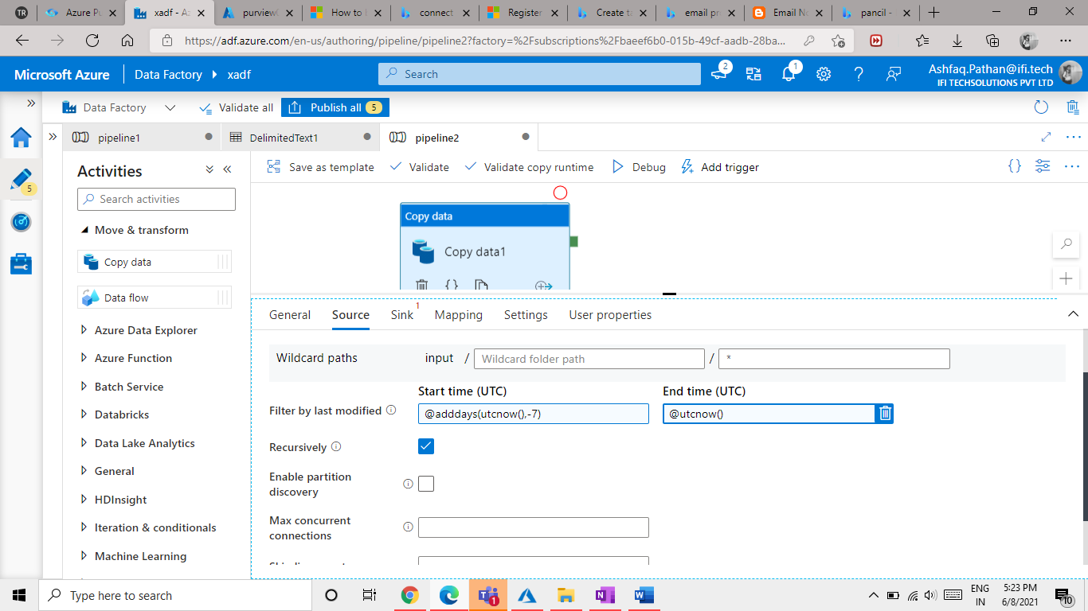

Step 12: Configure the Sink for copy activity.

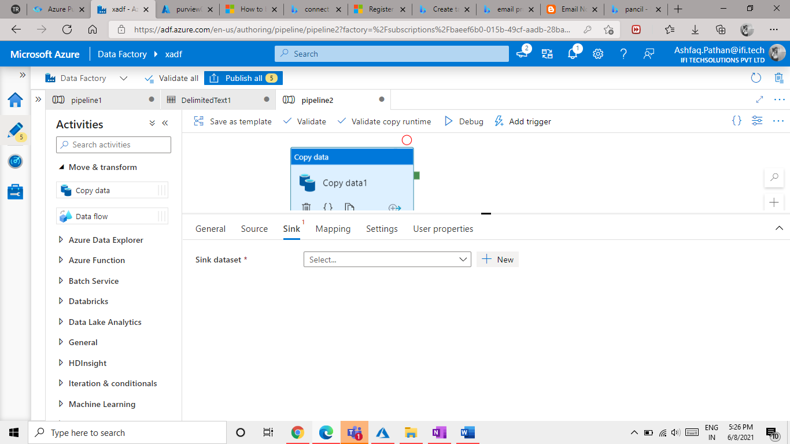

12.1 Click on New Button from Sink dataset Select Azure Blob Storage.

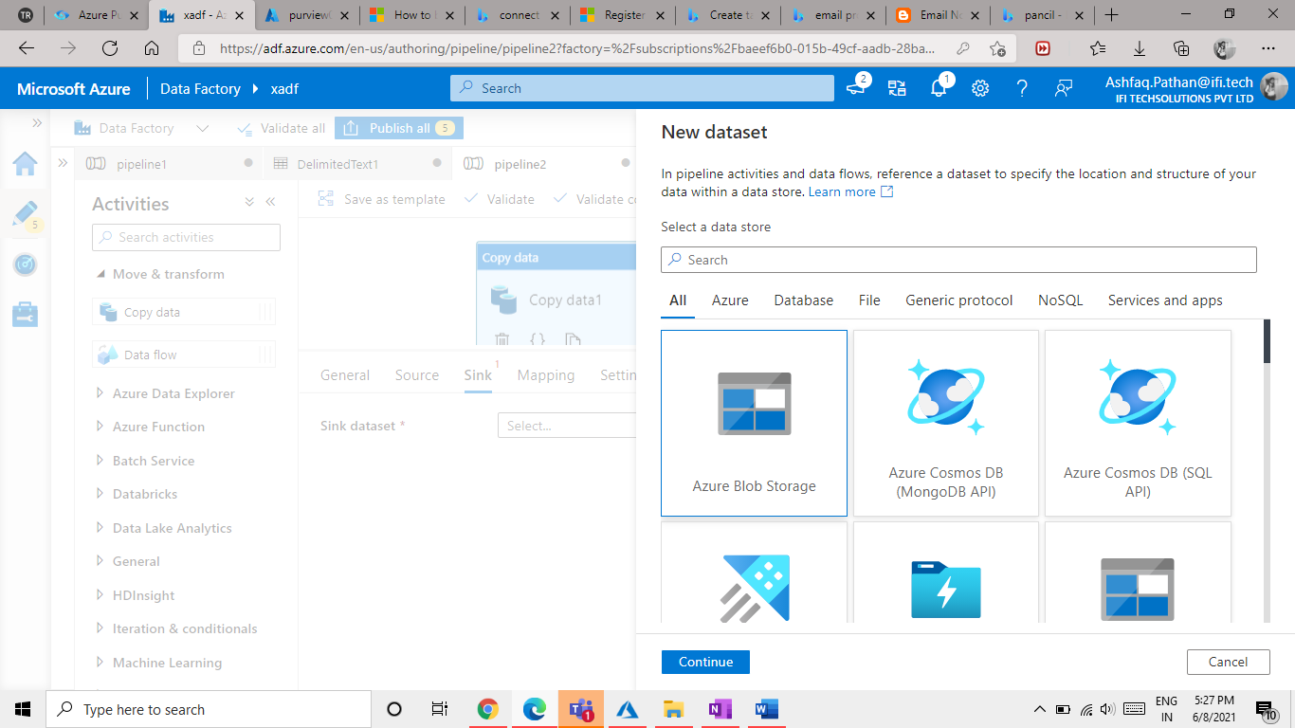

12.2 Select Delimited Text Click on Continue.

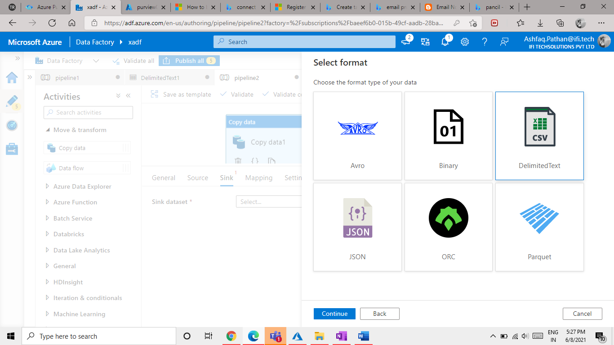

12.3 Select Output option and click on ok button.

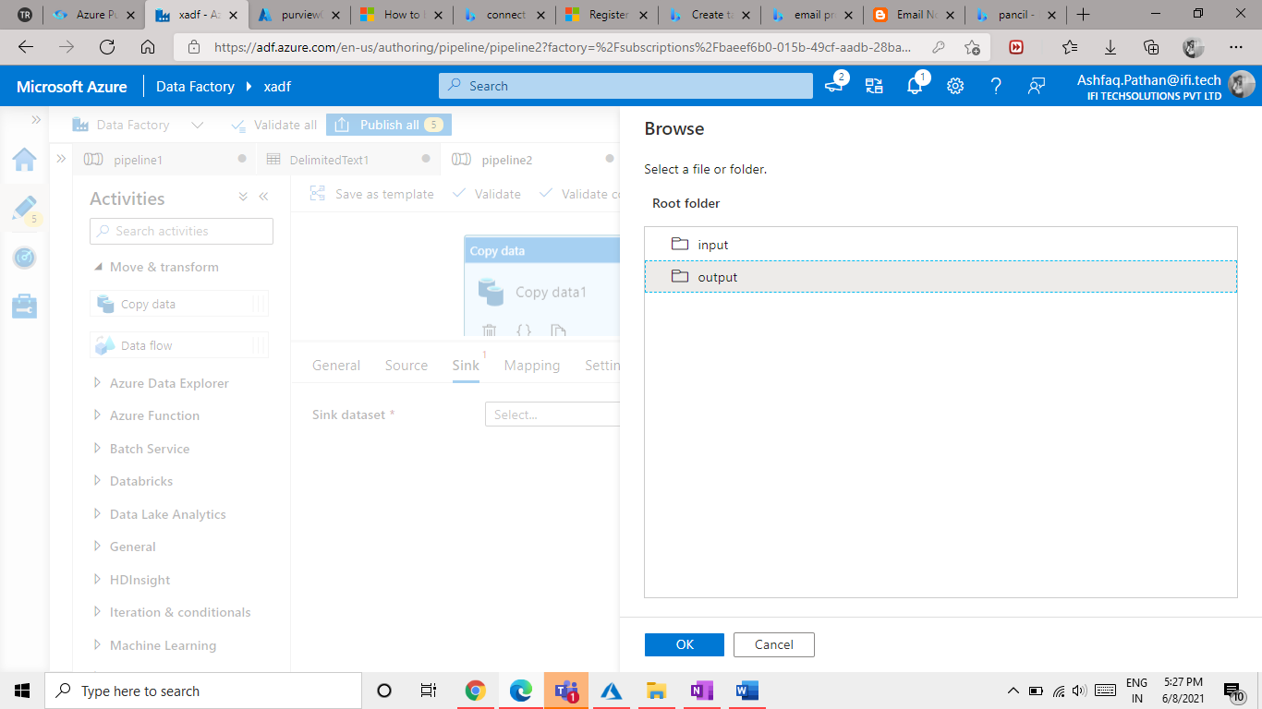

12.4 Open the container and click ok button.

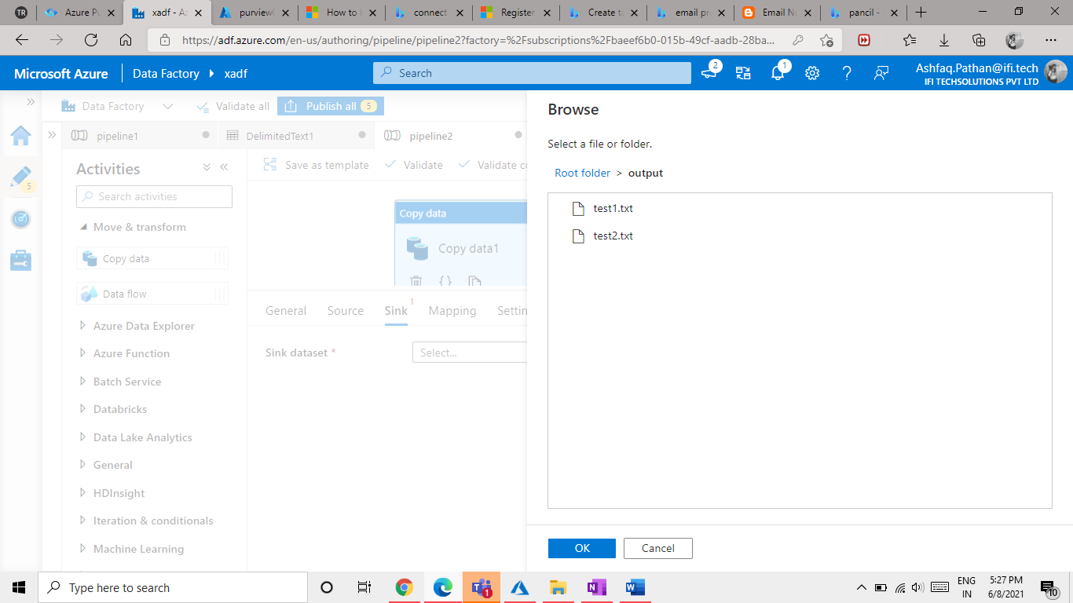

12.5 Select None option from import schema.

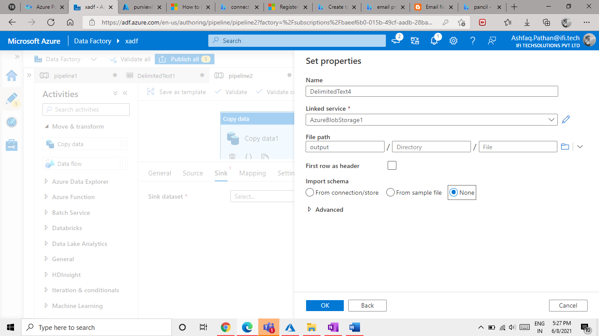

Step 13: Debug and check the operation status.

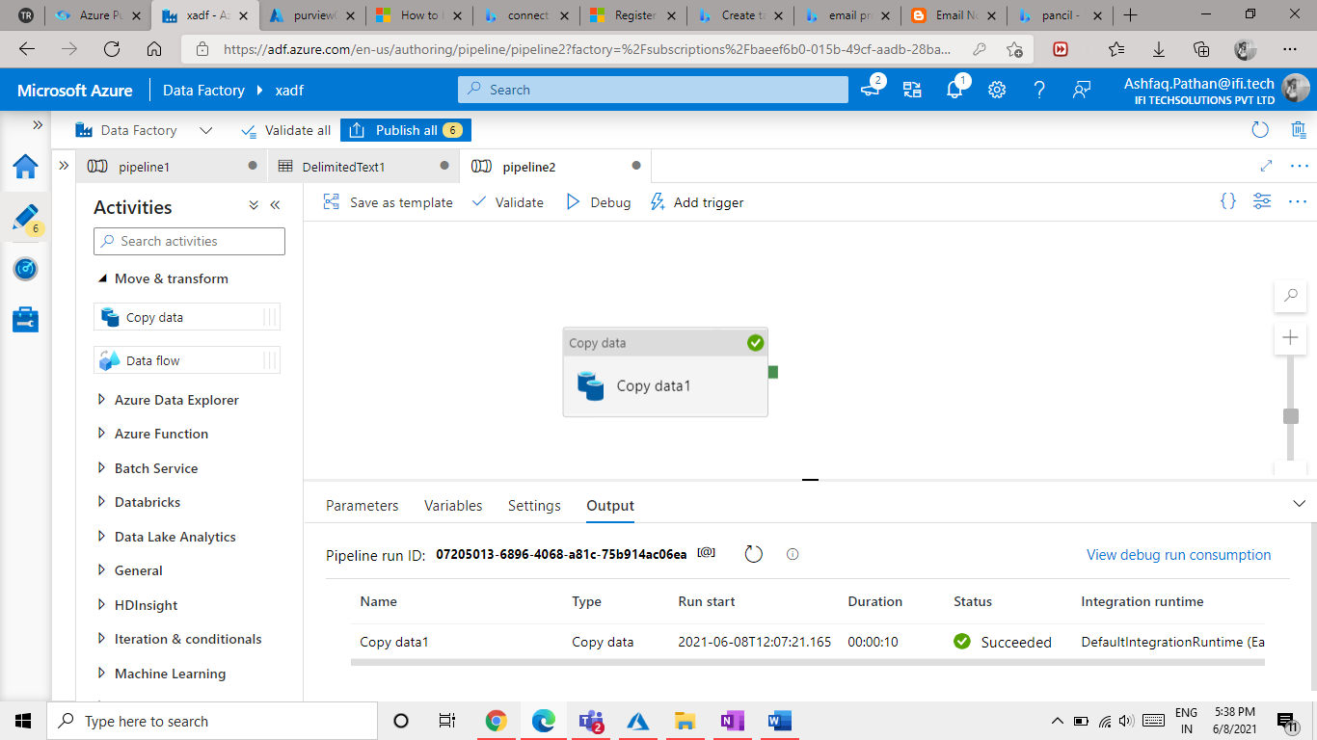

Output:

As we ca see in the below image 20 files have been copied from input container to output container.

