Take full, transactional ,differential backup on sql server 2016 b2ms automate this backup using maintenance plan, automate full back every 1hr, transaction- 5min, diff - 15 min

Prerequisite:

* Need a SQL-Server.
* Need a database.

Prerequisite settings:

 step 1 select Database Right-click goto properties

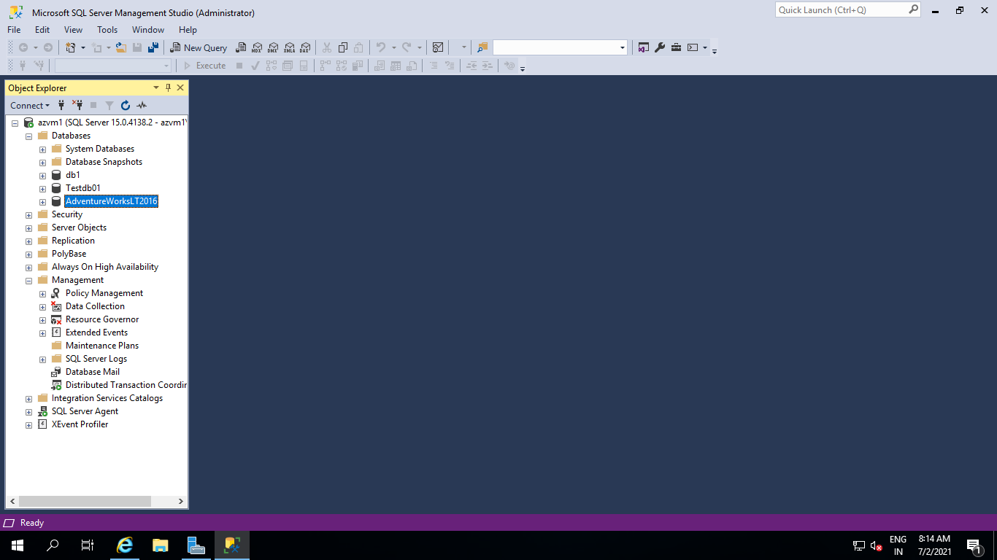

step 2 select Recovery Model: Full

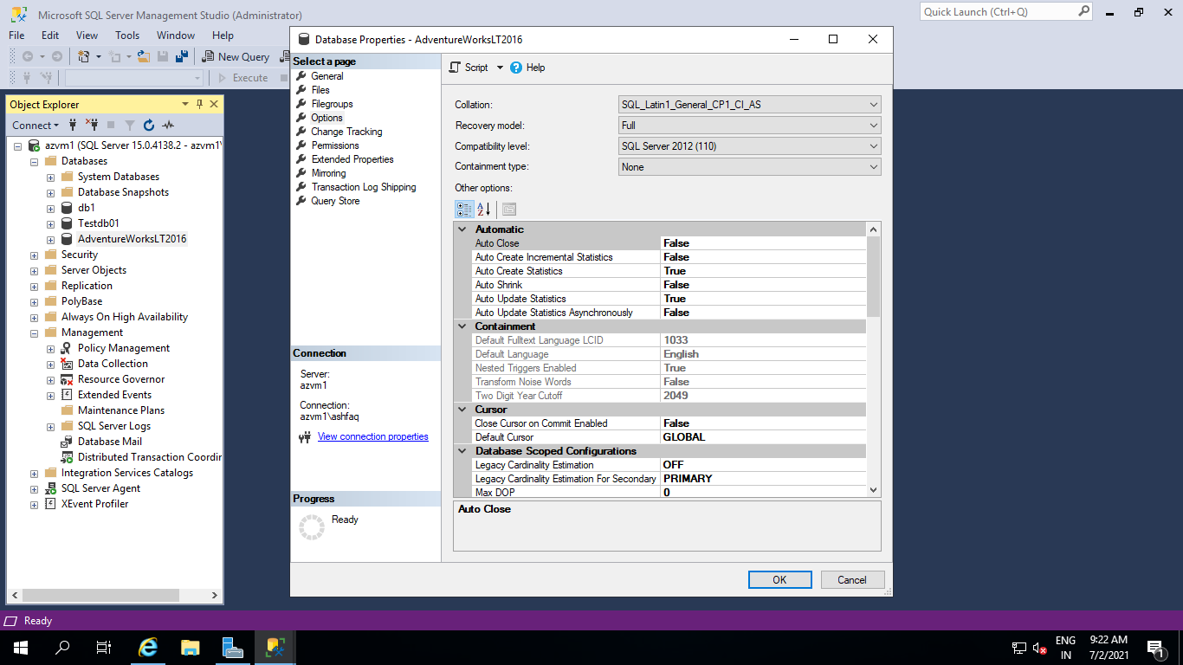

# Three types of backup steps show in below.

A Full Backup

B Differential Backup

C Transactional Log Backup

# A Full Backup

step 1 open Management folder select Maintenance Right-click

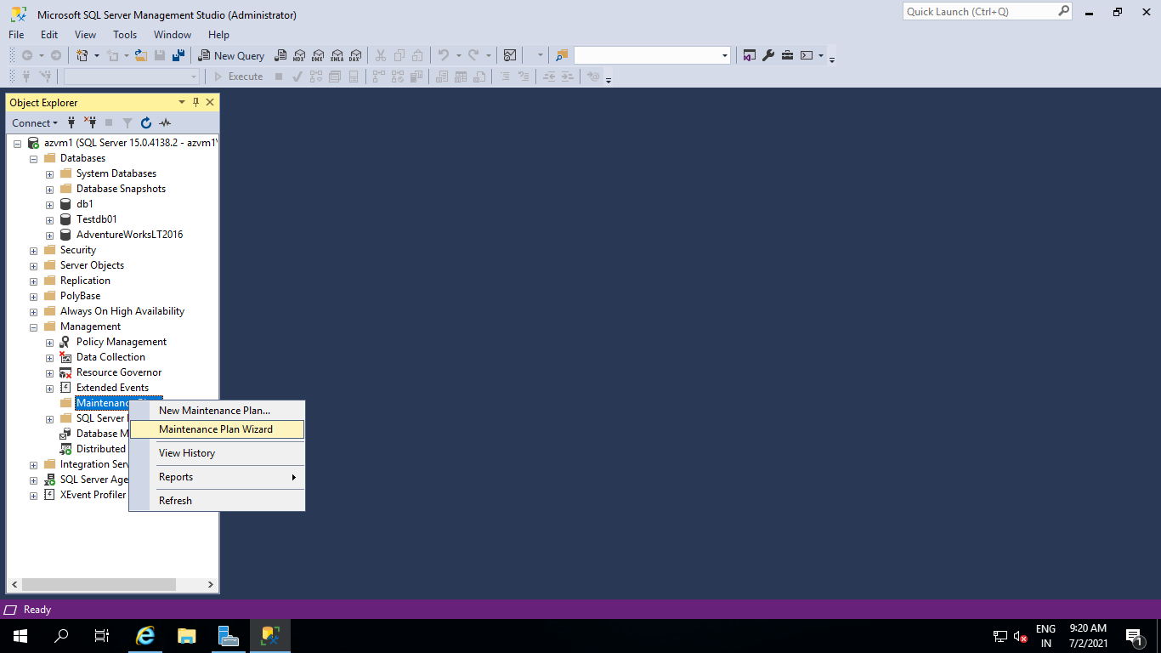

Step 2 Click the Next button.

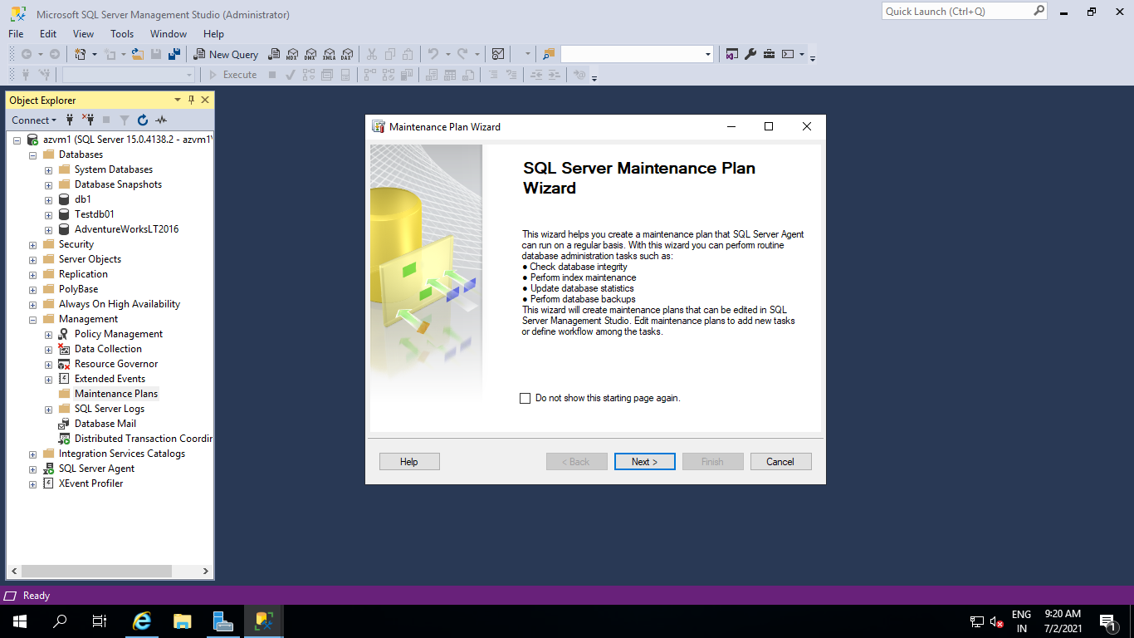

Step 3 give name & click on the **Change** button.

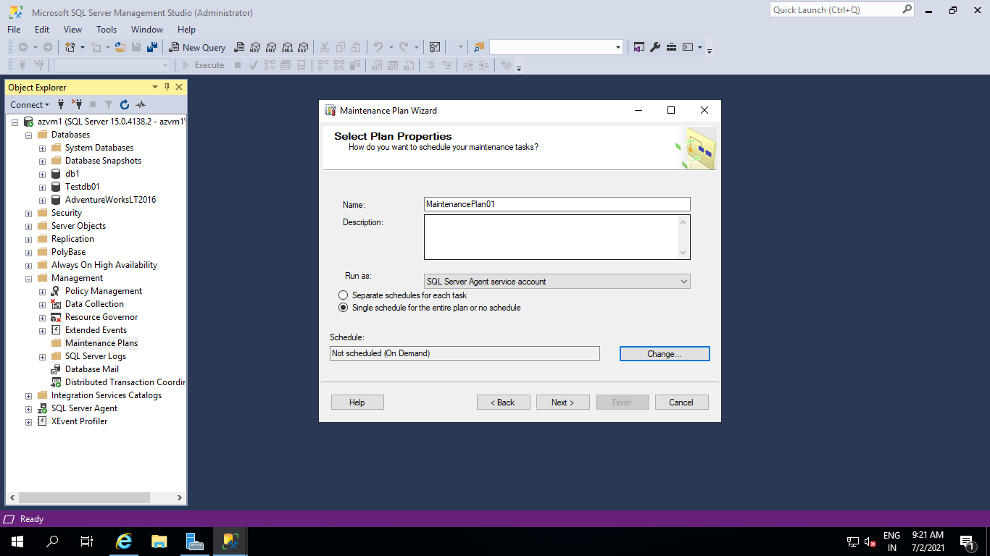

Step 4 Full backup schedule Config.

Occurs: Daly

Recurs every: 1 day

Occurs every: 1 Hour(s)

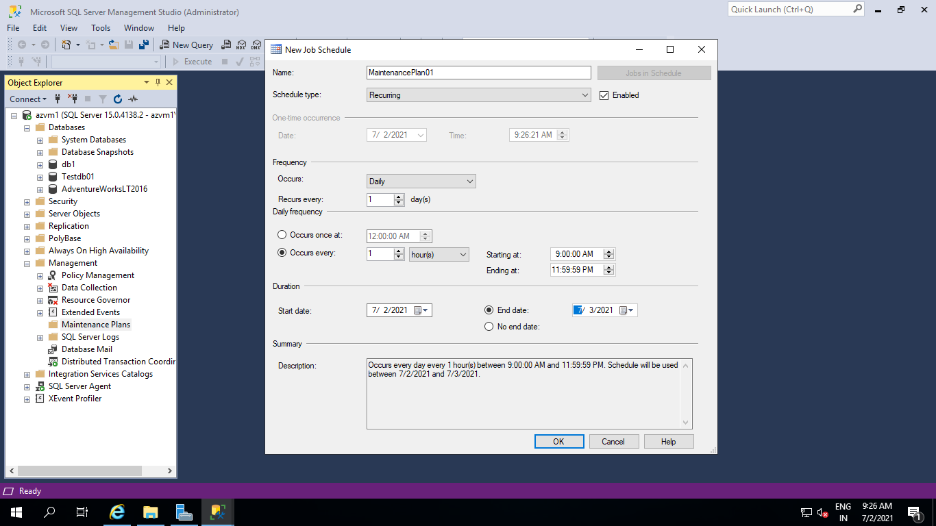

Step 5 select the Backup database (full) option.

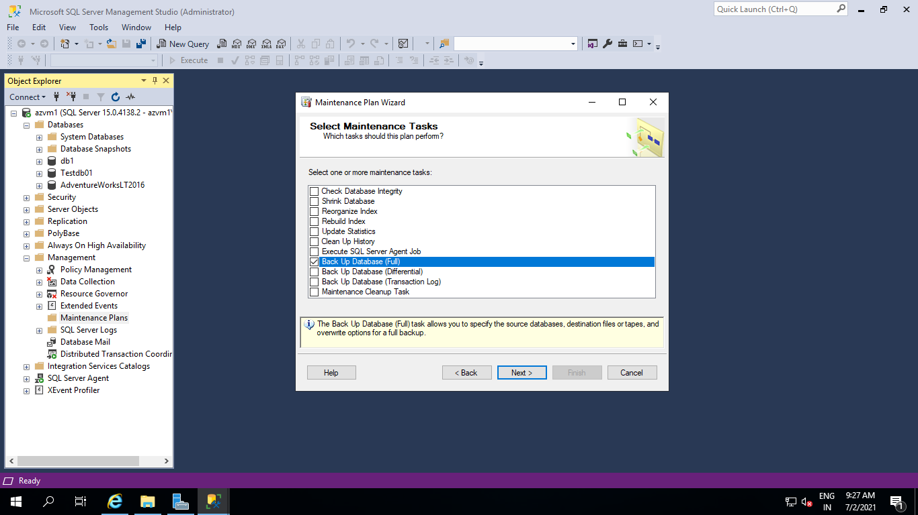

Step 6 Click the Next button.

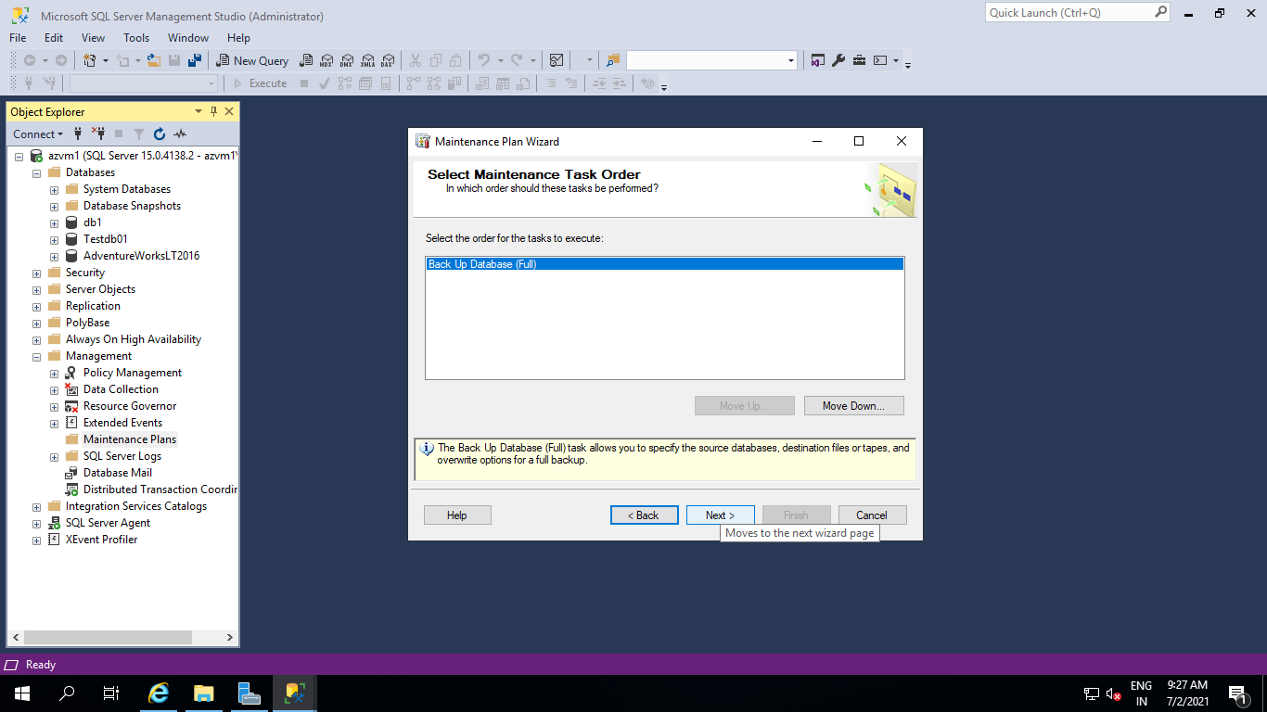

Step 7 In General wizard select Database(s) : 'any db witch you want to take a backup'

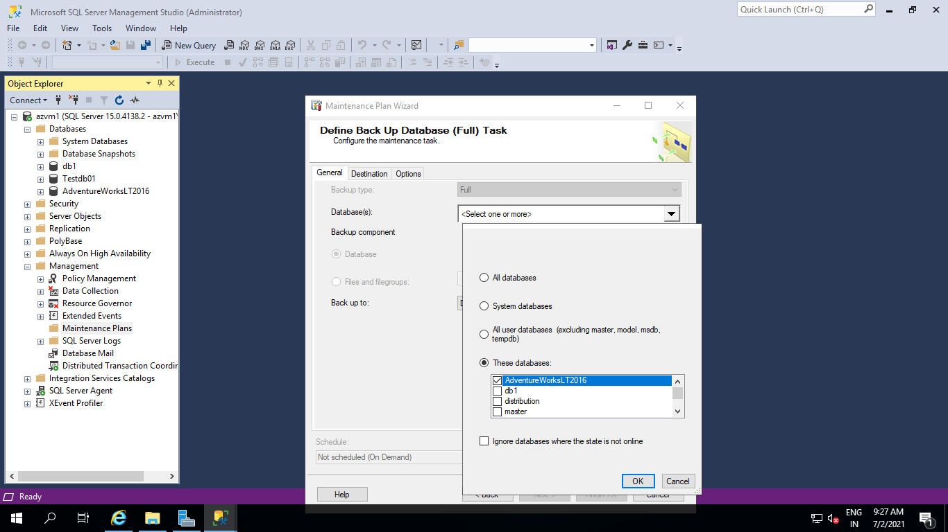

Step 8 Give a folder Path and click on next

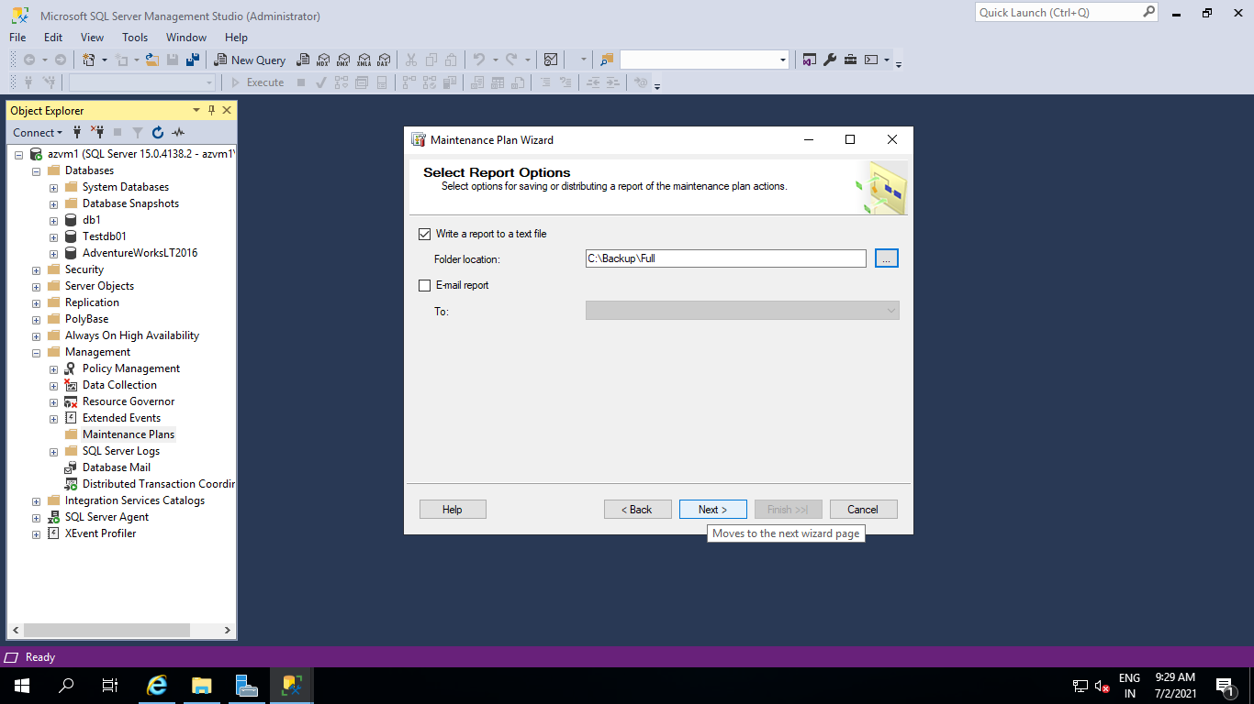

Step 9 Click on close.

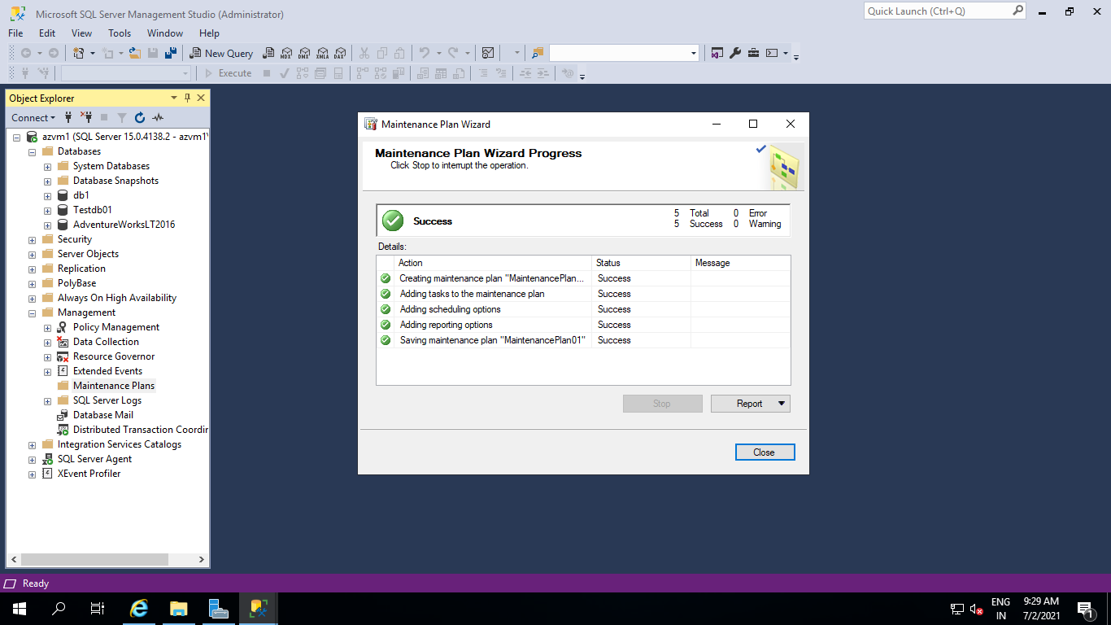

Step 10 : Backup files will be generate in selected folder.

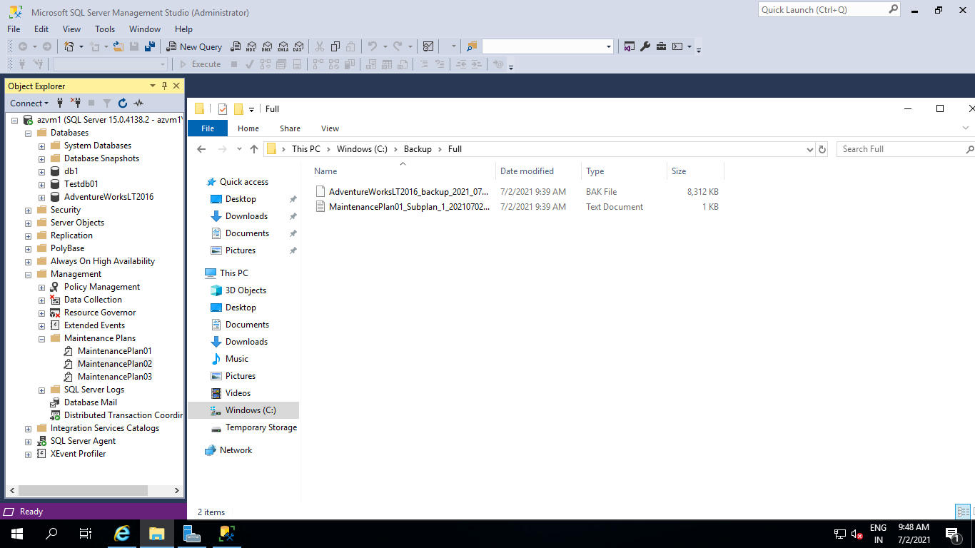

# B Differential Backup

step 1 open Management folder select Maintenance Right-click



Step 2 Click the Next button.

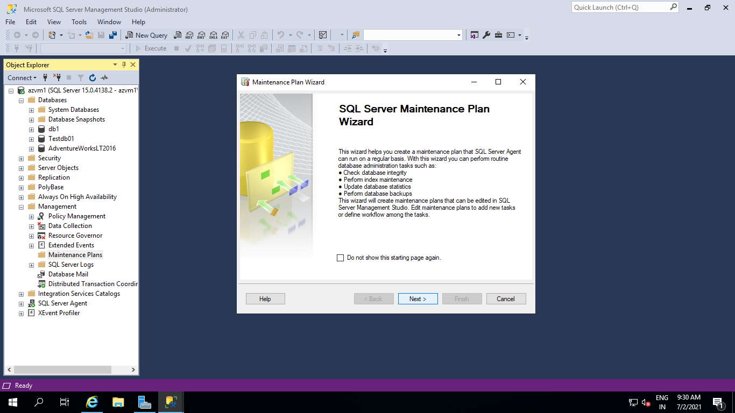

Step 3 Give name & click on the **Change**button.

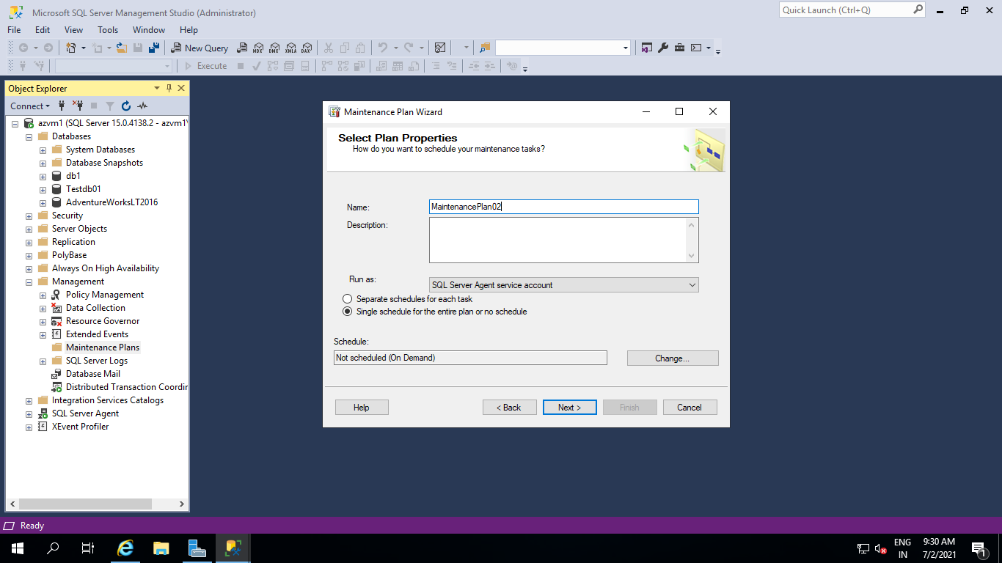

Step 4 Full backup schedule Config.

Config.

Occurs: Daly

Recurs every: 1 day

Occurs every: 15 Min

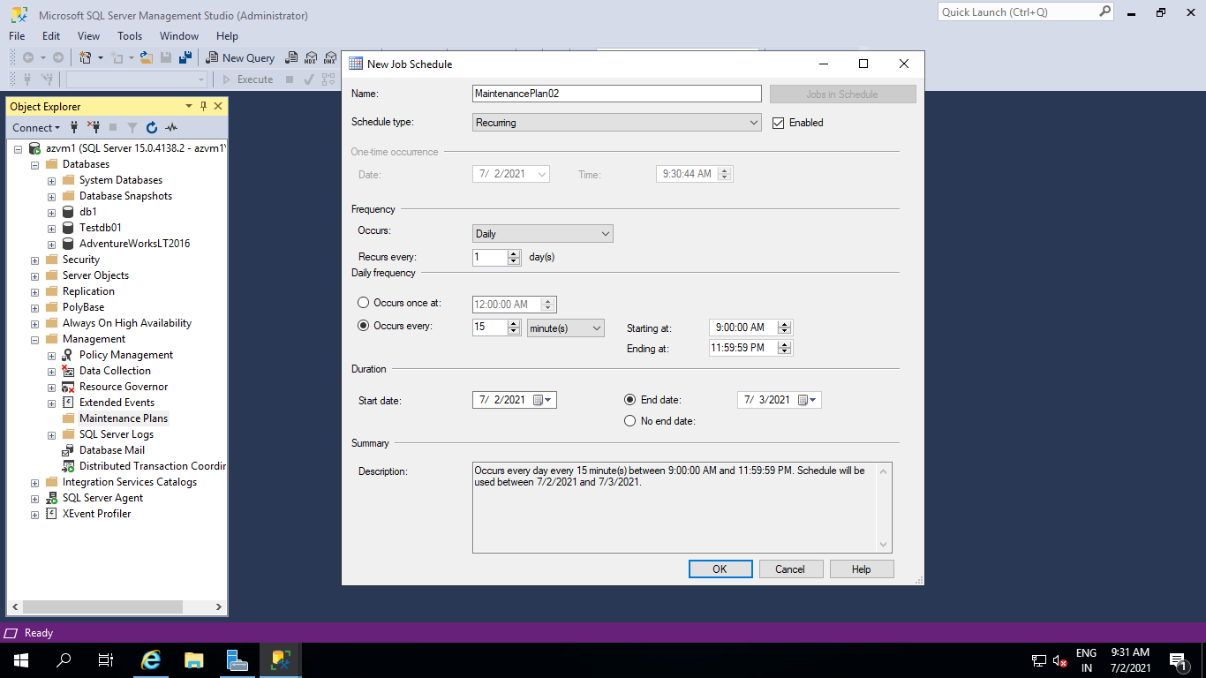

Step 5 Give a folder Path and click on next

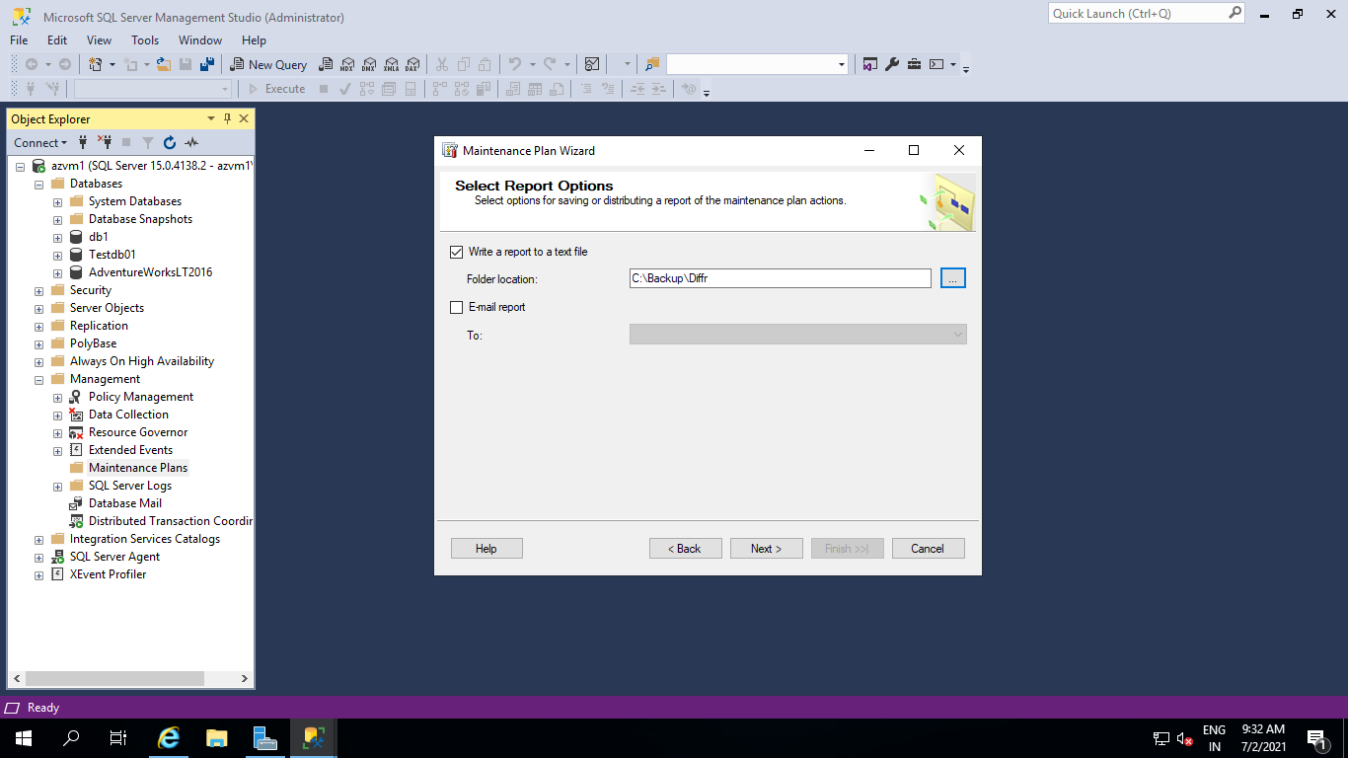

Step 6 Click on Finish

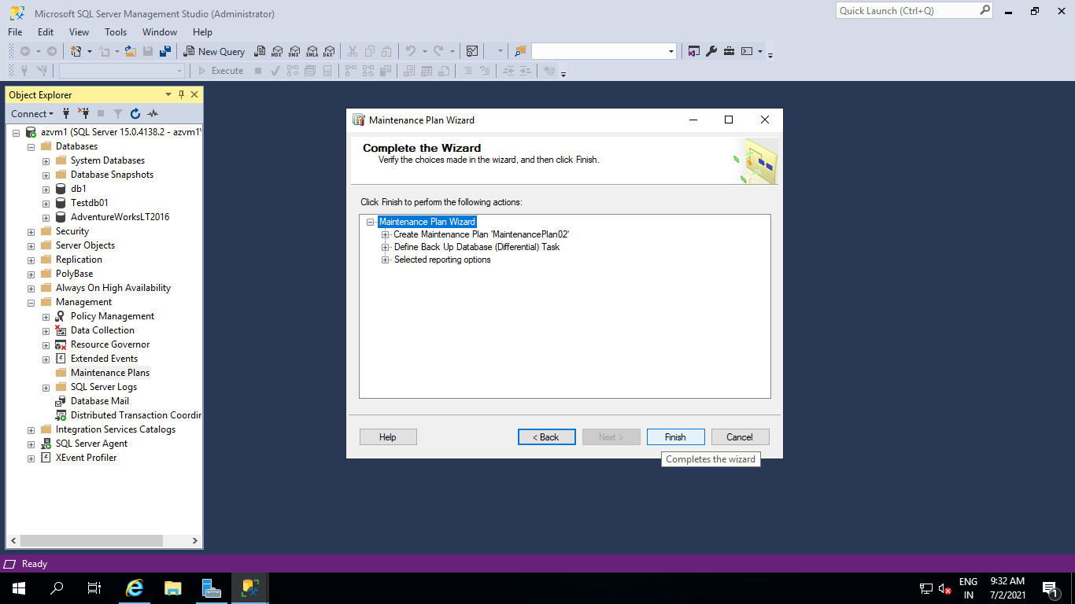

 Step 7 Click on close.

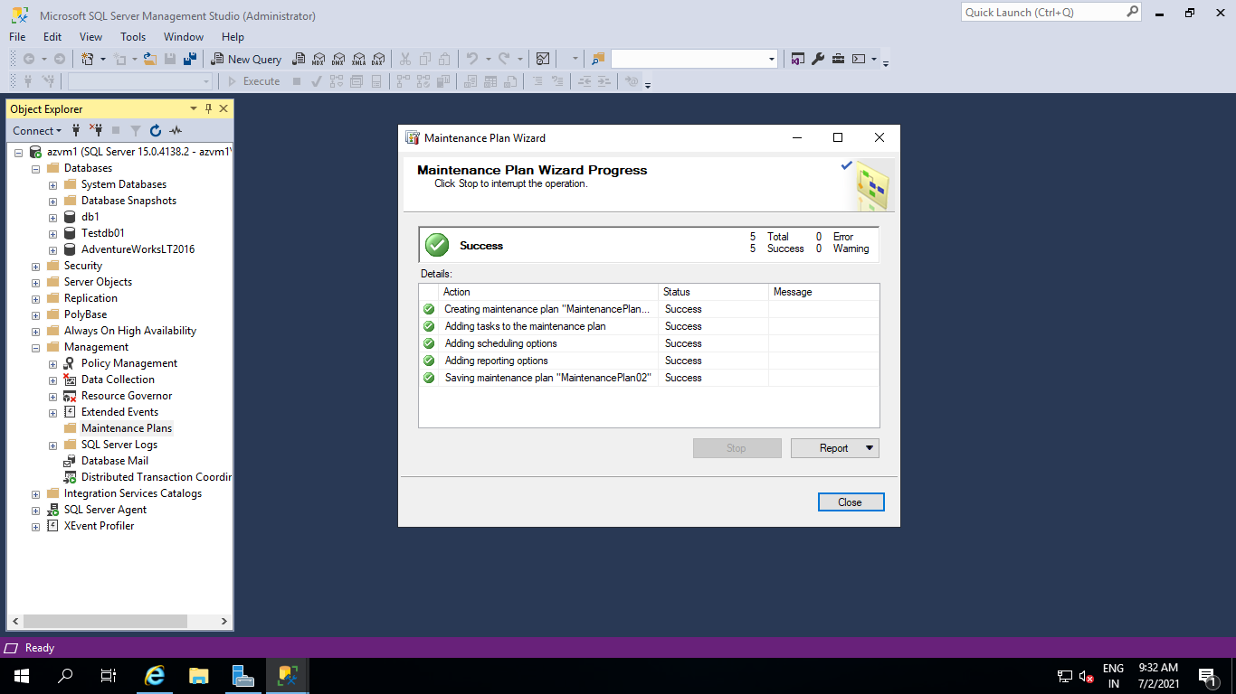

Step 8 Backup File Will be in selected Folder.

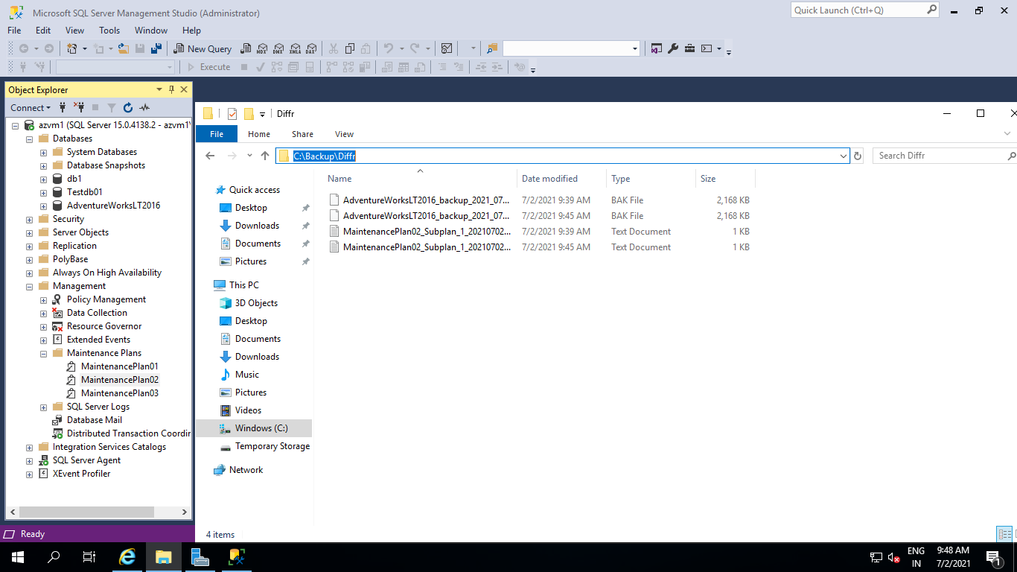

step 1 open Management folder select Maintenance Right-click



Step 2 Click the Next button.



Step 3 Give name & click on the **Change**button.

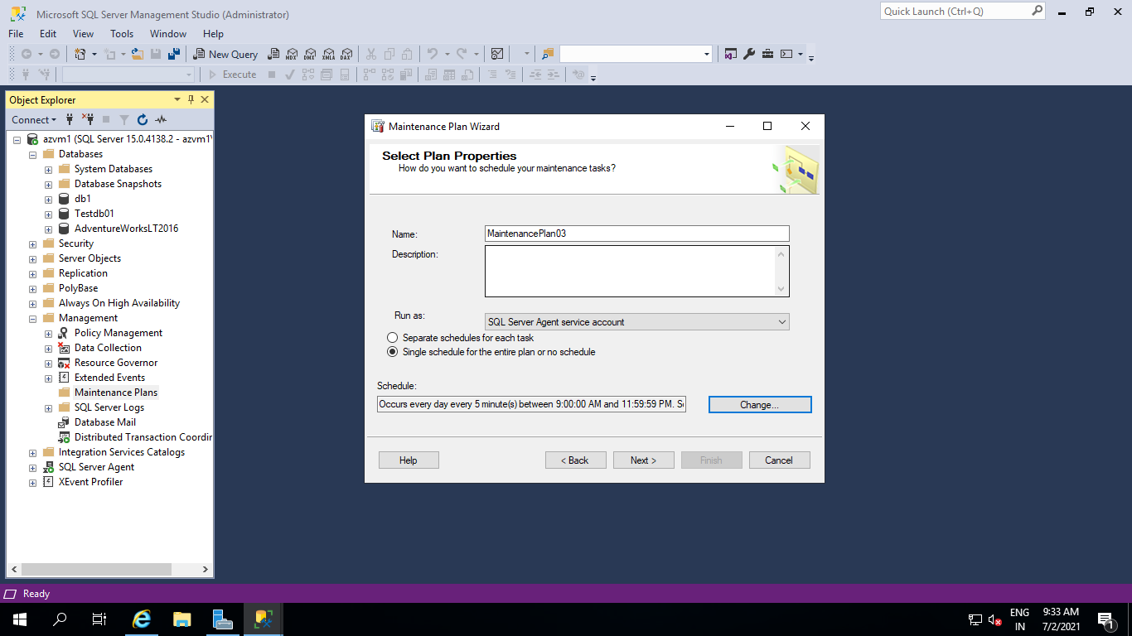

Step 4 Trn backup schedule Config.

Config.

Occurs: Daly

Recurs every: 1 day

Occurs every: 5 Min

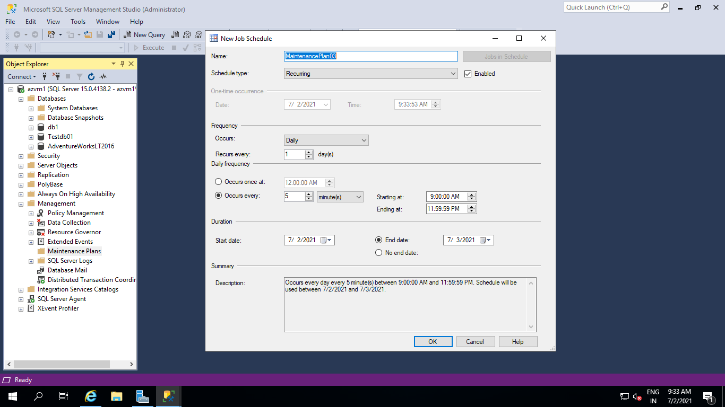

Step 5 select the Backup database (Transaction log) option.

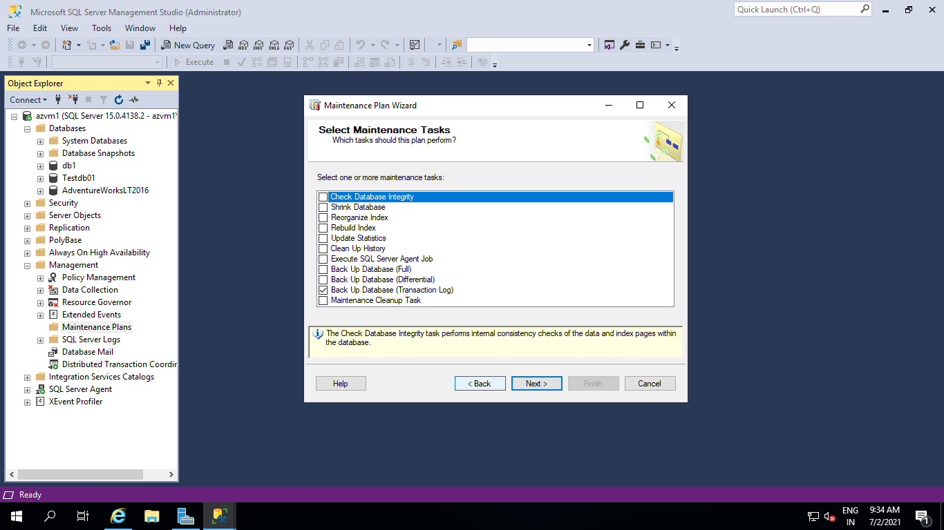

Step 6 Click the Next button.

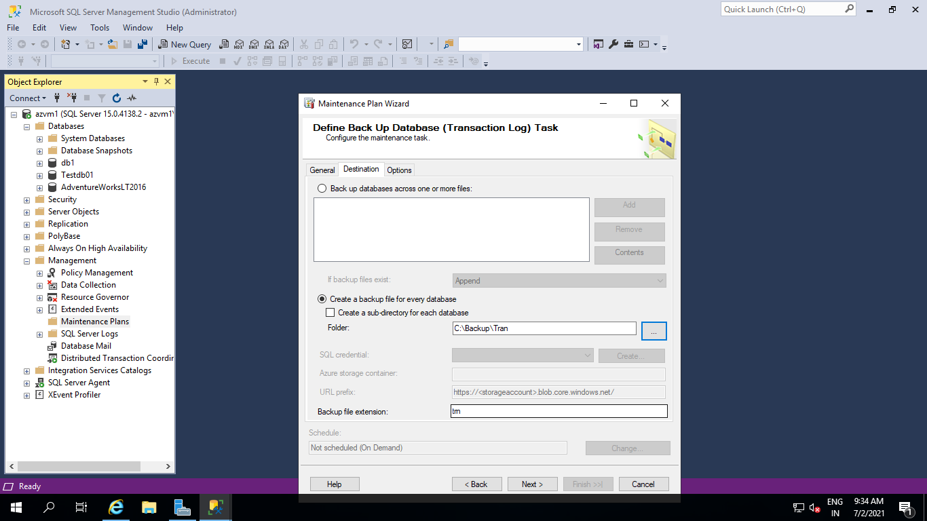

\

Step 7 Set path Click on next.

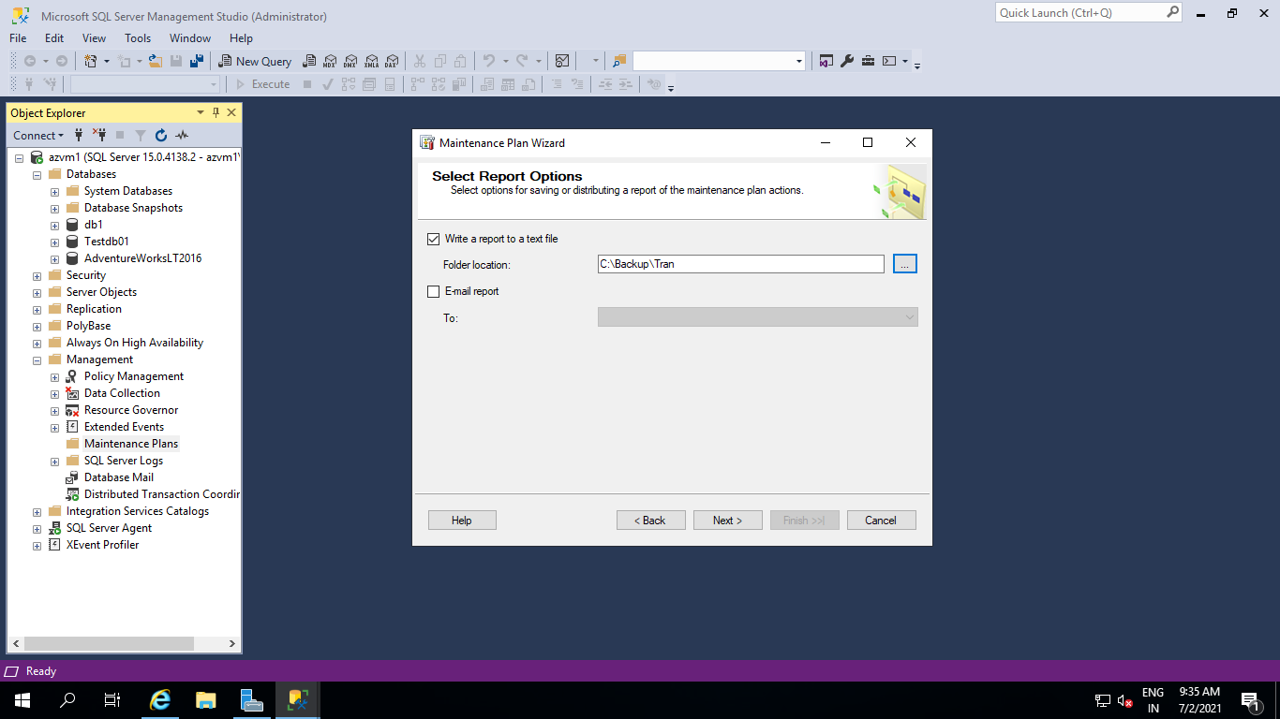

 Step 8 Click the Next button.

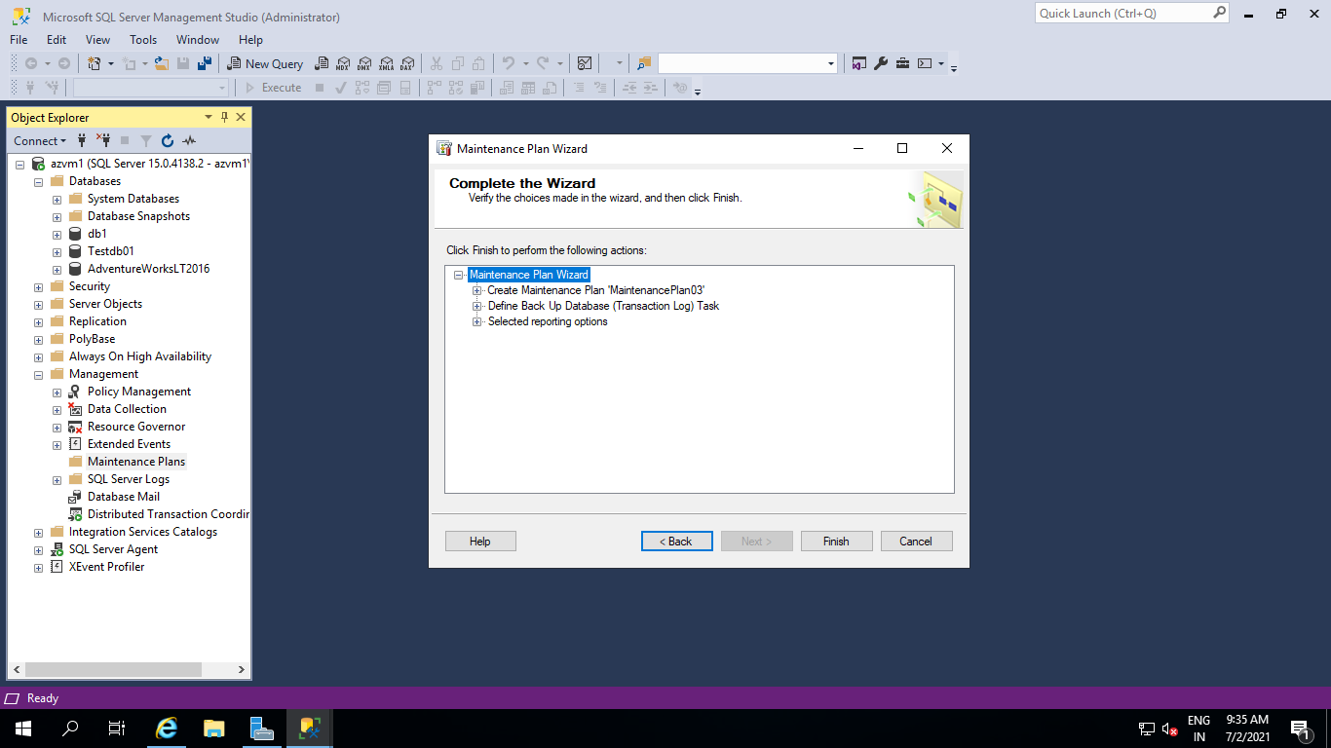

 Step 9 Click the Close button.

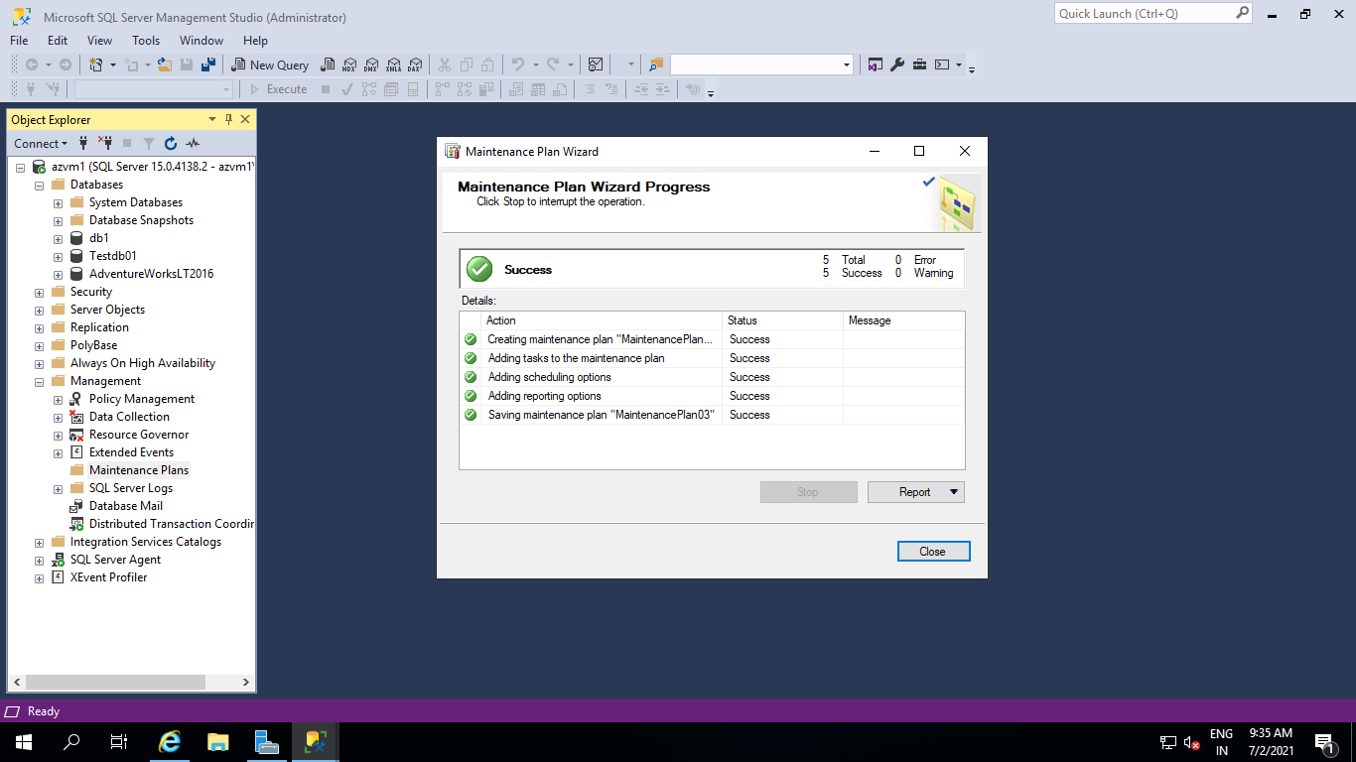

Step 10 Backup File Will be in selected Folder.

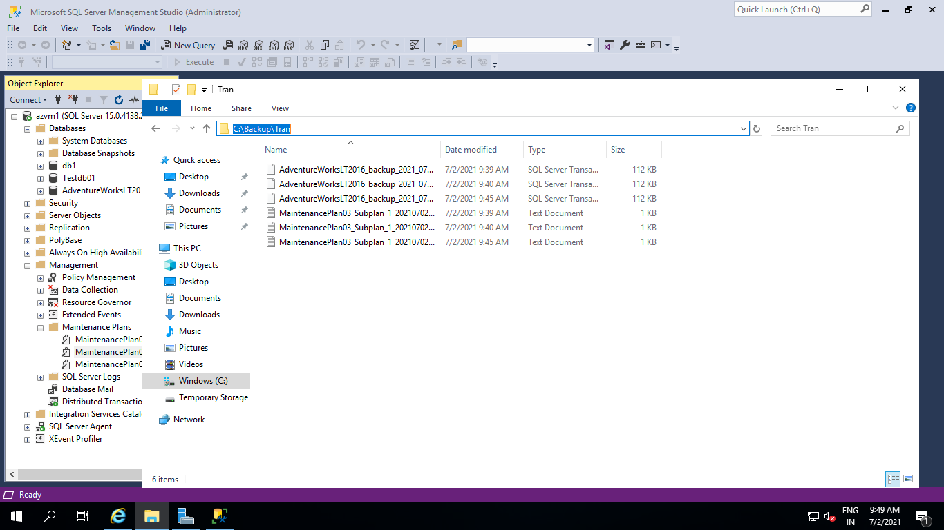

All 3 Back up Plans are listed below.

