* Creating an Email notification using logic app. as the pipeline in ADF run successful.

Prerequisite :  
-Need an Azure Subscription.  
-Need a ADF resource .  
-Need a storage account .  
 - Create 2 container with name : -input  
 -output

* For this I am creating a simple **copy activity** from data copy from **input container** to **output container** and add a **web activity** at the end of the flow

Following are the steps:

Step 1 Create a new pipeline in your **Factory Resource** With the name ‘Pipeline1’

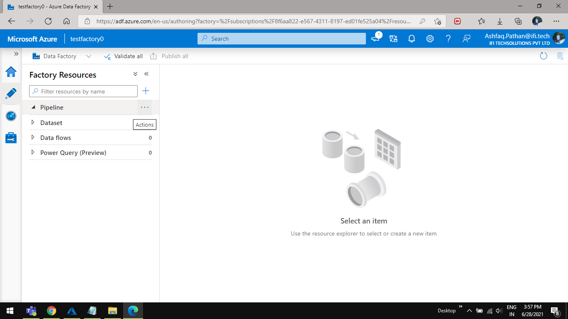

Step 2 Double click on your **pipeline1** to open it. 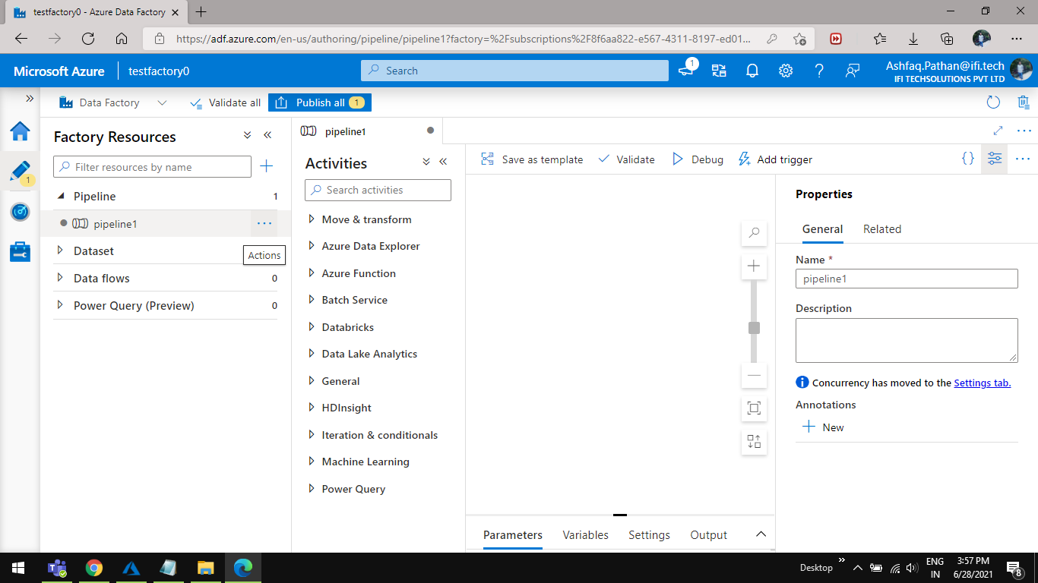 Step 3 Drag and drop **copy data** activity from the **Move & transform**. 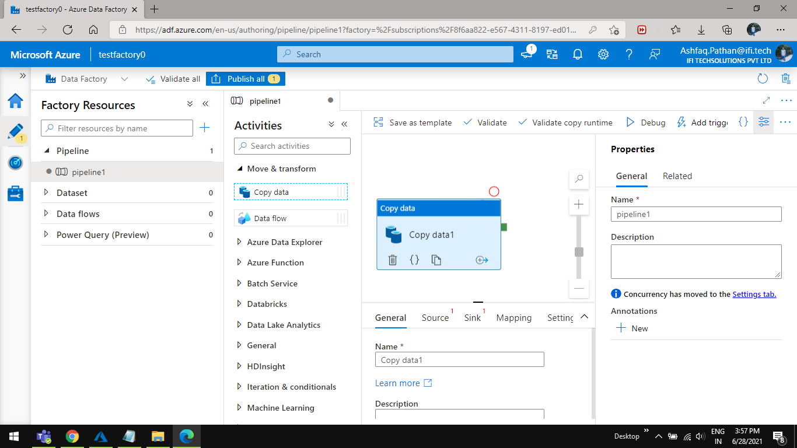

Step 4 Configure the **copy data** activity with **Source** and **Sink** .

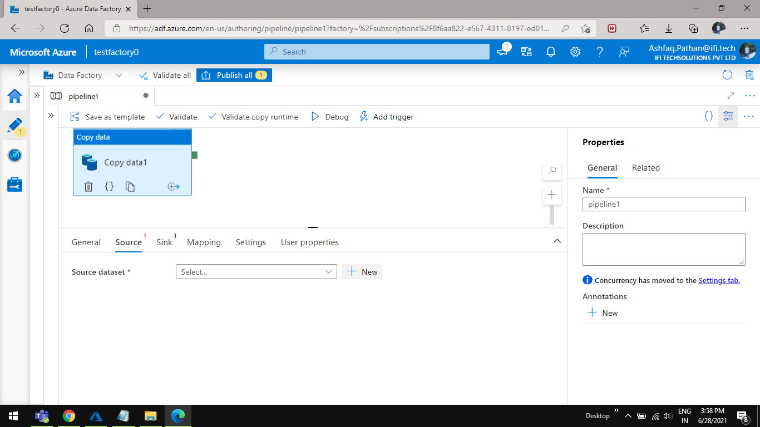

Step 5 Select the **Source** from the bottom Of the screen And click on **New** to add **Source dataset .**



Step 6 Select and **Azure Blob Storage** from the **New dataset** Wizard and click on **continue** button.

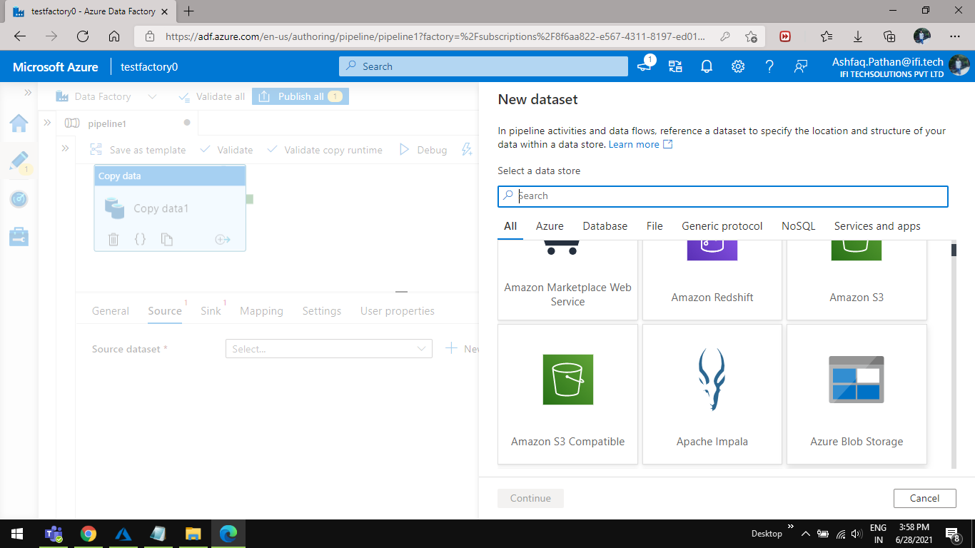

Step 7 You will see a **Select format** wizard select **Delimited Text**  and click on **Continue** button.

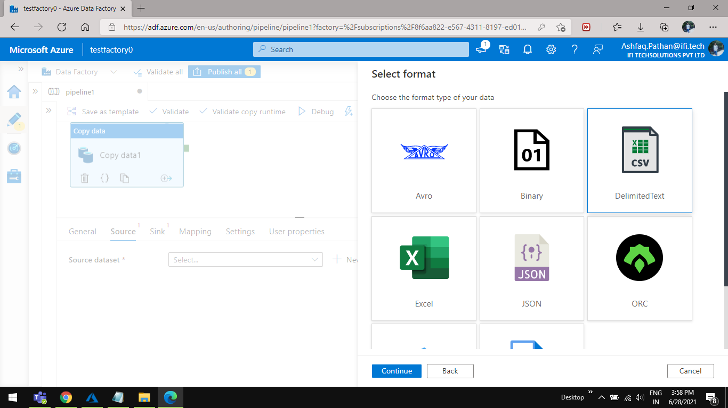

Step 8 Add **Linked Service** Click on **New** option to add .

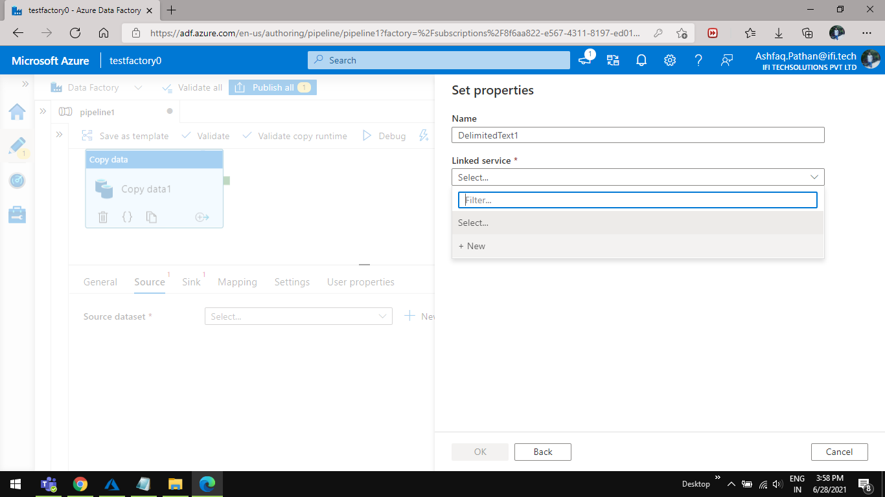

Step 9 Configure the **azure blob storage** connection Select **Azure subscription** from the dropdown and select the **storage account** **name** from the dropdown .

Click on **Test Connection** and then click on **Create**  button

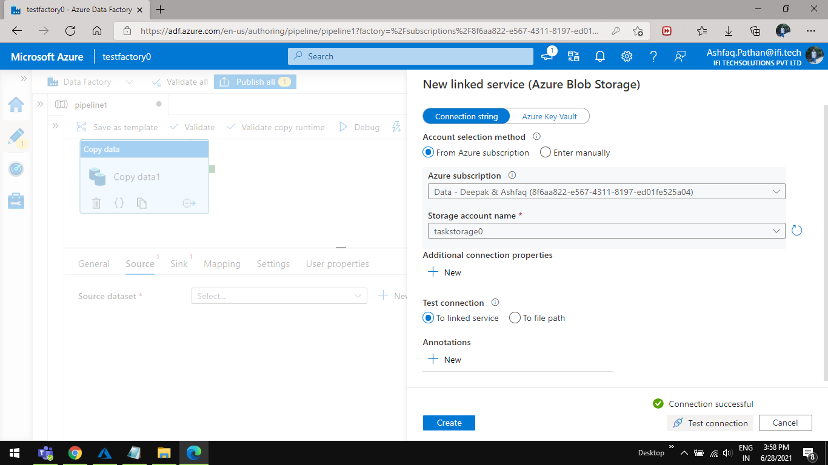

Step 10 Select the **File path** select **input** container And click on **ok.**

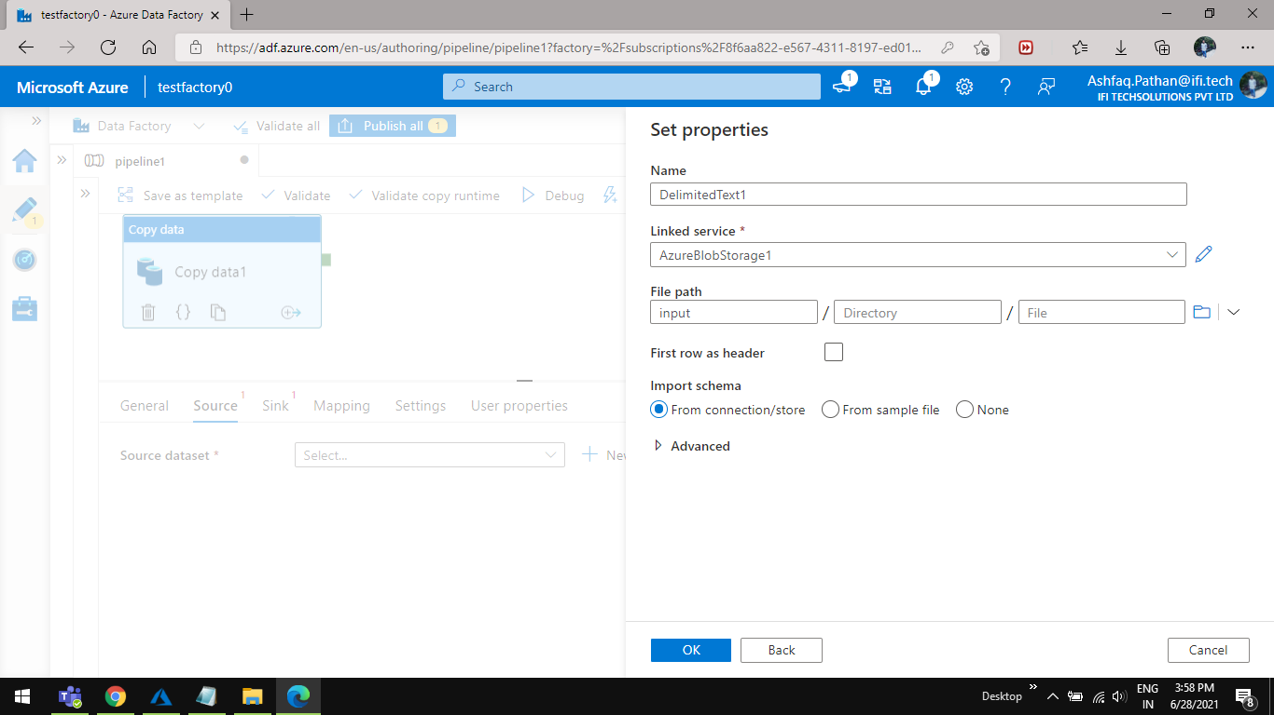

Step 11 Select **Sink** from the bottom of the screen and add a new **Sink dataset** .

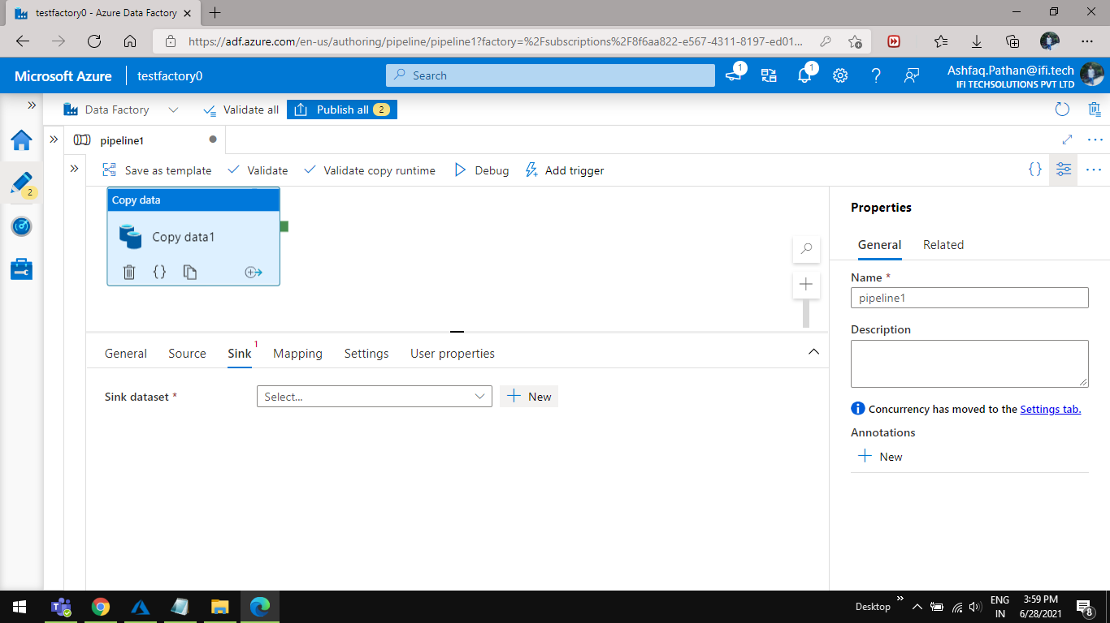

Step 12 Select the azure blob storage from the **New dataset** screen

And click **continue** button.

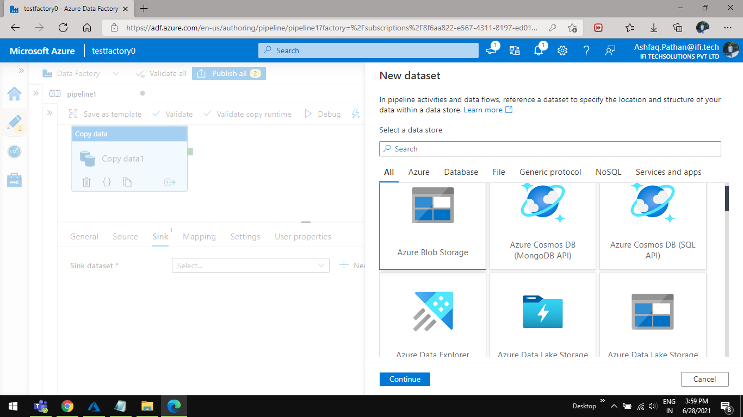

Step 13 You will see a **Select format** wizard select **Delimited Text**  and click on **Continue** button.

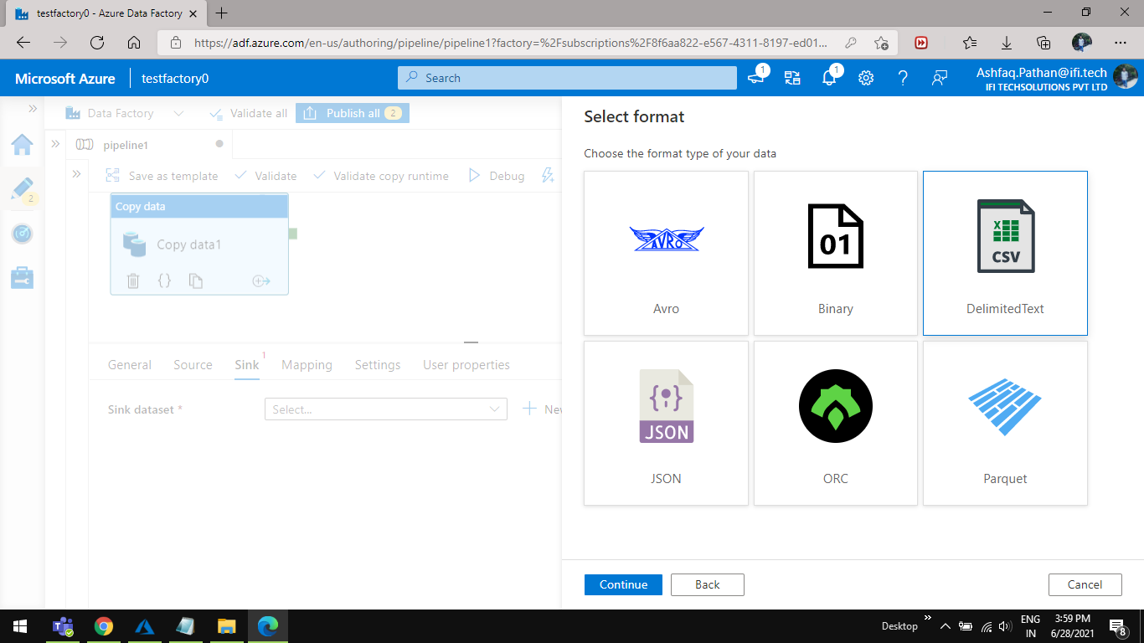

Type 14 In **set property** configure the **linked service** As we are using the same **blob storage** for the **Output** container so we will be using the same linked service As we have configured earlier for source so select from the dropdown.

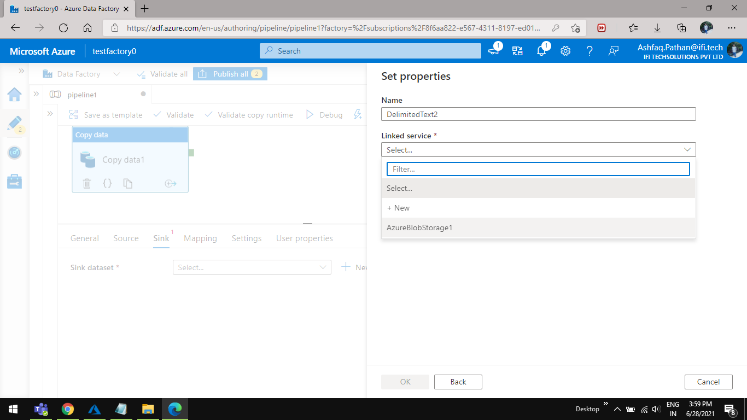

15 Select **output** container in the **File path** in **Set properties** andclick on **ok** button .

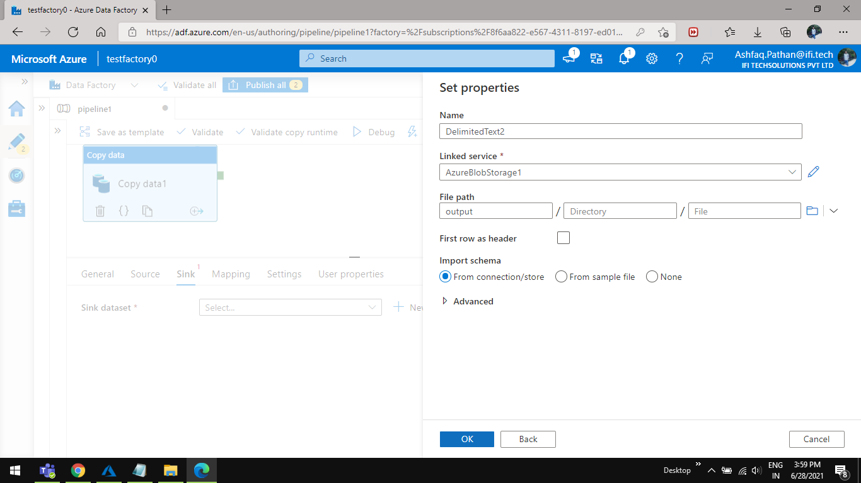

16 Add web activity from the **activity** panel drag and drop **web** activity from **General**  Configure the email activity rename the web activity to ‘send email’.

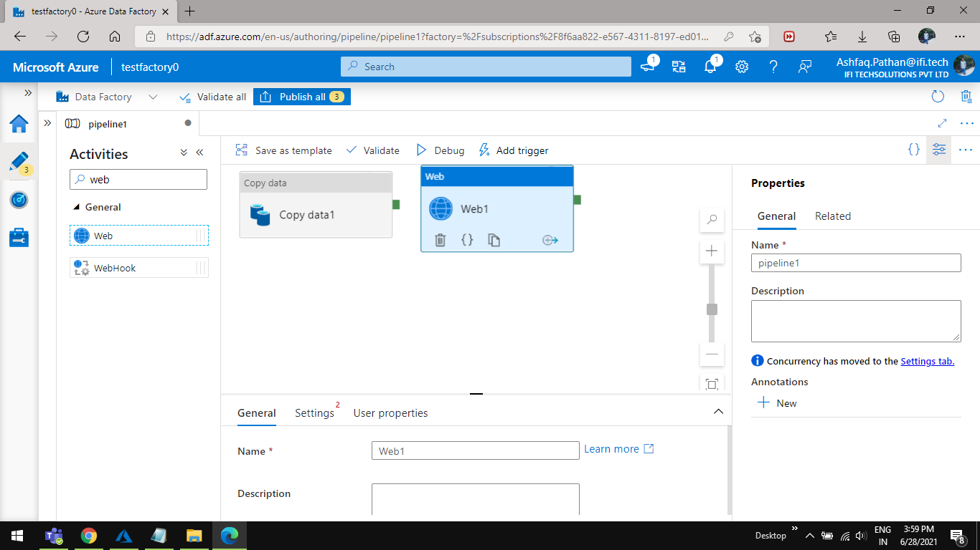

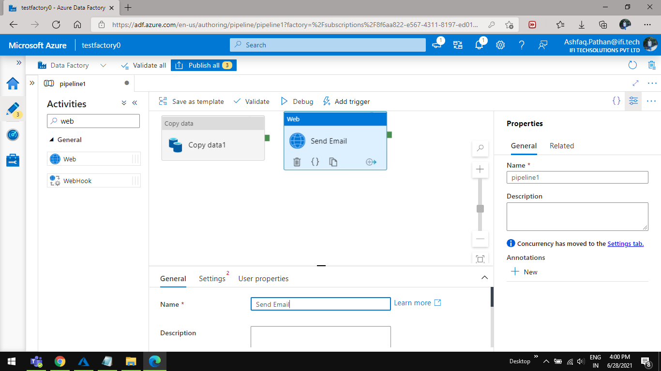

Step 17 Open your logic app from azure portal

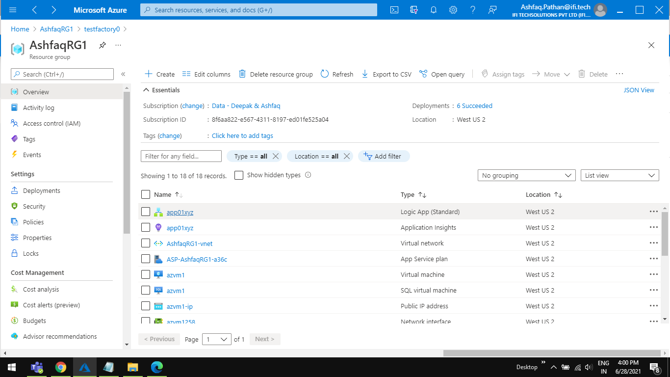

17.1 Select and workflow from the left panel Add a new workflow.

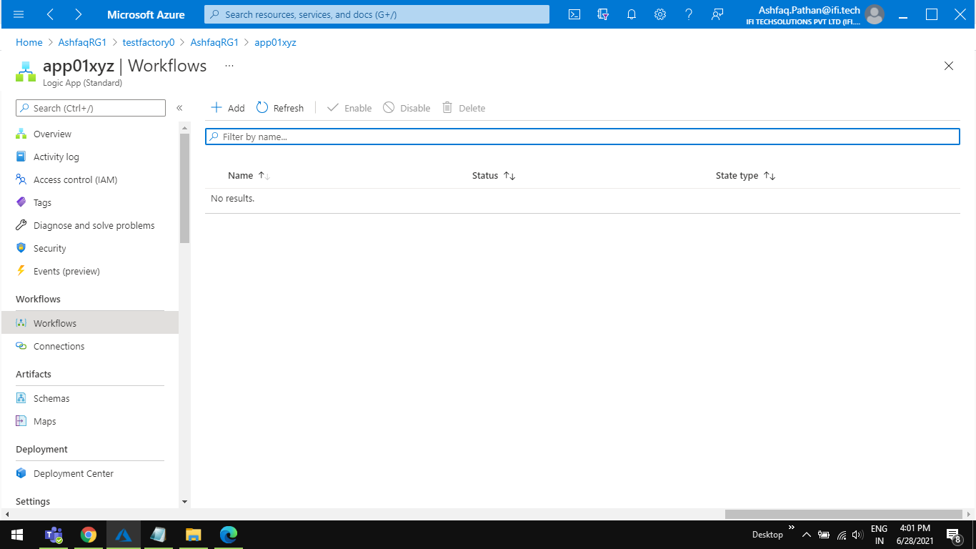

17.2 Add a new workflow name it ‘work1’.

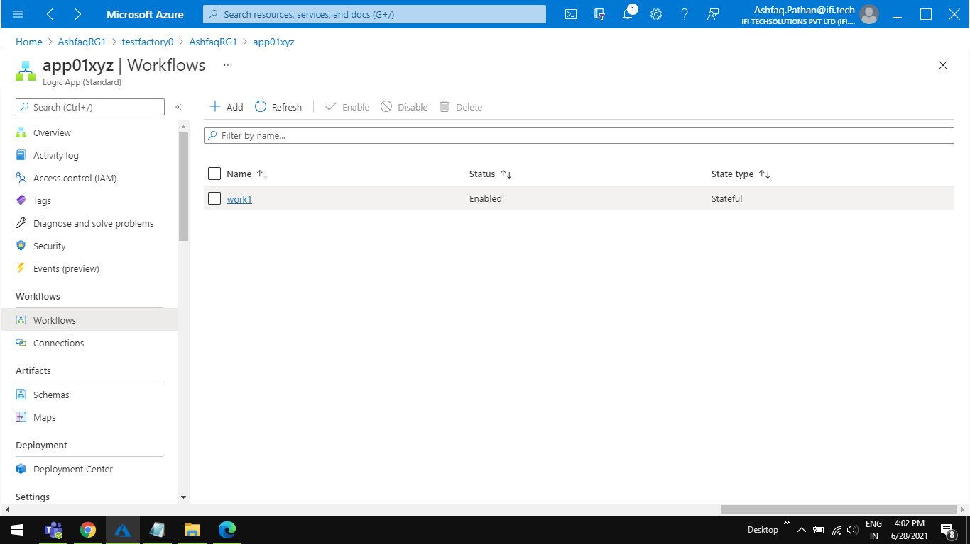

Step 18 Open the workflow and Add a ‘**when an HTTP request is received’** activity from the right search bar

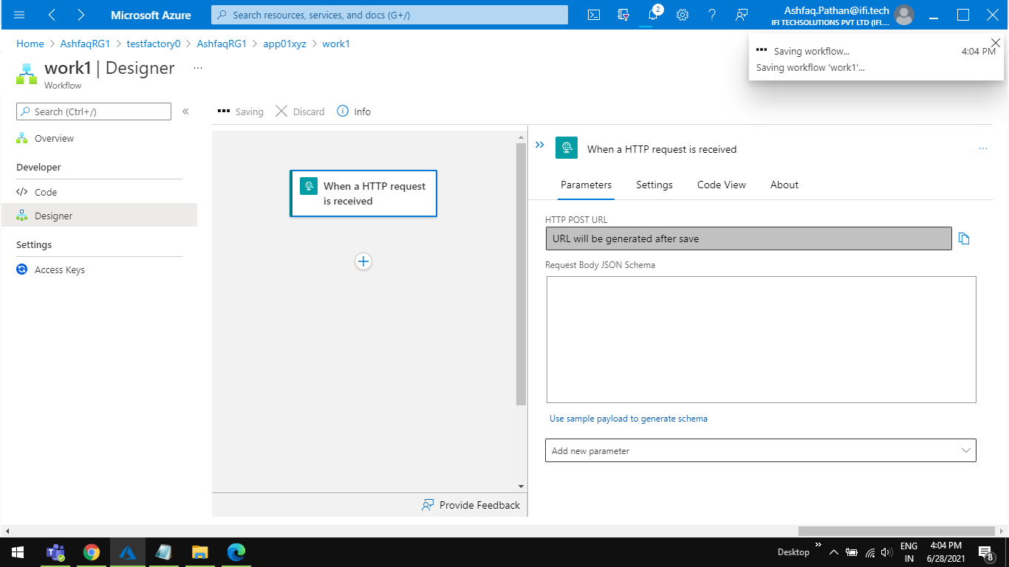

Step 19 Click on the activity And click on save button then you will get an HTTP post URL copy that URL.

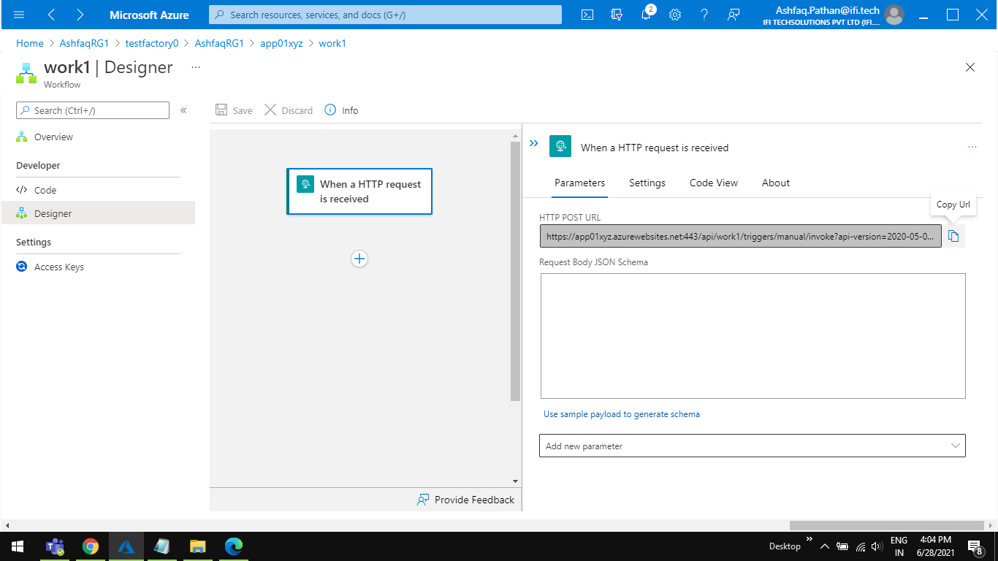

Step 20 Copy URL from logic app **http post** and paste that link in **Send Email > Settings > URL.**

And set **POST** in **Method.** Below **URL.**

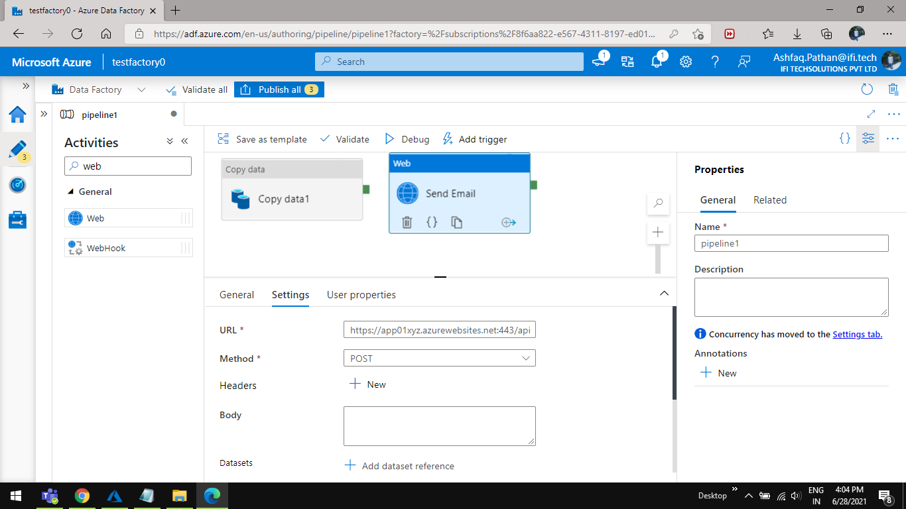

Step 21 Click on the Body and **Add dynamic content**

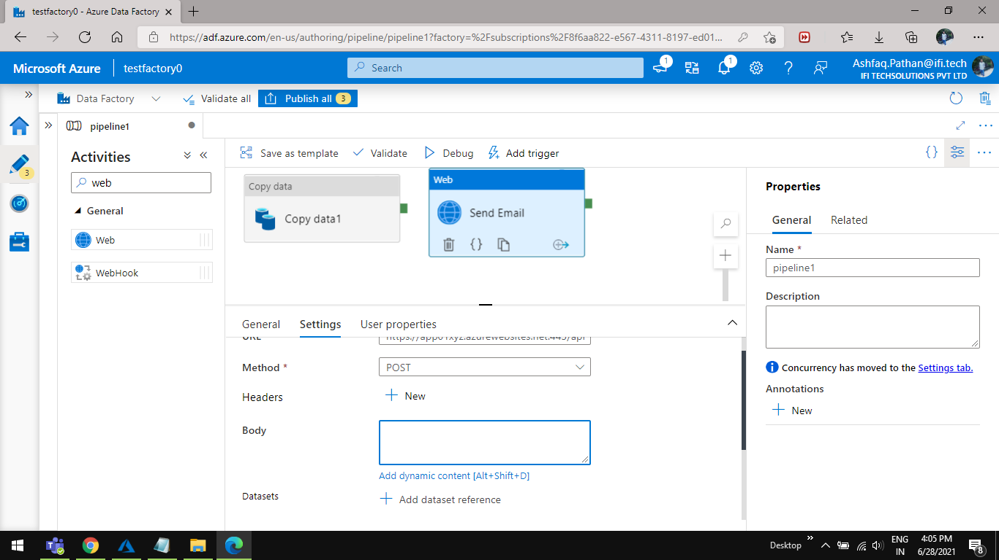

21.1 Type the below JSON code in a dynamic content Text area Click on finish .

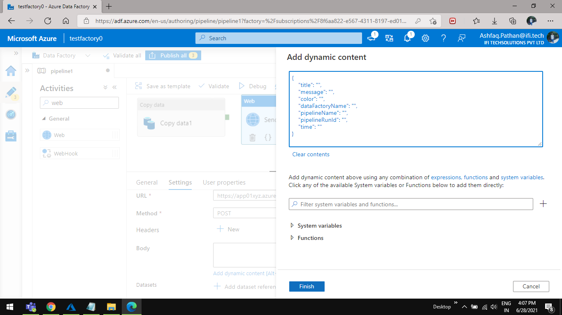

Step 22 Go and save your logic app from your azure portal and click on **Refresh** button.

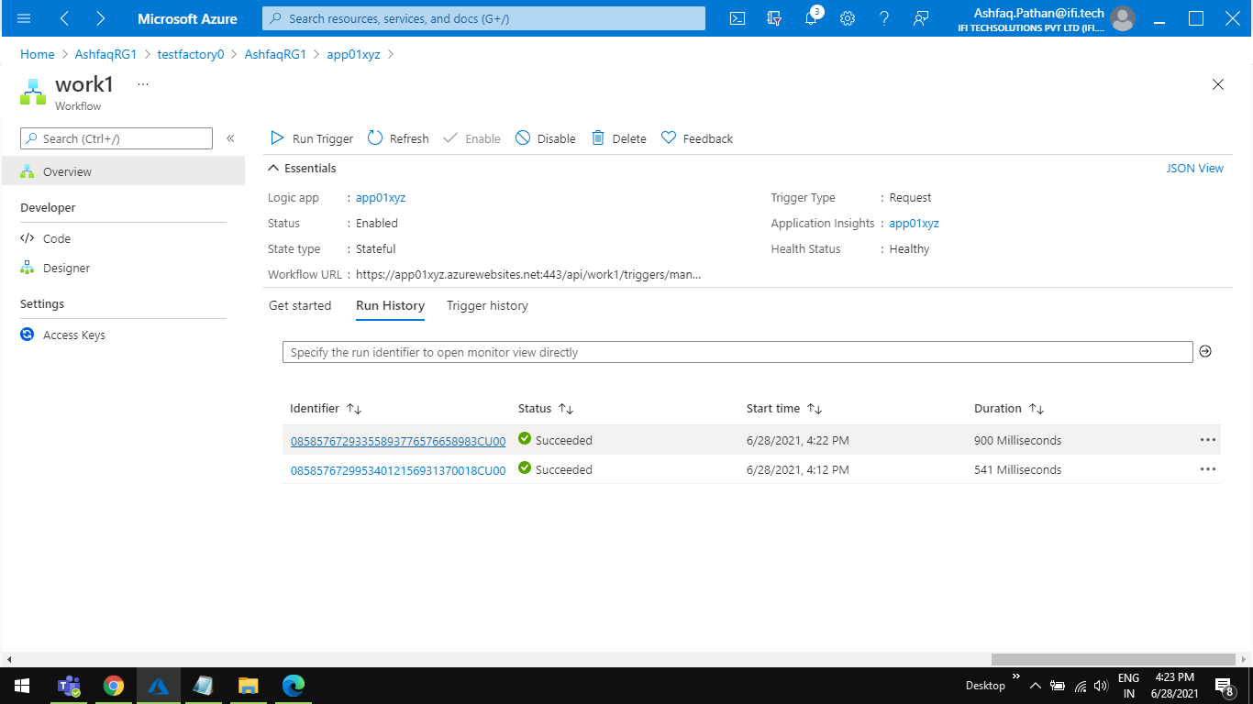

22.1 You will see a JSON format loaded in the ’**Request Body JSON Schema’** Automatic .

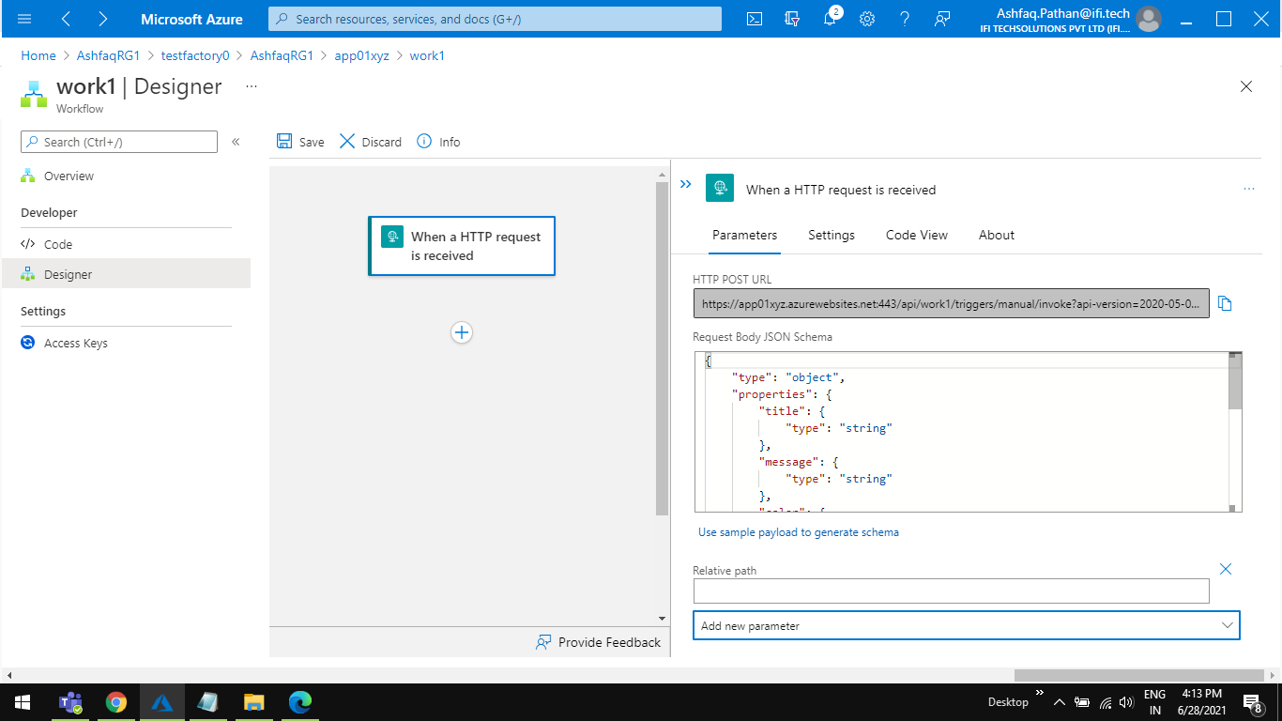

Step 24 Open **Data factory** go to ‘**Send Email’ > Settings > Body**  click on **Dynamic content** edit the below JSON code click on **Finish** button

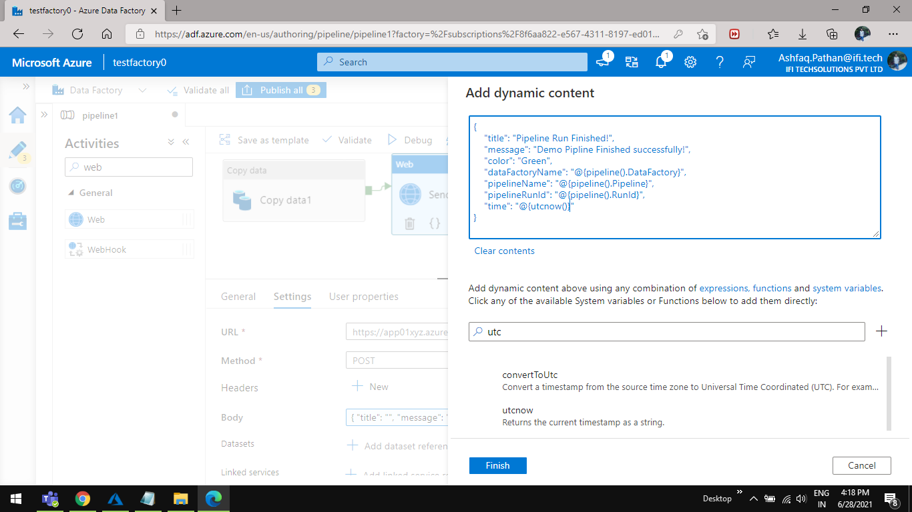

Step 25 Open ADF and click on Debug button.

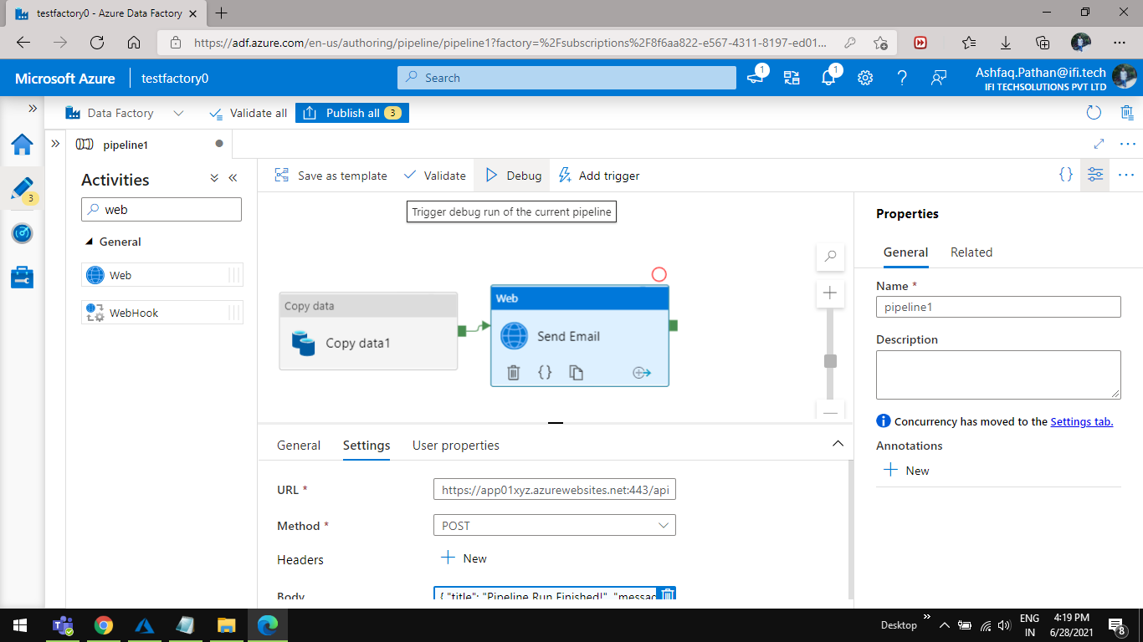

step 26 As you click on debug in ADF you will see a link in logic app overview Click on this link.



26.1 You will see a green tick that means we have received a post request to this logic app from ADF pipeline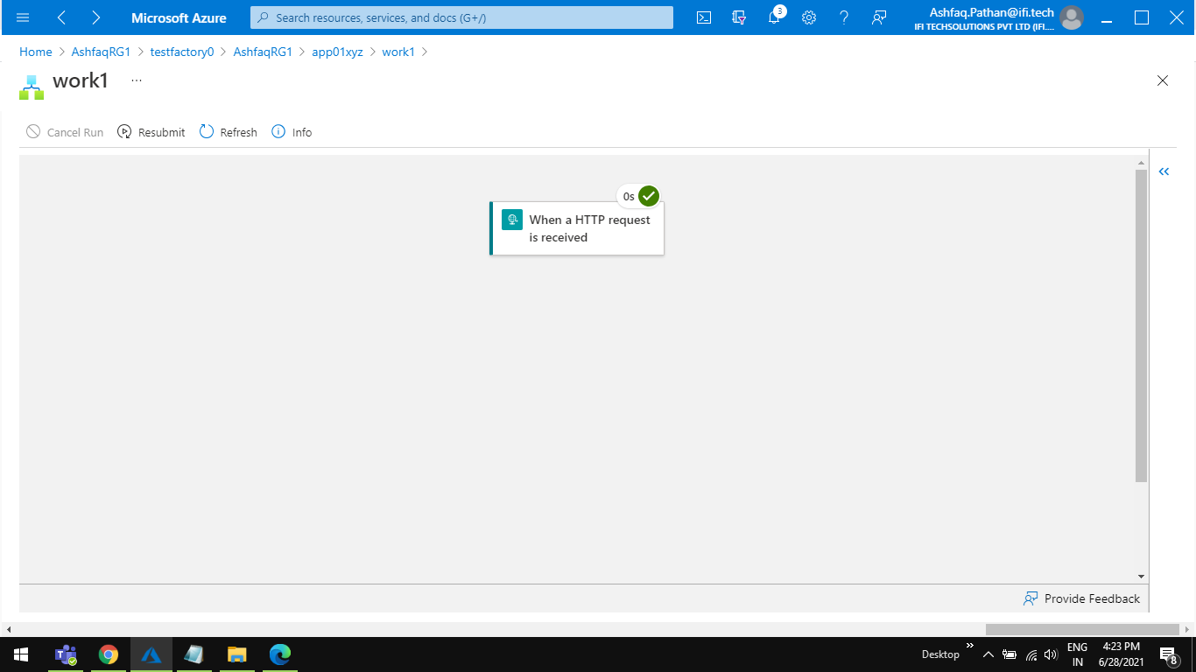

26.2 You can check the post data by double click on the activity.

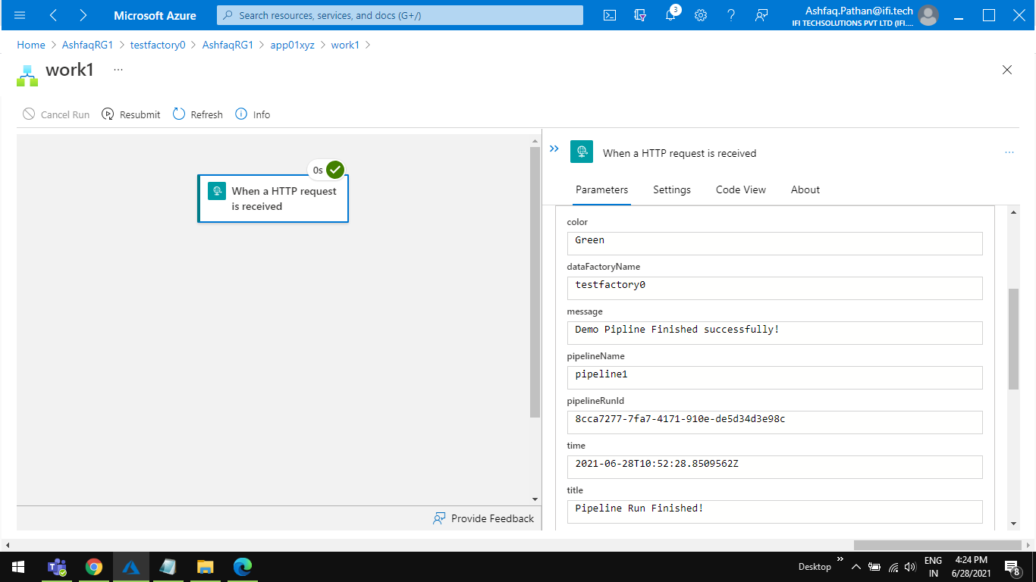

Step 27 Add a new action **outlook.com** for emailwe need to add **‘send an email (v2)’**

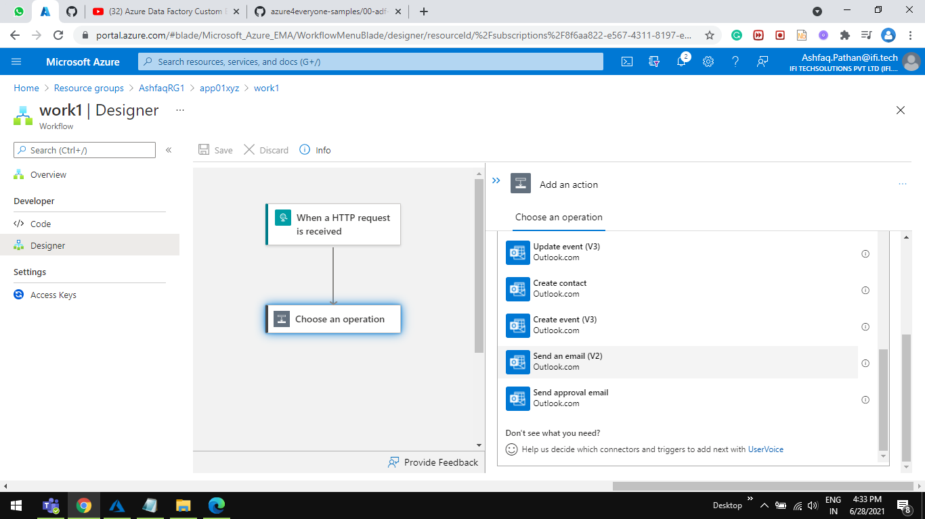

27.1 Click on outlook action it will ask for **sign in** with your outlook email.

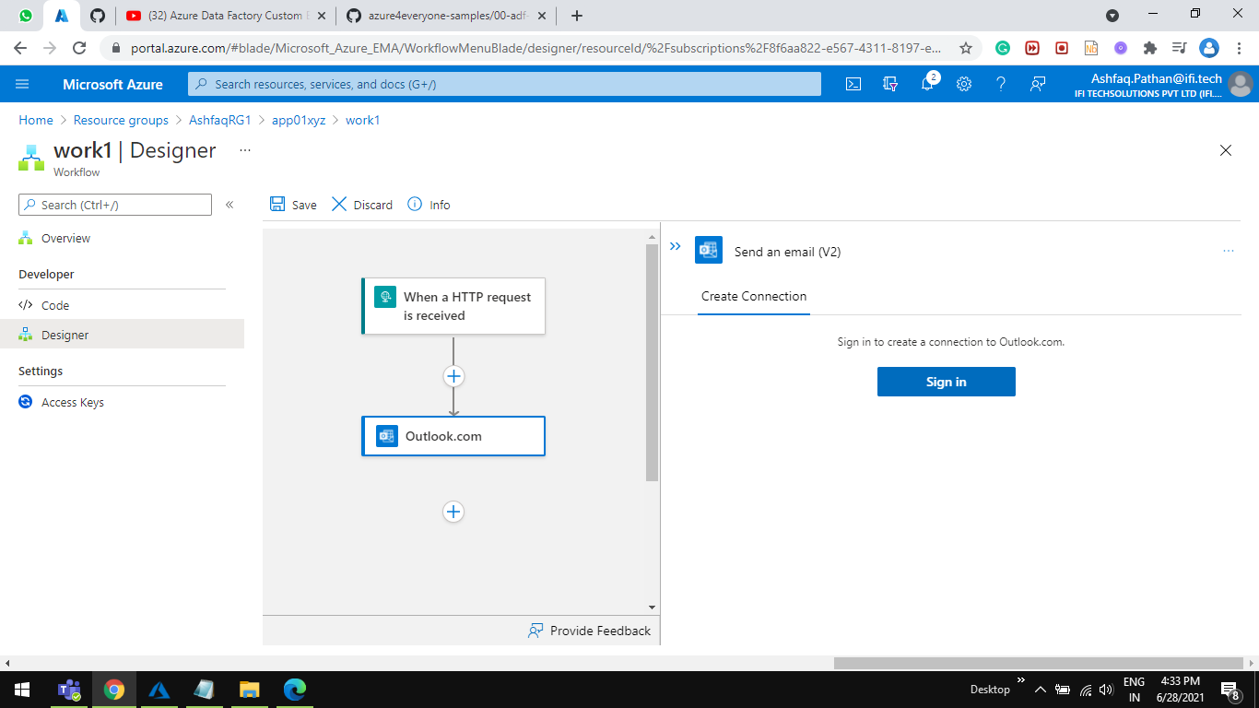

27.2 A new window will appear add login detail email click on **Next** button.

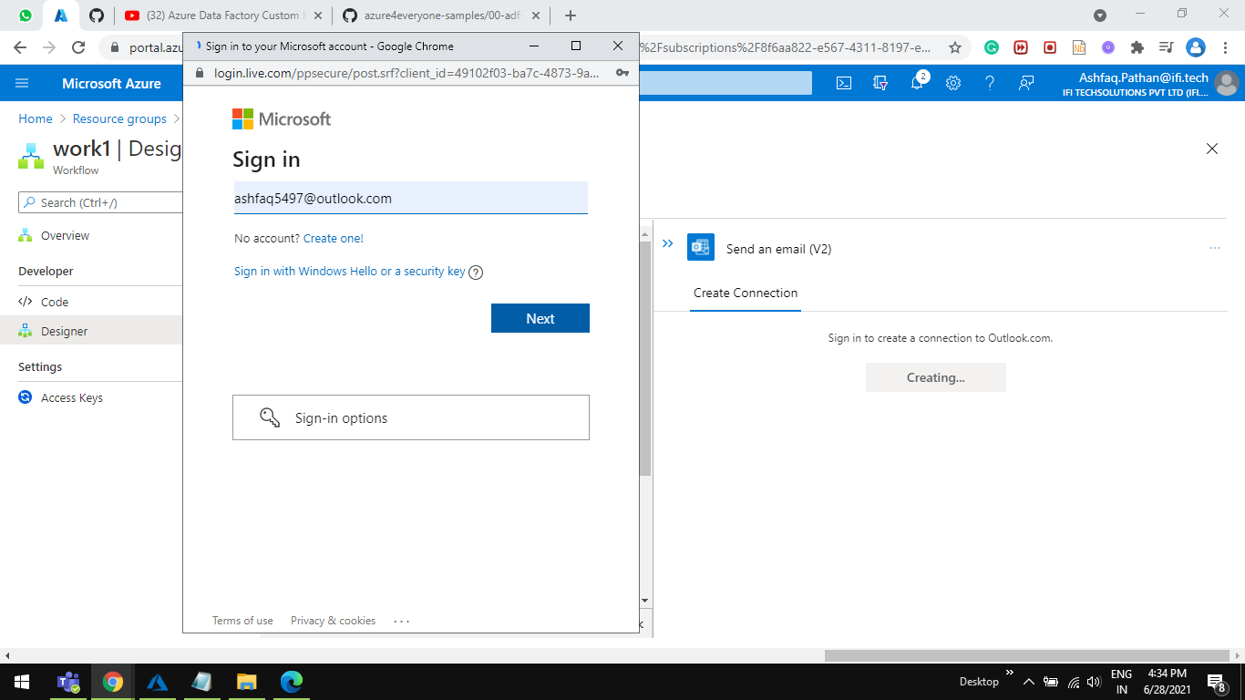

27.3 Add password and click on sign in button.

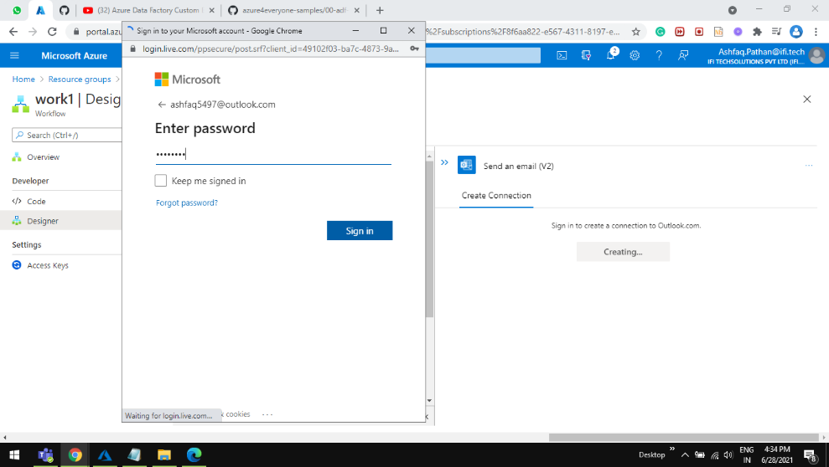

27.4 Click on **yes** button.

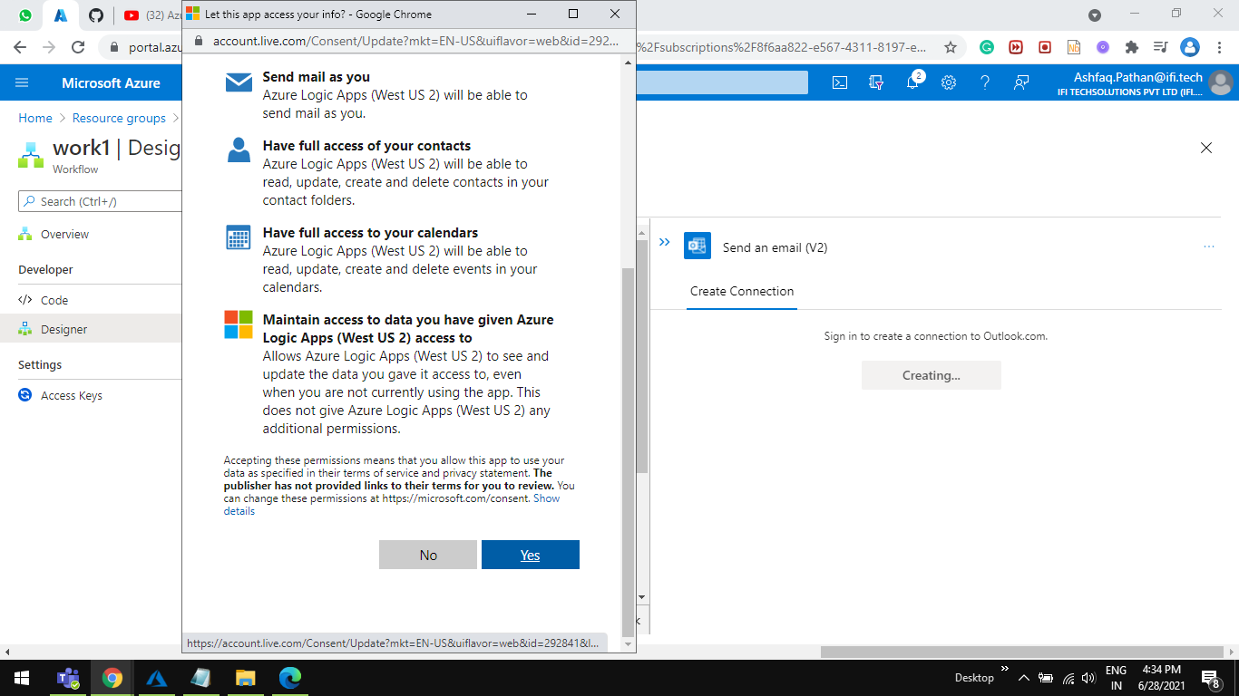

Step 28 Add email details in parameters

To* [put any valid email]

Subject* [ Title ] Note (we have created a title value in Jason so we can take that as a value in the subject text area)

Body* email body

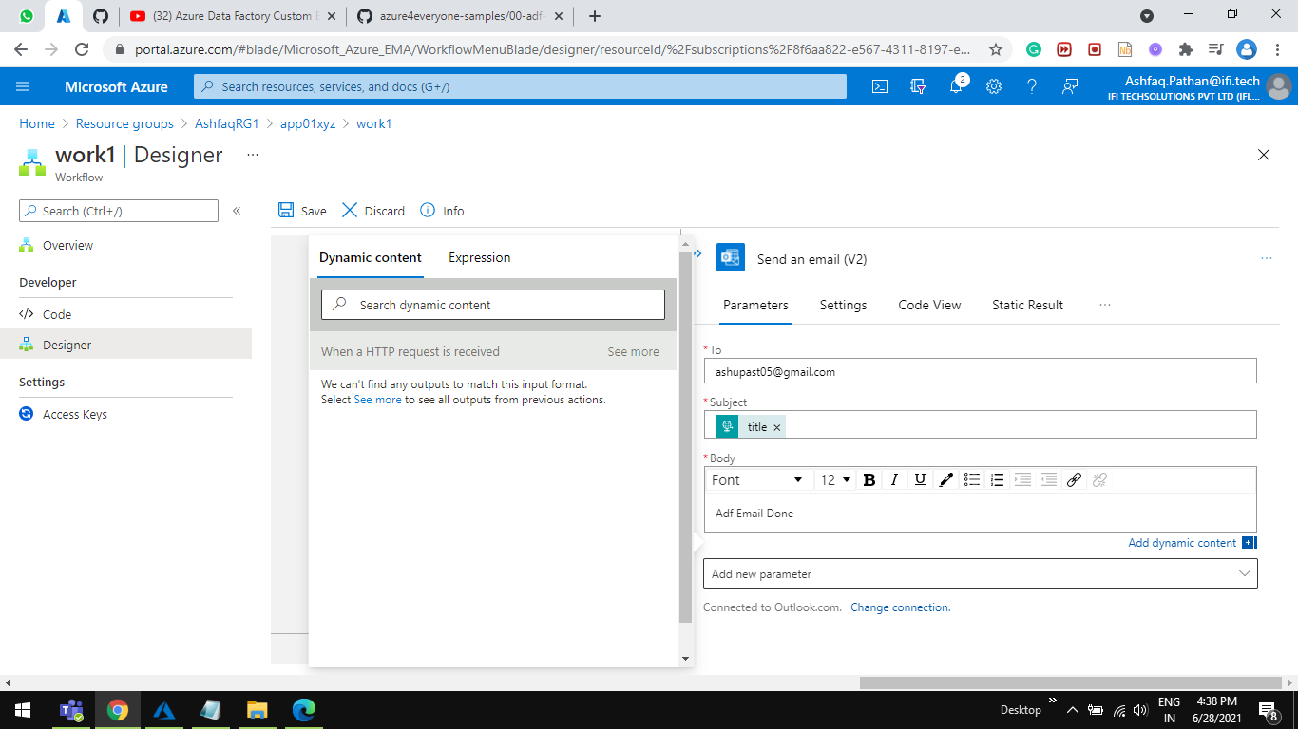

Step 29 Open ADF Pipline1 an click on Debug button



Step 30 As the pipeline complete you will get an email.

