Create a pipeline to move and delete multiple folders from source container to sink container in same azure blob storage whenever a new folder is created.

Prerequisites

Need an azure subscription.  
Need a ADF resource Create it from azure portal.  
Need a Storage account with 2 container in it for Input and output.

Following is the steps.

Step 1 Drop & Drag Copy data activity from Move & Transform.

Rename

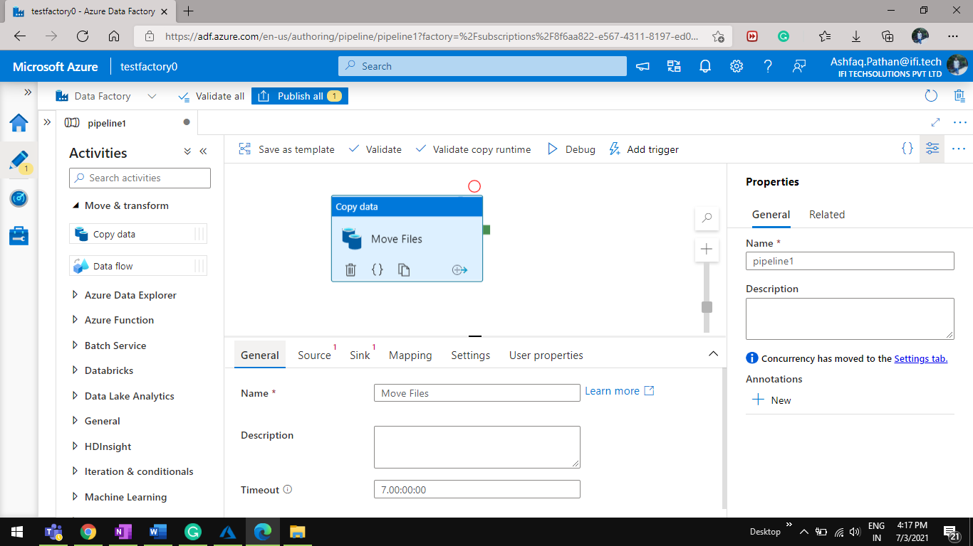

Step 2 Click on Source < +New Button Select Delimited text

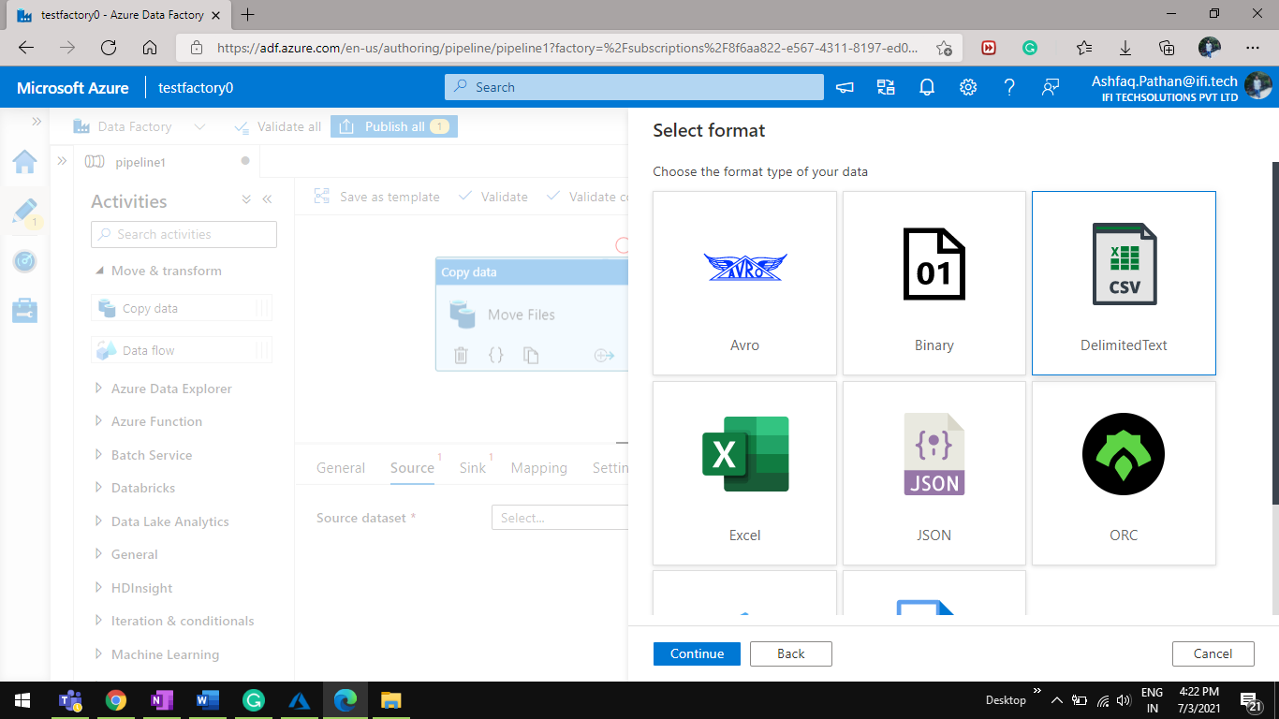

Step3 Select Blob Storage.

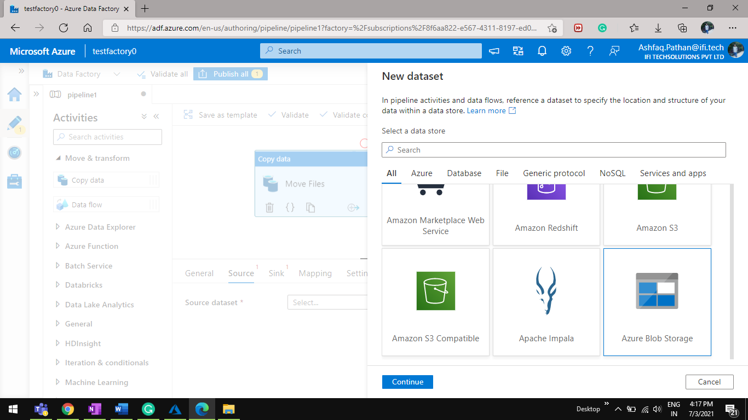

Step 4 Add subscription and storage account name from drop-down.

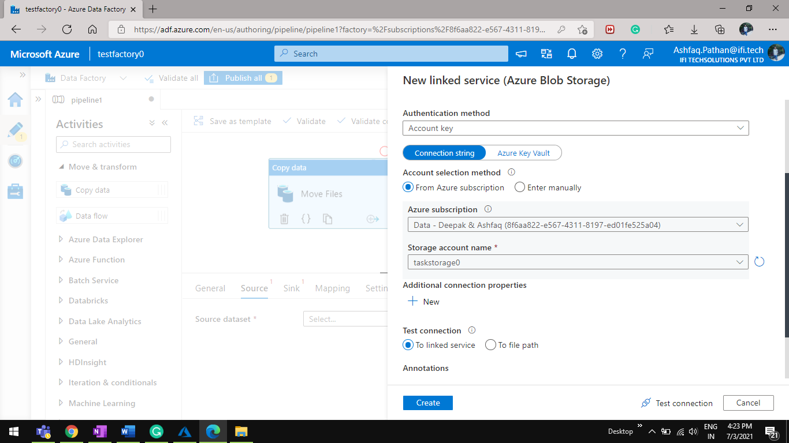

step 5 Add Linked service.

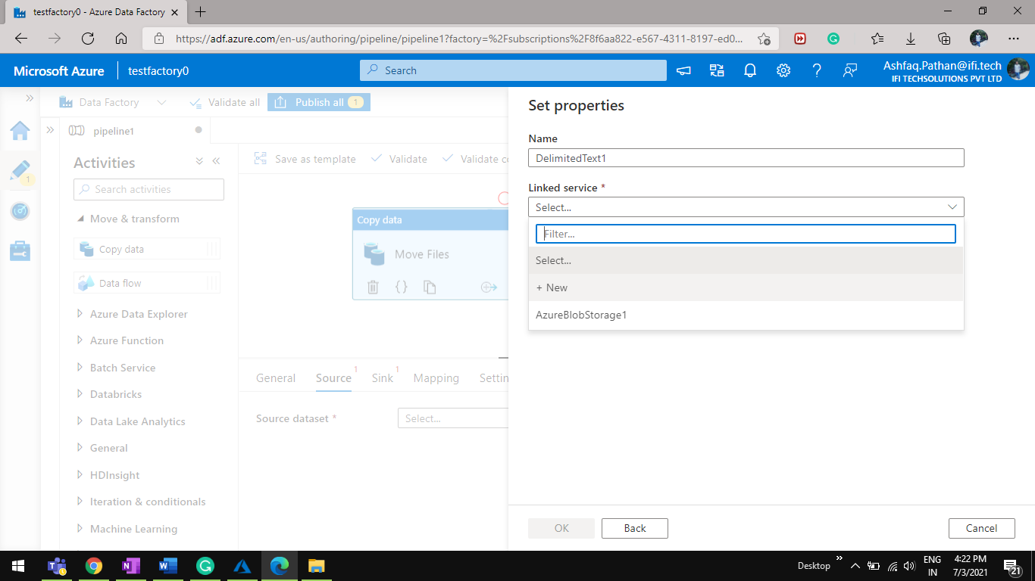

5.1 Add input Container path.

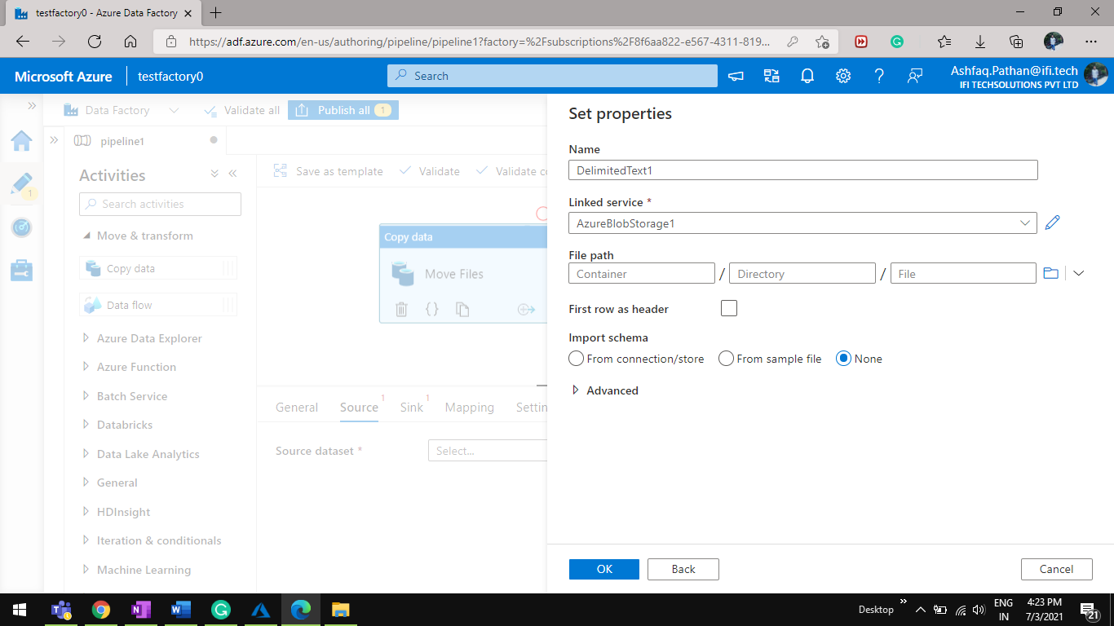

Step6 Config Sink For copy data Activity. Click on +New button.

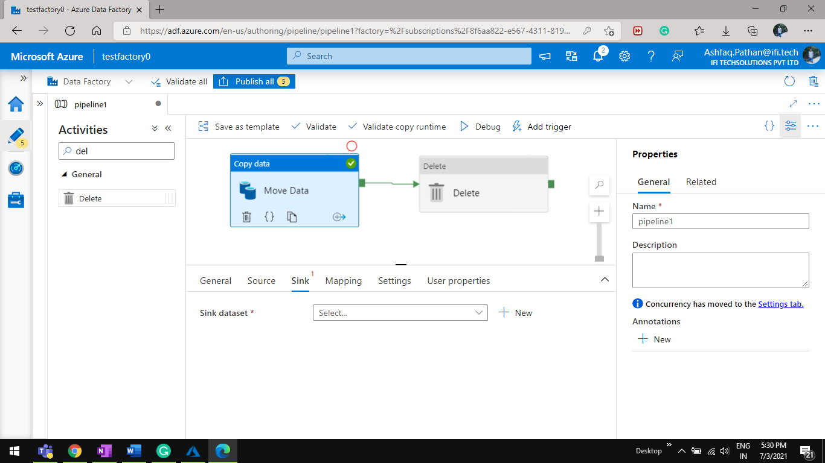

Step 7 Select Azure Blob Storage.

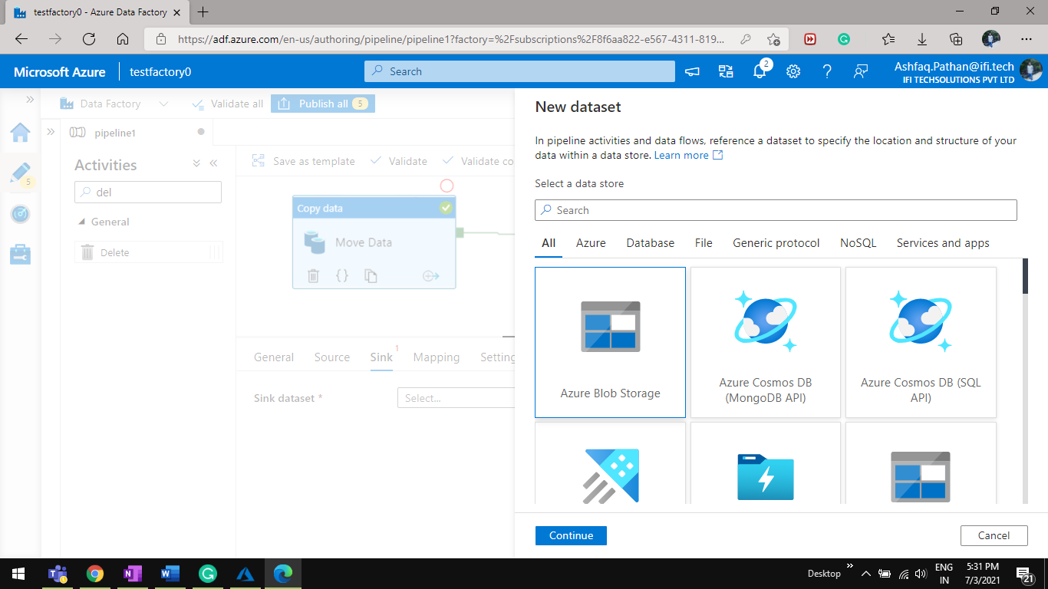

Step8 Select Delimited text.

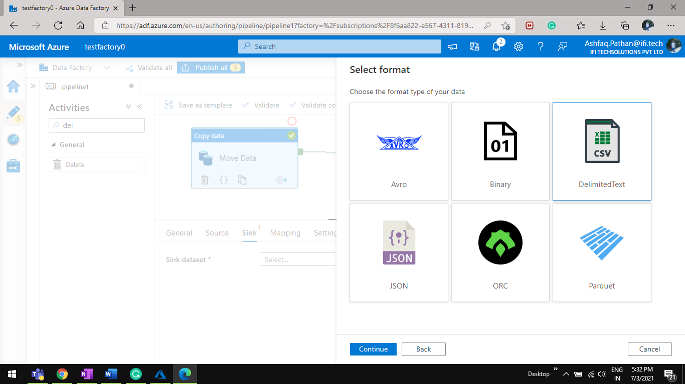

Step9 Select Linked Service.

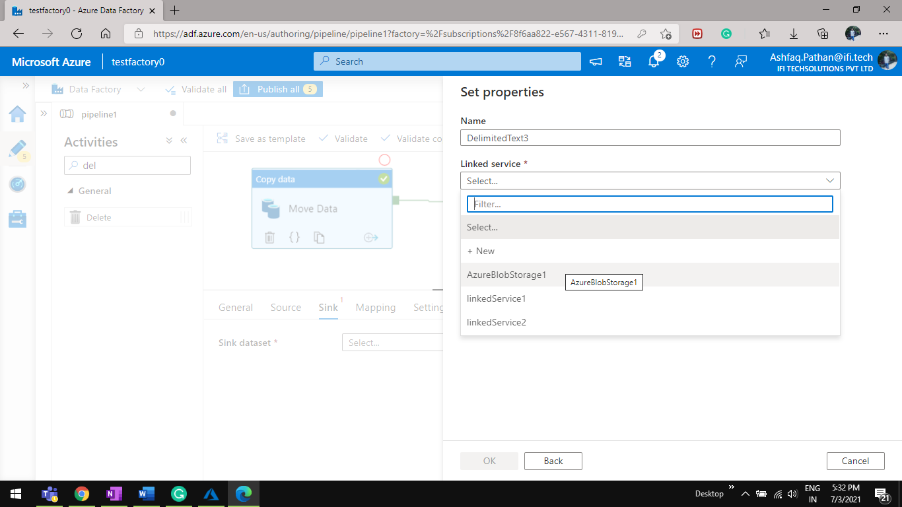

Step10 Select Output Container in File path.

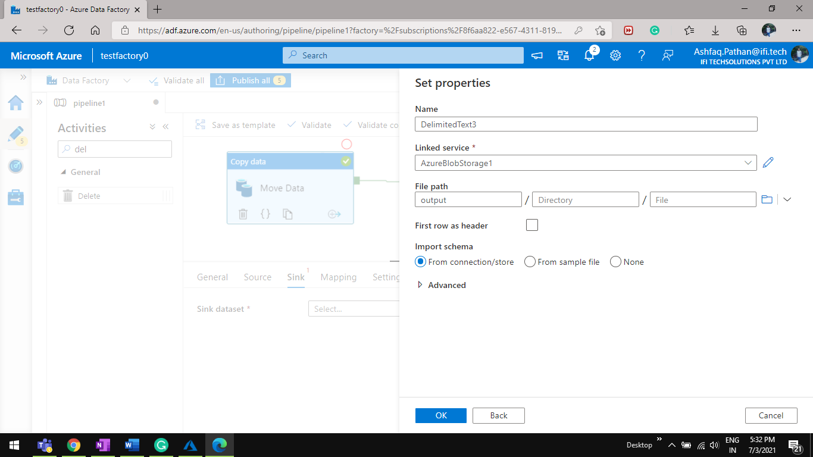

Step 11 Add Delete Activity from General drag & drop.

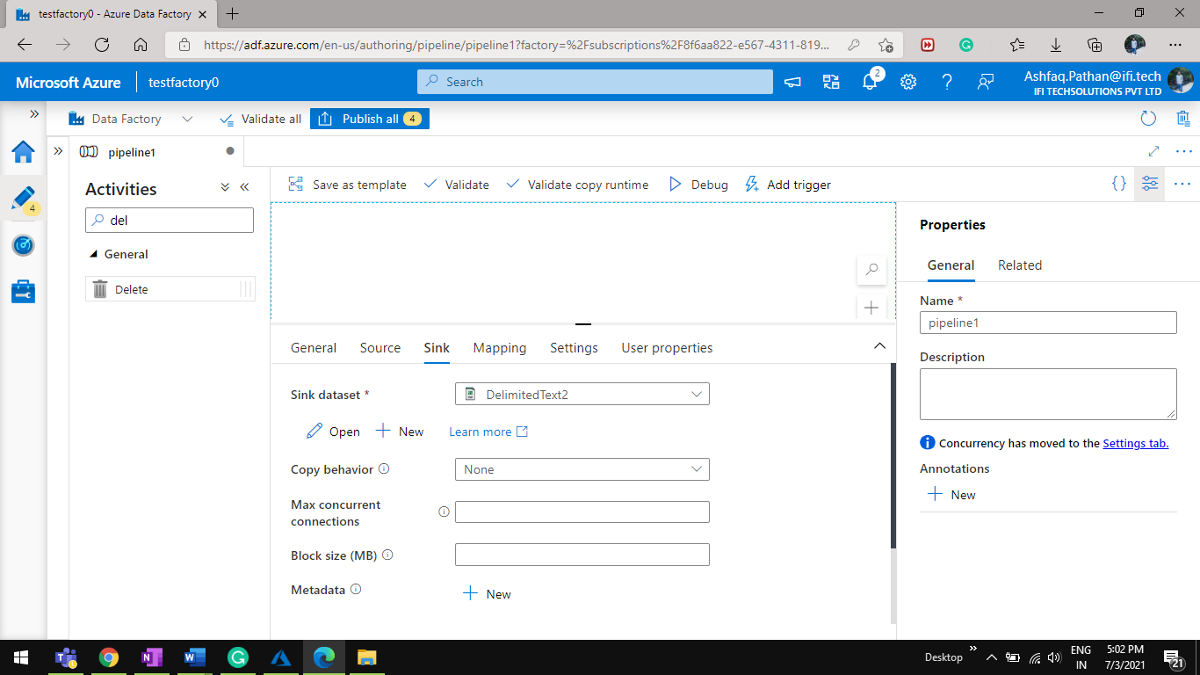

Step 12 Add Source Click on New Button.

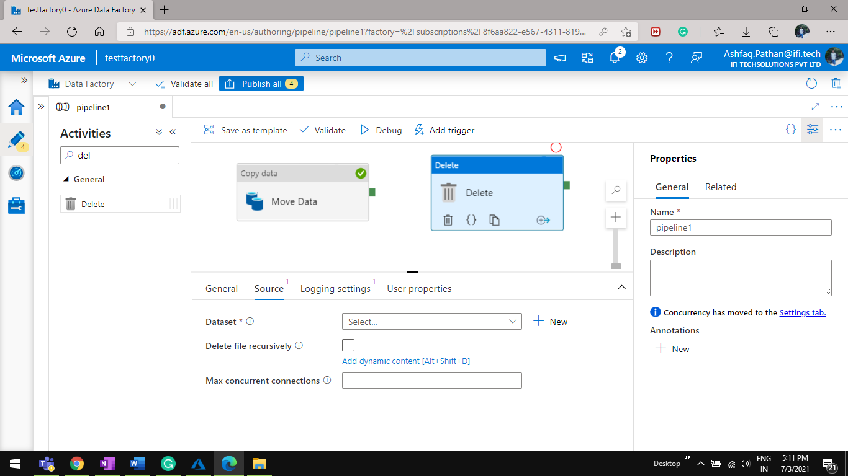

Step13 Select Azure Blob Storage.

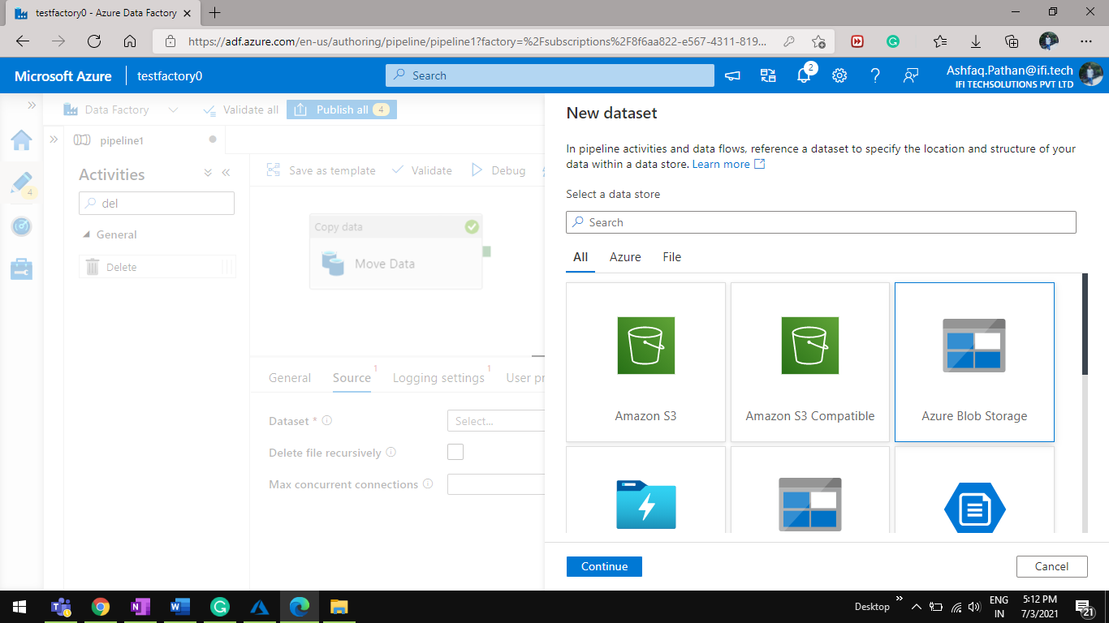

Step 14 Select File path Input.

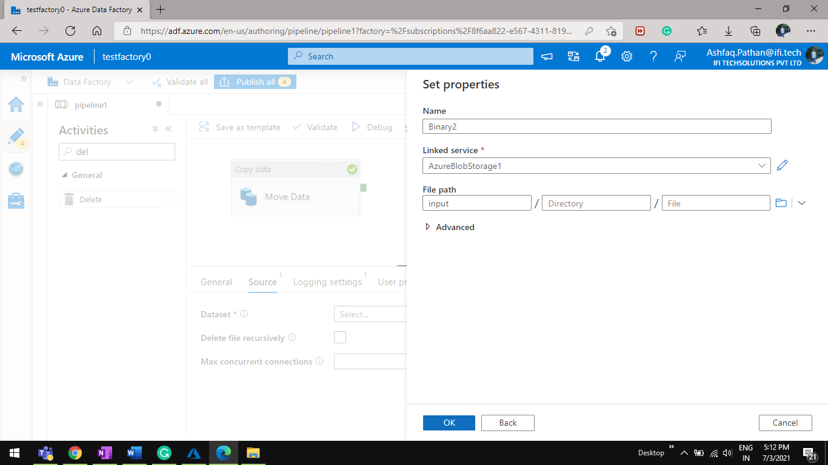

Step 15 Select Logging settings Select Logging account Linked Service add Folder path as Input Container.

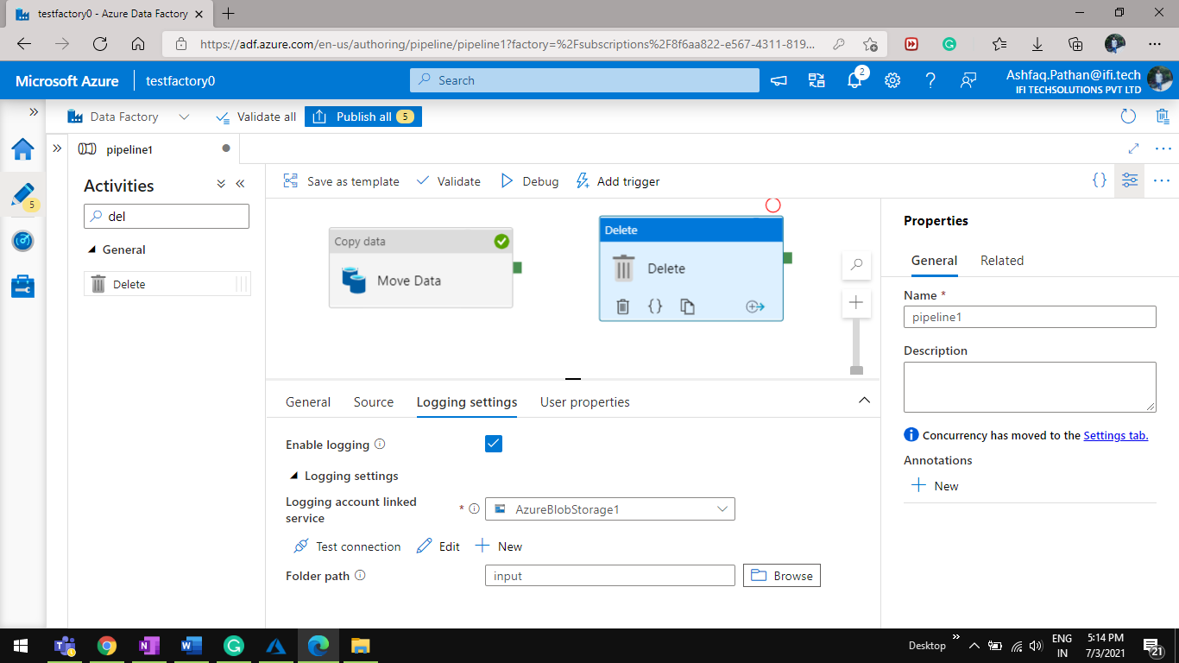

Step16 Click on debug.

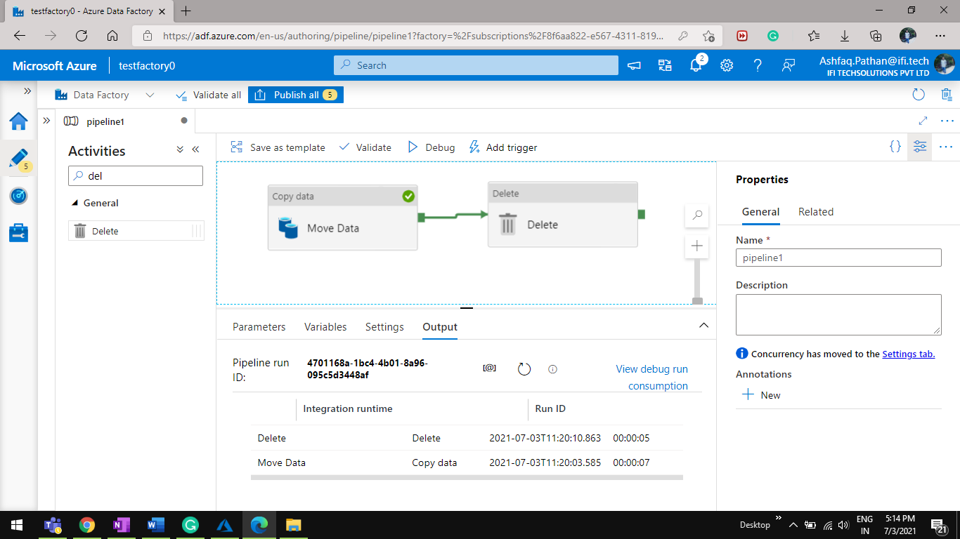

Step 17 Output of a pipeline.

