Pre-requisite

-You must create Power_Bi_Embedded resource using Azure Portal.

-login with the same account into power bi web portal link-> [Power BI](https://app.powerbi.com/home).

-Create a workspace with name: ‘Test01.’ In your power bi web portal.

-Connect your power bi workspace with Power_Bi_Embedded resource.

Login at power automation web platform-> [Microsoft Power Automate | Microsoft Power Platform](https://india.flow.microsoft.com/en-us/)

Note: you must log-in with same user id at (Azure Portal, Power bi, Power automation)

Step 1 :

Connect your Power_Bi_Embedded with power bi portal following are the steps.

-power bi portal >settings> admin portal> Capacity settings>power bi Embedded Configure the

Bi-embedded. It will appear as you create Power_Bi_Embedded in azure portal automatically.

Power_Bi_Embedded = ‘embedded01’

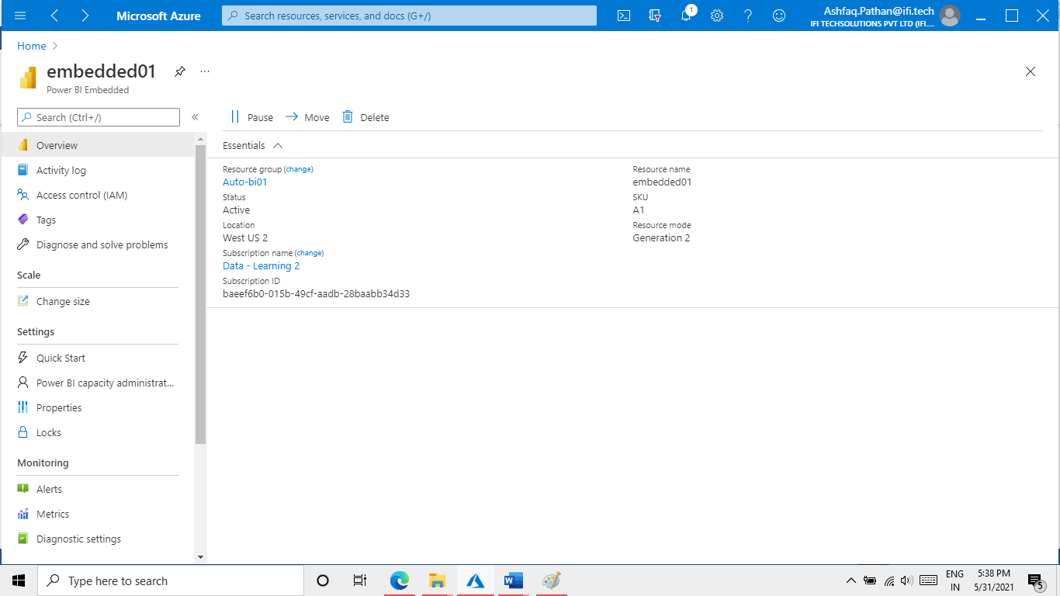

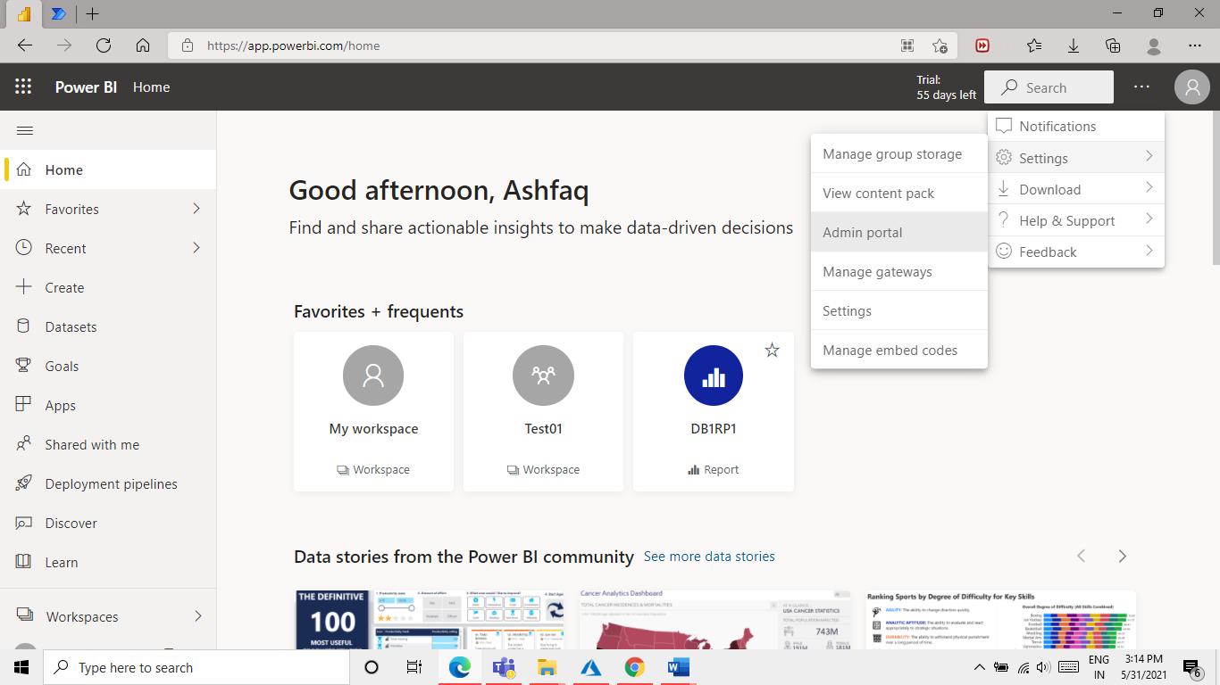

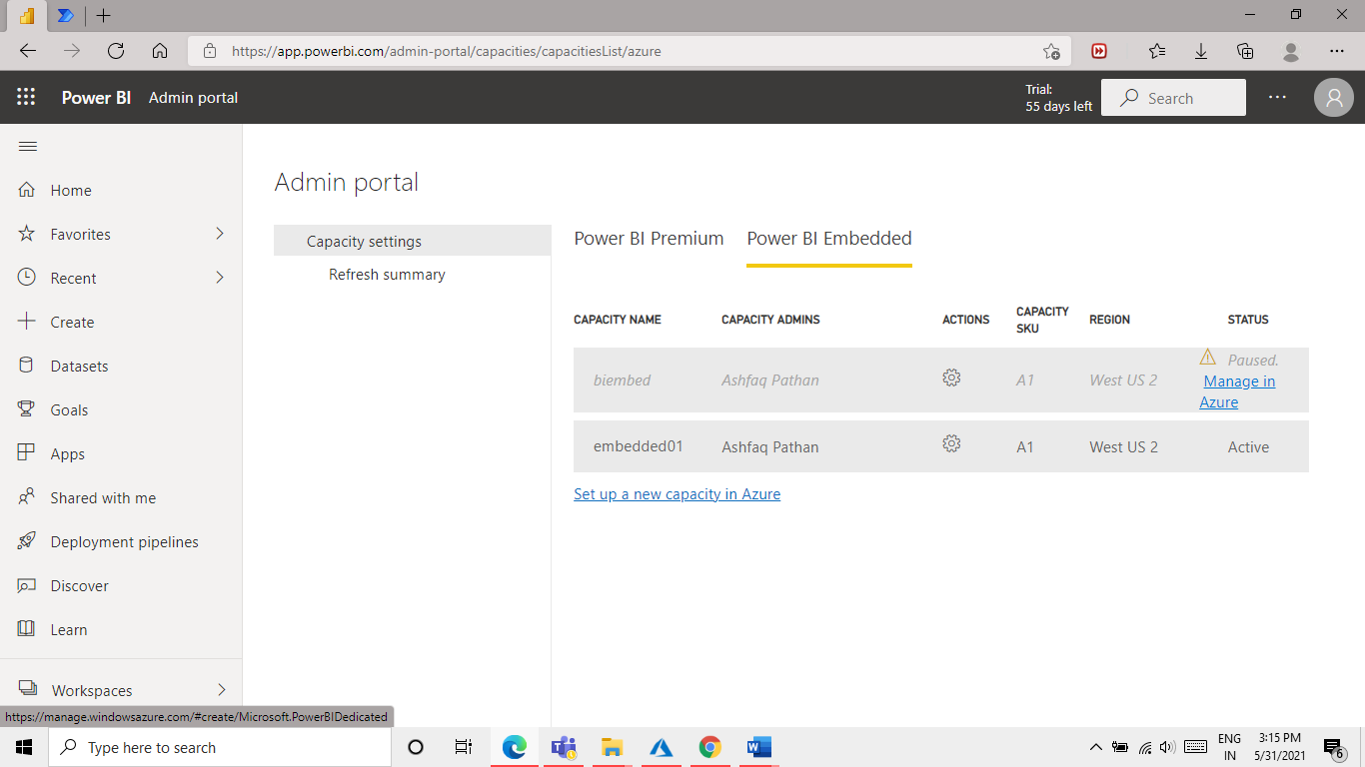

Step 2 :

Create a workspace in power bi portal and upload some .pbix files in that workspace.

-Create a Workspace

go to home select workspaces from left bar create new workspaces with name ‘Test01’.

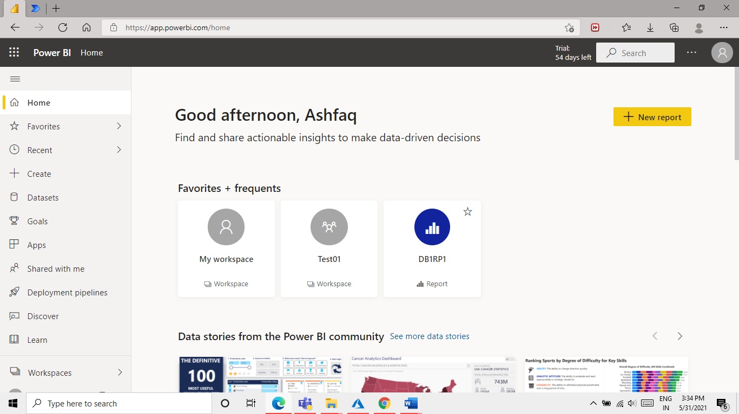

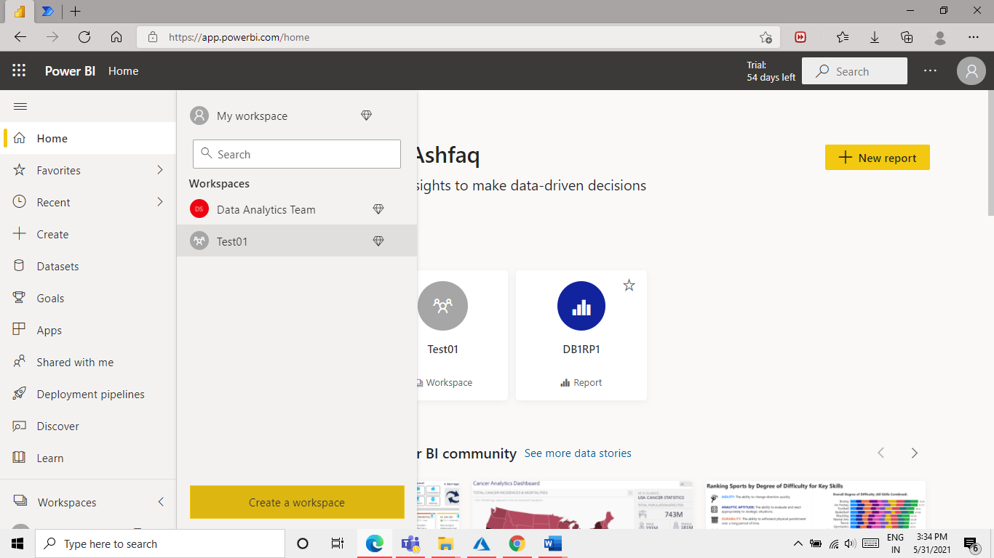

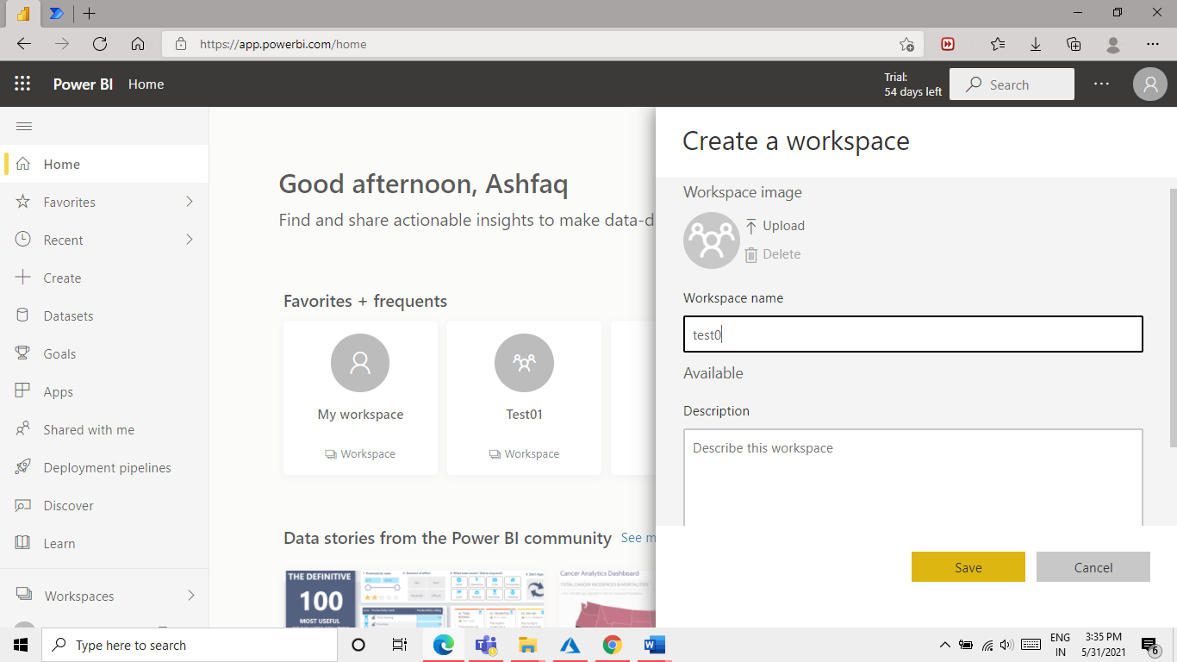

Step 2.1 : upload some .pbix file in to workspace.

Put some files in Workspace I will be using “Test01” .

Click on “+ New” Button and you can upload different types of files but now we will be uploading pbix files.

For this. Follow the images below.

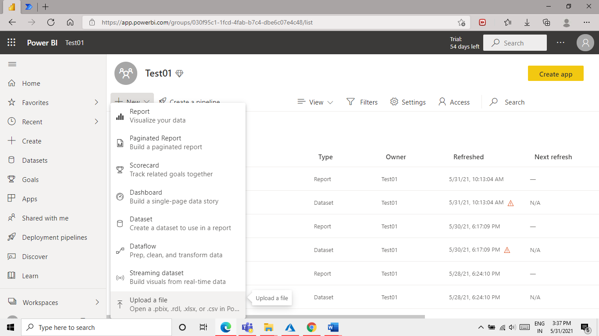

As you click on “upload a file” option the below page will be appear click on “local file” option.

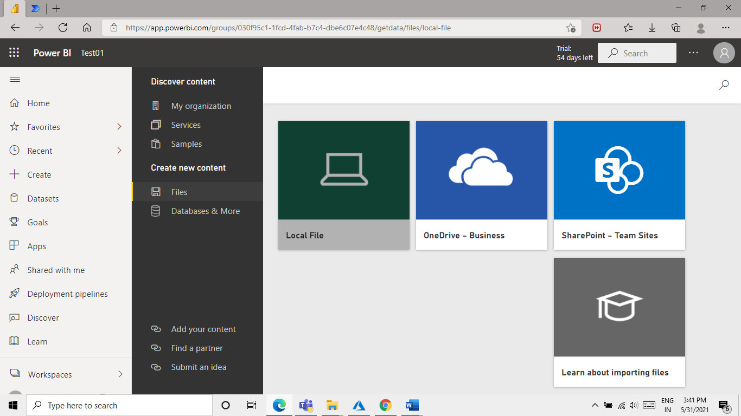

Select the power bi .pbix files and click ‘open’.

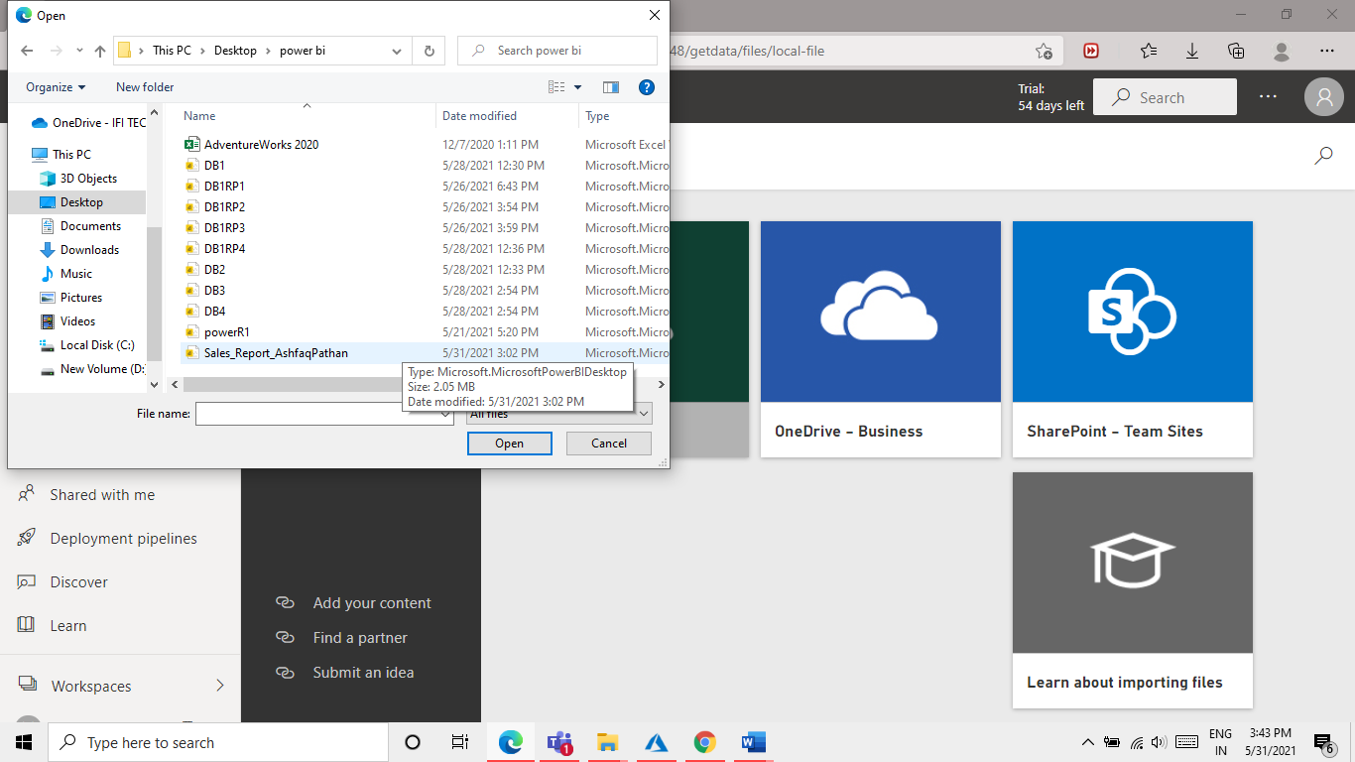

Ones you have uploaded a file it will create 2 file one is report file and second with data file.

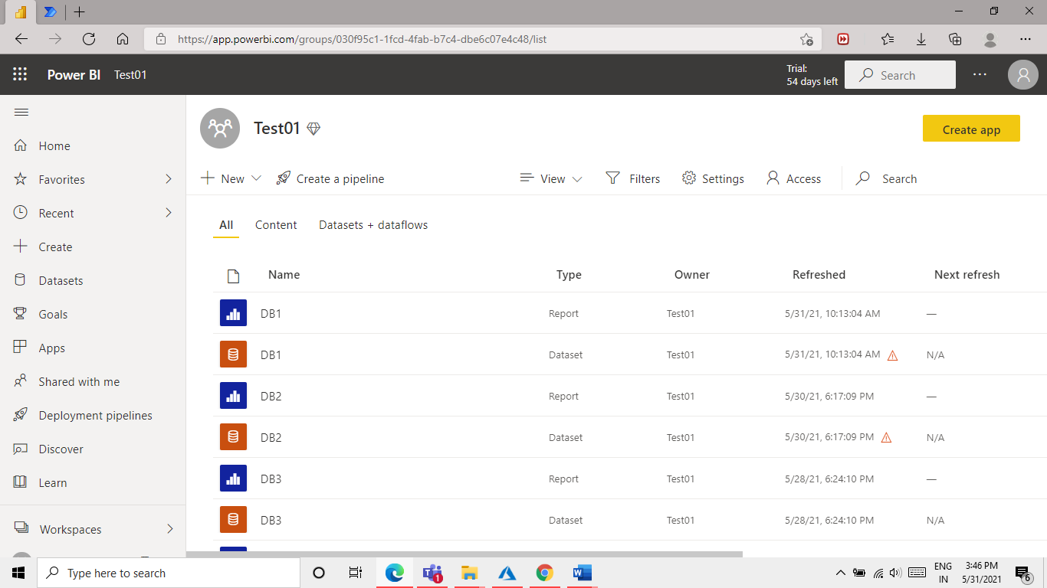

Now I will upload some more file in same way.

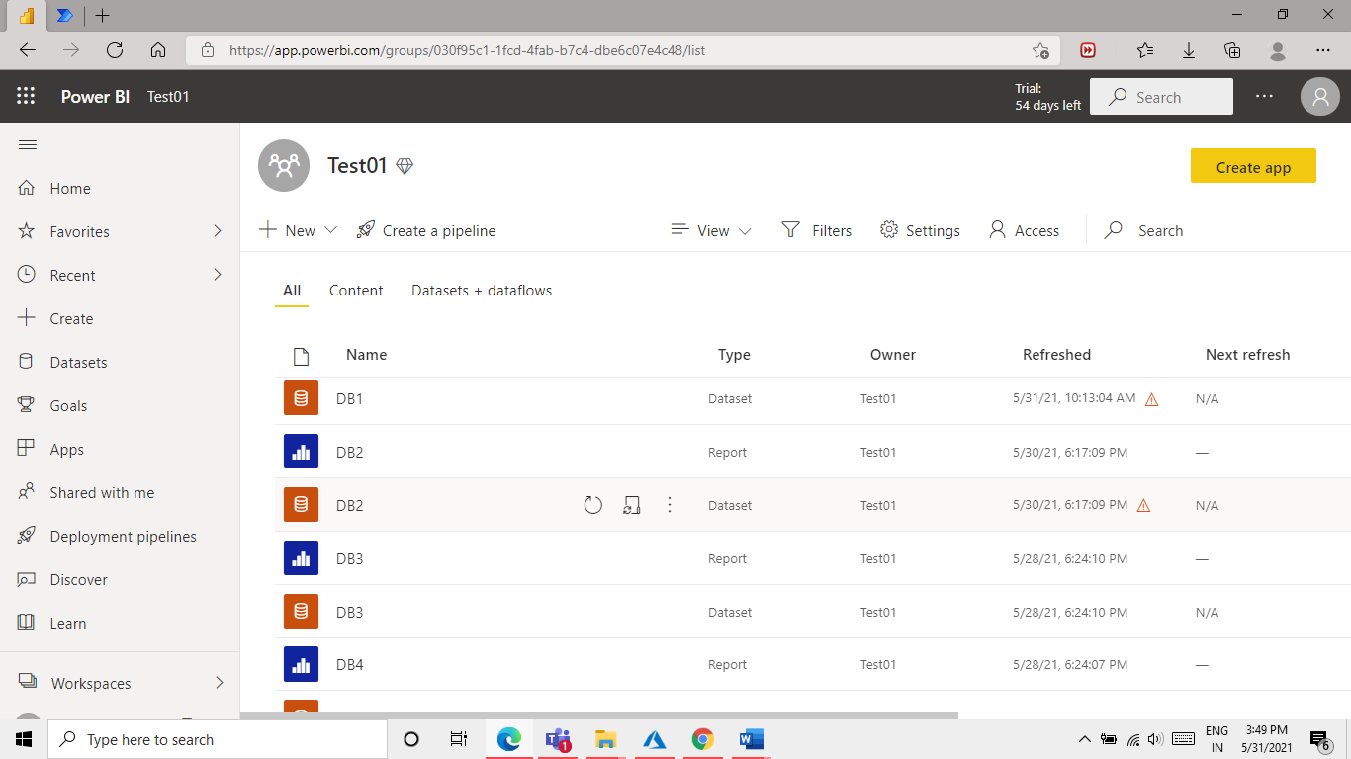

Step 3 Create a power automation flow.

Go to power automation web portal sign in with the same user id

[Microsoft Power Automate | Microsoft Power Platform](https://india.flow.microsoft.com/en-us/)

Power automation

For this demo we will create 2 flows based on random 2 scenarios

Test case 1: Refresh multiple data in a single flow the refresh time of this report will be same.

Test case 2: Refresh one set of data and adding a delay of 30 min to next second set of data.

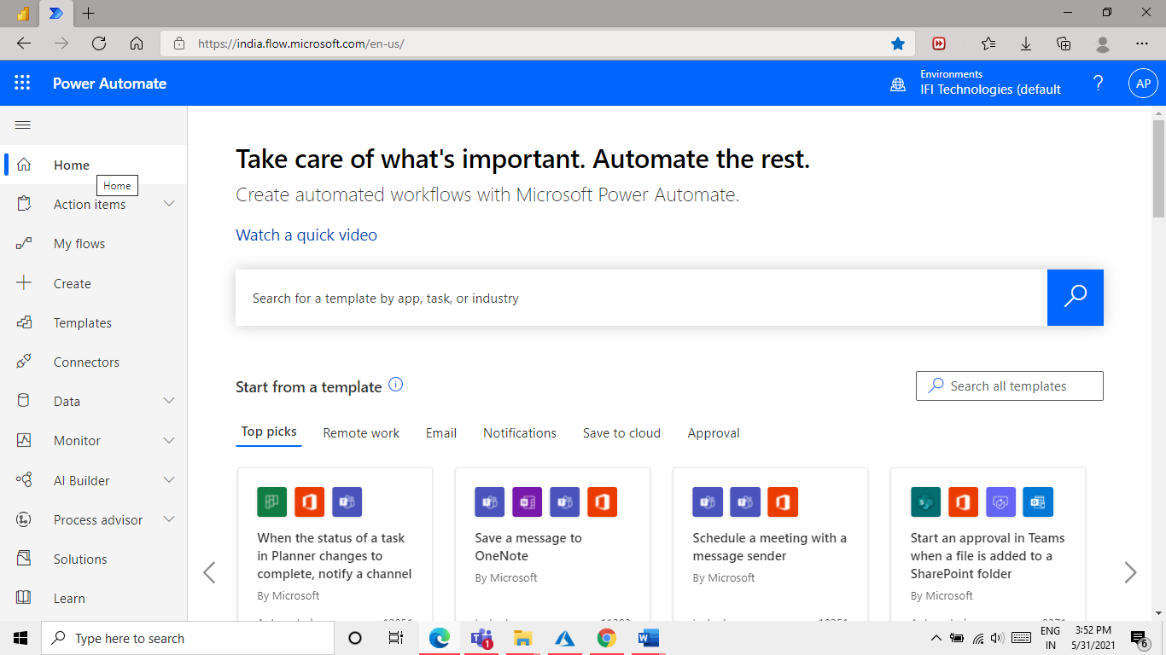

We will create a flow click on MY Flows from left bar 3rd option.

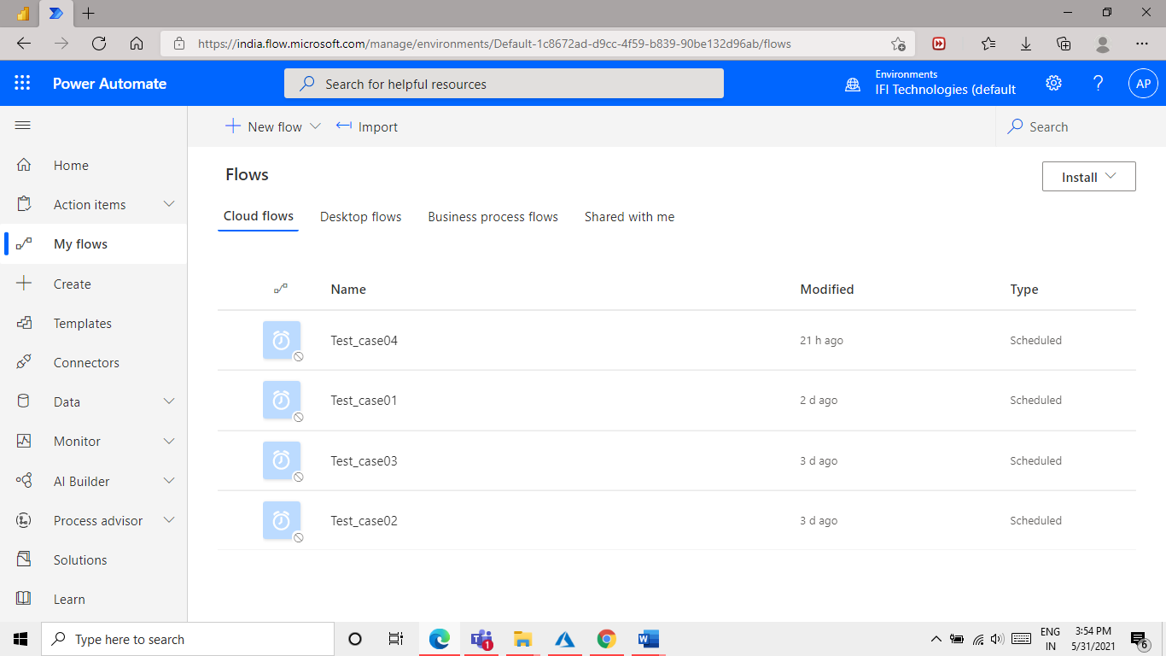

To create a new flow click on ” + New Flow” option we will be creating a Flow with this option “Scheduled Cloud Flow”

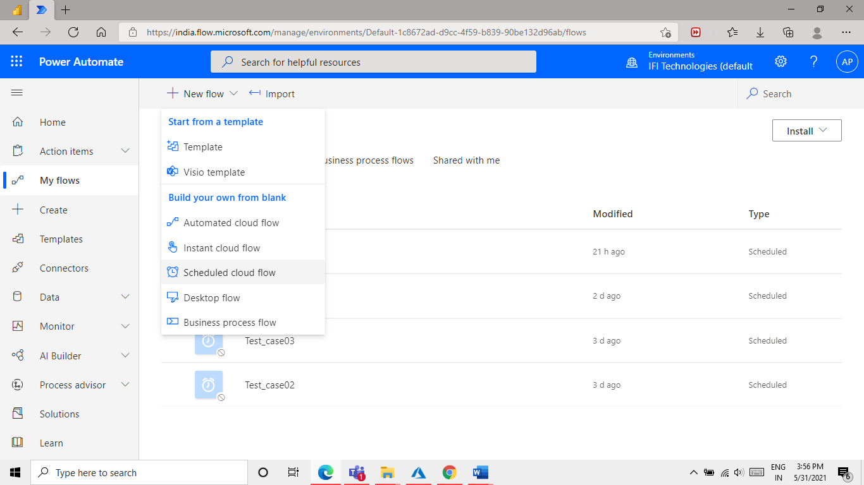

Give a name and click on Create.

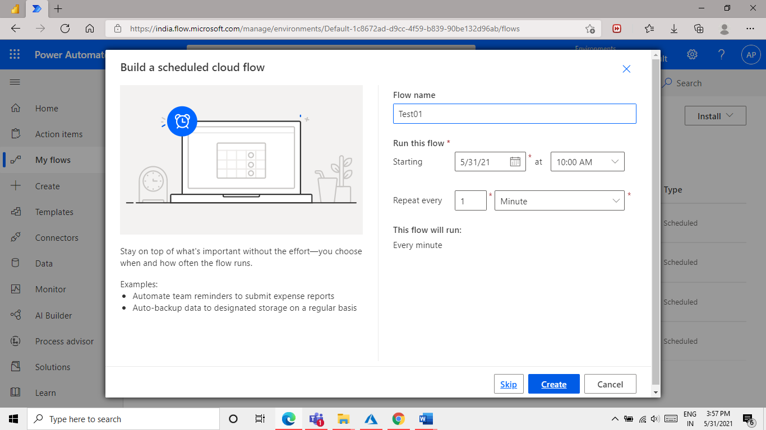

Step4 Create a flow for test case 1

open My flow click on “+ new step” to add a component to the flow

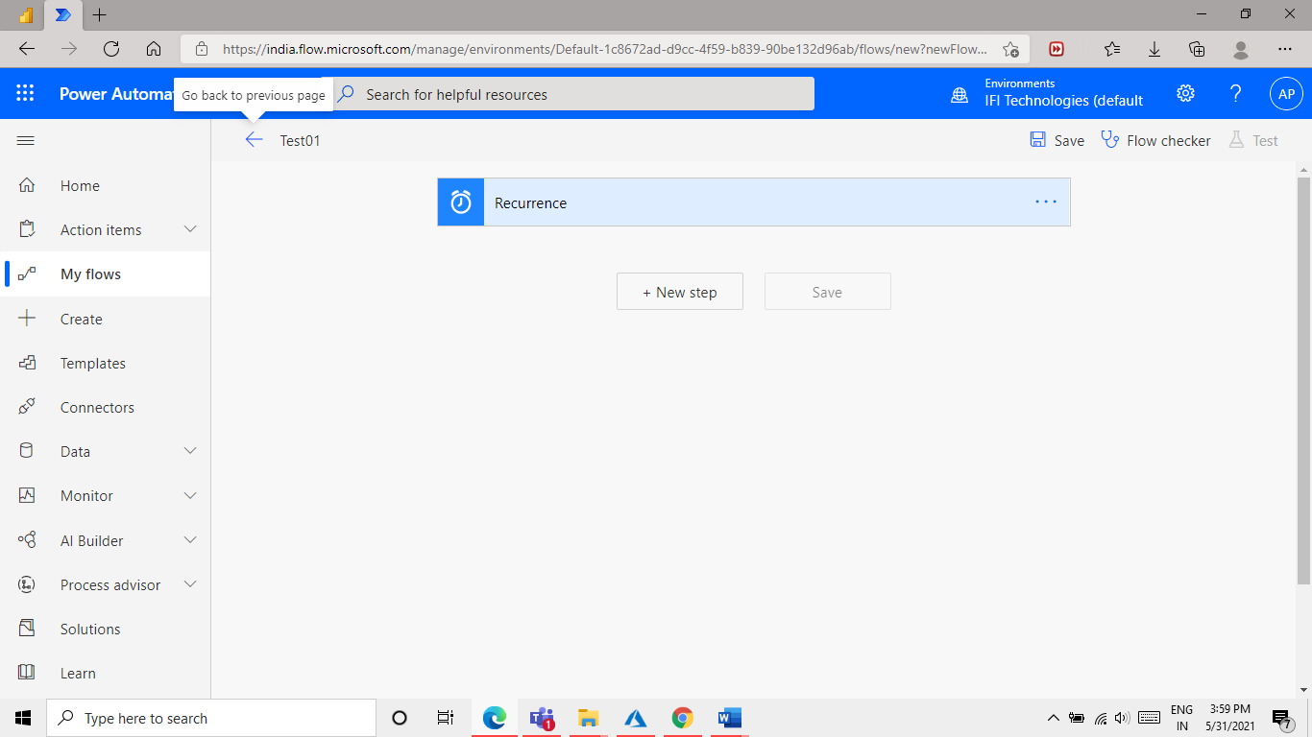

In “+New step” we will select “Refresh a dataset” Component. Follow below image.

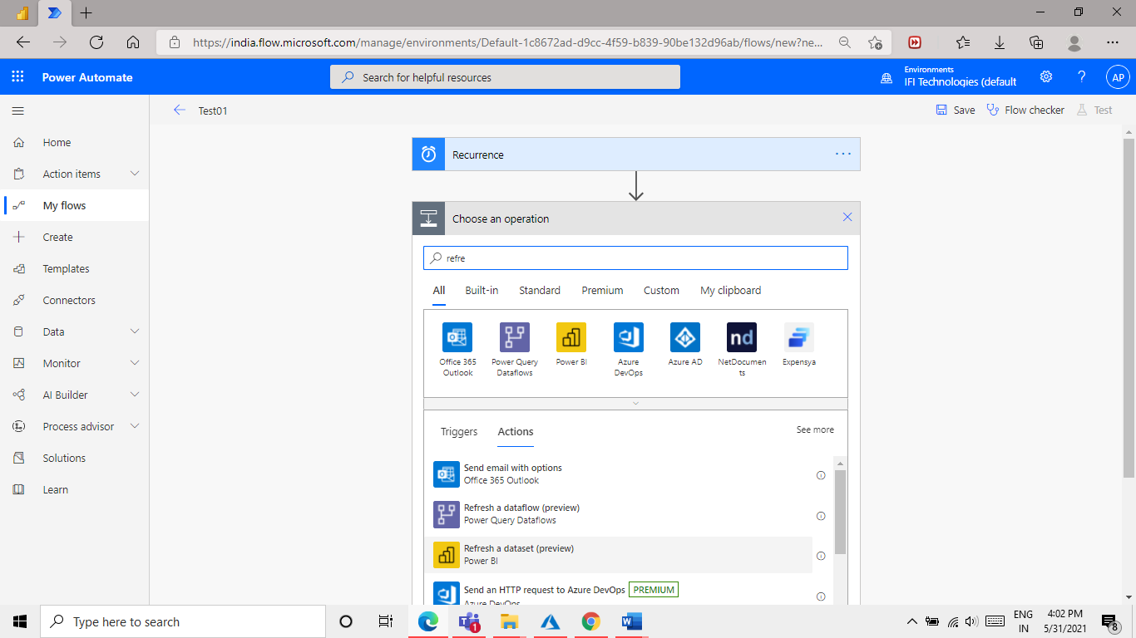

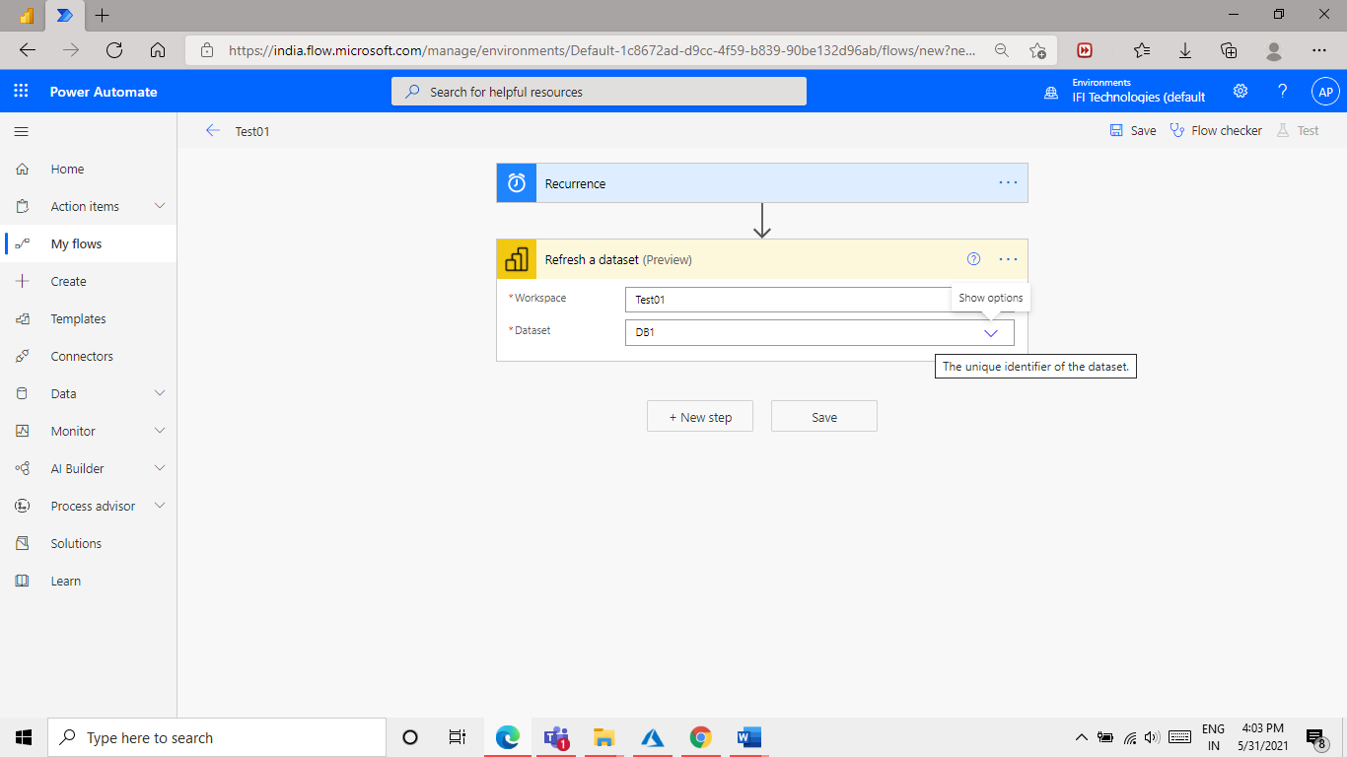

Add some more files here so that we can schedule multiple files refresh at ones.

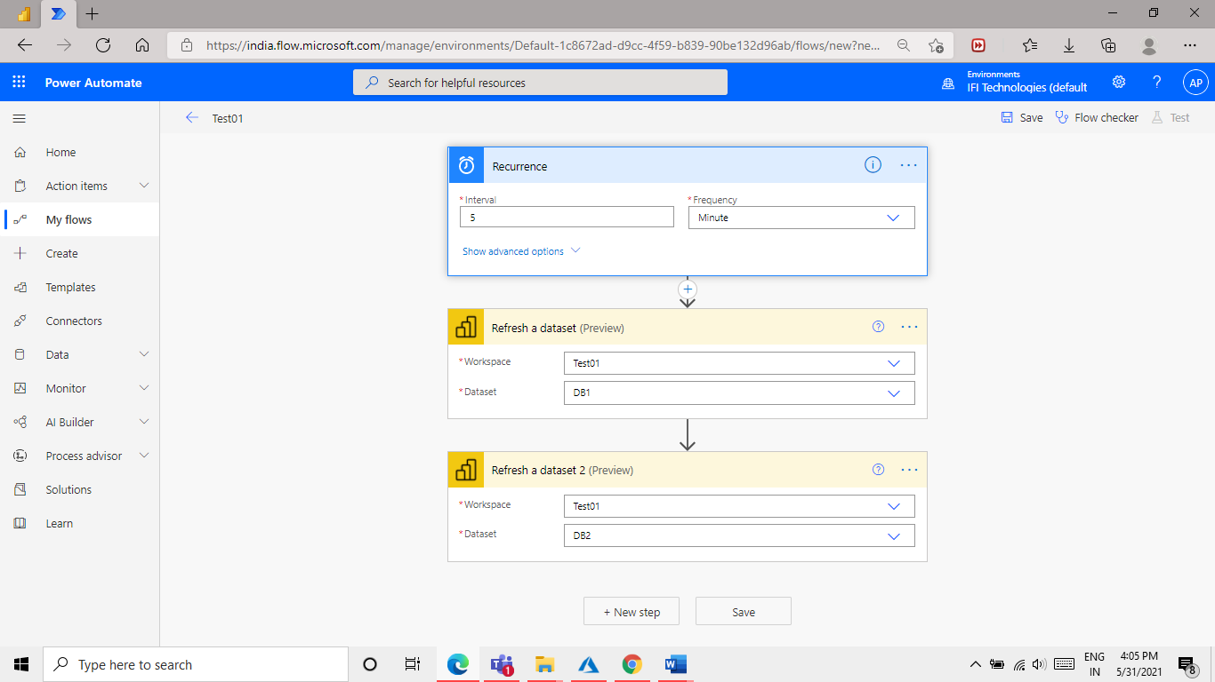

We can make changes in Recurrence time.as per use case.

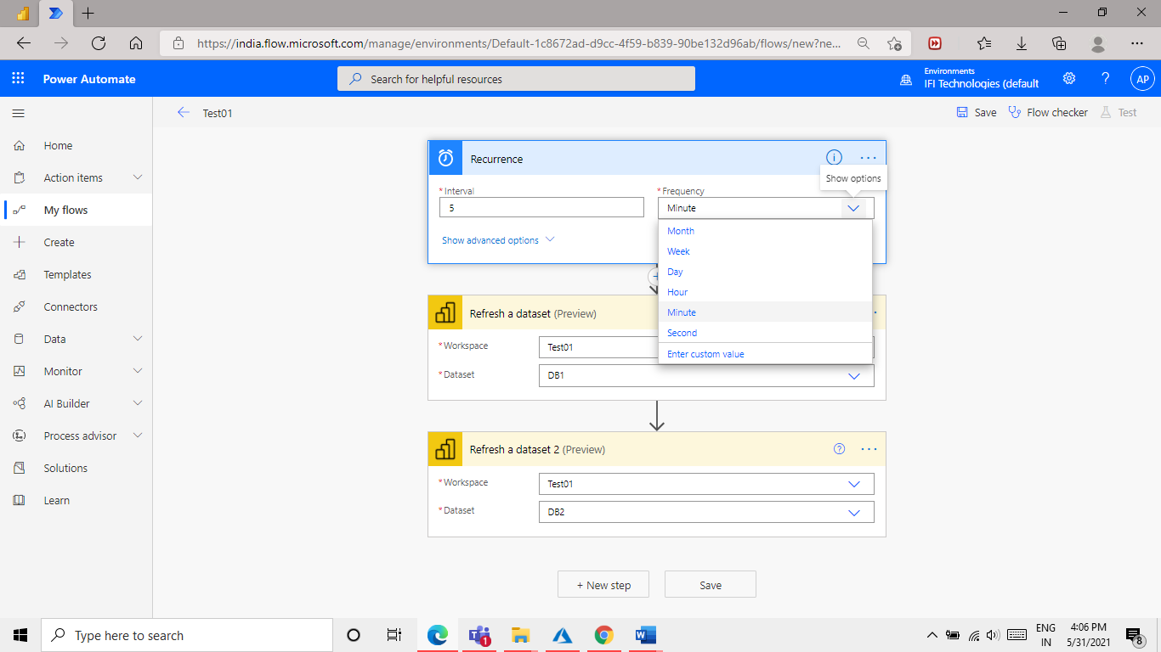

As you can see in below image we have Some option for time, day ,date that we can use as per our case needs.

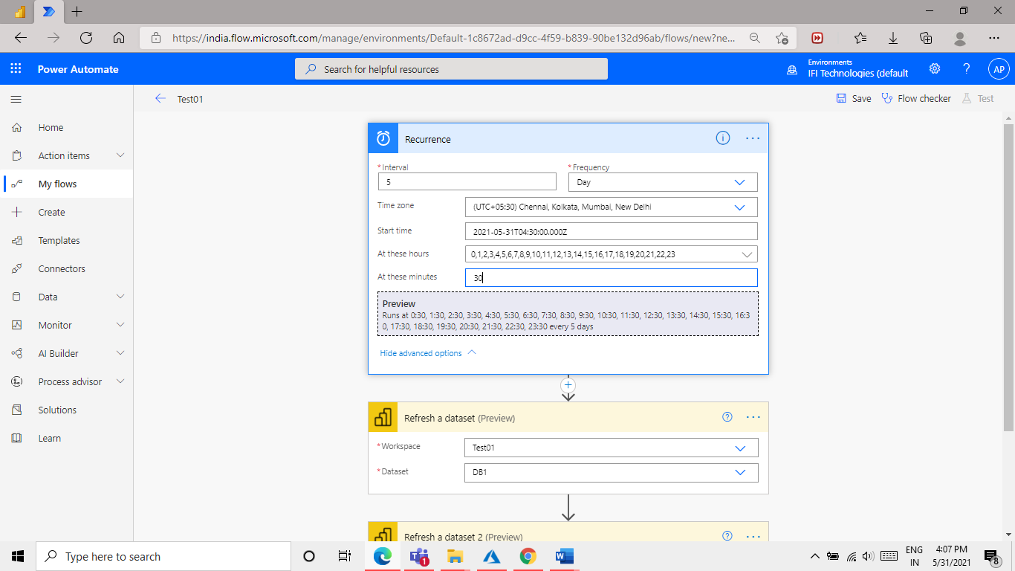

Click on save from top right side on screen and test the flow.

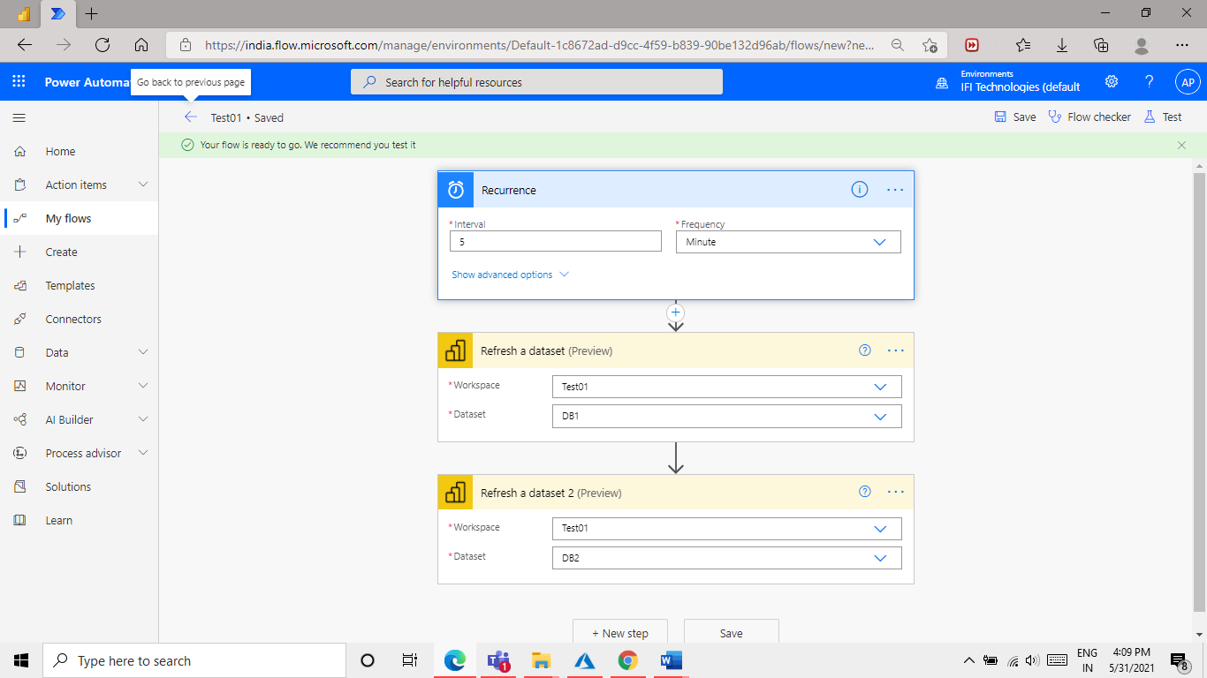

We will Test the flow. click on test and select manually option.

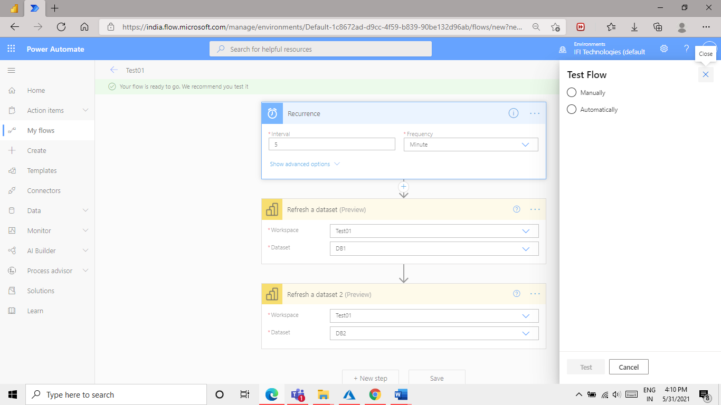

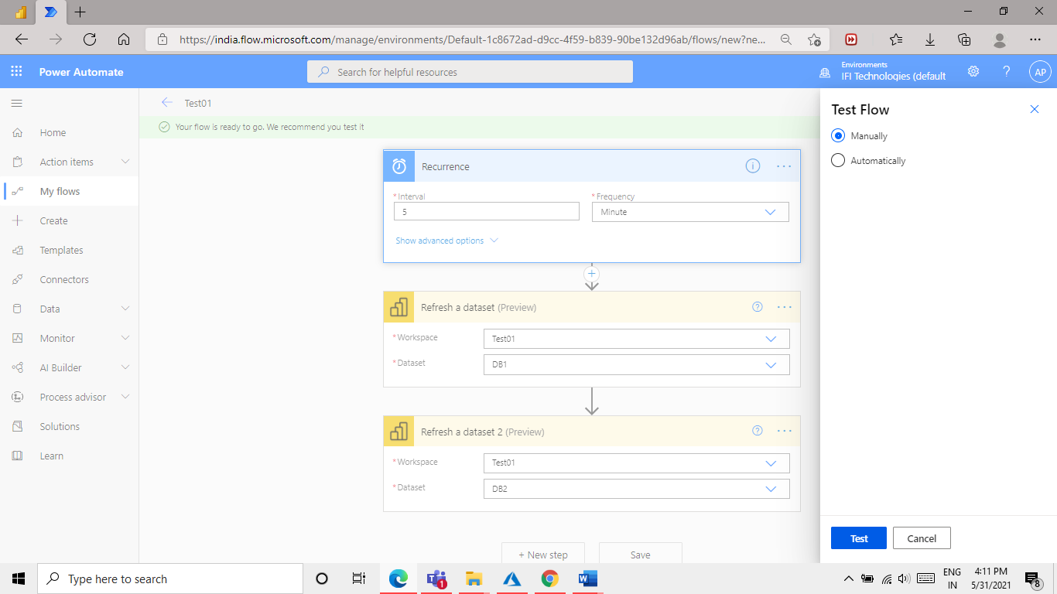

Click on run flow button.

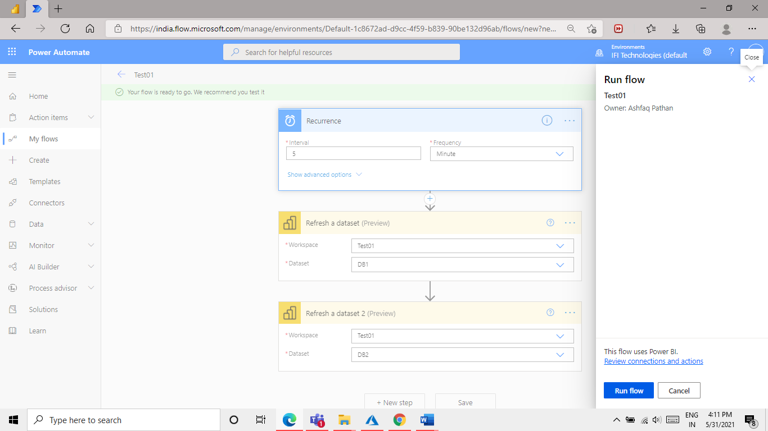

Click on Done button.

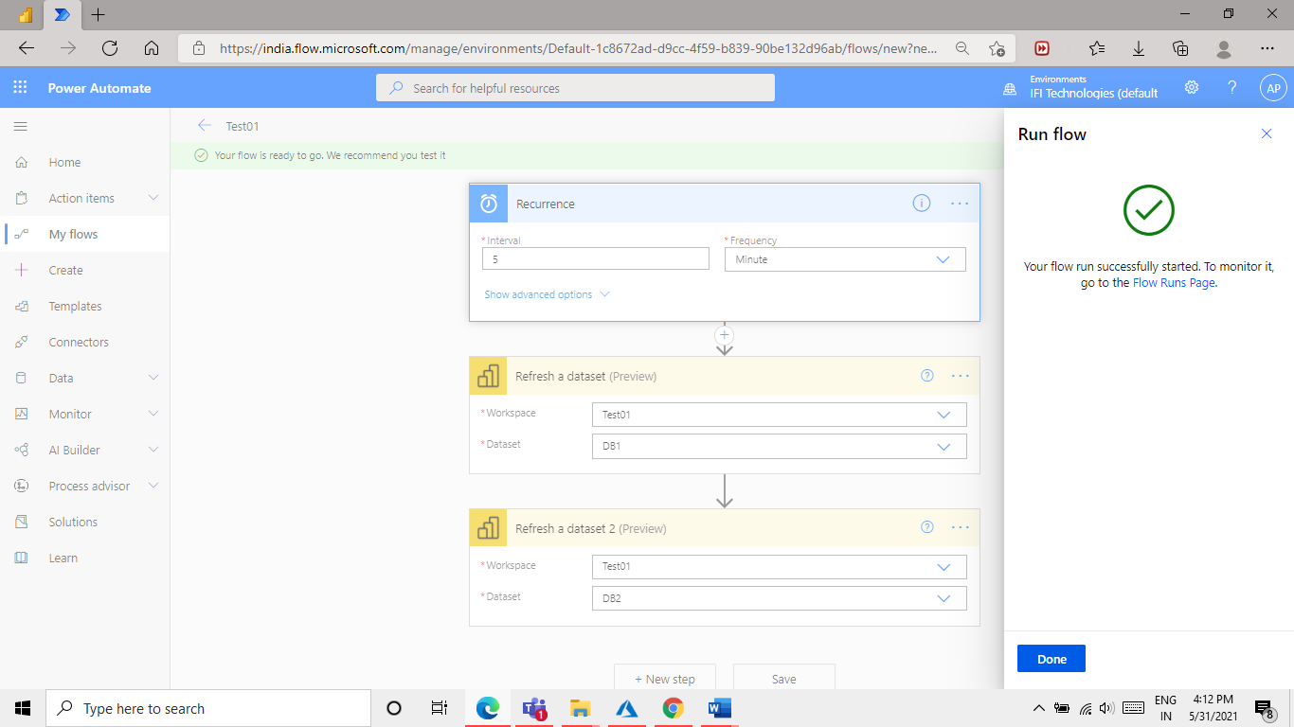

Step 5: check the refresh History.

You can check the flow status or refresh history from power bi portal.

go to - power bi portal >settings> admin portal>**Refresh summary**.

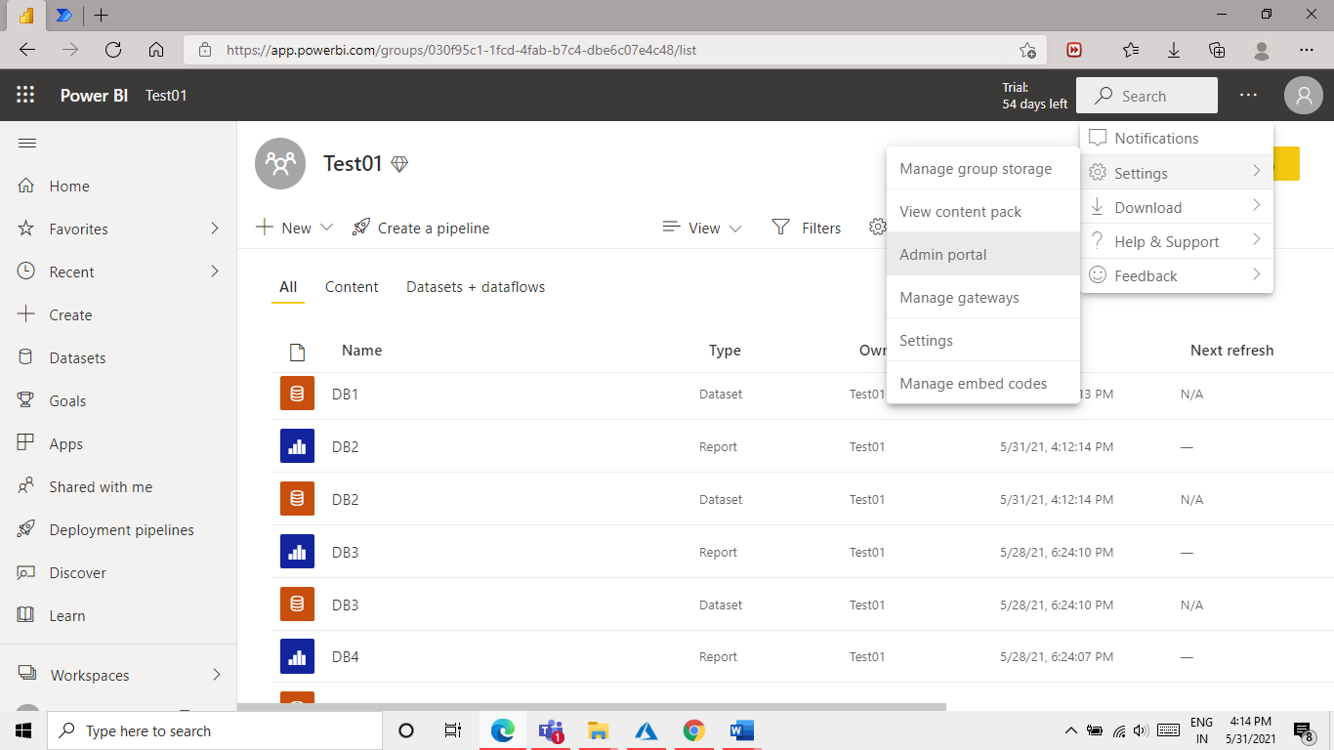

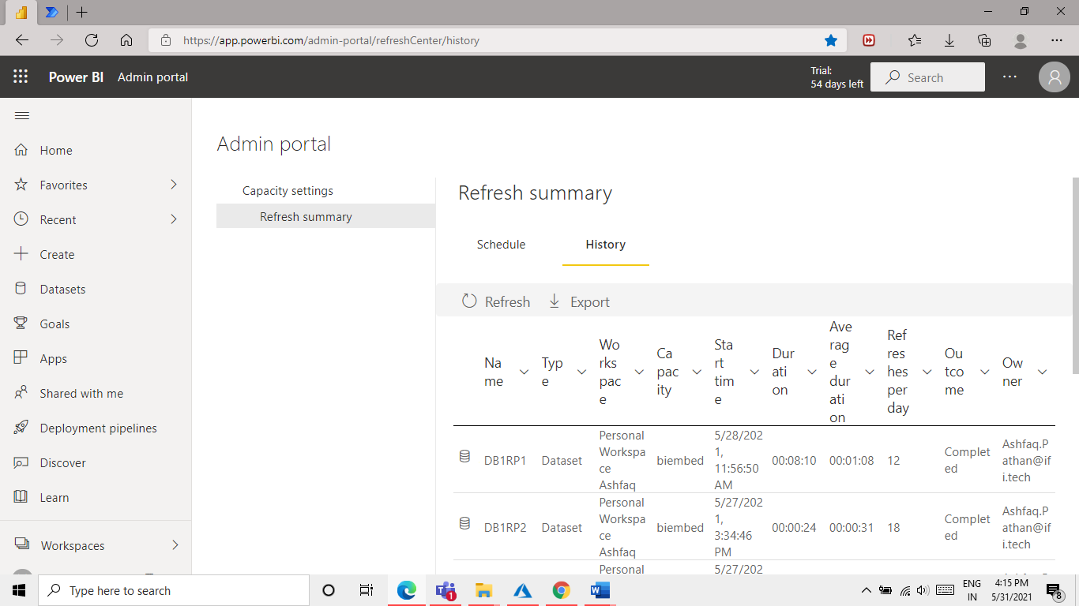

1st Refresh at 4:15 pm both DB1 and DB2 at same time.

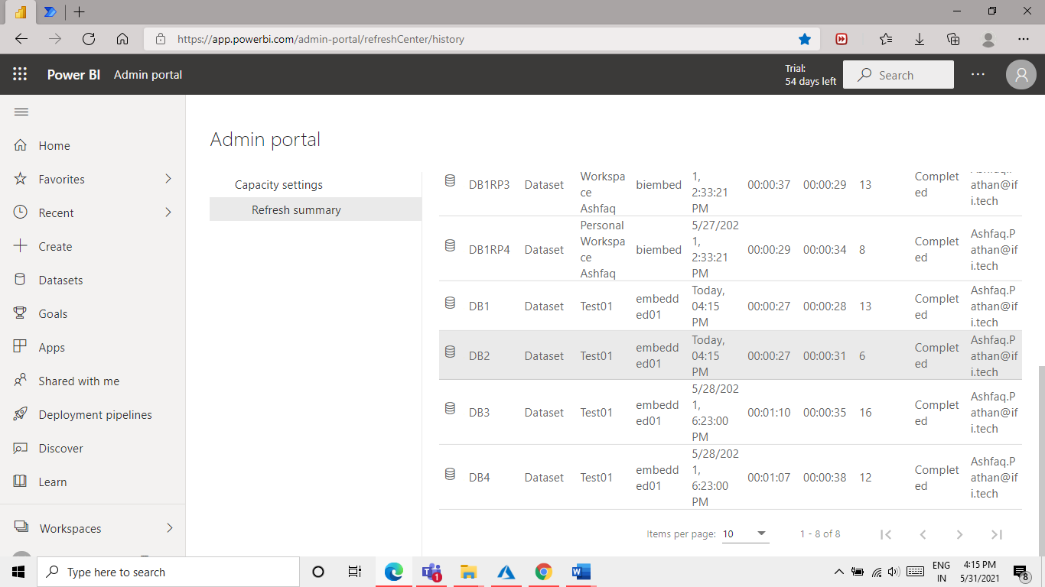

2nd Refresh at 4:20 pm both DB1 and DB2 at same time.

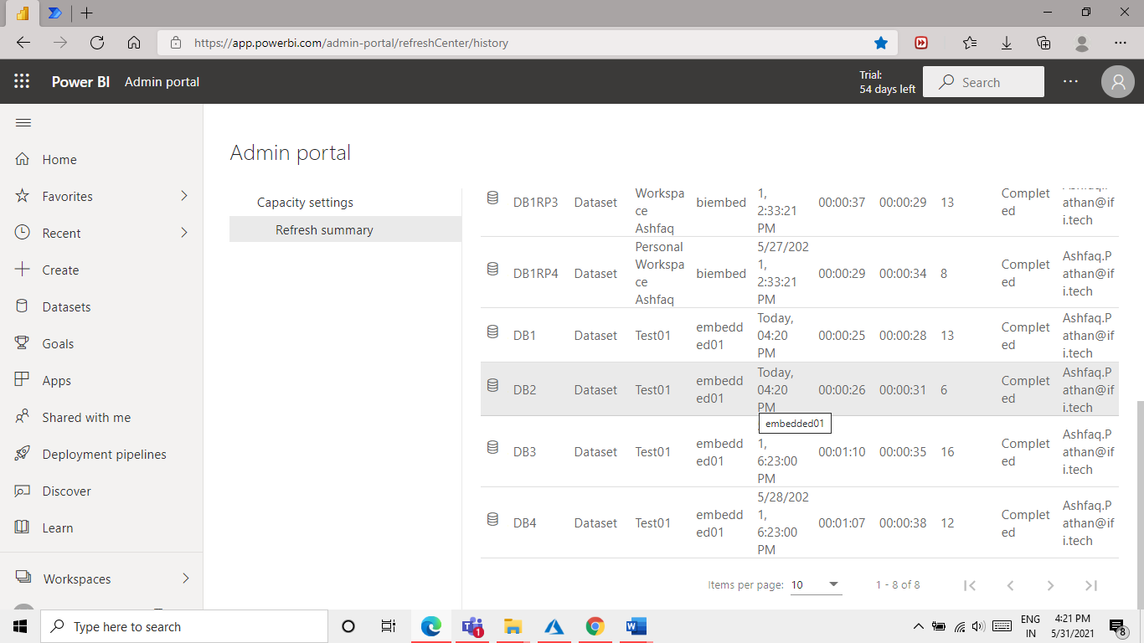

Flow is working properly. We can turn off this flow as shown below image.

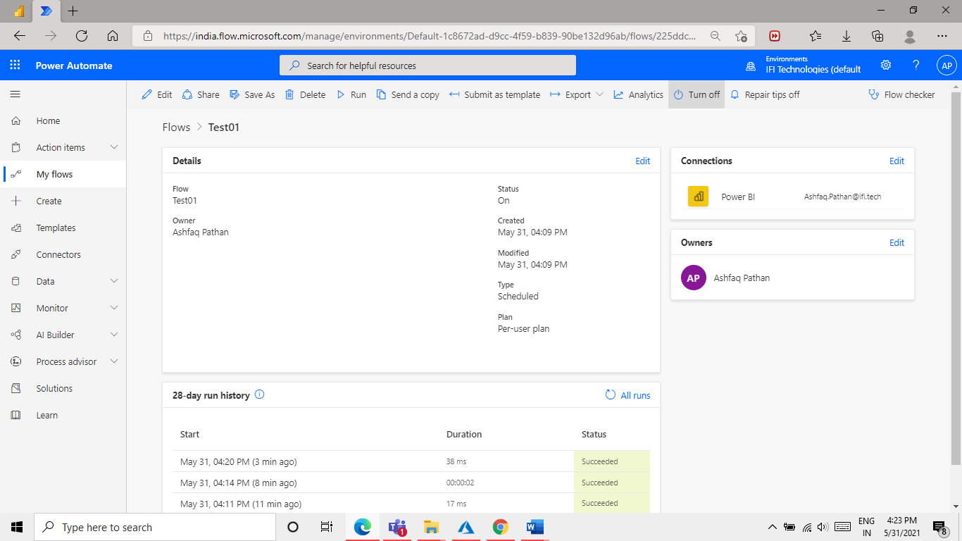

Step 6:

we will create one more flow for second case.

Test case 2: Refresh one set of data and adding a delay of 30 min to next set of data.

Create a new flow with name “Test_case02”.

R1,R2,R3,R4 this are report names below is a flow diagram of case.

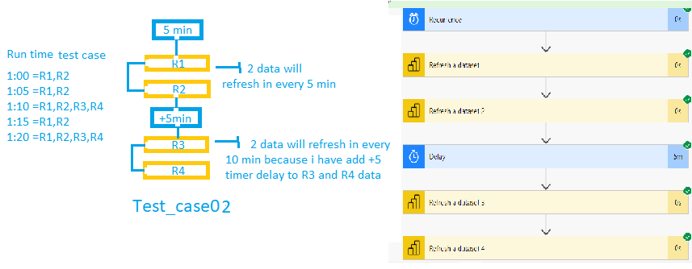

Add Refresh a dataset 2 time one for report1, and 2nd for report 2 and then select Delay option add 5 min delay time so the next 2 reports will run in every 10 min.

because the base time is 5min and we have added more 5min delay for second set of report which is so in total 10 min delay for second set. and first set will be refresh in every 5 min.

Refer the below image to understand the whole flow structure.

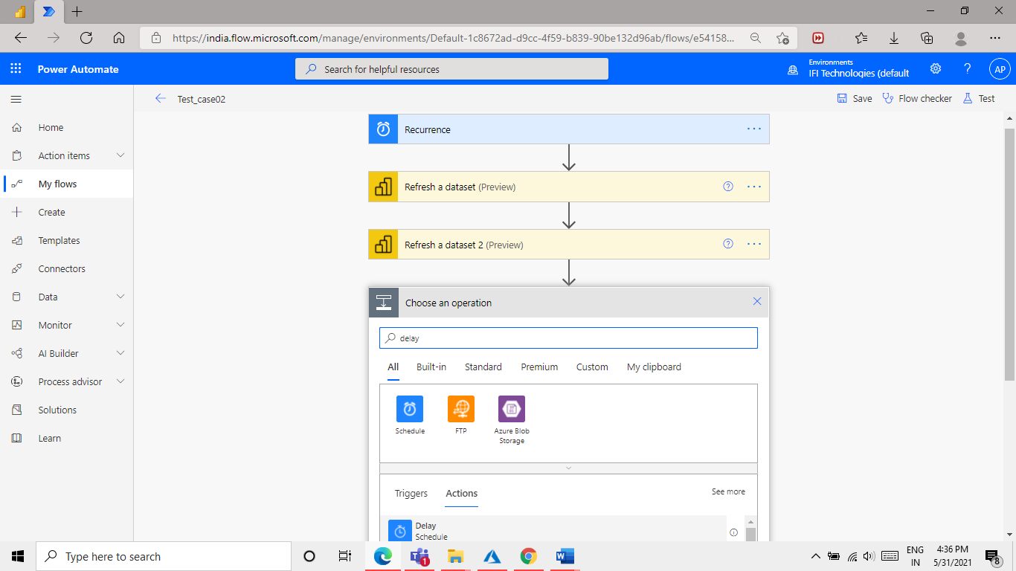

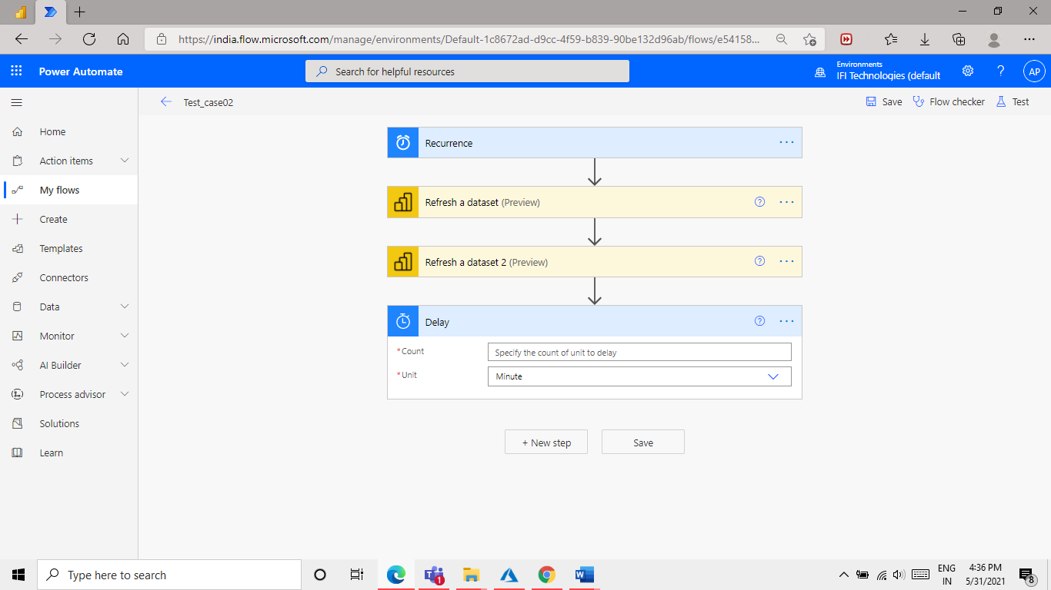

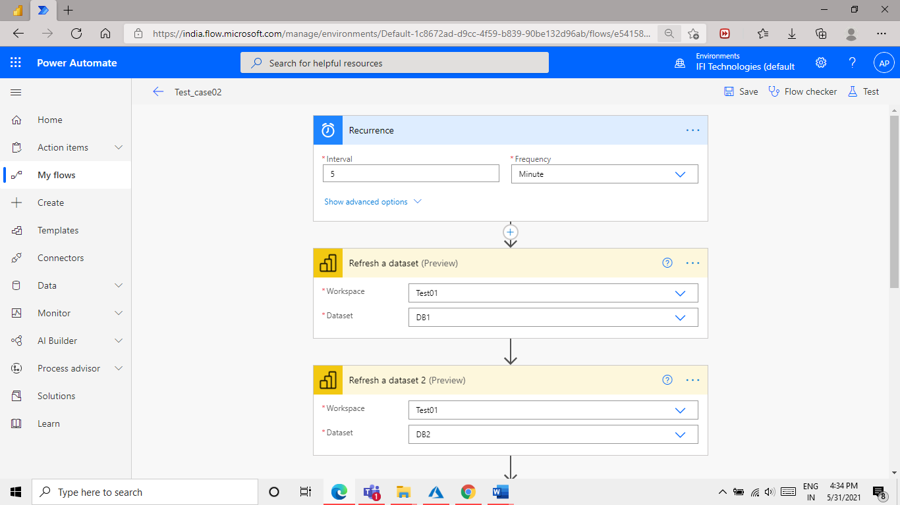

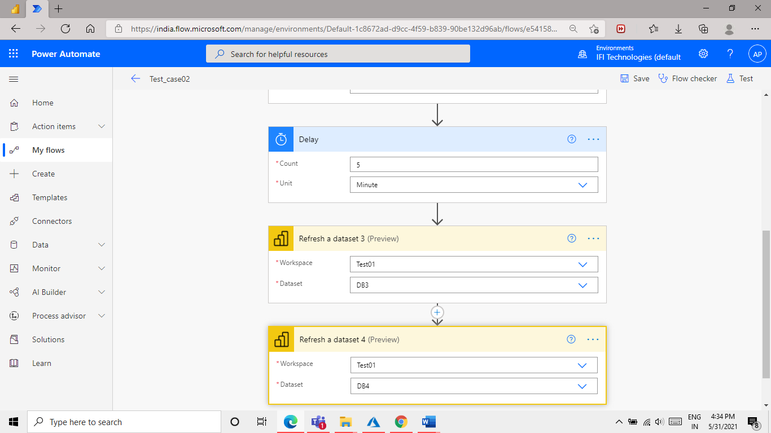

Save an test in same way we have done for test case 1

