Add local timestamp at the end of the excel files in ADF & move them from one container to another in the same storage account.

Prerequisite:

1 Need a Data factory.

2 Need a storage account and 2 containers in it “ input”, “Output”

Following are the steps.

Step 1 Create a new pipeline in ADF.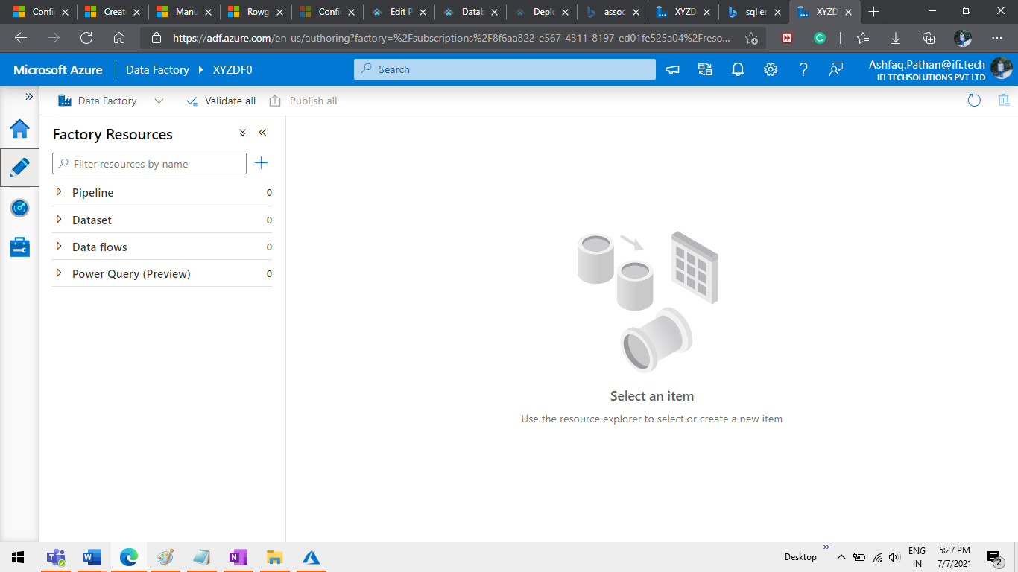

Step 2 Add a variable “TablelList” Type Array Value will be a list of file names.

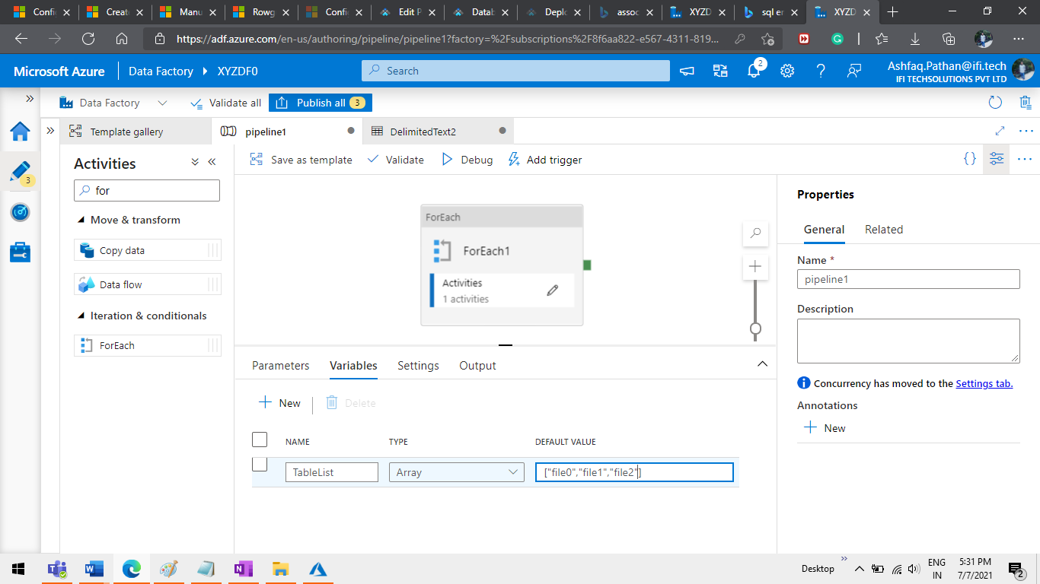

Step 3 Add a ForEach activity from the activities Search bar.

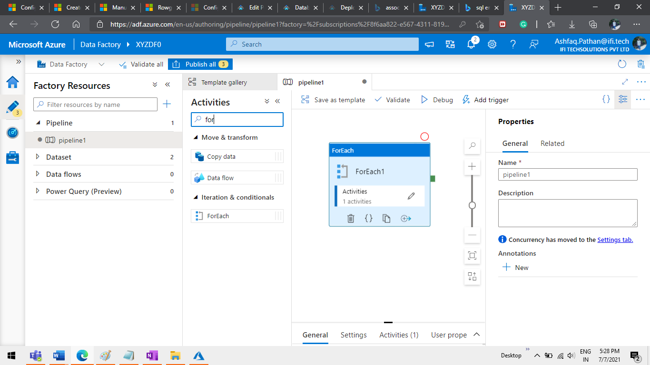

Step 4 Go to settings of Foreach activity and enter in items textbox “@variables(‘TableList’)”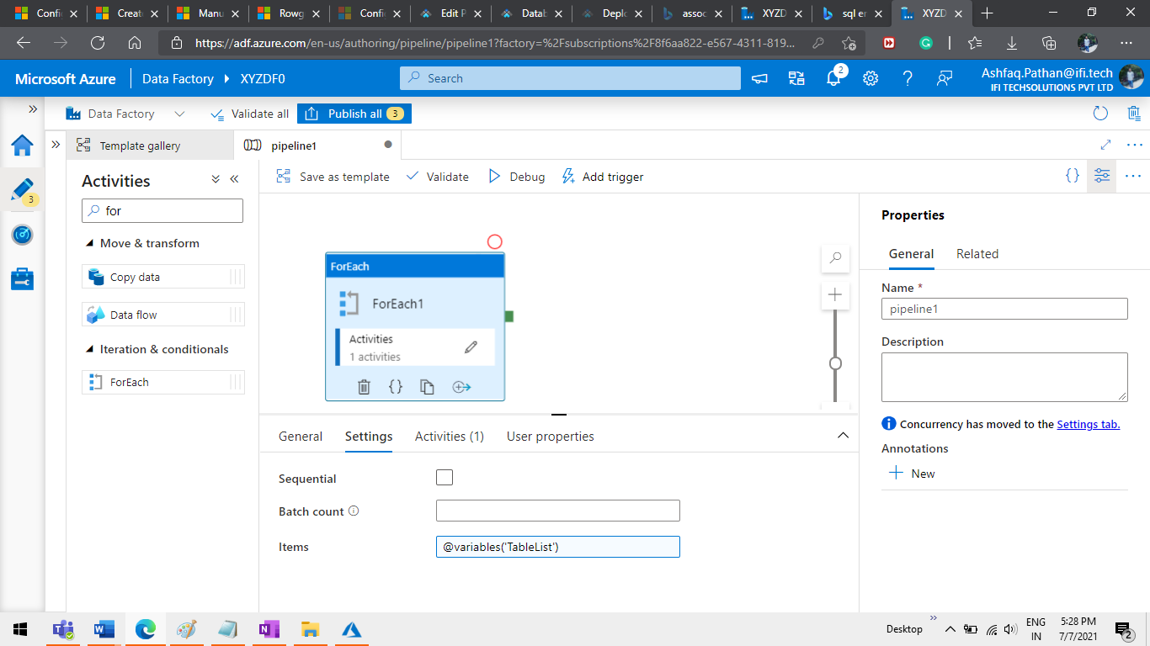

Step 5 Open the Foreach activity and add a copy activity from the Activities bar.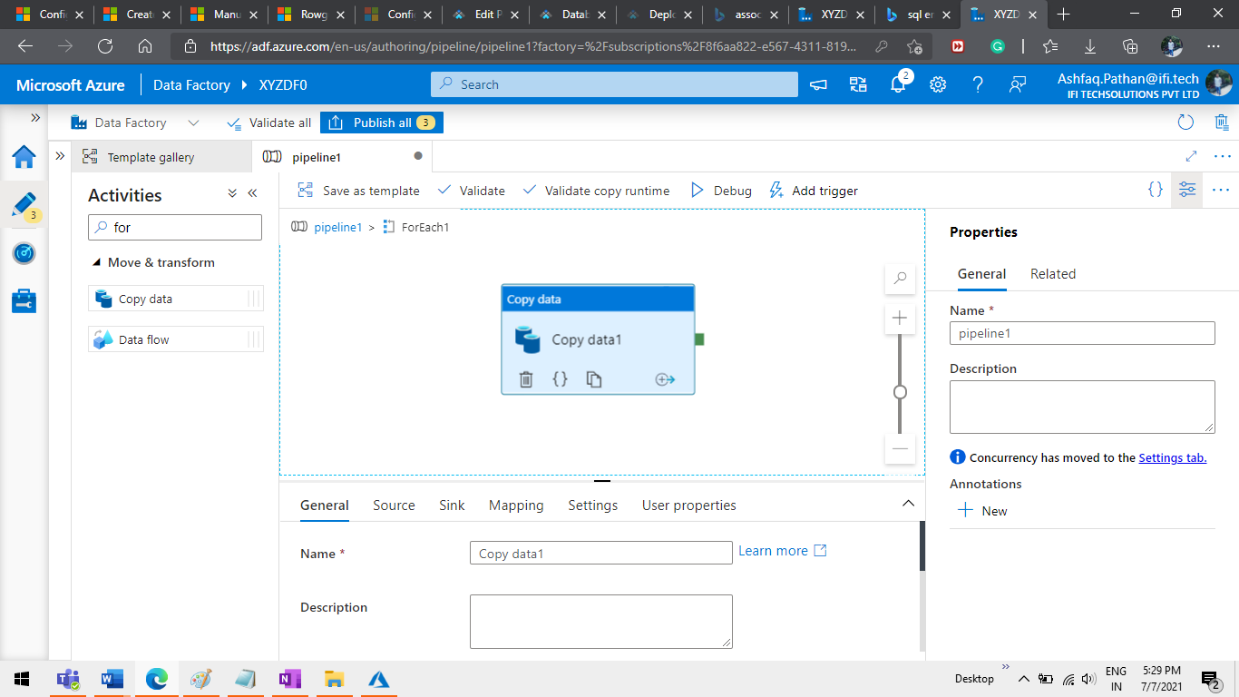

Step 6 Configure Source as blob storage Click on new Button.

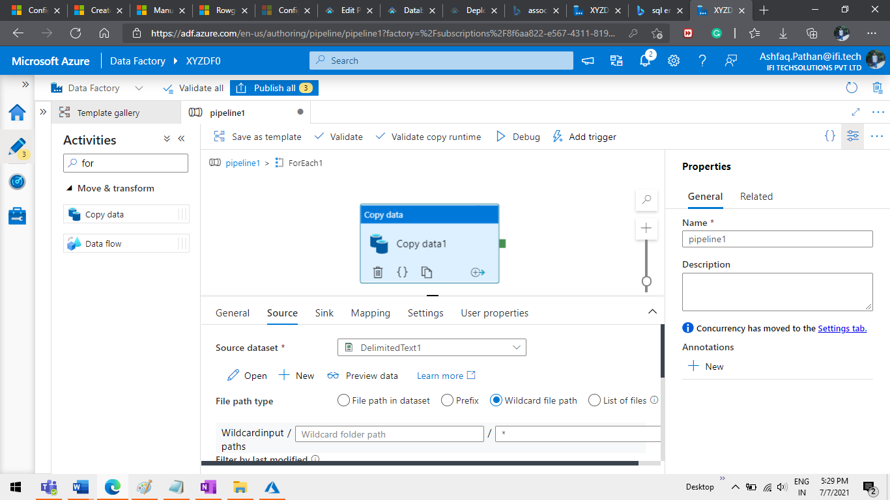

Step 7 Select Azure blob storage.

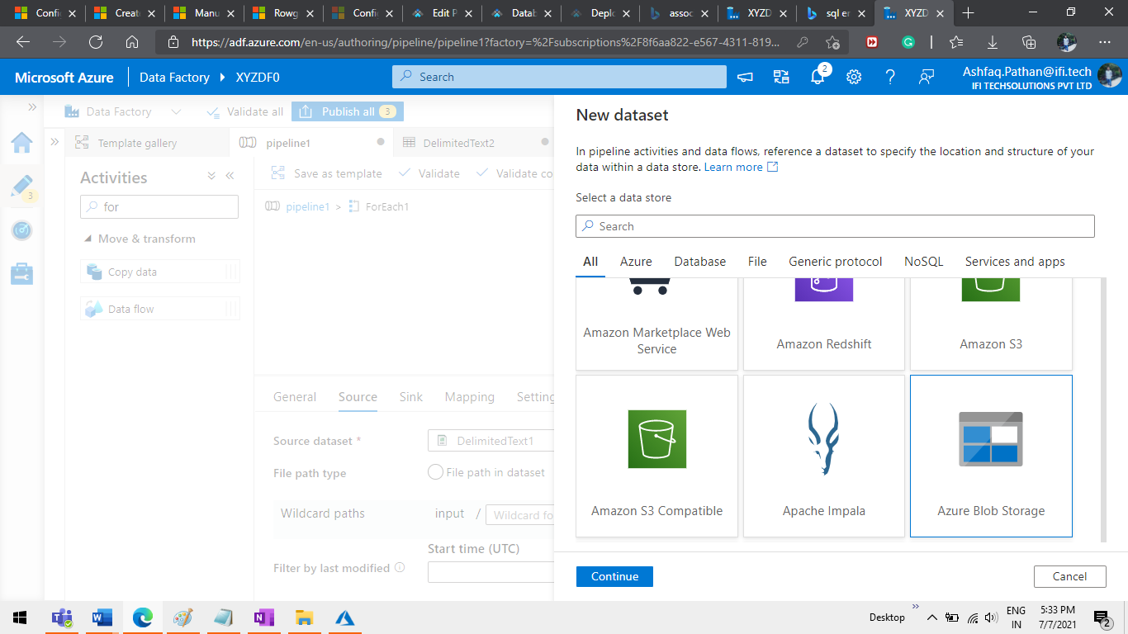

Step 8 Select DelimitedText Click the Continue button.

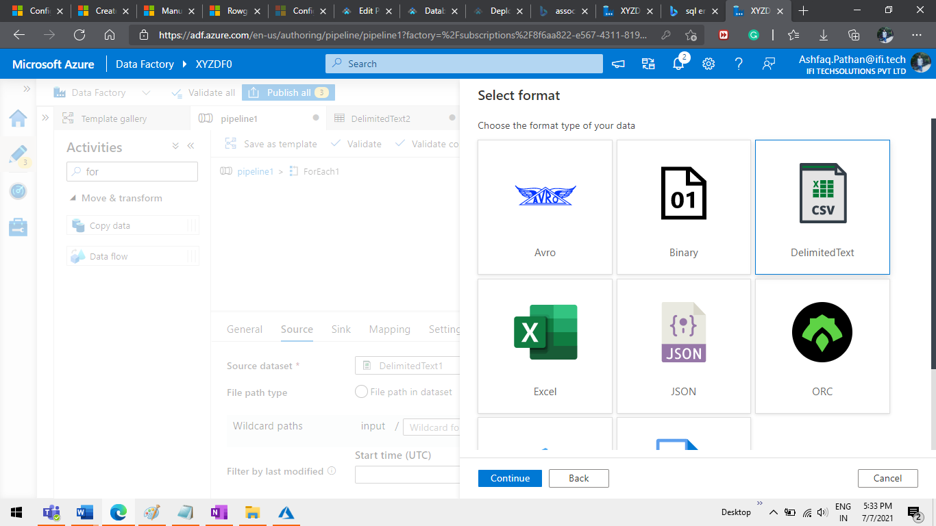

Step 9 select Folder as ‘input’ in the file path.

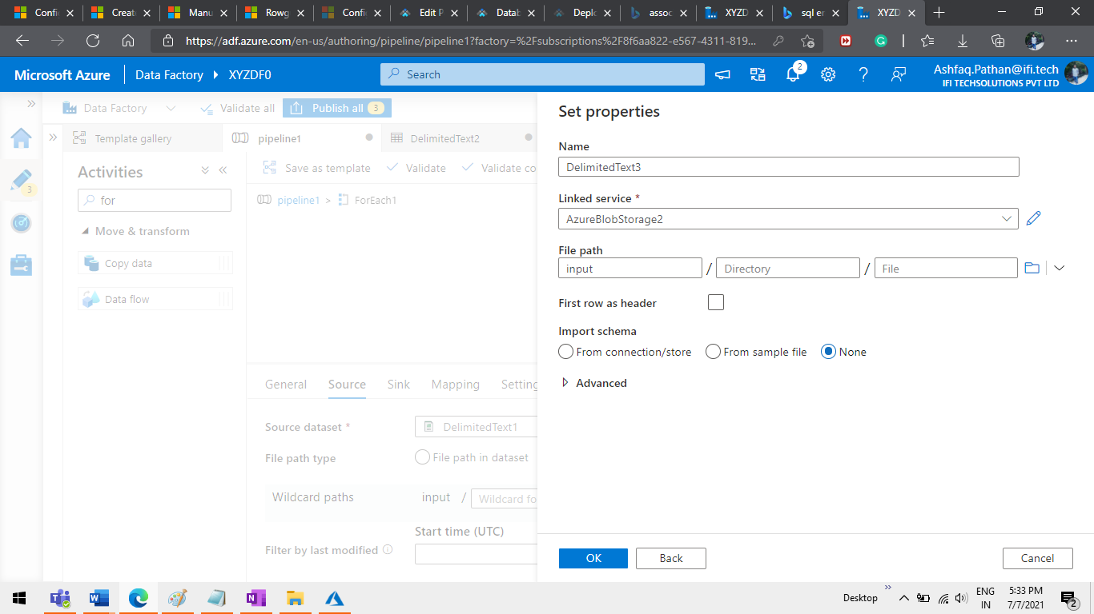

Step 10 Config Sink add new Click on the new button.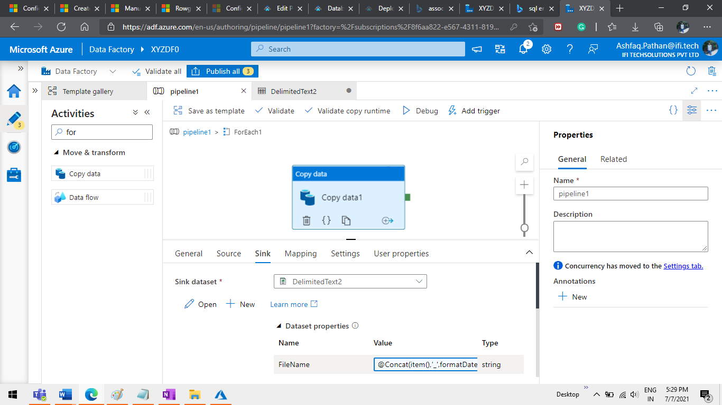

Step 11 Select azure blob storage.



Step 12 Select DelimitedText Click the Continue button.

Step 13 Select Folder as ‘output’ in the file path.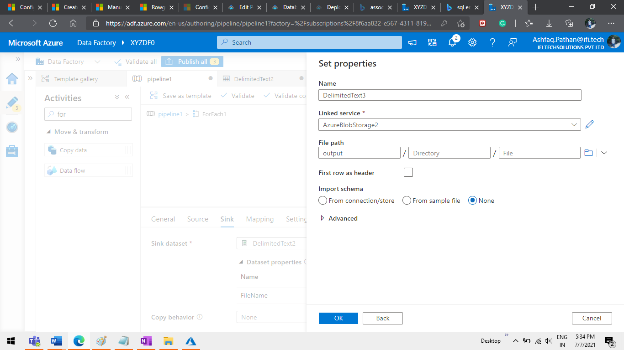

Step 14 Click on the Open button

Step 15 Click on parameters and add the parameters “ FileName”

And add “@dataset().FileName” in the file path as below image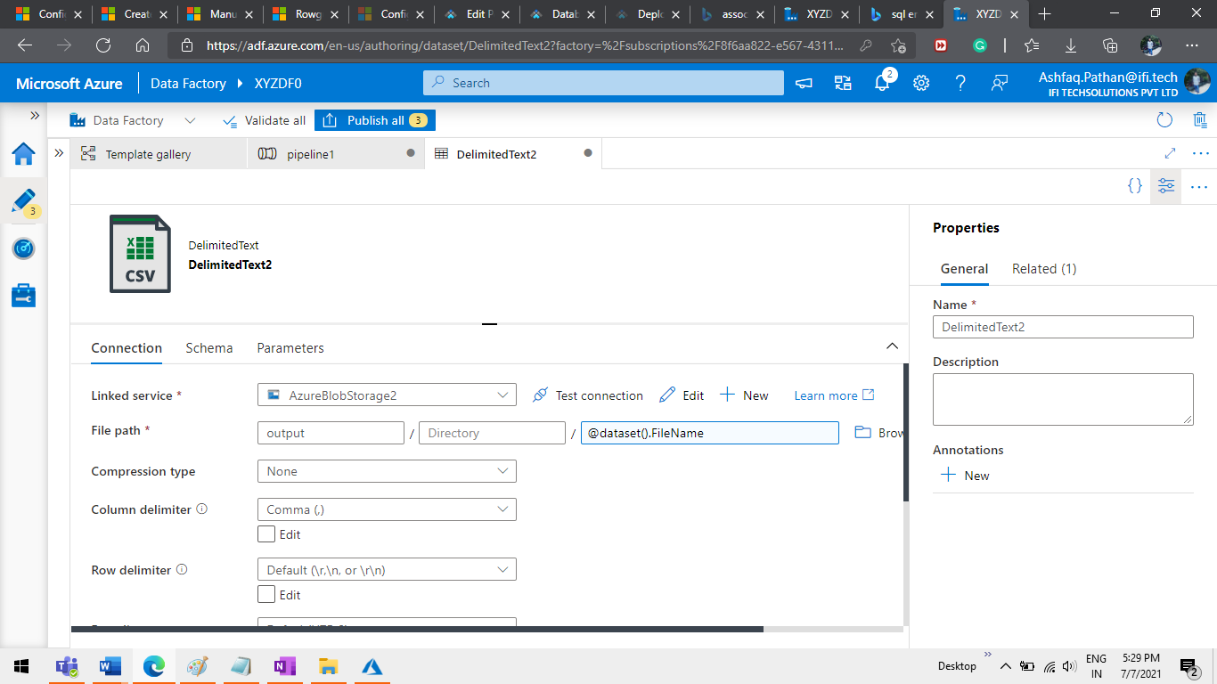

Step 16 Click on the FileName text box.

Step 17 add the below syntax and click on Finish.

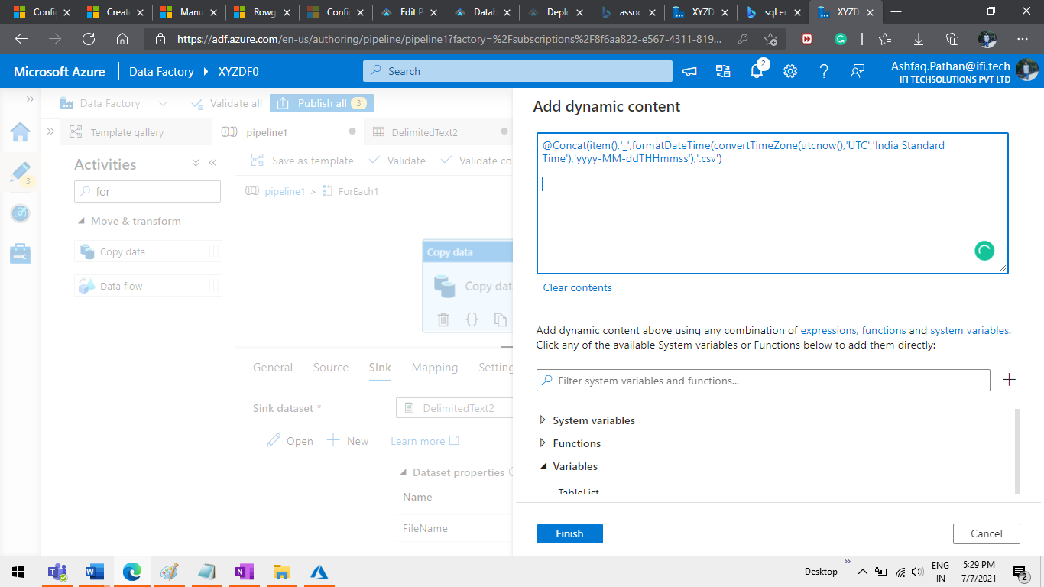

Step 18 Click on debug

Step 19 See the result.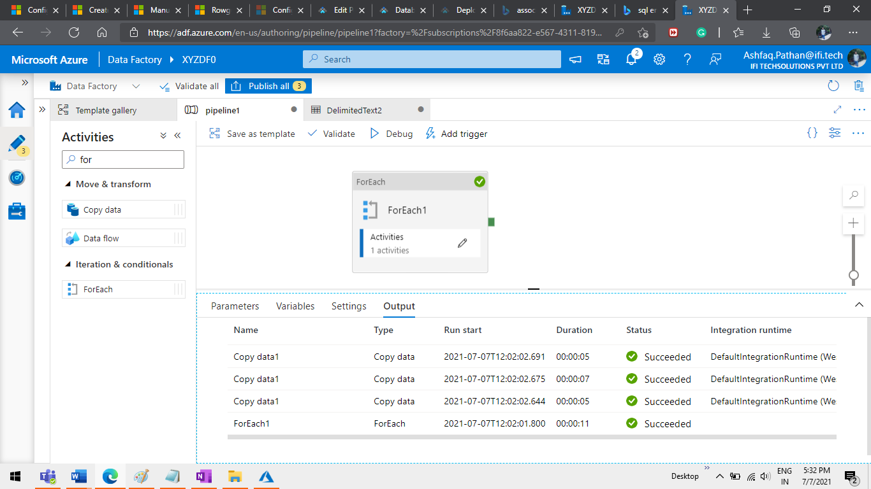

Step 20 Check the output.

