MS Project Case Study
26 August 2021
12:21

About Customer:
IFI Tech solutions is a cloud solution and managed services provider that was recognized as a 2020 Microsoft Partner of the Year Finalist. Founded by ex-Microsoft executives, IFI Tech solutions has earned Microsoft Azure Advanced Specializations on Windows Server and SQL Server Migration, Modernization of Web Applications and Windows Virtual Desktop.

Problem Statement:
Manager Want to analyse the MS Project data to Power bi reports MS Project Upsert data in Data verse. For Daily data tracking he needs something that will append Data in the Database.

Solution:
Using ADF Ingest Data from Data verse to Azure SQL Database

- Create Azure SQL DB using Azure.
- Build Store Procedure Remove Duplicate, Sum up Efforts using MSSM
- Connecting Data verse to ADF using linked services
- Connect Azure SQL DB using linked services to ADF
- Build ADF pipeline.

Visio Diagram:
1 MS Project ->Data Verse -> Azure Data Factory -> Azure SQL DB -> Power BI
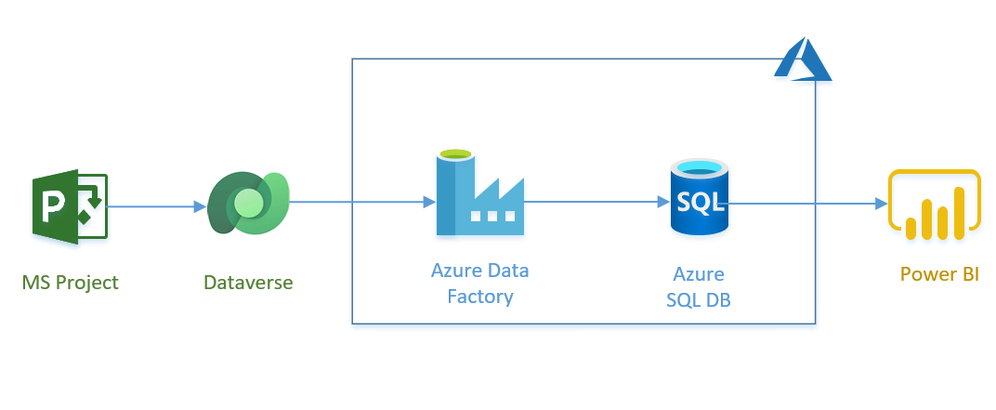

Services Details:

Resource information:

Azure Data Factory: Azure Data Factory is a cloud-based data integration service that allows you to create data-driven workflows in the cloud for orchestrating and automating data movement and data transformation. Azure Data Factory does not store any data itself

Azure SQL Database: Microsoft Azure SQL Database is a managed cloud database provided as part of Microsoft Azure. A cloud database is a database that runs on a cloud computing platform, and access to it is provided as a service. Managed database services take care of scalability, backup, and high availability of the database

Data verse: Dataverse is a straightforward platform that you can use to begin designing your data structures, it is cloud-based storage space. Data verse uses Azure Active Directory identity and access management mechanisms to help ensure that only authorized users can access the environment, data, and reports.

Sub-Services Component Description.

Azure Data Factory:

Pipeline: A Data Factory or Synapse Workspace can have one or more pipelines. A pipeline is a logical grouping of activities that together perform a task. For example, a pipeline could contain a set of activities that ingest and clean log data, and then kick off a mapping data flow to analyse the log data. The pipeline allows you to manage the activities as a set instead of each one individually.

Trigger: Triggers are another way that you can execute a pipeline run. Triggers represent a unit of processing that determines when a pipeline execution needs to be kicked off. Currently, the service supports three types of triggers:

Schedule Trigger: A trigger that invokes a pipeline on a wall-clock schedule can be based on day, week, or months.
Azure SQL Database:

Store Procedure: We need two Store procedure for this project we will create in Azure SQL DB using MSSM
- DELETE Duplicate
- SUMUP Efforts

Architecture:

Step 1: Create Azure SQL Using Azure Porter .

Step 2: Connect Data verse to Azure Data Factory in Source.

Step 3: Connect Azure SQL DB to Azure Data Factory in Sink.

Step 4: Build a pipeline To Copy data from Data verse to Azure SQL DB For 7 table with pre copy script Truncate Reload inside For-each loop.
Step 5: Build a Store procedure for DELETE Duplicate SUMUP Efforts in Azure SQL Db

Step 6: Add Copy activity outside for each loop for "Project task" table and apply the stores procedure on this activity.

Challenges:

- We need to Customise one Table with Store procedure and the rest of the Table should be simple Copy only with Truncate & Reload
- While building a store procedure for the "Project Task" table. we got problems with the primary key column so we have to consider 2 columns as a primary key
- It was a trick to handle two different scenarios one table with append data and the rest table with truncated and reload in the same pipeline with 8 tables

Conclusion:
- We Can Track the daily working Effort of the team members.
- Will be able to balanced work among the team members. so that team members aren't overutilize or underutilize.
- The manager will be able to assign a Task to the right person as per individual expertise based on their Learning & certificate data.

