Analysis services in SQL Server can be either deployed in multi-dimensional mode or tabular mode or power pivot for SharePoint as well. Tabular mode is a new enhancement in SQL Server 2012 analysis service database structure. It is a columnar database capable of incredible performance and compression ratio. At this point, there is a lot of confusion in users on why to use the tabular model when we already have multidimensional model. So, let’s discuss these points

**Tabular mode**

1) The tabular model uses DAX for scripting which is similar to using excel formulas and is faster to learn.

2) It uses Vertipaq (x-velocity) engine for in memory column storage, which gives great performance and direct query mode for retrieving data and aggregates directly from the database which is beneficial for querying data in real time.

3) PowerPivot models can be easily upgraded to tabular models, thus providing a path for business users and IT professionals to author models in familiar tools like MS Excel.

4) All the client applications that support multi-dimensional mode will also support tabular and work natively with it. This is because tabular uses the same data provider that understands both MDX and DAX queries.

**When Not to Use:**

1) When the source is based on dimensional modeling and has complex relationships with very large volume of data.

2) No support for writing back or parent, child hierarchy

3) When you want to do complex calculations, scoping and named sets

**Multi-dimensional mode**

A SSAS multidimensional data model is composed of different database objects like dimensions, measures, data source, aggregations, perspectives, etc.

**Data Source**: Use to Connect Database

**Data Source View**: A Data Source View in SSAS is a set of **tables or views from the database that is required to design the cube** (We can call this as data set). Analysis services can only access the tables or views inside the Data Source View, anything outside the Data Source View is not accessible

**Cubes**: Cube is nothing but combination of Dimension and Measures.

Dimension - Master Data like Employee, Geography etc.

Measures - Is any number whose aggregation makes sense in reporting or anything which you can quantify.

**Dimensions**: **dimensions** are groups of attributes based on columns from tables or views in a data source view. **Dimensions** exist independent of a cube, can be used in multiple cubes, can be used multiple times in a single cube

**Roles**: Set up roles in SSAS and restrict access to data accordingly for each role. Create user groups in Dundas BI that correspond exactly to the SSAS roles. Connect to SSAS using the Roles impersonation option.

**Some Sub-Concepts in SSAS**

**calculated column**:

A calculated column is **based on data that you already have in an existing table** or created by using a DAX formula. For example, you might choose to concatenate values, perform addition, extract substrings, or compare the values in other fields. To add a calculated column, you must have at least one table in your model.

**Impersonation:**

Impersonation allows SSAS to assume the identity/security context of the client application which is used by SSAS to perform the server-side data operations like data access, PROCESSING, etc.

### Named Calculation

A Named Calculation is a new column added to a Table in DSV and is based on an expression. This capability allows you to add an extra column into your DSV which is based on one or more columns from the underlying data source Table(s)/View(s) combined using an expression without requiring the addition of a physical column in the underlying database Table(s)/View(s).

**KPI**

In Analysis Services, kpi is a collection of calculations that are associated with a measure group in a cube that is used to evaluate business success. We use KPI to see the business at the point, this is represented with some graphical items such as traffic signals.

**Build:**Verifies the project files and creates several local files.

**Deploy:** Deploy the structure of the cube (Skeleton) to the server.

**Process:**Read the data from the source and build the dimensions and cube structures

**Build Multi-dimensional mode -Demo**

**Prerequisite:**

. Need a database in my case I have Azure SQL-VM

. Need a Visual Studio on-premises

. Need to install SSAS you can use Visual Studio Extension marketplace

**A**: Create a Multi-dimensional project

**B**: Configure Data Source

**C**: Data Source View

**D**: Cubes & Dimensions

**A: Create a Multi-dimensional project**

Step 1 : Open visual studio

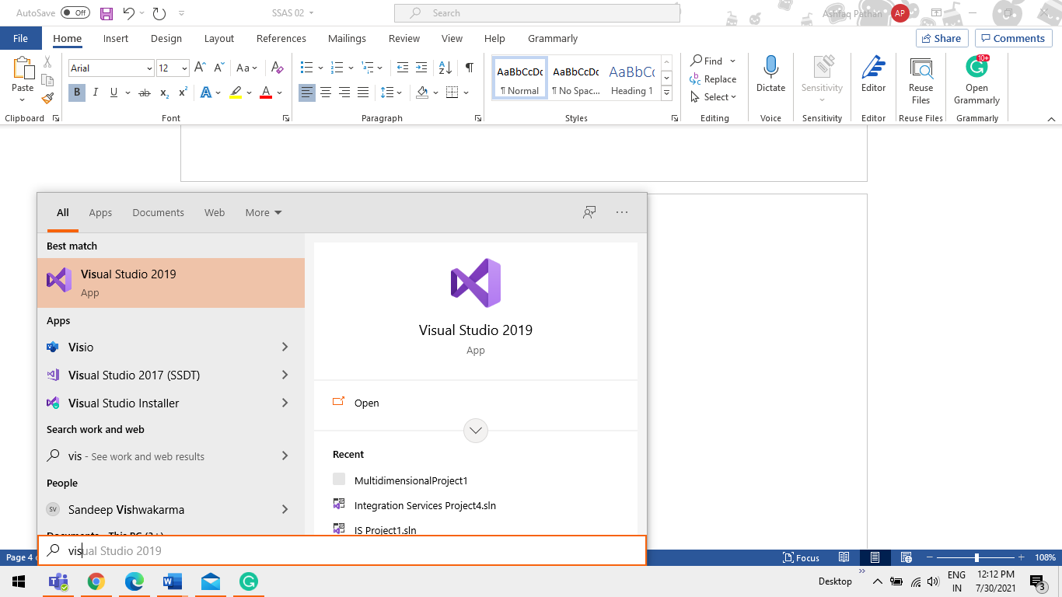

Step 2 From Home page Click on New Project

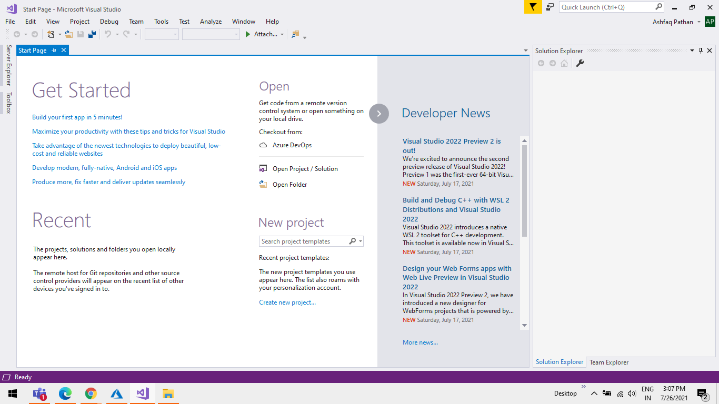

Step 3 Give a name for Project and select Multidimensional Services and Click on ok

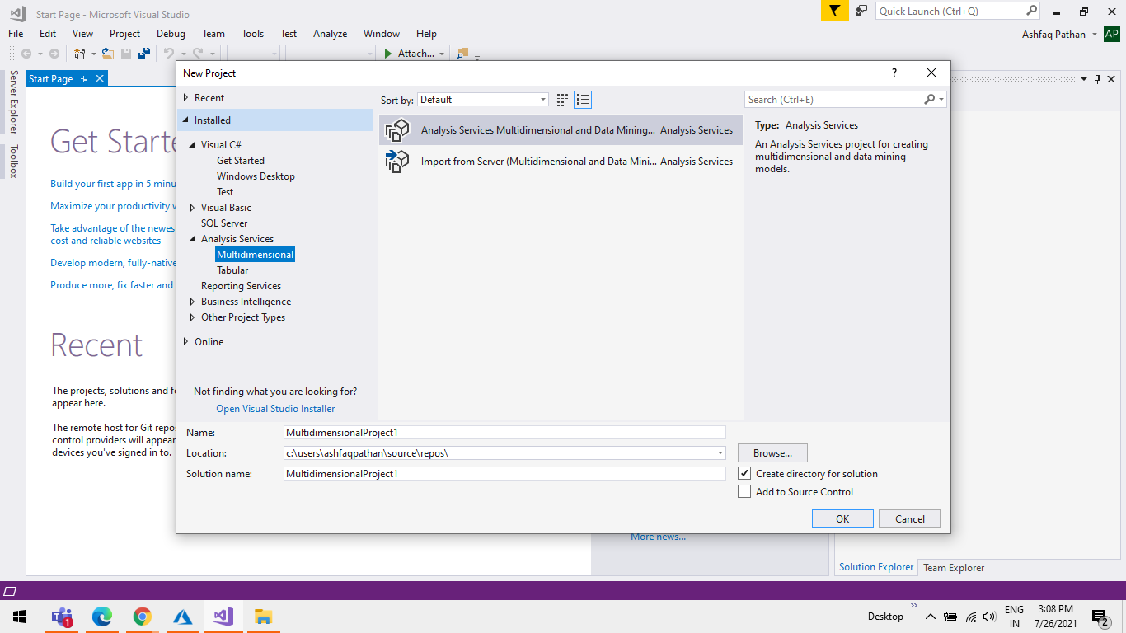

Step 4 Once Project is Create you will see a list of folders.

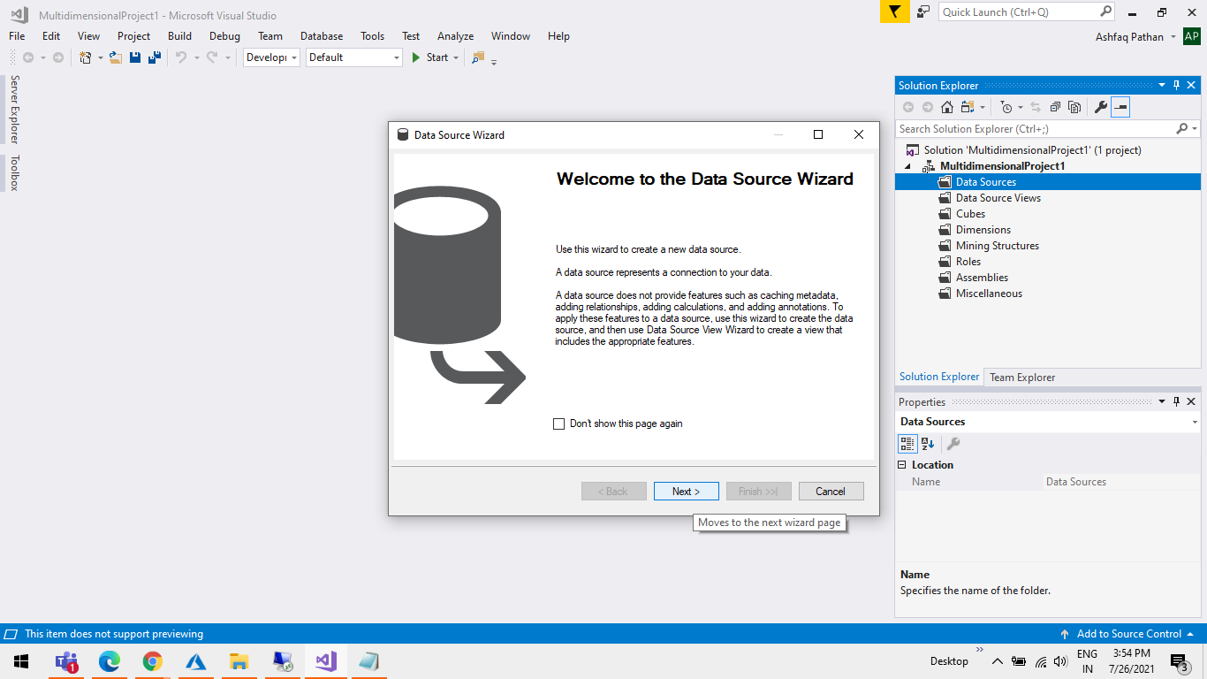

**B: Configure Data Source**

Step 1 Right Click on Data Source Create a new Data Source.

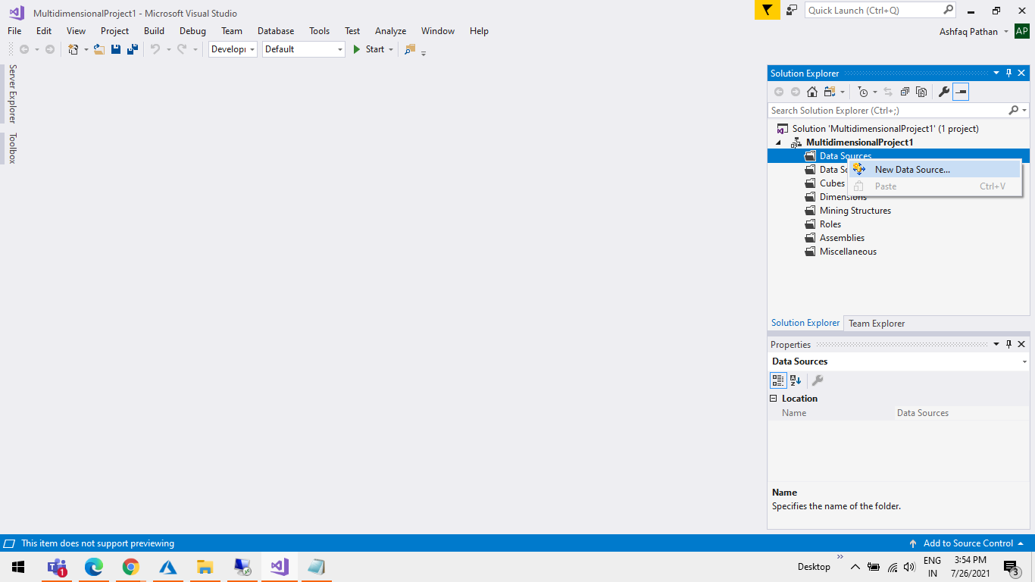

Step 2 Click on Next Button.



Step 3 Click on New Button to add a New data source.

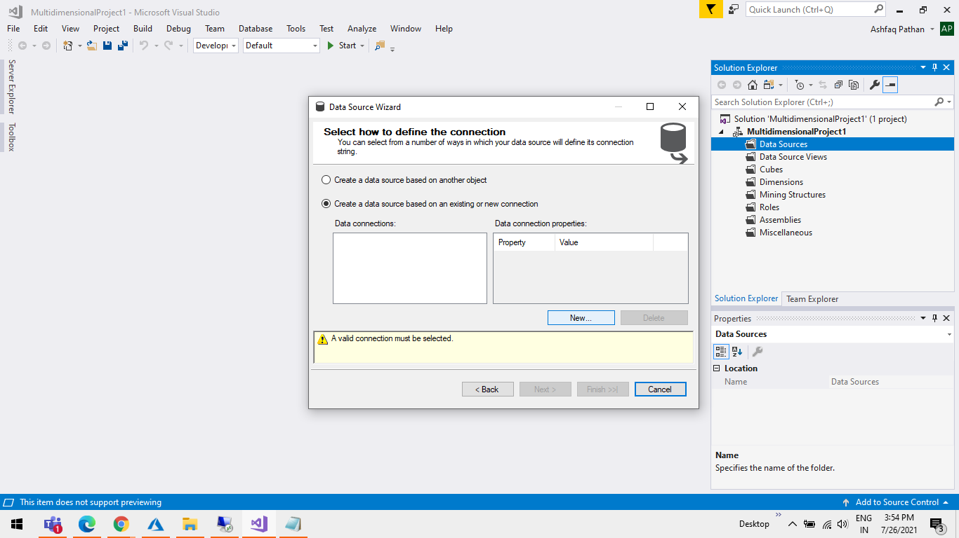

Step 4 1. Server name =use SQLVM IP or DNS

2. Use name & Password = User login id & Password for SQLVM

3. Select Database = AdvantureWorksDW2014

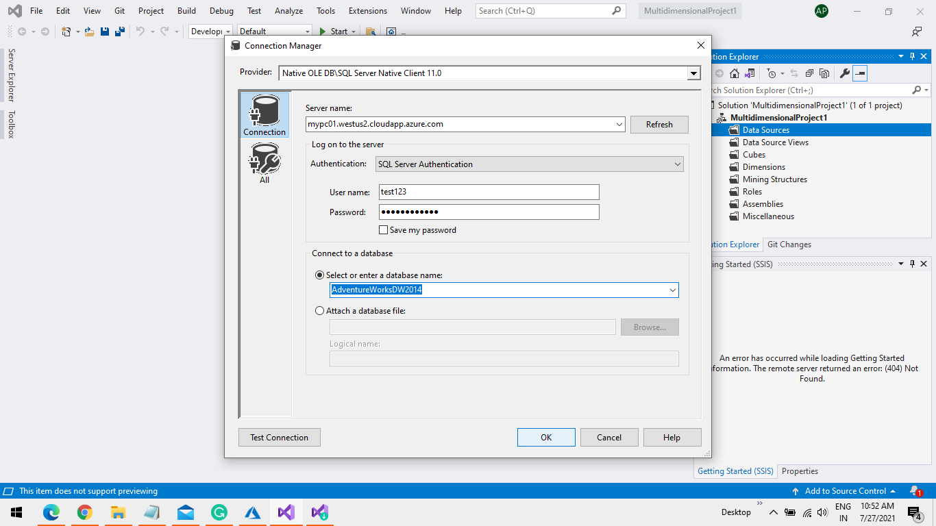

Step 5 Click on Next Button

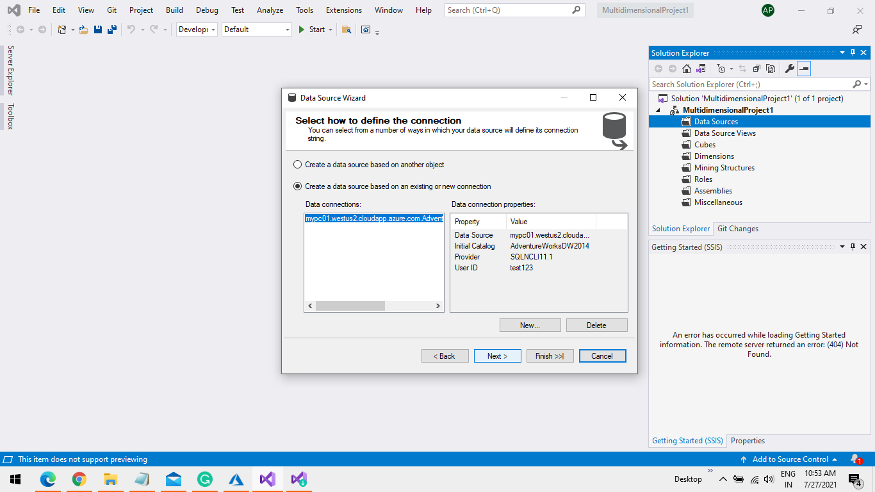

Step 6 Select “Use The Service Account” and Click on Next Button.

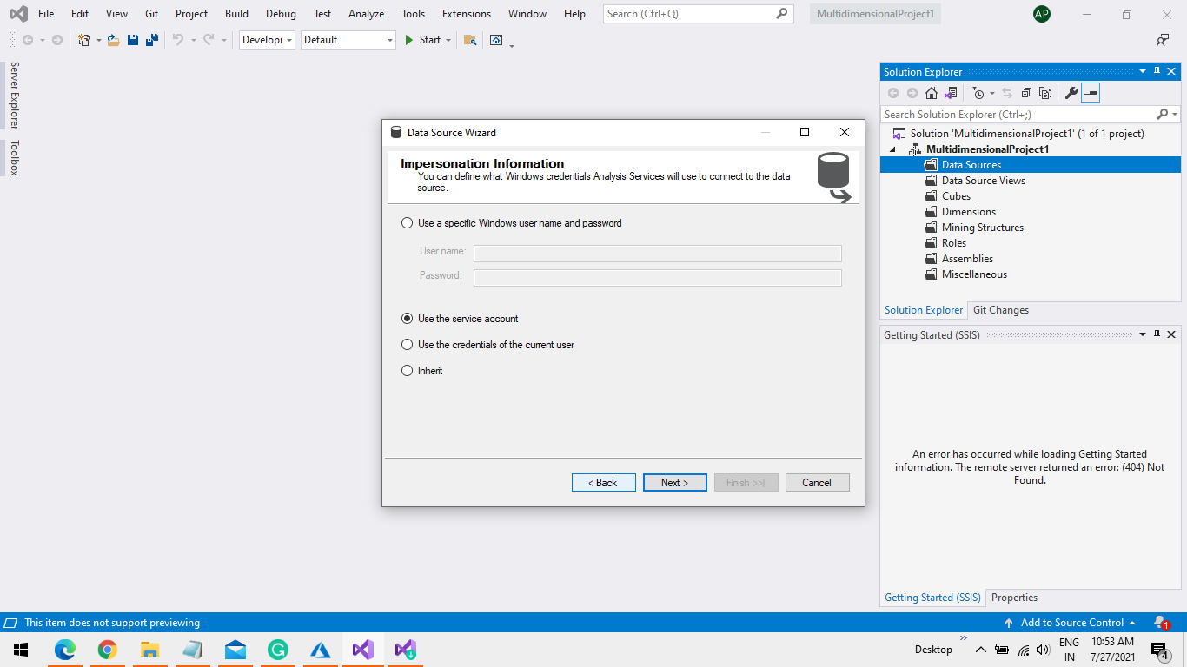

Step 7 You will get your database under Data source folder

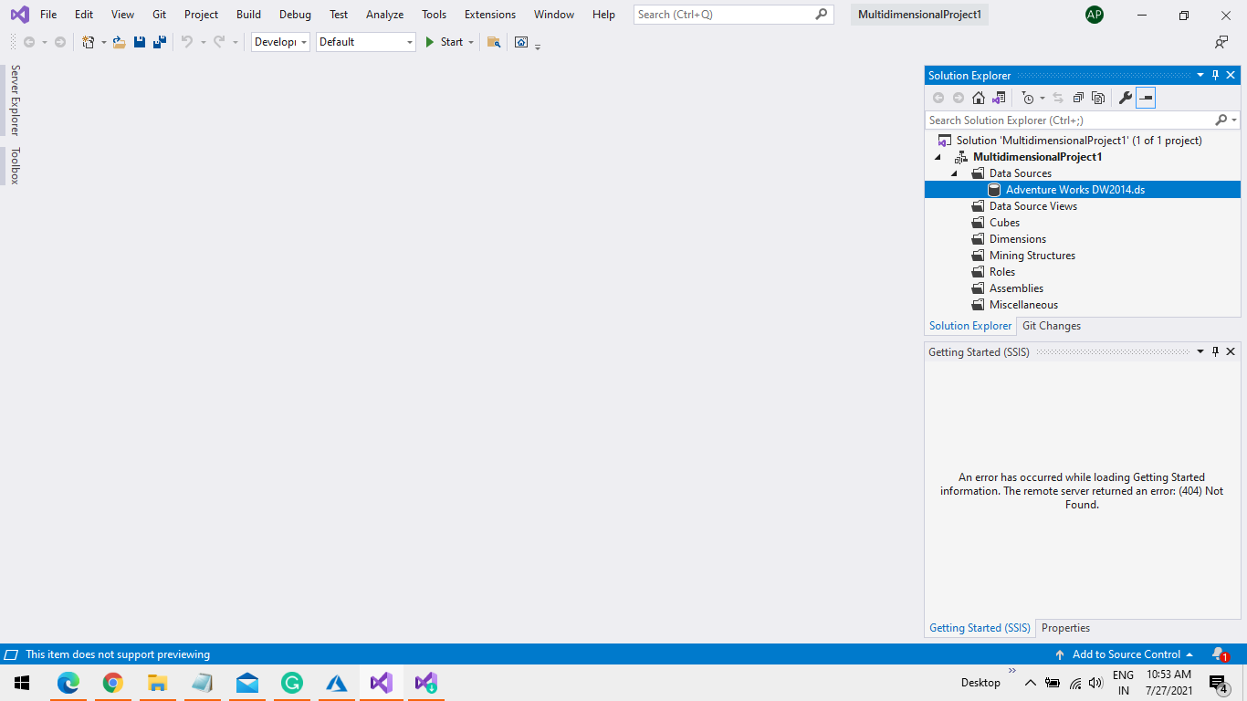

**C: Data Source View**

Step 1 Right Click on Data Source View to Create a new Data Source View.

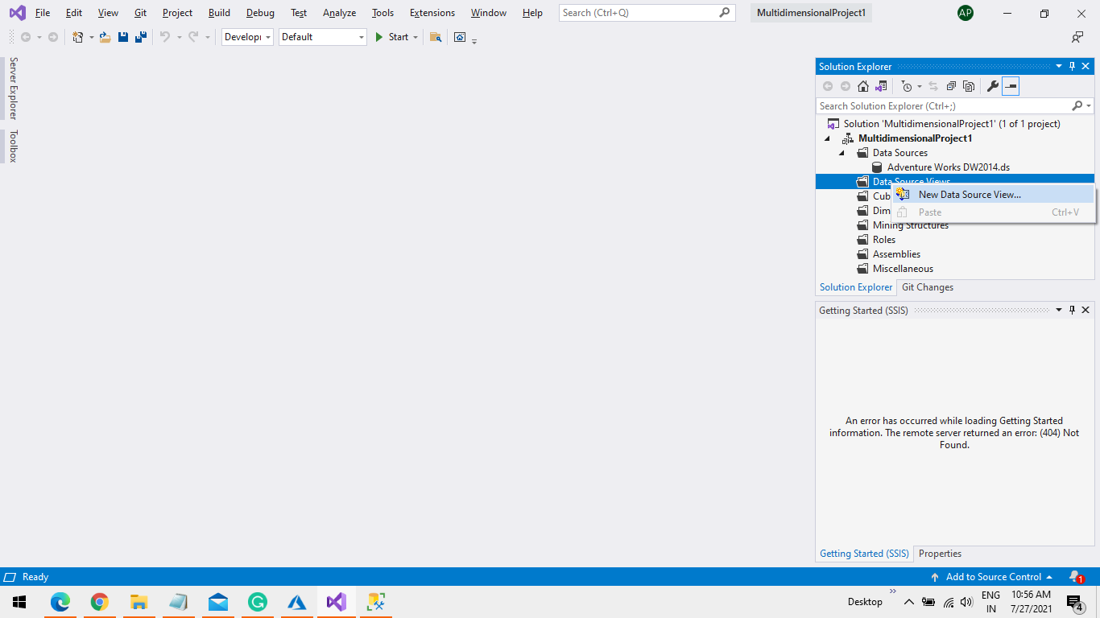

Step 2 Click on Next Button.

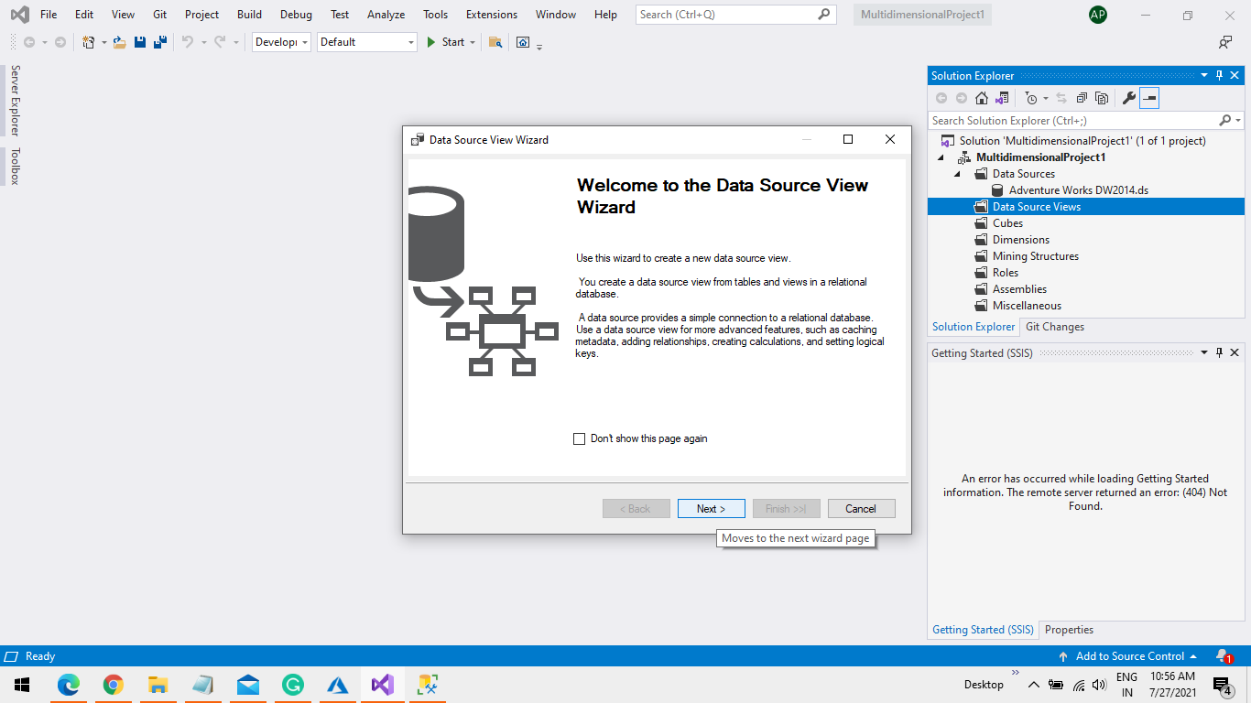

Step 3 In my case I have Selected Some Dim Table And One Fact Table.

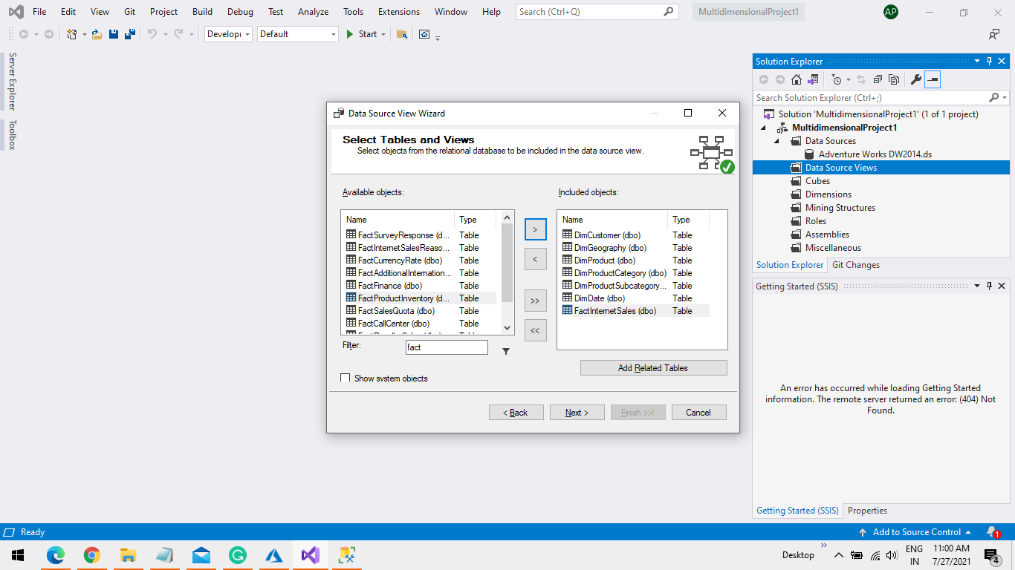

Step 4 Give a Name for a data Source View as “SaleTable” And Click on Finish Button.

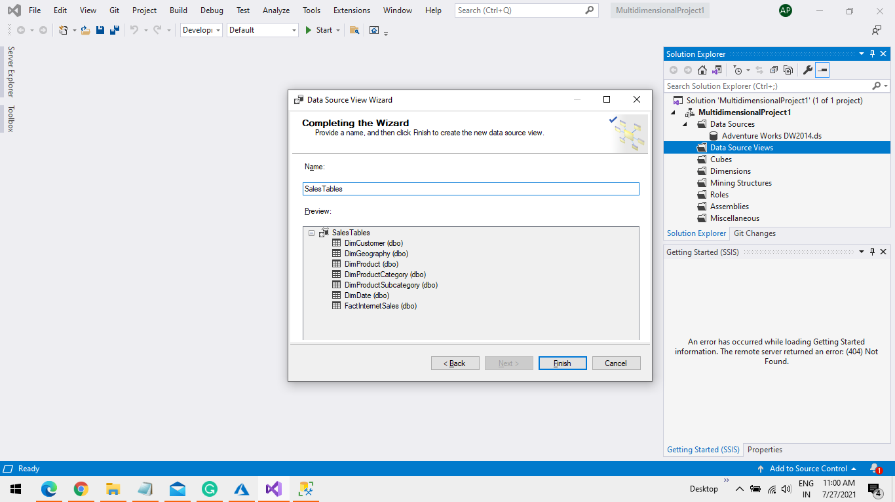

Step 5 You will See SSAS Have Built a Relationship based on Primary key for selected table in data Source View.

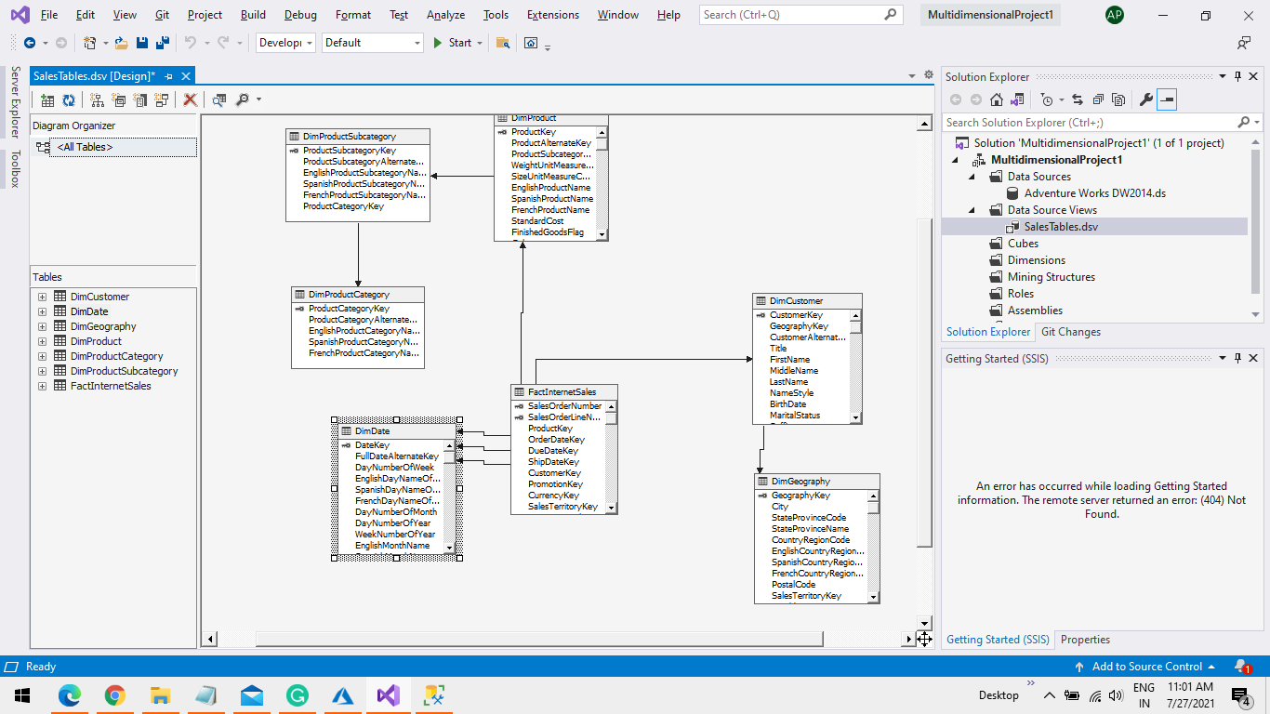

**D: Cubes & Dimensions**

Step 1 Right Click on Cube to Create a New Cube.

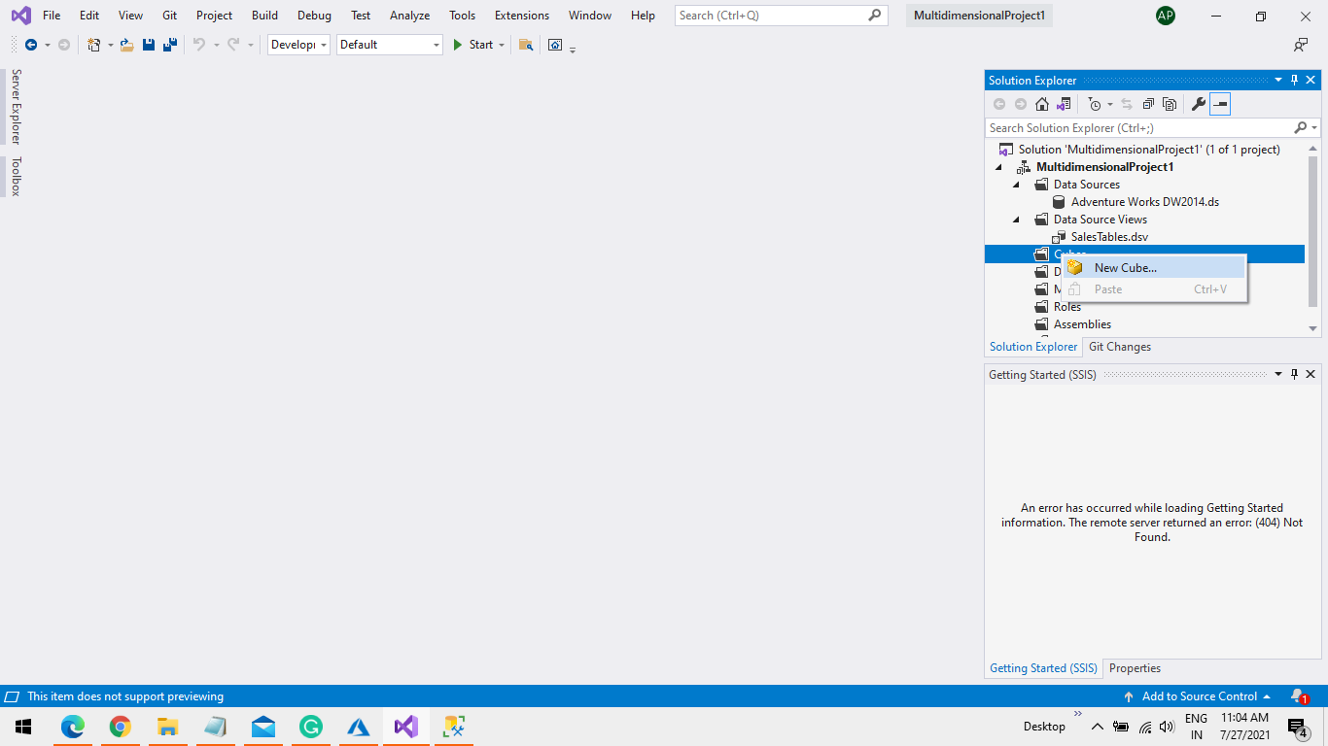

Step 2 Click on Next Button.

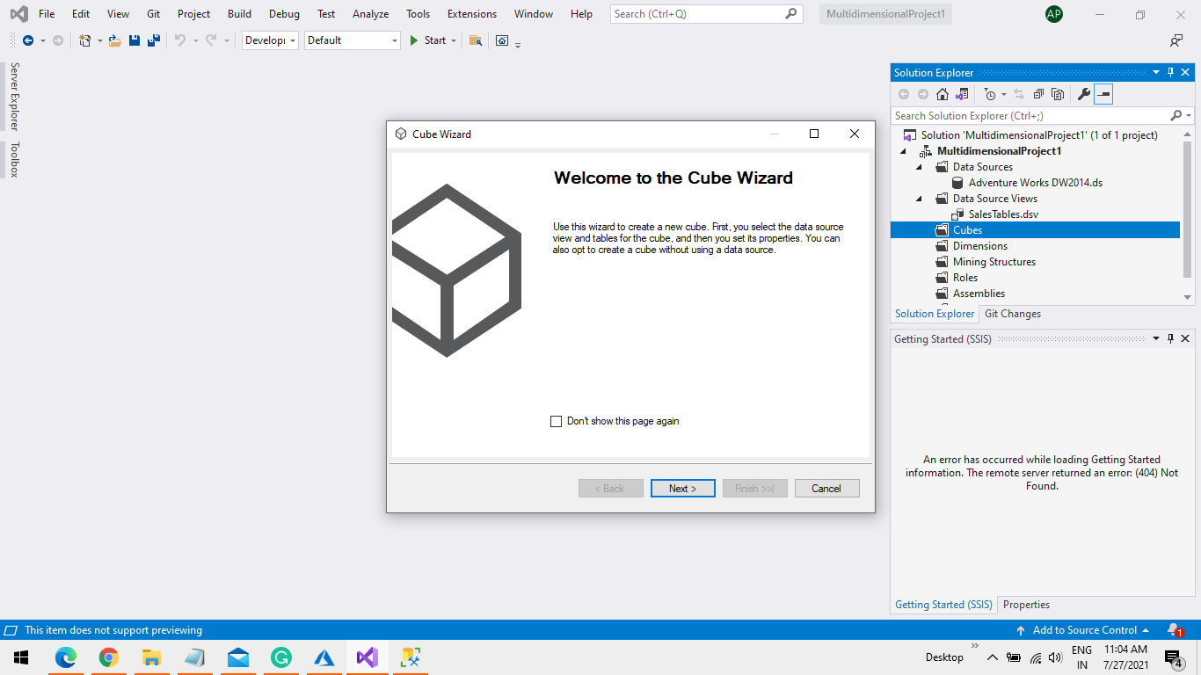

Step 3 Select “Use Existing Table” and click on Next Button.

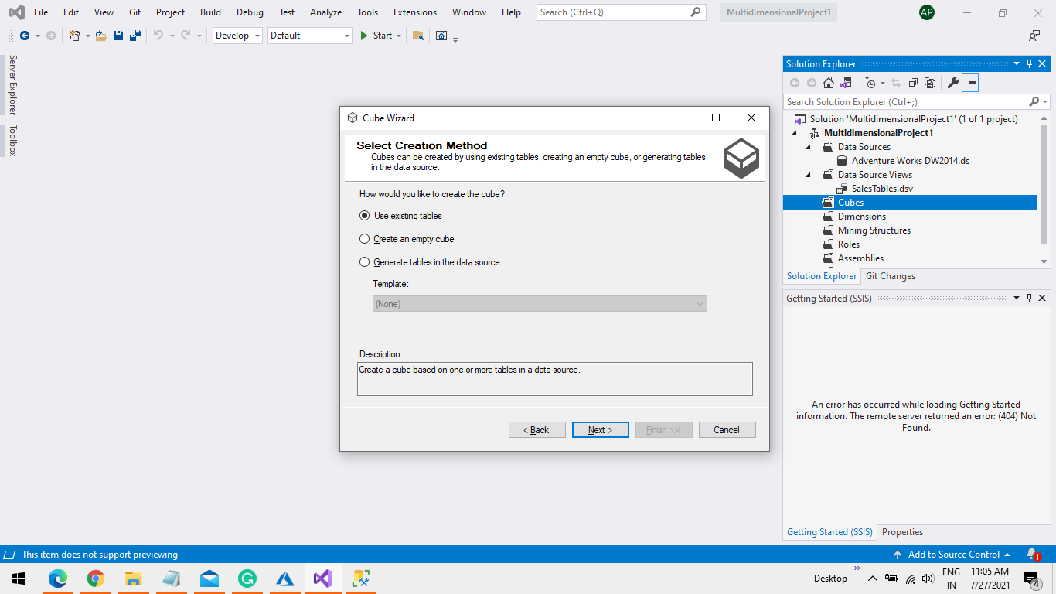

Step 4 Select “FactInternetSales” and Click on Next Button

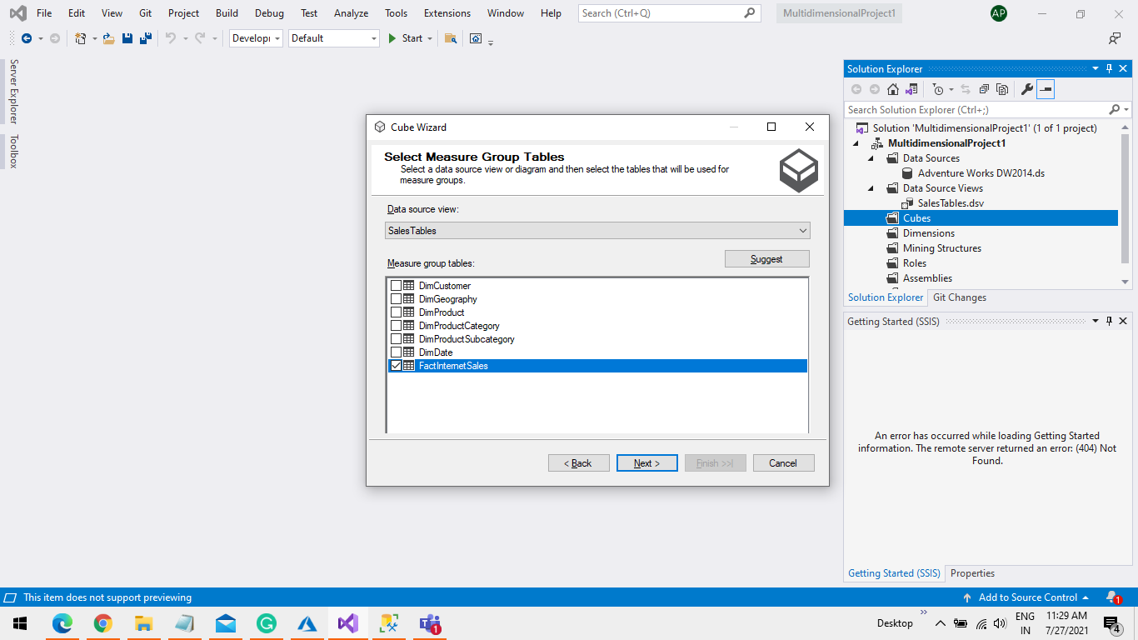

Step 5 Select the Measures Column Only and Click on Next Button.

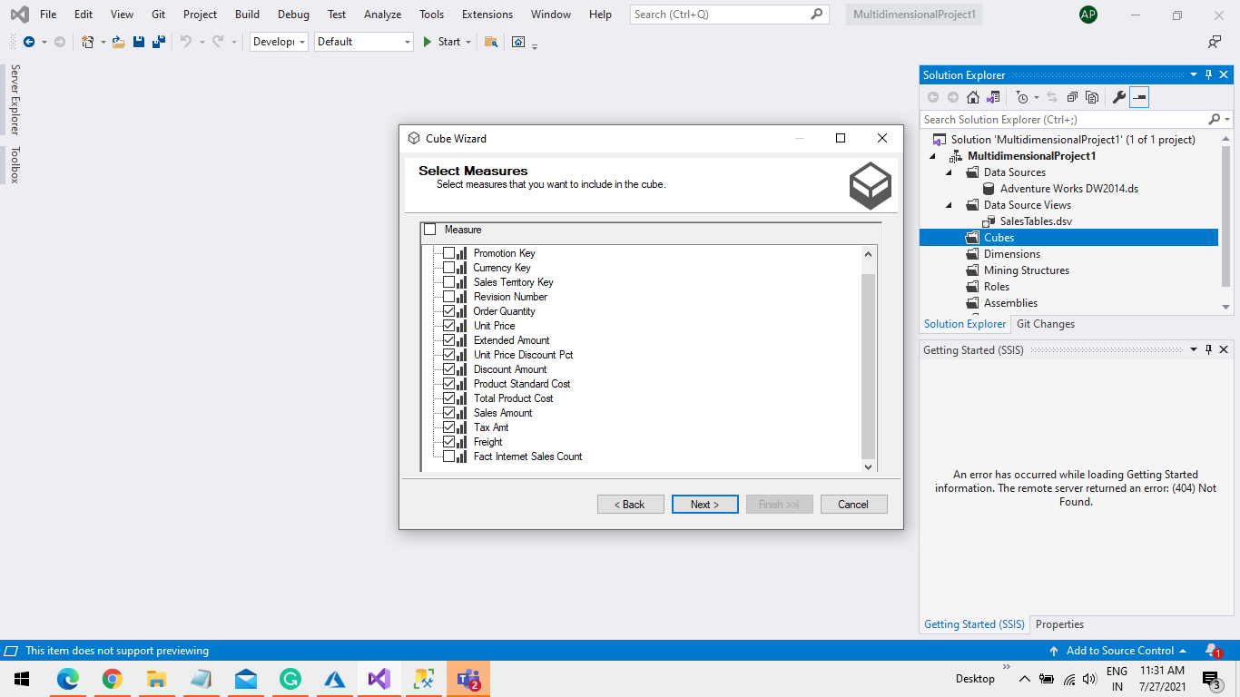

Step 6 Uncheck the Fact Table and Select all the Dimension tales. Click on Next Button

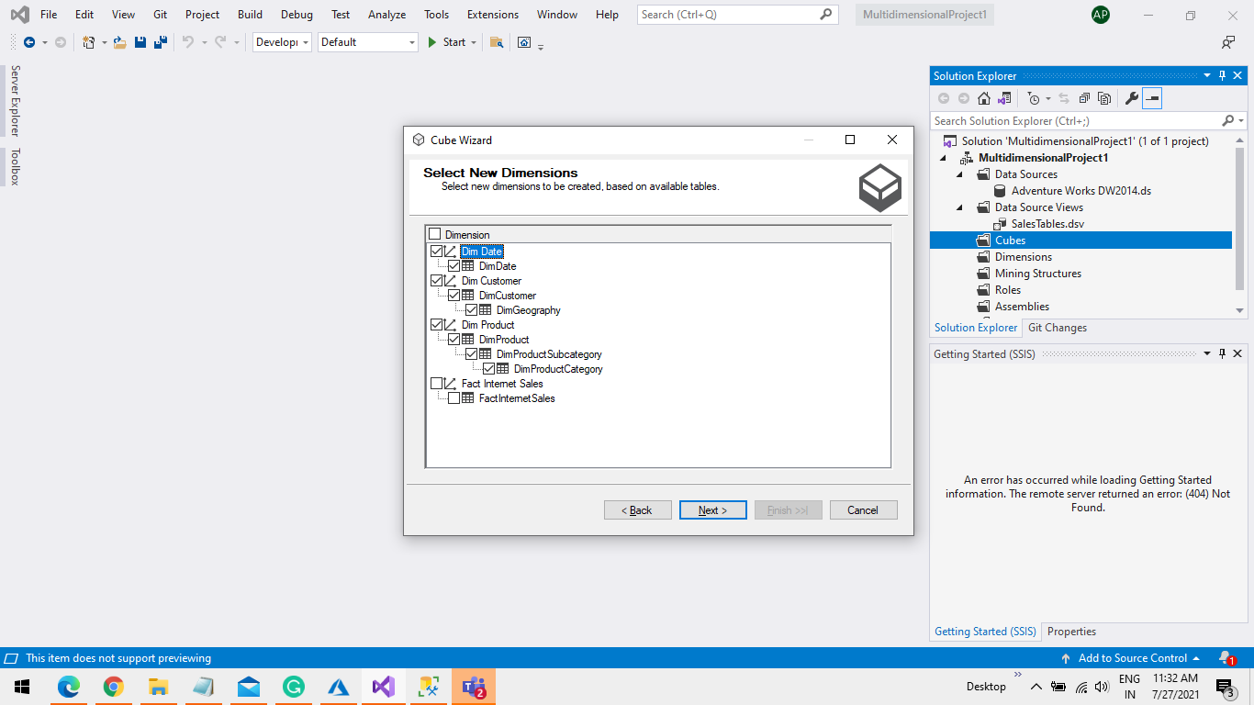

Step 7 Enter a name For Cube and Click on Next Button.

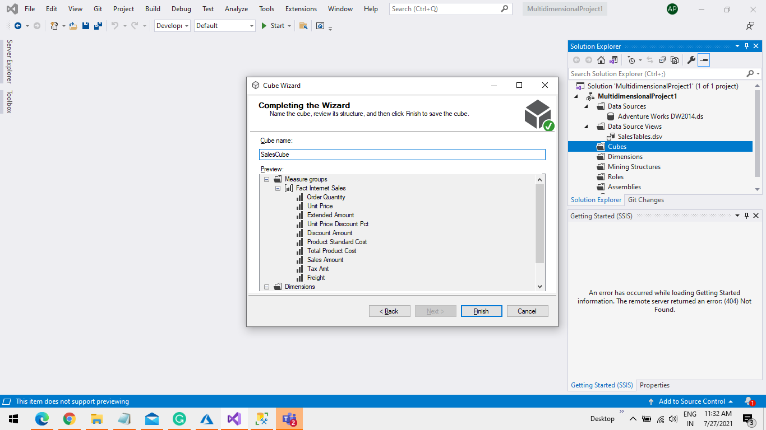

Step 8 You see a “SalesCube.cube” Under Cube Folder and Some Dim Table Under Dimensions folder

