|  |  |  |  |  |
| --- | --- | --- | --- | --- |
| **分类号:** |  |  | **密级:** | **公开** |
| **U D C:** |  |  | **编号:** |  |



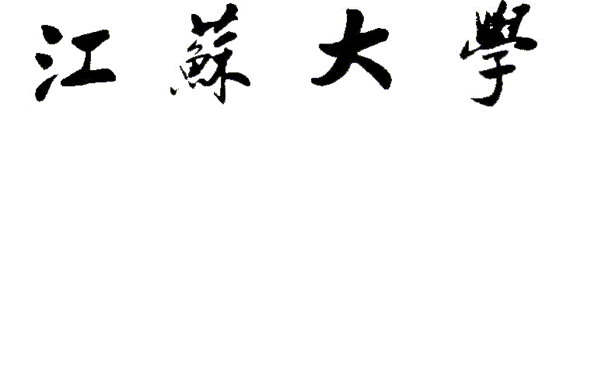

**JIANGSU UNIVERSITY**

**硕 士 学 位 论 文**

**MASTER’S DEGREE THESIS**



|  |  |
| --- | --- |
| 论文题目: | THE TITLE OF YOUR THESIS, SHOULD BE IN UPPERCASE |
| **Chinese Title** |
| 学科专业: | **COMPUTER SCIENCE AND TECHNOLOGY** |
| 作者姓名: | **Your Name** |
| 指导教师: | **Your Supervisor** |
| 答辩日期: | **Graduation Month, Year** |

**The Title of Your Thesis**

**By**

**YOUR NAME**

A DISSERTATION

Submitted to

The Graduate School, Jiangsu University, China in partial fulfillment of the requirements for the degree of

MASTER OF SCIENCE

**MAJOR IN COMPUTER SCIENCE AND TECHNOLOGY**

**Supervisor: Dr. ___________**

**DATE**

独 创 性 声 明

本人郑重声明：所呈交的学位论文，是本人在导师的指导下，独立进行研究工作所取得的成果。除文中已注明引用的内容以外，本论文不包含任何其他个人或集体已经发表或撰写过的作品成果，也不包含为获得江苏大学或其他教育机构的学位或证书而使用过的材料。对本文的研究做出重要贡献的个人和集体，均已在文中以明确方式标明。本人完全意识到本声明的法律结果由本人承担。

学位论文作者签名：

2021 年 06 月 08 日

Enclosure:

Declaration of Authorship

I solemnly declare that the dissertation submitted is the result of my independent research work under the guidance of my supervisor. In addition to the content cited in the article, this article does not contain any of the works published or written by any other individual or group, nor does it contain materials used to obtain degrees or certificates from the Jiangsu University or other educational institutions. The individuals that have made important contributions to this study have been clearly identified in the text. I am fully aware that I am obligated to undertake the legal consequence of the statement.

Signature of the Candidate:

2021 Year 06 Month 08 Day

学位论文版权使用授权书

江苏大学、中国科学技术信息研究所、国家图书馆、中国学术期刊（光盘版）电子杂志社有权保留本人所送交学位论文的复印件和电子文档，可以采用影印、缩印或其他复制手段保存论文。本人电子文档的内容和纸质论文的内容相一致，允许论文被查阅和借阅，同时授权中国科学技术信息研究所将本论文编入《中国学位论文全文数据库》并向社会提供查询，授权中国学术期刊（光盘版）电子杂志社将本论文编入《中国优秀博硕士学位论文全文数据库》并向社会提供查询。论文的公布（包括刊登）授权江苏大学研究生院办理。

本学位论文属于不保密 ☑ 。

学位论文作者签名： 指导教师签名：

2021 年 06 月 09 日 2021 年 06 月 09 日

Open Access Authorization for Dissertation

The Jiangsu University, the China Institute of Science and Technology Information, the National Library and the Chinese Academic Journal (soft copy) have the right to retain the copies and electronic documents of the degree papers. They can use photocopies or other means of copying to save the paper. The content of the electronic document should be consistent with the content of dissertation in my hard copy. It allows the paper to be consulted and borrowed, and authorizes the Chinese science and Technology Information Institute to compile this paper into the full text database of China's dissertations and provide inquiries to the society, and authorizes the Chinese Academic Journal (optical disk Edition) to incorporate this paper and its use to the community. The publication of the paper (including publication) is authorized by the Graduate School of Jiangsu University.

The Dissertation of this degree is not confidential

Signature of the Candidate: Signature of the Supervisor:

20201 Year 06 Month 09 Day 2021 Year 06 Month 09 Day

**DEDICATION**

This dissertation is sincerely dedicated to………..