Technical PRD
Support-Led Ordering System

Customer Support Backend with Freshchat Integration

Version | 1.0
Date | January 14, 2026
Status | Draft
Author | Engineering Team

Table of Contents
- 1. Overview
- 2. User Flow
- 3. System Architecture
- 4. Data Models
- 5. API Specifications
- 6. Service Layer
- 7. Mobile Integration
- 8. Analytics & Reporting
- 9. Deployment
- 10. Implementation Timeline
- 11. Success Metrics

1. Overview

1.1 Problem Statement
Current catering order flow relies heavily on human sales intervention. Users abandon orders due to trust issues, menu/quantity confusion, and high cognitive load with choices.

1.2 Solution
Build a Support-Led Ordering System where:
- App is the primary interface
- Human support is contextual (triggered only when needed)
- Every interaction is logged as an "Incidence" for product improvement

1.3 Selected Platform
Freshchat Growth — chosen based on:
- Native React Native SDK support
- Budget fit (₹9,600/mo for 6 agents)
- Robust webhooks and REST API
- 2-week implementation timeline

2. User Flow
Visual Overview:
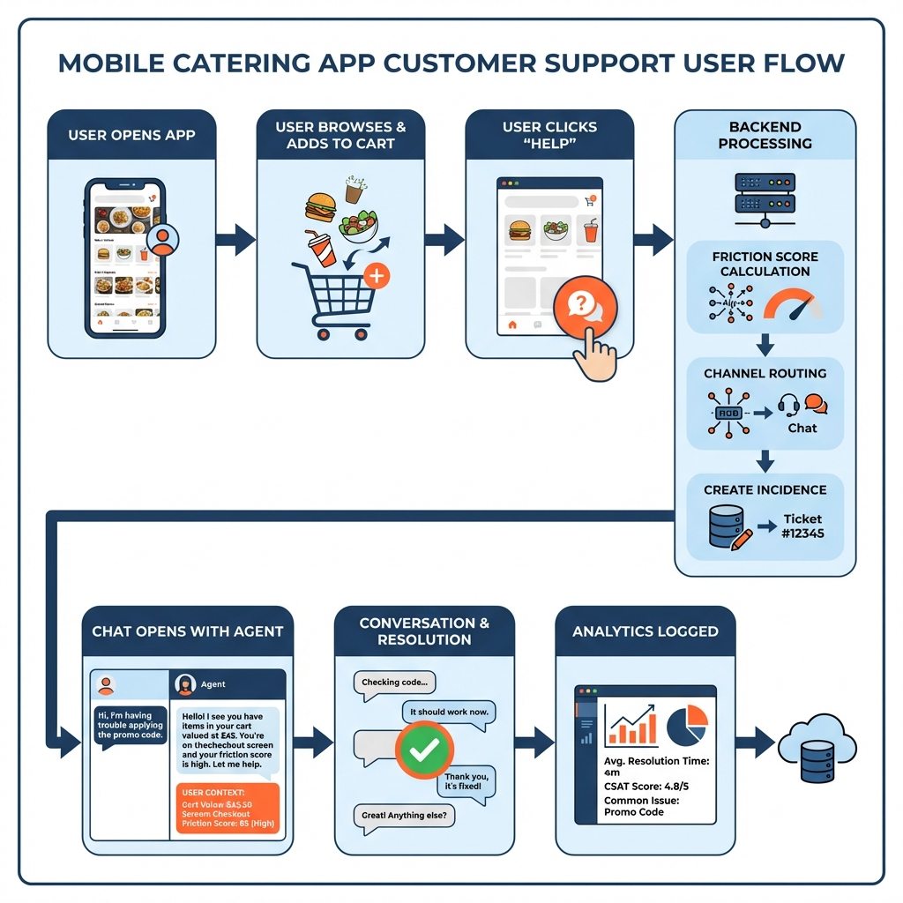

2.1 End-to-End Support Flow
This section describes the complete user journey from browsing the app to getting support assistance.

Step 1: User Browses the App
The user opens the mobile app (React Native) and browses menus, customizes platters, adds items to cart.
Behind the scenes:
- Context Tracker monitors: current screen, cart updates, navigation patterns
- This data is continuously synced to Freshchat via setUserProperties()

Step 2: User Requests Support
User clicks "Chat with Support" or a help button.
What happens:
- Frontend sends current context to Backend (POST /context/update)
- Context includes: current_screen, cart_value, guest_count, behavior signals
- Example: cart_value=₹25,000, guest_count=100, inactivity_seconds=75

Step 3: Backend Processes the Request
The backend performs three key operations:
A. Friction Score Calculation:
- Inactivity > 60s: +30 points
- Back navigation > 3: +25 points
- Price checks > 5: +20 points
- High-value event: +15 points
- First-time user: +10 points
B. Channel Router Applies Cost Rules:
Cart Value | Allowed Channels | Priority
< ₹5,000 | None (self-serve only) | -
₹5,000 - ₹25,000 | Chat only | Normal
> ₹25,000 | Chat + Call | High

C. Incidence Created:
- New record created in incidences table
- Links to user's context and session
- Outcome set to IN_PROGRESS

Step 4: Chat Opens via Freshchat
The agent dashboard shows full user context instantly — no need to ask "What are you looking at?"
Agent sees:
- User: John Doe (Gold Tier)
- Screen: Checkout
- Cart: ₹25,000 | 100 guests
- Event: Wedding - Feb 15
- Friction Score: 55 (HIGH)
- Items: Paneer Tikka, Dal Makhani, Biryani

Step 5: Conversation Happens
- Every message triggers a webhook to your backend
- message_create event → logged to incidence_timeline
- Agent helps user complete order with full context visibility

Step 6: Resolution
When chat is resolved:
- Webhook: conversation_resolution is received
- Backend updates incidence: outcome → CONVERTED, order_impact → PLACED
- Time to resolve is calculated and logged
- Analytics Service logs for KPI tracking

2.2 Flow Summary Diagram
User Opens App → Browses → Clicks 'Help' → Backend calculates (Friction Score, Allowed Channels, Creates Incidence) → Freshchat shows chat with full user context to agent → Webhooks log everything back to database → Resolution → Analytics

3. System Architecture

3.1 High-Level Architecture
The system consists of three main layers:
1. MOBILE APP: React Native application with Freshchat SDK, Context Tracker, and Friction Detector
2. FRESHCHAT CLOUD: Agent Inbox, User Context storage, Conversation handling
3. BACKEND SERVICES: FastAPI server with Webhook Handler, Incidence Service, Channel Router, and Analytics Service

3.2 Component Overview
Component | Technology | Purpose
Mobile App | React Native | User-facing app with Freshchat SDK
API Gateway | FastAPI (Python) | REST API, webhook handling
Database | PostgreSQL | Persistent storage
Cache | Redis | Real-time context, session data
Queue | Celery + Redis | Async webhook processing

4. Data Models

4.1 Incidence Model
The Incidence is the core entity representing every support interaction. It replaces the traditional 'lead' concept with rich contextual data.
Key fields:
Field | Description
id | UUID - Unique identifier
user_id | Reference to user
conversation_id | Freshchat conversation ID
stage | PRE_ORDER or POST_ORDER
channel | IN_APP_CHAT, CALL, or WHATSAPP
trigger | USER_INITIATED or SYSTEM_INITIATED
app_screen | Screen user was on when help requested
cart_value | Cart value at time of incidence
friction_score | Calculated friction score (0-100)
outcome | RESOLVED, DROPPED, CONVERTED, or IN_PROGRESS
issue_category | Categorized issue type
time_to_resolve_seconds | Resolution time

4.2 User Context Model
Real-time user state visible to agents. Stored in Redis for fast access. Updated on every screen navigation and cart change.
- User profile (name, email, phone, tier, past orders)
- Current session (screen, duration, session start)
- Cart state (items, value, guest count, event date)
- Behavior signals (friction score, back navigations, payment retries)

5. API Specifications

5.1 Webhook Handler
Endpoint: POST /webhooks/freshchat
Receives real-time events from Freshchat and processes them to create/update Incidences.
Supported Events:
Event | Action
message_create | Create incidence, log to timeline
conversation_assignment | Update agent assignment
conversation_resolution | Close incidence with outcome
conversation_reopen | Reopen incidence

5.2 Context API
Base Path: /api/v1/context
Endpoint | Purpose
PUT /{user_id}/screen | Update user's current screen
PUT /{user_id}/cart | Update cart state
POST /{user_id}/friction-signal | Log friction signal

5.3 Channel Router API
Endpoint: POST /api/v1/channel/route
Business Rules:
- < ₹5,000: No human support (self-serve only)
- ₹5,000 - ₹25,000: Chat only
- > ₹25,000: Chat + Call
- High-importance events (Wedding, Corporate, Religious): Always Chat + Call

6. Service Layer

6.1 Incidence Service
Core service for managing support incidences.
Key Methods:
- create() — Create new incidence with context
- close() — Close incidence with resolution details
- get_by_conversation() — Lookup by Freshchat conversation ID
- log_timeline() — Add event to incidence timeline

6.2 Friction Detection Service
Monitors user behavior and calculates friction score. Triggers help prompts when friction exceeds threshold (60).
Friction Weights:
Signal | Weight
Inactivity on checkout (>60s) | 30 points
Back navigation loops (>3) | 25 points
Excessive price checking (>5) | 20 points
High-importance event | 15 points
First-time user | 10 points
Payment failure | 40 points

6.3 Channel Router Service
Routes users to appropriate support channels based on order value and event type. Enforces cost boundaries to optimize support spend.

7. Mobile Integration

7.1 Freshchat SDK Setup
Key integration steps:
1. Initialize Freshchat SDK with app credentials on app startup
2. Identify user after login (set name, email, phone)
3. Set custom properties for agent context (tier, past orders, etc.)
4. Sync real-time context on screen navigation and cart updates
5. Control chat visibility based on channel routing rules

7.2 Context Tracker
Tracks user behavior and maintains real-time context. Syncs with both Freshchat (for agent visibility) and backend (for analytics).
Tracked behaviors:
- Screen navigation and time spent
- Cart updates (value, items, guest count)
- Back navigation patterns
- Payment attempts and failures
- Friction score calculation

8. Analytics & Reporting

8.1 Key Metrics
Metric | Calculation
Self-serve conversion rate | Orders completed without human help / Total orders
Assisted conversion rate | Orders with help that converted / Total assisted
Average time to resolve | Mean resolution time across all incidences
Cost per assisted order | Total support cost / Assisted orders
Top friction reasons | Most common issue categories

8.2 Weekly Report
Generated every Monday, includes: total orders, self-serve rate, assisted orders, average resolution time, cost analysis, and top 10 friction reasons.

9. Deployment

9.1 Infrastructure Requirements
Component | Specification | Monthly Cost
API Server | 2 vCPU, 4GB RAM | ~₹3,000/mo
PostgreSQL | 2 vCPU, 4GB RAM, 50GB | ~₹2,500/mo
Redis | 1GB | ~₹1,000/mo
Celery Workers | 1 vCPU, 2GB RAM | ~₹1,500/mo
TOTAL |  | ~₹8,000/mo

9.2 Total Monthly Cost
Freshchat (6 agents): ₹9,600
Infrastructure: ₹8,000
TOTAL: ₹17,600

10. Implementation Timeline
Week | Tasks | Deliverable
Week 1 | Freshchat setup, SDK integration, context passing | Chat working in app
Week 2 | Webhook handler, Incidence Service, database | Incidences being logged
Week 3 | Channel Router, Friction Detection | Smart routing active
Week 4 | Analytics Service, Agent Dashboard config | Weekly reports

11. Success Metrics
Metric | Target (Month 1) | Target (Month 3)
Self-serve conversion | 60% | 75%
Avg. time to resolve | <10 min | <5 min
Cost per assisted order | <₹50 | <₹30
Repeat friction issues | Track baseline | -30%

Document Status: Ready for Engineering Review

Next Steps: Review with team → Sprint planning → Implementation

