Learned about the Facebook flux concepts.

The action will be triggered whenever there is an update in the UI.

The dispatchers will have a group of registered callbacks, based on the action type. We are going to send the payload to the store.

The store is responsible for handling the data and updating the data and then creating the event emitter to send the data to the UI.

The react is going to get the data and then update the UI.

Learned about the controller view

The controller view is responsible for handling the state received from the store and place the data in the state and then pass the data to the child as props.

Learned about the structure of the store.

Looked at an example for the flux application.

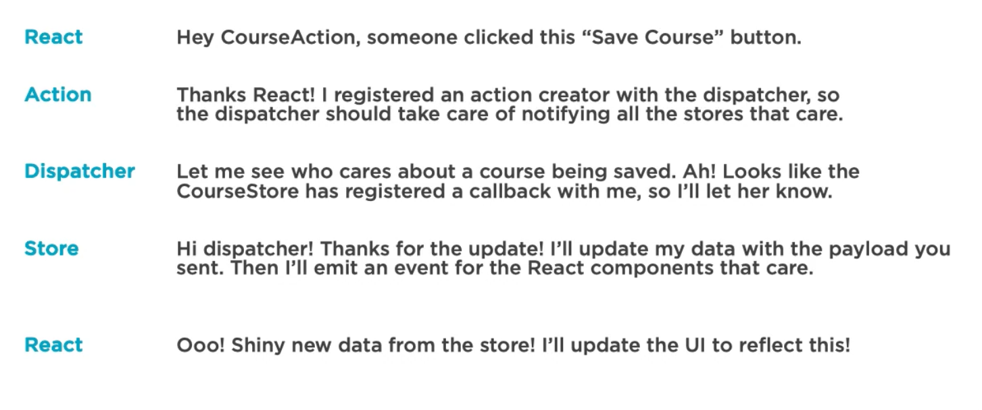

Learned about the flux api.

