# Data Visualization

The CSV file has not been edited.

Import Data:

df <- read.csv("data/cereal.csv")

library(ggplot2)

For replacing negative values I’ve used the following:

df[df<0] <- 1

**Histogram of calories_per_cup (computed element)**

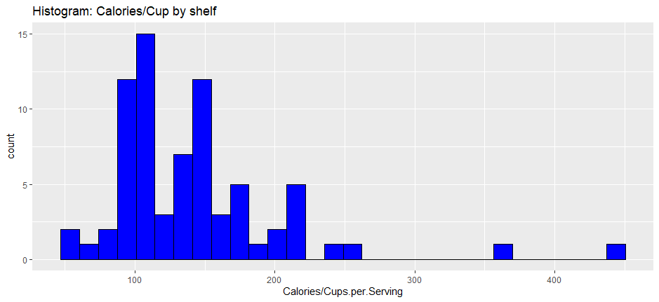

Code:

ggplot(data=df,aes(x=Calories/Cups.per.Serving))+ggtitle("Histogram: Calories/Cup by shelf")+geom_histogram(colour='black',fill="blue")

**Histogram of calories_per_cup  faceted by Shelf**

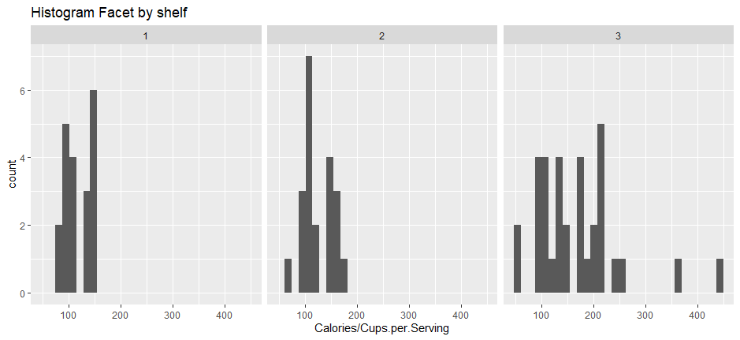

Code: h+facet_wrap(~Display.Shelf,nrow=1)+ggtitle('Histogram Facet by shelf') + scale_fill_gradient(low="blue")

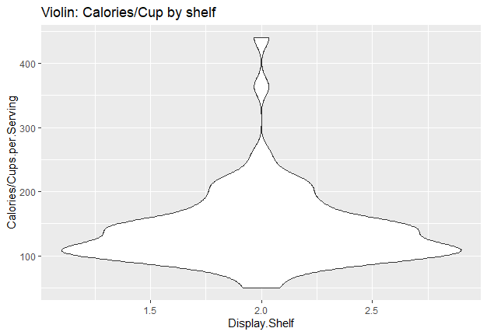Violing

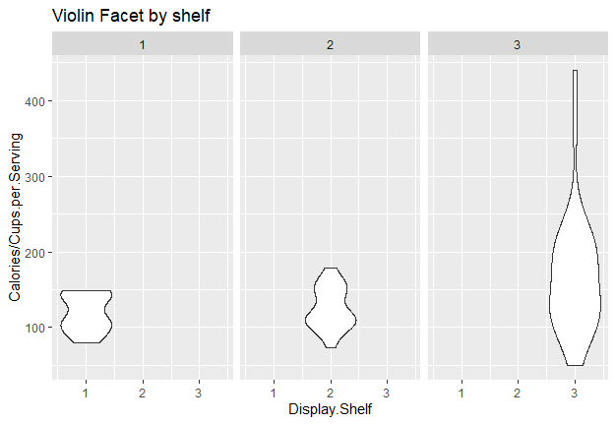

v <-ggplot(data=df,aes(x=Display.Shelf,y=Calories/Cups.per.Serving))+ggtitle("Calories/Cup by shelf")+geom_violin()

v+facet_wrap(~Display.Shelf,nrow=1)+ggtitle('Violin Facet by shelf')