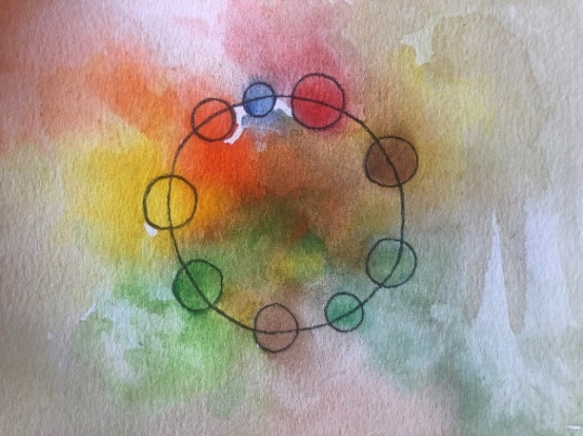

Dear Group Member,

Starting group therapy may be a new experience. There will be up to eight regular members. Each group member will meet with me individually before joining the group. You can enter the group at your own pace; when you feel ready.

This group is offered online, for 90 minutes on a weekly basis. The commitment is for one year initially. Please use a quiet room with full privacy and no interruptions. **Group members are encouraged to log into zoom, 5 minutes before the group starts so we can begin together.**

Groups are confidential and so, you must keep confidential the identities of group members and all that they share. If you chose to share details of your own group experience, I encourage you to do so in a way that does not reveal any personal information about other group members. Recording of sessions is not permitted.

The group therapy fee is typically £100 per month; payable one month in advance. Prices may vary between group members. I use a slide scale for calculating fees and ask that people pay what they can afford. If you miss a session, you will still need to pay. This is part of your ongoing commitment to the group. We will take breaks at Christmas, Easter and during the month of August. Individual sessions for group members are £50.

Endings are important. I ask that you give a minimum of one month’s notice before ending therapy. If for some reason you are unable to attend further sessions, I ask that you contact me to communicate this so that we have a shared understanding about the ending.

I look forward to seeing you in the group.

Sincerely,

Aisling Fegan, Art and Group Psychotherapist.