Emma through the clouds



B.S. (CS) Final Year Project Report

Submitted by:
Syeda Urooba Amjad Seat number
Ashfia Binte Waqar Seat number
Hadiya Manzar Seat number

July 2021

Department of Computer Science and Software Engineering

Jinnah University for Women
5-C Nazimabad, Karachi 74600

Table of Contents

Project Summary 1
Algorithm 3
Project Flow 7
Code Explanation 10
Screenshots 13

Project Summary

Introduction:

This game is a remake of the popular mobile game Doodle jump, made with Emma. Emma through the clouds is a platforming game where the aim of the player is to guide Emma up a never-ending series of platforms. The primary objective of the player is to gain score by going higher as much as they can, they can only go higher by jumping over the platforms. If the player falls to the bottom they lose.

Gameplay:

Player moves Emma through left and right arrow keys and jump on different platforms to go up.

Following are the rules in the game:
- The player can move left or right or stay.
- The right side of the playing area is connected with the left side and vice versa.
- There is an end to the game only if the player falls to the bottom of the screen.
- Player can get a short boost through an object that looks like a spring.

Features:

- There is a spring object which boosts the player up.

- There are three different platforms:
  - Regular platforms: Platforms that are fixed in their position, look like clouds.
  - Moving platforms: Platforms that move left and right, colored blue.
  - Breaking platforms: Platforms that are fixed in their position and break on player collision, colored red.

GitHub Link

https://github.com/urooba26/emmathroughtheclouds

https://github.com/ashfiabintewaqar/EmmaThroughTheClouds

https://github.com/HadiyaManzarAli/EMMATHROUGHTTHECLOUDS

Algorithm

STEP#1 START
STEP#2 Import pygame, sys and random prompt pygame.locals import *
STEP#3 Define variables font = “small_pixel-7.ttf”, screen_width=800 and screen_height=600
STEP#4 Initialize pygame
STEP#5 Open new pygame window
Screen=pygame.display.set_mode((screen_width, screen_height))
STEP#6 Define variables white=(255, 255, 255), black=(0, 0, 0), gray=(77, 77, 77, 255), lightskyblue= (135, 206, 250, 255), lightpink=(219, 112, 147, 255), clock = pygame.time.Clock(), FPS=60
STEP#7 Call the main_menu() function
STEP#8 STOP

ALGORITHM (main_menu() function):

STEP#1 START
STEP#2 Define variables menu=True, selected="start"
STEP#3 while menu
for event in pygame.event.get():
if event.type==pygame.QUIT:
pygame.quit()
sys.exit()
if selected=="start" then
Call the function game() in the class EmmaThroughTheClouds()
if selected=="quit" then
pygame.quit()
sys.exit()
STEP#4 Update pygame display
STEP#5 Set pygame display caption as “Emma Through The Clouds”

ALGORITHM (text_format(displaytext, textFont, textSize, textColor) function):

STEP#1 START
STEP#2 newFont = pygame.font.Font(textFont, textSize)
STEP#3 newText = newFont.render(displaytext, 0, textColor)
STEP#4 return newText

ALGORITHM (game() function) in class EmmaThroughTheClouds:

STEP#1 START
STEP#2 Call the method __init__(self) to initialize attributes in class
STEP#3 Call the function generatePlatforms()
STEP#4 while True:
Blit bg_surface in position (bg_x,bg_y)
for event in pygame.event.get() then
if event.type == QUIT then
pygame.quit()
sys.exit()
if playery - cameray > 600 then
Call the function game_over()
Call the function generatePlatforms()
Call the functions drawPlatforms(), updatePlayer(), updatePlatforms()
Blit score on top left
Flip pygame display

ALGORITHM ( __init__(self) method) in class EmmaThroughTheClouds:

STEP#1 START
STEP#2 Declare variables fixedplatform, movingplatform breakplatform, brokenplatform, playerRight, playerRight_1, playerLeft, playerLeft_1, spring and spring_1 to load images
STEP#3 Define variables direction = 0, playerx = 400, playery = 400, platforms = [[400, 500, 0, 0]], springs = [], cameray = 0, jump = 0, gravity = 0 and xmovement = 0 for player movement and platforms.

ALGORITHM (updatePlayer(self) function) in class EmmaThroughTheClouds:

STEP#1 START
STEP#2 if jump then
Subtract jump from playery
elif not jump then
Add gravity to playery
STEP#3 ` Input key pressed
STEP#4 if key[K_RIGHT] then
if xmovement < 10 then direction = 0
elif key[K_LEFT] then
if xmovement > -10 then
direction = 1
else:
if xmovement > 0 then
Subtract 1 from xmovement
elif xmovement < 0 then
Add 1 to xmovement
STEP#5 if playerx > 850 then
playerx = -50
elif playerx < -50 then
playerx = 850
STEP#6 Add xmovement to playerx
STEP#7 if playery - cameray <= 200 then
Subtract 10 from cameray
STEP#8 I if direction==0 then
if jump then
Blit playerRight_1 (playerx, playery - cameray) on screen
else
Blit playerRight (self.playerx, self.playery - self.cameray) on screen
else
if jump then
Blit playerLeft_1 (playerx, playery - cameray) on screen
else
Blit playerLeft (playerx, playery - cameray) on screen

ALGORITHM (updatePlatforms(self) function) in class EmmaThroughTheClouds:

STEP#1 START
STEP#2 for p in platforms:
if rect.colliderect(player) and gravity and playery < (p[1] - cameray) then
if p[2] != 2 then
jump = 18
gravity = 0
else:
p[-1] = 1
if p[2] == 1 then
if p[-1] == 1 then
Add 5 to p[0]
else then
p[0] -= 5

ALGORITHM (drawPlatforms(self) function) in class EmmaThroughTheClouds:

STEP#1 START
STEP#2 for p in self.platforms:
check = platforms[1][1] - cameray
if check > 600 then
platform = random.randint(0, 950)
if p[2] == 0 then
Blit fixedplatform (p[0], p[1] - cameray)
elif p[2] == 1 then
Blit movingplatform (p[0], p[1] - cameray)
elif p[2] == 2 then
if not p[3]:
Blit breakplatform (p[0], p[1] – cameray)
else
Blit brokenplatform (p[0], p[1] - cameray)
STEP#3 for spring in springs:
if spring[-1] then
Blit spring_1 (spring[0], spring[1] - cameray)
else
Blit spring (spring[0], spring[1] – cameray)
ALGORITHM (generatePlatforms(self) function) in class EmmaThroughTheClouds:

STEP#1 START
STEP#2 Define variable on = 500
STEP#3 while on > -100 then
x = random.randint(0,700)
platform = random.randint(0, 1000)
if platform < 800 then
platform = 0
elif platform < 900 then
platform = 1
else then
platform = 2
platforms.append([x, on, platform, 0])
Subtract 50 from on

ALGORITHM (game_over(self) function) in class EmmaThroughTheClouds:

STEP#1 START
STEP#2 Define variables menu=True, selected="playagain"
STEP#3 while menu then
for event in pygame.event.get() then
if event.type==pygame.QUIT then
pygame.quit()
sys.exit()
if selected=="playagain" then
return
if selected=="quit":
pygame.quit()
sys.exit()
Update pygame display

Project Flow

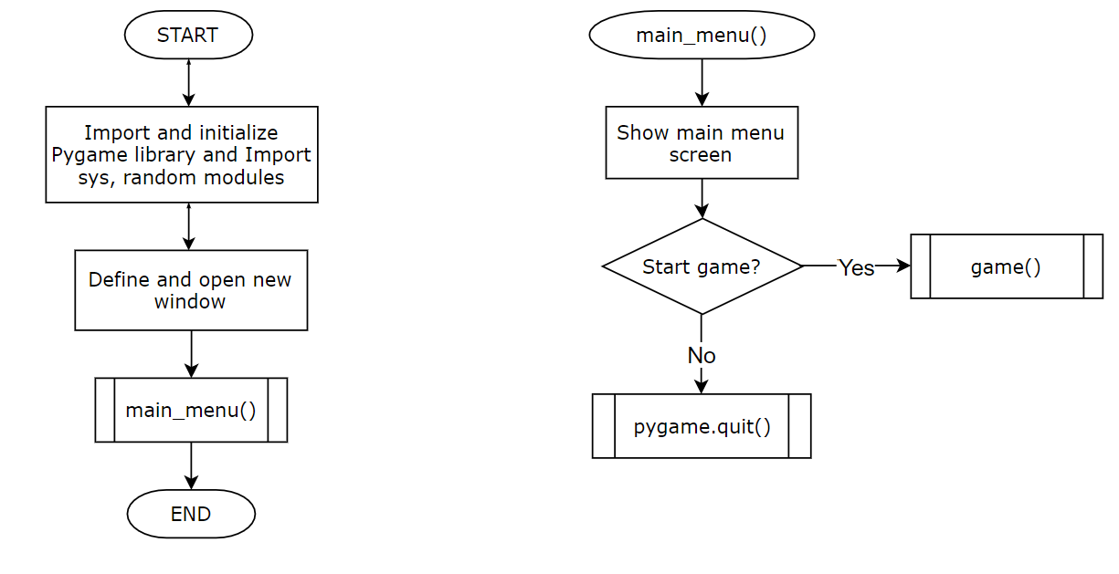
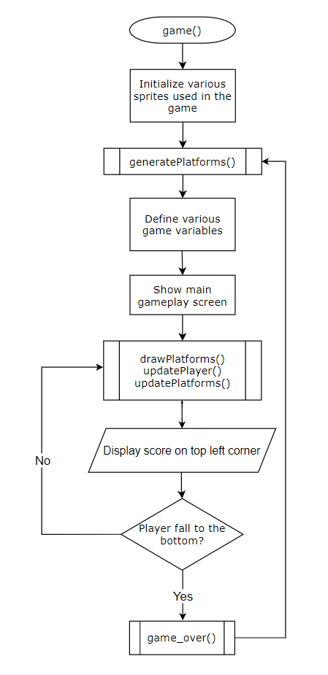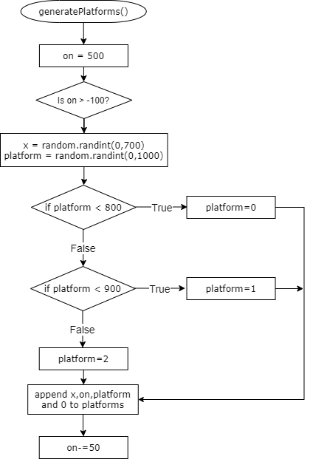
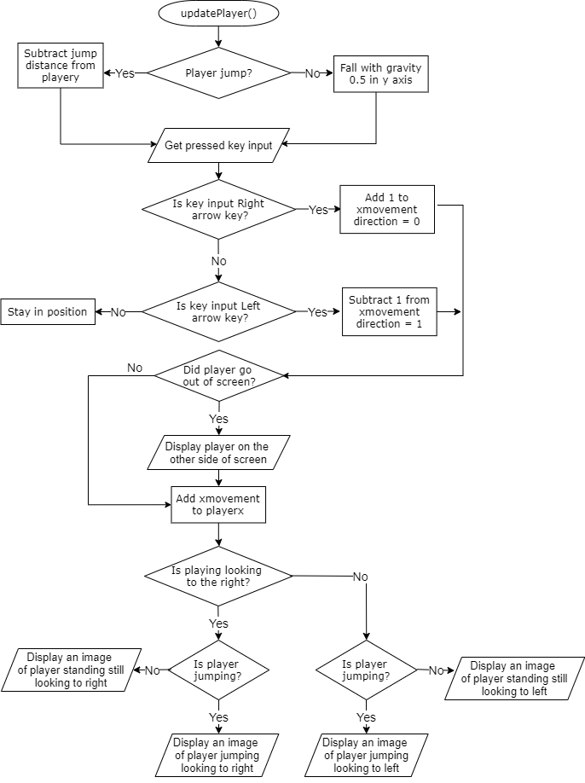
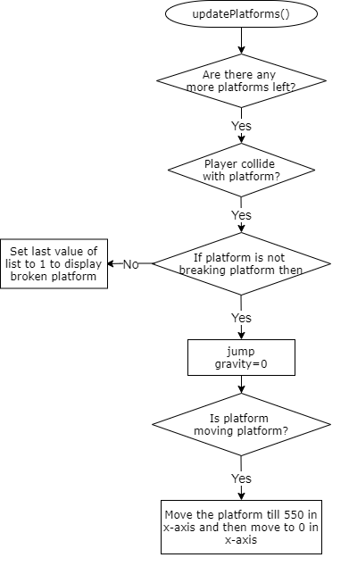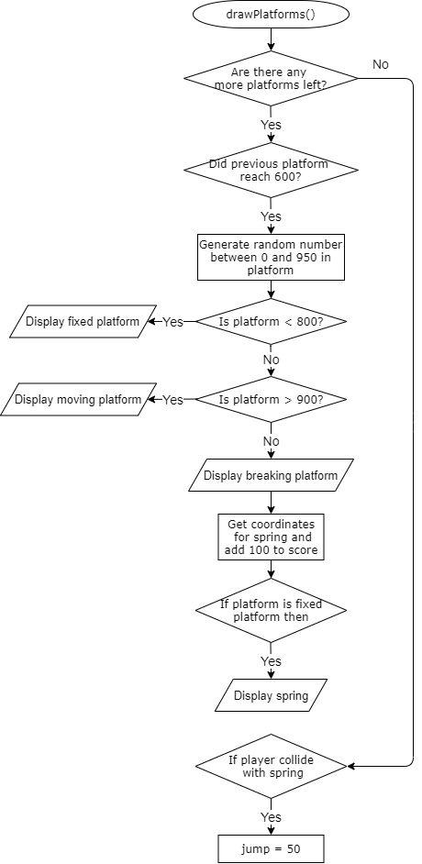

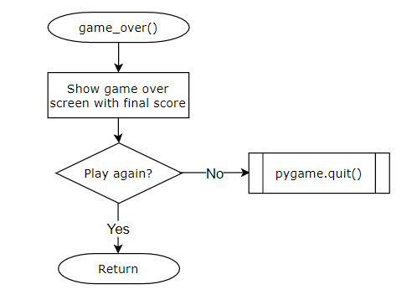

Code Explanation

CODE EXPLANATION OF main_menu() function:

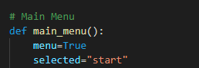

This function consists of main menu screen code for the pygame application. It takes input from the player to either start the game or quit the game. It also displays the title of the game, the start game and quit options on the screen.
If the player selects start game option the program will proceed to the main game loop of the program otherwise if quit option is selected the program will end.

CODE EXPLANATION OF game(self) function:

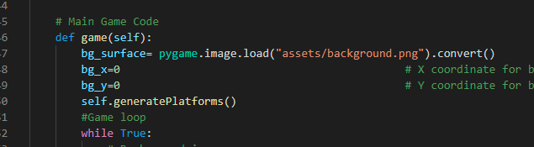

This function consists of the main game loop which runs after all the pygame attributes are initialized. The main loop is a while loop with a True condition which does the following things:
- Handles events.
- Updates the game state.
- Calls all the functions needed for the game.
- Updates the score
Since the game state is usually updated in response to events (such as keyboard presses) or the passage of time, the game loop is constantly checking and re-checking many times a second for any new events that have happened. It also checks if the player falls to the bottom of the screen and then resets all the game variables.

CODE EXPLANATION OF generateplatforms(self) function:

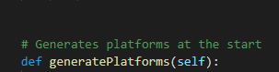

This function generates platforms at the start of the game. This function contains a while loop which is set to generate twelve platforms at the start, there are total three platforms in this game naming:
- Fixed platforms (Clouds).
- Moving Platforms (Blue platform).
- Break Platform (Red platform)
The position of platform on x-axis and y-axis, the type of platform and 0 for break platform is appended to platforms in this function that is then used to display the platforms on screen in drawplatforms function.

CODE EXPLANATION OF drawplatforms(self) function:

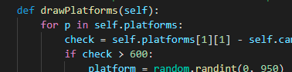

This function helps to draw new platforms as the game goes on. It removes initial platforms list so that it can draw new platforms as player goes up. It also draws springs on fixed platforms; springs are objects which gives player a long jump. Basically, this function decides which platforms to be drawn and at what position, where to draw springs and jump if player hits a spring.

CODE EXPLANATION OF updatePlayer(self) function:

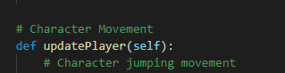

This function controls the movement of the player (like jumping movement, player’s direction movement etc.) through arrow keys on keyboard which are as follows:
- Right arrow key (Moves the character in right direction)
- left arrow key (Moves the character in left direction)
It also controls player’s appearance on screen if the player moves outside the screen they will appear on the other side as well as manages the player to jump at their position continuously. It also controls camera/screen movement to move in equivalence to the player’s movement.

CODE EXPLANATION OF updatePlatform(self) function:

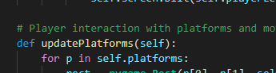

This function controls the movement of moving platform (blue platform). It also controls the player to jump only on the fixed platforms (clouds) or moving platforms (blue platforms) and to change break platform to broken platform when player collides with it. It maintains smooth movement of moving platforms in left and right direction.

CODE EXPLANATION OF game_over(self) function:

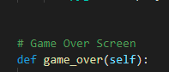

This function consists of the game over screen code for the pygame application. It displays only after the player falls to the bottom of the screen. It takes input from the player to either restart the game or quit the game. It displays the score achieved and also options to play the game again and quit.
This is the function that decides to either run the entire game loop again or quit the game.

Screenshots

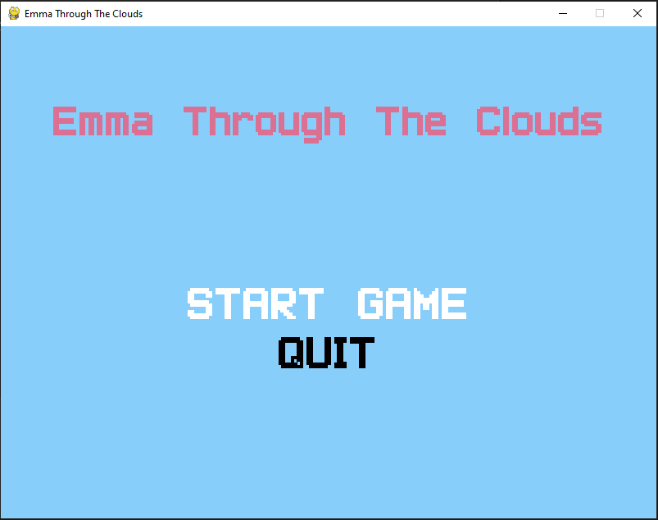
Figure 1 : Main menu screen

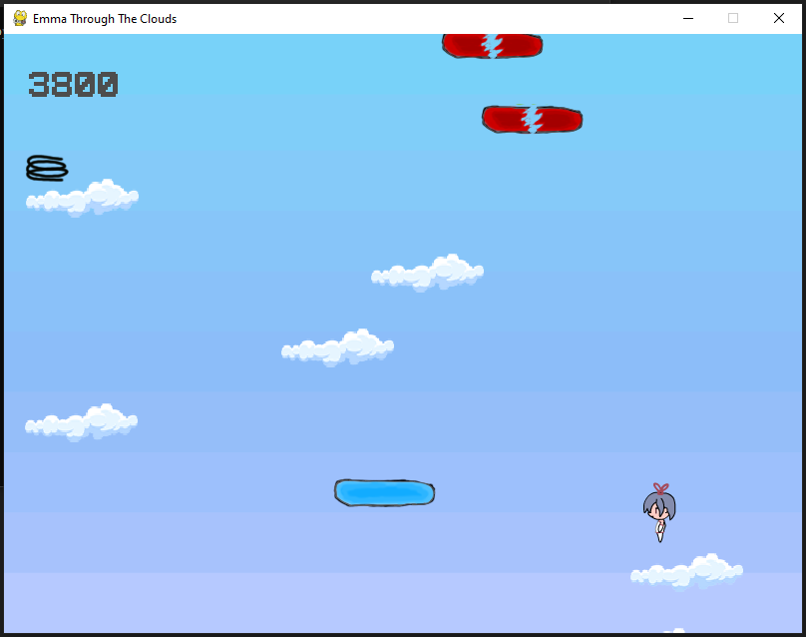
Figure 2 : Gameplay screen

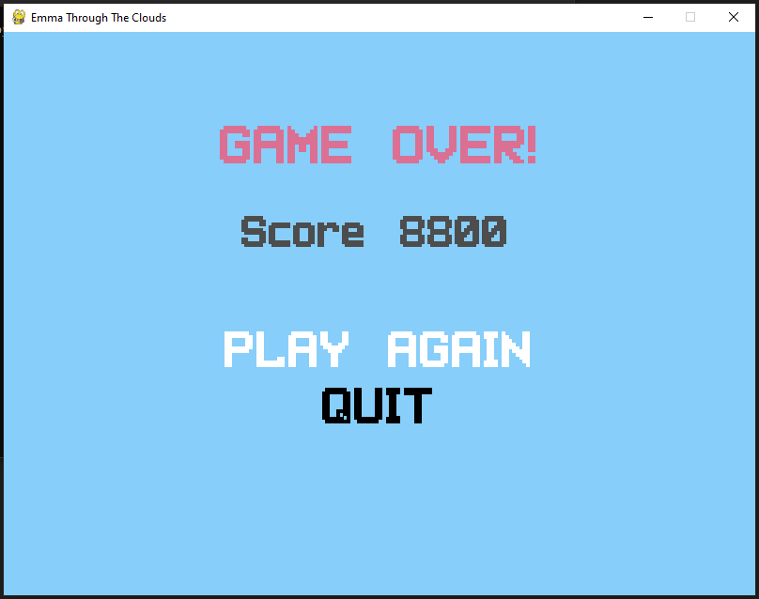
Figure 3 : Game over screen

