Local Restaurant Sales Report

Executive Summary
Total Sales: 275230
Total Orders: 1000
Average Order Value: 275.23

Top-Selling Items
Item Name | Total Sales
Sandwich | 65820
Burger | 57500
Cold coffee | 54440
Lemonade | 31950
French Fry | 24520
Spring Roll | 20880
Chicken Wings | 20120

Visualizations
Items by Sales:
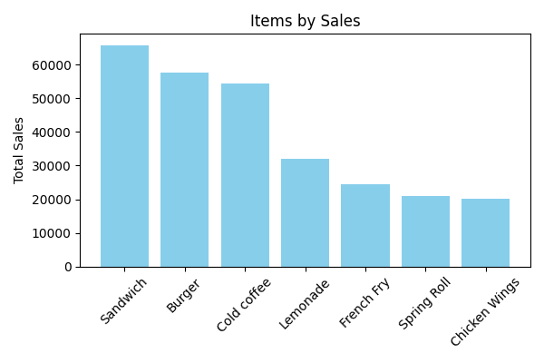
Sales by Time of the Day:
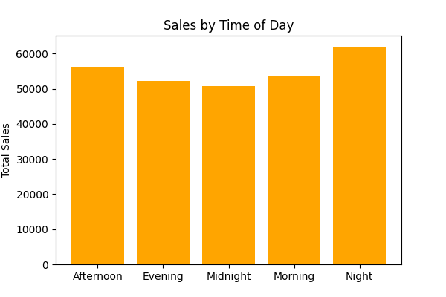

Sales by Day of the Week:
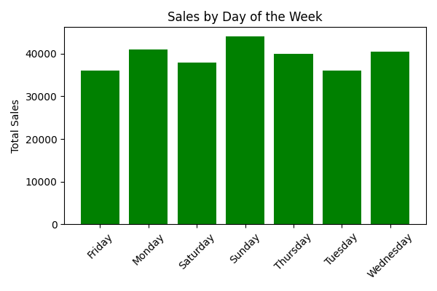
Sales by Payment Method:
