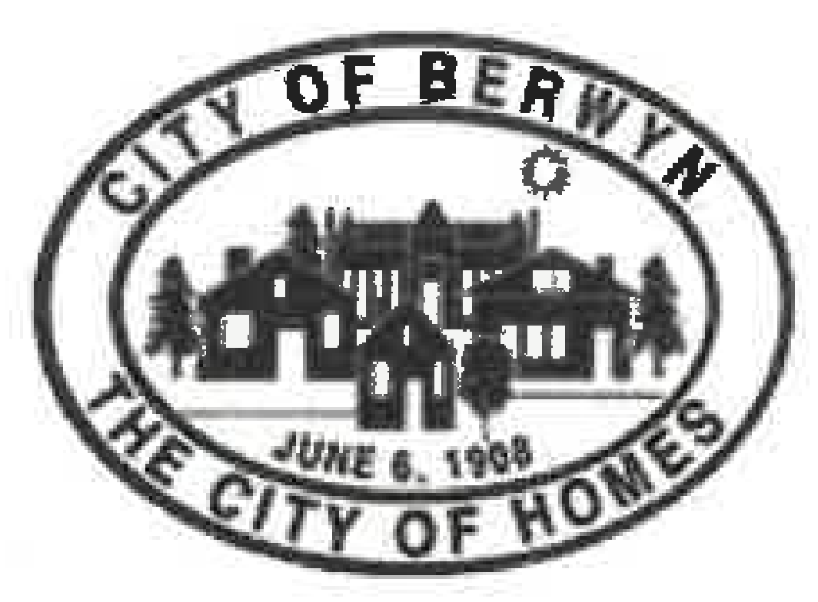
The Berwyn Tree Board
Minutes of the Regular Meeting of October 21st, 2026
Meeting No. 1 — Berwyn City Hall
Meeting Information
- Date: Wednesday, October 21st, 2026
- Location: Berwyn City Hall
- Meeting No. 1: First meeting of the newly seated Berwyn Tree Board
- Calendar listing: City of Berwyn event calendar — Tree Board Meeting
- Video of livestream: BoxCast — 10/21/26 Berwyn Tree Board Meeting
- Next meeting: Wednesday, January 27th, 2027, at 7:00 p.m., Berwyn City Hall
Members Present
- Matt Olsen — Chair (elected at this meeting)
- Philip Matsikas — Vice Chair (elected at this meeting)
- Ash Hill — Secretary (elected at this meeting)
- Brianne Spayer— Board Member
- Alfredo Vargas — Forestry Foreman and Certified City Arborist
Quorum: With seven appointed Board members and one available City Arborist, quorum currently stands at five. The 4th Ward seat has not yet been appointed, and the City does not have a second Arborist at this time.
Call to Order and Introductions
The Board convened for its first meeting at 7:00 p.m.. Members introduced themselves.
Review of the Tree Board Ordinance
- Matt read through the current 2025 Tree Board Ordinance.
- Discussion was held regarding Berwyn's Arborist staffing, as the City previously employed two City Arborists.
- Ash asked whether the Ordinance needs amending with respect to Arborist availability. This question will be directed to the City Clerk.
- Matt asked Alfredo to confirm his role as Forestry Foreman. Alfredo confirmed that he serves as both Forestry Foreman and Certified City Arborist, and noted that Public Works Director Marchand recommends crew members go through the credentialing process so that more members can become Certified Arborists.
- Philip added that, per Tree City standards, two Arborists are required.
Board Appointments
- Chair: Matt, nominated by Philip. Unanimous agreement.
- Vice Chair: Philip, nominated by Ash. Unanimous agreement.
- Secretary: Ash, nominated by Philip. Unanimous agreement.
Board Logistics
Brianne asked about future Board committees (community outreach, City education, events, etc.). Matt referred to a past discussion with the City Clerk, stating that sub-groups within the Tree Board are not recommended at this time due to Tree Board size and constraints, as well as Open Meetings Act (OMA) requirements.
Arborist Insights
Alfredo shared the following information:
- Alfredo is a certified arborist.
- Tree and stump removals are handled by Lyons Tree Service.
- Tree pruning is handled by Winkler Tree & Lawn Care.
- Alfredo manages the tree inventory list and updates it as the work happens.
- Alfredo has not heard any updates about the City filling the role of a second arborist.
- Alfredo has crew members interested in getting arborist certifications.
- 80 trees will be a part of fall planting.
- Species include Hackberry, Linden, Lilac and Crabapple.
- Philip advocated for Oaks to be included.
- The tree rating system is on a 1–5 scale, with 1 as best health and 5 as critical risk.
- Trees that present a hazard are prioritized. Community requests are then addressed in the order they were received, and available City resources affect the pace of that work.
- The tree nurseries that Berwyn is locked into using often lack quality and diversity.
- Berwyn typically requests trees a few weeks to a few months ahead of planting, while some municipalities request two years in advance. Alfredo plans to order both the Fall and Spring trees for upcoming plantings; the City usually uses the Hinsdale nursery.
- The City subsidizes parkway plantings at approximately $600 per tree.
- Residents who request new trees often don't take care of them in their first three critical years, leading to transplant failure.
- Compliance is seen as the main issue. Residents are given an information sheet to provide tree care knowledge.
- There is no contract between the homeowner and the City regarding tree care.
- Berwyn does not have a water truck; some municipalities do and use this for routine waterings.
- Gator bags can work to maintain moisture, though they still need to be filled and maintained.
- Alfredo recommends watering parkway trees when there has been no rainfall for 1-2 weeks, mulching properly around the base of the tree, add native plantings near trees to support tree root systems (in place of lawn/grass) and avoid injuring tree trunks with decorations.
- Berwyn does not provide preventative tree healthcare and is reactive to tree issues.
Current Issues
- The tree inventory is behind from 2022.
- All members agree Chapter 1028 needs to be updated. Alfredo points out some guidelines may be outdated since their inception dating back to 1987.
- All members agree more trees need to be planted.
- Alfredo's crew manages a high workload.
- The crew juggles a high number of resident calls, administrative work and actual on-the-field tree work.
- Non-critical issues become low priority and slow to manage.
- The crew is currently running behind the desired schedule and is tackling a four-month-old backlog of work.
- The tree team consists of 3 to 4 crew members. Alfredo noted it can be difficult to strategize because of the day-to-day volume of calls.
- For tree removals, approximately one month passes between the recommendation for removal and the actual removal.
Ideas
- Brianne recommends an increase in Tree Board meeting frequency in the short-term, while the Board gets up and running, to increase Board efficiency at fulfilling the Ordinance.
- Philip recommends Berwyn establish a tree nursery, with a possible partnership with local schools as an educational project. Matt had asked whether the City has considered developing its own nursery, as suggested in the City's Forestry Plan; Alfredo noted the difficulties involved, including spacing and ongoing care.
- Alfredo recommends conservation organization Openlands as a useful contact, particularly around outreach and strategy.
- Alfredo suggests the possibility of a tree rebate program, where the City might pay for a portion of a tree (e.g. 50%) and the resident pays the other portion, with the rebate given if the tree survives after a two- to three-year period.
- Ash recommends streamlining the tree inventory maintenance process.
Board and City Communication
- Alfredo offered to provide communication between the Board and Public Works / the City.
- Board members are to provide the questions the Board has for Public Works and the City to Matt, who will compile them.
- The Public Works Director should be included in Public Works correspondence.
- Members agreed that collaboration between the groups is important and necessary for the Board to fulfill the Ordinance.
Arbor Day Planning
Brianne suggested the Board acknowledge a need to begin Arbor Day event planning. Matt agreed that the Board should connect more with the City and begin planning.
Open Forum
Discussion on homeowner responsibilities for new plantings, and strategies to support homeowner education and engagement in tree care. One homeowner expressed support for Alfredo’s tree planting rebate idea.
Adjournment
There being no further business before the Board, the meeting adjourned at 8:45 p.m. The next regular meeting is scheduled for Wednesday, January 27th, 2027, at 7:00 p.m. at Berwyn City Hall.

Respectfully submitted,

Ash Hill
Secretary, Berwyn Tree Board

