MSC DATA SCIENCE PROJECT
Student Success Analytics and Early Warning System
A Machine Learning-Based Decision Support System for Early Academic Intervention
Prepared by: [Student Name / Register Number]
Programme: MSc Data Science
Project status: Research prototype completed; Power BI-ready model prepared
Document date: 1 September 2026
Human review is required. The system supports academic intervention; it does not make decisions about students.

Executive Summary
This project develops a student-support early warning prototype using anonymized historical higher-education data. It combines assessment progress, previous attempts, study load, registration timing, and Virtual Learning Environment (VLE) activity available by day 40. A calibrated machine learning model estimates the probability of a later adverse academic outcome, defined as Fail or Withdrawn. The probability is converted into Low, Medium, and High support-review tiers. Faculty members must check the record and student context before offering support.
The completed work includes data integration, cleaning, leakage checks, exploratory analysis, feature engineering, model comparison, calibration, threshold selection, held-out testing, SHAP explanations, subgroup auditing, intervention rules, Streamlit dashboards, Power BI-ready data assets, automated tests, and responsible-use documentation.

1. Project Introduction
Educational institutions collect information about student assessments, submissions, learning-platform activity, previous attempts, and final outcomes. When the number of students is large, it is difficult for faculty to review every record at the right time. This project organizes available early information and highlights records that may need human attention.

2. Problem Statement and Motivation
Academic difficulty is sometimes recognized only after a missed assessment, failure, or withdrawal. A repeatable method is needed to summarize early indicators, estimate later risk, explain why the model produced an estimate, and support timely academic help.
The motivation is to provide more time for tutoring, assessment guidance, study planning, access support, or an adviser conversation. The model is deliberately limited because inaccurate predictions can stigmatize students or distribute attention unfairly.

3. Aim and Objectives
Main aim: to design and evaluate a responsible machine learning decision-support prototype for early academic intervention.
- Create a clean and reproducible day-40 student-module snapshot.
- Use only information available by the prediction date and prevent target leakage.
- Compare baseline and machine learning classification models.
- Prioritize High-tier recall while considering faculty review capacity.
- Explain model behaviour using SHAP and visible support indicators.
- Audit performance across approved demographic groups.
- Provide separate faculty, student, and evaluation dashboard views.
- Document privacy, fairness, limitations, and human oversight.

4. Scope and Decision Boundary
In scope | Out of scope
Historical public-data research prototype | Automatic academic or disciplinary decisions
Faculty review prioritization | Changing grades, enrolment, scholarships, or services
Supportive intervention suggestions | Mental-health, motivation, or character inference
Model and fairness evaluation | Claiming local deployment validity without new evidence

5. Alignment with the Given Data Analytics Guidelines
The project follows the stages listed in the supplied ‘Steps in a Data Analytics Project’ document.
Guideline stage | How this project addresses it
Problem identification | Defined the need for early and supportive academic review.
Requirement analysis | Specified users, outputs, success metrics, privacy rules, and non-automated use.
Data collection | Used anonymized OULAD CSV tables from the Open University dataset.
Data understanding / EDA | Checked 27,042 snapshots, distributions, missing values, modules, cohorts, and outcomes.
Data cleaning | Removed ineligible records, checked duplicates and ranges, and documented missing scores.
Data preprocessing | Integrated seven tables, created day-40 features, encoded categories, imputed within folds, and split chronologically.
Visualization | Produced EDA outputs, Streamlit views, and a Power BI-ready workbook/theme.
Model building | Compared Dummy Prior, Logistic Regression, Random Forest, and Histogram Gradient Boosting.
Evaluation | Reported ROC-AUC, PR-AUC, recall, precision, calibration, confusion matrix, and subgroup metrics.
Interpretation | Used SHAP and rule-based support indicators without causal claims.
Dashboard | Built Faculty, Student, and Evaluation views; specified five Power BI pages.
Deployment | Provided local run scripts; production deployment remains outside the MSc prototype.
Documentation | Prepared report, model card, ethics protocol, data dictionary, and reproducible code.
Presentation | Dashboard screenshots and Power BI assets are ready for demonstration; final slides remain a presentation-stage task.

6. Dataset Source and Structure
The primary dataset is the Open University Learning Analytics Dataset (OULAD), originally published by The Open University. It is anonymized and is available from the official dataset source; copies may also be distributed through Kaggle. The original OULAD publication should be cited even when a Kaggle mirror is used.
Source table | Use in the project
studentInfo.csv | Student, module, presentation, previous attempts, credits, and final outcome.
studentRegistration.csv | Registration and unregistration timing.
assessments.csv | Assessment dates, types, and weights.
studentAssessment.csv | Submission dates and assessment scores.
studentVle.csv | Dated student interactions and click counts.
vle.csv | Learning activity metadata.
courses.csv | Module presentation information.
The processed unit is one student in one module presentation at day 40. The snapshot contains 27,042 rows, 37 columns, four presentations, seven modules, and no duplicate student-module-presentation keys.

7. Outcome Definition
The binary training outcome is ‘adverse_outcome’. Fail and Withdrawn after the day-40 cutoff are coded as 1; Pass and Distinction are coded as 0. Final outcomes are used only as labels and never as prediction inputs. The model output is a probability, which is converted into support-review tiers using thresholds selected on validation data.
Tier | Definition | Meaning
Low | Probability below 0.3882 | Continue normal monitoring.
Medium | Probability from 0.3882 to below 0.5915 | Consider an academic check-in after review.
High | Probability at or above 0.5915 | Priority for faculty review; not a factual label.

8. Prediction Features
Feature group | Features used
Previous study and workload | Number of previous attempts, studied credits, registration date.
Assessment progress | Assessments due/submitted, late assessments, submitted weight, mean/minimum score, weighted score, completion rates.
VLE engagement | Total clicks, active days, recent 7- and 14-day clicks, previous-week clicks, recent active days, days since last activity, trend, no-activity flag.
Academic context | Module code and presentation season.
Gender, age band, disability, highest education, and deprivation-band fields were excluded from the prediction model and retained separately for authorized fairness analysis. OULAD does not contain ordinary classroom attendance, GPA, or backlog fields, so these were not invented or renamed. VLE activity is treated only as an engagement indicator.

9. Data Processing and Quality Controls
- Included students registered by day 40 with a supported final outcome.
- Excluded withdrawals already known on or before day 40.
- Aggregated only assessments due and VLE events observed by the cutoff.
- Checked duplicate keys, ranges, missingness, and impossible completion rates.
- Handled missing assessment scores within training folds to avoid information leakage.
- Used chronological cohorts rather than a random split.
Important profile values: 11,663 of 27,042 records had a later adverse outcome (43.1%). The median day-40 VLE activity was 284 clicks across 17 active days. Missing assessment averages occurred in 16.42% of rows, mainly where no scored assessment was yet available.

10. Modelling Method
Training presentations were 2013B and 2013J (11,628 rows), validation used 2014B (6,366 rows), and the untouched test cohort was 2014J (9,048 rows). Model and threshold decisions were made using training and validation data only.
Model | Reason for comparison
Dummy Prior | Uninformed baseline.
Logistic Regression | Interpretable linear baseline.
Random Forest | Captures nonlinear relationships and interactions.
Histogram Gradient Boosting | Efficient nonlinear boosting benchmark.
The calibrated Random Forest was selected because it narrowly achieved the best validation ranking under the project’s High-recall and review-capacity policy.

11. Test Results
Metric | Held-out 2014J result | Interpretation
ROC-AUC | 0.761 | Useful ranking ability, but not perfect separation.
Precision-recall AUC | 0.711 | Performance under class imbalance.
Brier score | 0.193 | Probability error; lower is better.
High-tier recall | 45.5% | High tier captured 45.5% of later adverse outcomes.
High-tier precision | 72.5% | 72.5% of High-tier records later had the adverse outcome.
High review rate | 24.9% | 2,253 of 9,048 test records were High.
Medium + High recall | 74.5% | Broader review tiers captured 74.5% of adverse outcomes.
These are historical test results, not promises about future students. High-tier recall below 50% means many students with later adverse outcomes were not placed in High, so the system must not replace normal academic support processes.

12. Explainability and Intervention Support
SHAP was used to show how model features contributed to predictions globally and for a selected test sample. SHAP values explain the model calculation; they do not prove why a student experienced an outcome.
Visible indicator | Faculty-reviewed support option
No recent VLE activity | Check access, engagement, and study planning.
Incomplete due assessment | Verify the record and discuss deadline or academic support.
Low available assessment score | Offer feedback, tutoring, or study-skills resources.
Recent engagement decline | Confirm the pattern and consider a supportive check-in.
Previous attempt | Consider an academic-adviser review.

13. Dashboard and Decision-Support Interface
The Streamlit prototype contains Faculty, Student, and Evaluation views. The Faculty view shows the review queue, support tier, probability, indicators, support options, and a permanent human-review warning. The Student view avoids risk labels and focuses on understandable learning records and support. The Evaluation view reports model performance, calibration, SHAP factors, and subgroup audits.
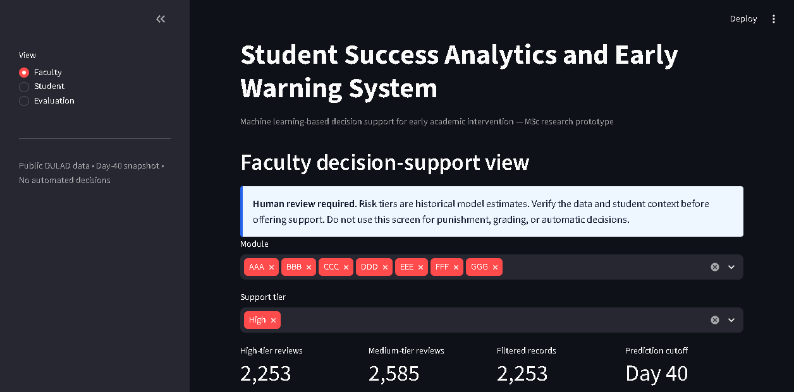
Figure 1. Faculty decision-support dashboard prototype.
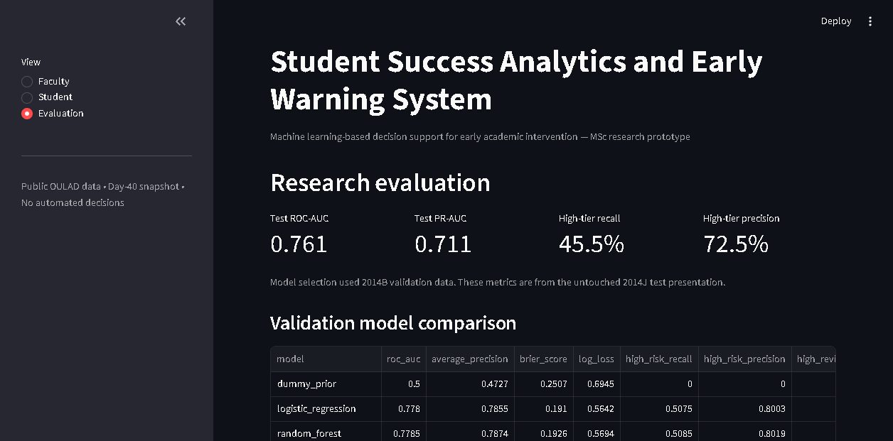
Figure 2. Research evaluation dashboard prototype.
A Power BI-ready Excel data model, DAX measure list, visual theme, and five-page dashboard specification have also been prepared. Native .pbix assembly remains to be completed on a computer with Power BI Desktop.

14. Privacy, Fairness, and Responsible Use
- Use only the minimum necessary data and keep direct identifiers outside modelling data.
- Restrict student-level access and maintain review and access logs.
- Allow students to correct inaccurate source records.
- Do not use the model for discipline, grading, admissions, scholarships, or denial of services.
- Review group recall, precision, selection rate, and false-positive rate before any local pilot.
- Communicate uncertainty and keep faculty responsible for the final decision.
The subgroup audit showed similar High-tier recall by gender but different false-positive rates, which requires investigation rather than a simple declaration of fairness. Demographic differences are monitoring signals, not explanations of student behaviour.

15. Testing and Reproducibility
The repository contains run scripts for data preparation, exploratory analysis, model training, support outputs, SHAP explanations, and dashboard launch. Automated tests cover schema checks, label creation, risk tiers, feature construction, and intervention rules. The complete test suite passed 13 tests during the latest verified run.

16. Current Project Update
Work item | Status | Evidence / output
Problem, scope, objectives | Completed | Project charter and final report.
Dataset selection and provenance | Completed | OULAD selection document and raw source tables.
Data cleaning and preprocessing | Completed | 27,042-row day-40 snapshot and profile.
EDA | Completed | Summary JSON, CSV tables, and HTML report.
Model comparison and calibration | Completed | Selected calibrated Random Forest and evaluation files.
SHAP and fairness audit | Completed | Global/local SHAP and subgroup audit artifacts.
Intervention rules | Completed | Transparent support-indicator rules.
Streamlit dashboard | Completed | Faculty, Student, and Evaluation views.
Power BI preparation | Completed | Import-ready workbook, DAX measures, theme, and build guide.
Native Power BI .pbix | Pending | Requires Power BI Desktop to assemble and save the report.
Final dissertation and presentation | In progress | Content exists; institutional formatting and slides remain.
Institutional deployment | Not started / out of scope | Requires approval, local data, security, and prospective validation.

17. Main Deliverables
- Processed OULAD day-40 dataset and feature pipeline.
- EDA report, trained model bundle, metrics, review queue, SHAP explanations, and fairness audit.
- Faculty, Student, and Evaluation Streamlit dashboard.
- Power BI-ready workbook, DAX measures, dashboard plan, and visual theme.
- Project charter, dataset selection, data dictionary, model card, ethics protocol, and final project report.
- Automated tests and one-command PowerShell run scripts.

18. Limitations and Future Work
OULAD represents distance-learning modules from one institution. VLE activity does not measure offline study or classroom attendance. The model cannot observe personal circumstances, and Fail and Withdrawn may have different causes. The selected model only narrowly exceeded Logistic Regression during validation. Public-data results do not establish performance at another university.
- Compare prediction cutoffs at days 20, 40, and 60.
- Model failure and withdrawal separately.
- Evaluate simpler models for possible local use.
- Complete the native Power BI report and add role-based security for demonstration.
- Conduct approved local validation and user testing with students and faculty.
- Study whether interventions are timely, acceptable, and beneficial.

19. Conclusion
The project now demonstrates the complete technical and responsible-design workflow required by the supplied data analytics guidelines. It converts public historical data into a leakage-aware early-warning prototype, evaluates multiple models, explains outputs, audits groups, and presents support options through dashboards. Its correct role is to help faculty organize supportive review while keeping people responsible for every final decision.

References
Kuzilek, J., Hlosta, M., & Zdrahal, Z. (2017). Open University Learning Analytics Dataset. Scientific Data, 4, 170171. https://doi.org/10.1038/sdata.2017.171
Lundberg, S. M., & Lee, S.-I. (2017). A Unified Approach to Interpreting Model Predictions. Advances in Neural Information Processing Systems, 30.
Scikit-learn documentation. https://scikit-learn.org/
SHAP documentation. https://shap.readthedocs.io/

