## **Schema: 🔧 1. Users Table**

Users (

UserID PK,

Name,

Email,

PhoneNumber,

PasswordHash,

Role, -- ENUM: 'CarOwner', 'Buyer', 'ServiceProvider', 'Admin'

ProfileImage,

Verified BOOLEAN,

CreatedAt TIMESTAMP

)

**🚗 2. Vehicles Table**

Vehicles (

VehicleID PK,

OwnerID FK → Users(UserID),

RegistrationNumber UNIQUE,

Make,

Model,

Year,

FuelType,

Transmission,

KilometersDriven,

Location,

Description,

Status, -- ENUM: 'Available', 'Sold'

CreatedAt TIMESTAMP

)

**🖼️ 3. VehicleImages Table**

VehicleImages (

ImageID PK,

VehicleID FK → Vehicles(VehicleID),

ImageURL

)

**🏷️ 4. Listings Table**

Listings (

ListingID PK,

VehicleID FK → Vehicles(VehicleID),

ListedBy FK → Users(UserID),

Price,

ListingDate TIMESTAMP,

IsActive BOOLEAN

)

**🛠️ 5. ServiceProviders Table**

ServiceProviders (

ProviderID PK,

UserID FK → Users(UserID),

BusinessName,

Address,

Verified BOOLEAN,

Rating FLOAT

)

**⚙️ 6. ServicesOffered Table**

ServicesOffered (

ServiceID PK,

ProviderID FK → ServiceProviders(ProviderID),

ServiceName,

Description,

Price

)

**📅 7. Appointments Table**

Appointments (

BookingID PK,

VehicleID FK → Vehicles(VehicleID),

ProviderID FK → ServiceProviders(ProviderID),

UserID FK → Users(UserID),

ServiceID FK → ServicesOffered(ServiceID),

ScheduledDateTime TIMESTAMP,

Status -- ENUM: 'Booked', 'Completed', 'Cancelled',

)

**🧾 8. ServiceHistory Table**

ServiceHistory (

HistoryID PK,

VehicleID FK → Vehicles(VehicleID),

ServiceDate DATE,

Description,

DocumentID FK → Documents(DocumentID)

)

**📃 9. Documents Table**

Documents (

DocumentID PK,

OwnerID FK → Users(UserID),

DocumentType, -- ENUM: 'RC', 'PUC', 'Insurance'

FileURL,

UploadDate TIMESTAMP

)

**⭐ 10. Reviews Table**

Reviews (

ReviewID PK,

ReviewerID FK → Users(UserID),

TargetID, -- Can be UserID or ProviderID (polymorphic)

RoleReviewed, -- ENUM: 'Seller', 'ServiceProvider'

Rating INT,

Comments,

Date TIMESTAMP

)

**🔧 11. AdminActions Table**

AdminActions (

ActionID PK,

AdminID FK → Users(UserID),

TargetType, -- ENUM: 'User', 'Listing', 'Review'

TargetID,

ActionType, -- ENUM: 'Verify', 'Ban', 'Flag', 'Resolve'

Notes,

Timestamp

)

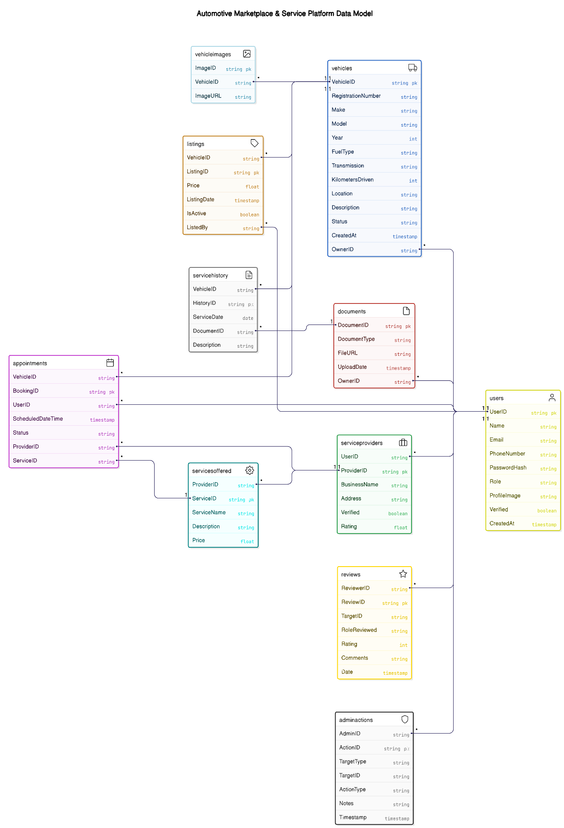**ER Diagram**