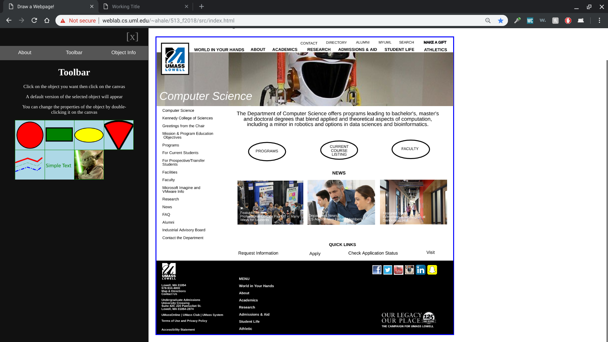

Original UML CS Website: <https://www.uml.edu/Sciences/computer-science/>

