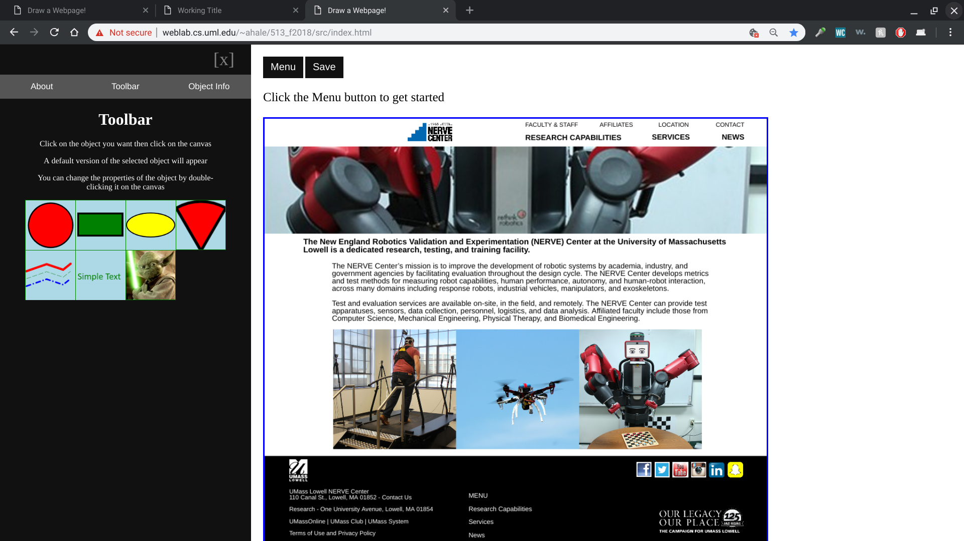

Original website: <https://www.uml.edu/Research/NERVE/default.aspx>

