# **Answer Me This**

## By Ashley Hale & Farzeen Harunani

### **Example Decision Tree:** Cancer decider

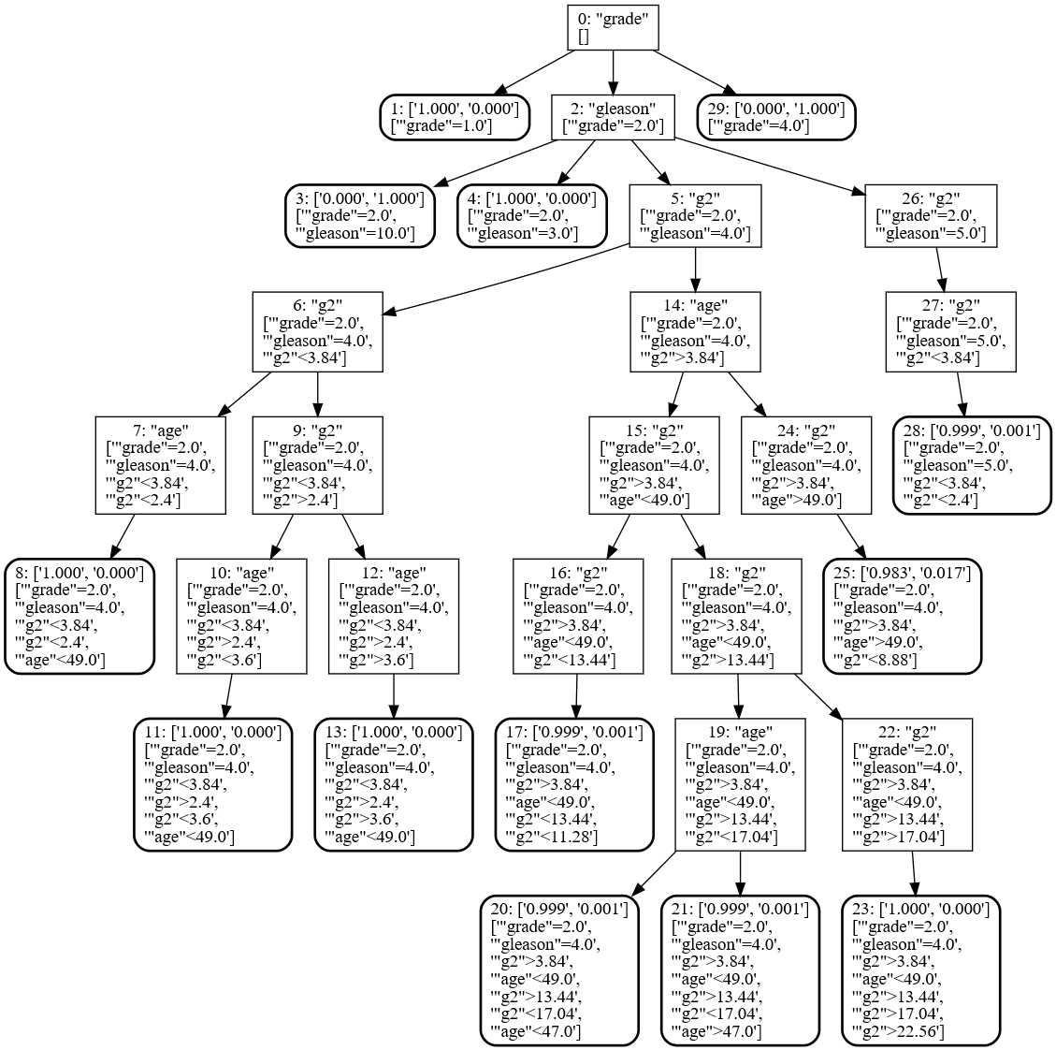

### Explanation

In a decision tree, the root node is the “decision” being made. Let’s say the user is wondering if they have cancer. The program will ask the users questions to determine “features” about the user’s answer. For example, it will prompt the user for their age. After some questions, the program will make a guess. If it guesses incorrectly, then the user will tell it so. Then, the user will enter the correct answer, and the learning tree will add this new training data record to its tree for future knowledge.

### Ethical Implications

In the case of our work, thankfully, there are few ethical implications with a simple tree that determines what “object” a user is thinking about. However, the abstract concept of a decision tree can have more significant implications in terms of ethics. Any time a computer is left to make “decisions”, it will maximize utility of some sort. A decision becomes a math problem, with all emotion left out. To use a pop culture example: In “I, Robot”, a computer decides to save an adult male over a female child because the adult had a higher chance of surviving. A human left to make the same decision will more often pick the child. When computers are left to choose between life and death, the idea of letting a computer make decisions (and therefore implementing decision trees at all) becomes a tougher call. However, when a computer needs to pick whether the user picked a cat or a dog? The ethical implications are quite small, indeed.