

Tribhuvan University
Faculty of Humanities and Social Sciences

TASK MANAGEMENT SYSTEM
MID-DEFENSE REPORT

Submitted to
Department of Computer Application
Triton International College
Koteshwor, Kathmandu

In partial fulfillment of the requirements for the Bachelors in Computer Application

Submitted by
Aastha Sharma
University Reg. No.: 6-2-529-3-2021

June 2025

Under the Supervision of
Mr. Milan Baral

Abstract
The Task Management System is a web-based application developed to streamline and enhance task organization and tracking, particularly in collaborative environments. Managing numerous tasks can quickly become overwhelming, often resulting in missed deadlines, incomplete projects, and dissatisfied stakeholders. This system addresses these challenges by offering a structured solution for managing daily responsibilities, delegating team tasks, and achieving personal goals efficiently.
Developed using the MERN stack, the application integrates HTML, CSS, JavaScript, React.js, Redux, and Tailwind CSS for a responsive and dynamic front-end interface. The server-side is powered by Node.js and Express.js, while MongoDB with Mongoose handles data storage and retrieval. The system supports two primary roles: Admin and User. Admins can create and assign tasks, form teams, monitor task progress, and manage user activities via an intuitive admin dashboard. Users interact with a user-friendly to-do list interface to manage their personal and team-assigned tasks.
Key features include sub-task creation, a notification panel, and user profiles, enhancing task granularity and user engagement. Security is a top priority, with JWT and Bcrypt implemented for robust user authentication and data protection. The modular architecture ensures maintainability and scalability, enabling easy integration of future enhancements.
The system is also optimized for cross-device compatibility through responsive design, ensuring accessibility and a consistent user experience across all screen sizes.
Keywords: Task Management System, MERN Stack, User Authentication, Admin Dashboard, Task Tracking, Responsive Web App

Table of Contents
Supervisor’s Recommendation II
Letter of Approval III
Abstract IV
Acknowledgement V
Table of Contents VI
List of Abbreviations VIII
List of Tables IX
List of Figures X
Chapter 1: Introduction 1
1.1. Introduction 1
1.2. Problem Statement 1
1.3. Objectives 2
1.4. Scope and Limitations 2
1.4.1. Scope 2
1.4.2. Limitations 2
1.5. Report Organization 3
Chapter: 2 Background Study and Literature Review 5
2.1. Background Study 5
2.2. Literature Review 5
2.2.1. Existing Applications 5
2.2.2. Academic Research 6
2.2.3. Existing Nepalese Platforms 6
Chapter: 3 System Analysis and Design 8
3.1. Methodology 8
3.1.1. Requirements Analysis 8
3.1.2. System Design 8
3.1.3. Implementation 9
3.1.4. Testing 9
3.1.5. Deployment 9
3.1.6. Maintenance 9
3.2. System Analysis 9
3.2.1. Requirement Analysis 10
3.2.2. Feasibility Study 12
3.2.3. Data Modelling 14
3.2.4. Process Modelling 14
3.3. System Design 16
3.3.1. Working Mechanism 16
3.3.2. Architecture Design 16
3.3.3. Database Schema Design 17
3.3.4. Interface Design 18
Chapter: 4 Implementation and Testing 21
4.1. Implementation 21
4.1.1. Tools Used 21
4.1.2. Implementation Details of Modules 21
4.2. Testing 23
4.2.1. Test Cases for Unit Testing 23
4.2.2. Test Cases for System Testing 26
Chapter 5: Conclusion and Future Recommendations 28
5.1. Lesson Learnt / Outcome 28
5.2. Conclusion 28
5.3. Future Recommendations 29
Appendices 30
References 39

List of Abbreviations
MERN | MongoDB, Express.js, React.js, Node.js
JWT | JSON Web Token
CSS | Cascading Style Sheets
HTML | Hypertext Markup Language
UCD | User-Centered Design
GIS | Geographic Information Systems
ER | Entity-Relationship
DFD | Data Flow Diagram
IDE | Integrated Development Environment
MD5 | Message Digest Algorithm 5
GPS | Global Positioning System

List of Tables

Table 4.1: Unit Testing for User Registration Module 23
Table 4.2: Unit Testing for Login Module 24
Table 4.3: Unit Testing for Destination Management Module 25
Table 4.4: Unit Testing for User Registration Module 25
Table 4.5: System Testing for Overall System Functionality 26
Table 4.6: System Testing for Performance 27
Table 4.7: System Testing for Security 27

List of Figures
Figure 3.1: Iterative Waterfall Methodology 8
Figure 3.2: Use Case Diagram of the System 11
Figure 3.3: Gantt Chart of the System 13
Figure 3.4: ER Diagram of the Task Management System 14
Figure 3.5: 0 Level DFD of the Task Management System 15
Figure 3.6: 1 Level DFD of the Task Management System 15
Figure 3.7: Architecture Design of the System 16
Figure 3.8: Database Schema Design of the System 17
Figure 3.9: Login Page Interface Design 18
Figure 3.10: Registration Page Interface Design 18
Figure 3.11: Home Page Interface Design 19
Figure 3.12: Details Page Interface Design 20

Chapter 1: Introduction

. Introduction
A digital platform to cater to the needs to manage our tasks efficiently is a necessity. The “Task Manager " is a task managing application that enables users to efficiently plan, track, and manage their daily tasks. Productivity and time management play a crucial role in our personal and professional life. This project introduces a custom-built task manager designed with simplicity, role-based control, and essential task operations.

Problem Statement
Existing tools, although robust and feature-rich, can be overwhelming for users looking for simple task management with a focus on task priority and user-specific assignments. Additionally, many of these platforms limit core functionality unless under a paid tier, and offer limited control over internal roles and access in custom use cases. This project seeks to provide a lightweight, flexible alternative that simplifies task tracking and supports role-based access for users and admins.

Objectives
The development of “Task Manager” has been guided by a set of clear and focused objectives aimed at overcoming the challenges identified in the problem. The primary objectives of this project are:
- To allow users to register, manage, and track tasks
- To enable admins to manage users and assign tasks
- To incorporate role-based access control (RBAC)
- To provide a responsive, user-friendly interface
By achieving these objectives, “Task Manager” aims to revolutionize the way travellers plan their journeys, making travel planning more accessible, enjoyable, and personalized while promoting the exploration of Nepal's diverse attractions in a sustainable and responsible manner.

Scope and Limitations

Scope
- Web-based interface with user registration and login
- CRUD functionality for tasks
- Admin dashboard for user and task management
- Role-based access: regular users and administrators

Limitations
- No mobile app version
- No team-based task collaboration (limited to individual users and admin oversight)
- No calendar integration or advanced analytics

Development Methodology
The project was developed using a simplified iterative waterfall methodology ensure a structured yet flexible approach to development. This methodology combines waterfall methodology with iterative cycles, allowing for adjustments and refinements throughout the development process.

Report Organization
This report provides an overview of the system and follows an outline. The report has different chapters included and this provides a brief description of what each chapter entails. This organization of the report ensures a logical flow of information and helps the reader understand the context and progression of the project.

Chapter 1: Introduction
This chapter introduces the project, providing background information and context. It details the problem statement, objectives, scope, and limitations of the project. This chapter sets the stage for the rest of the report by outlining the motivation and goals of the project.

Chapter 2: Background Study and Literature Review
This chapter deals with the theoretical foundation and existing research related to task managing applications. It comprises two main sections:
- Background Study: This section discusses fundamental theories, general concepts, and terminologies relevant to the project. It provides the reader with the necessary background to understand the project.
- Literature Review: This section reviews similar projects and research conducted by other scholars. It highlights the current state of task management systems, identifies gaps, and explains how this project addresses those gaps.

Chapter 3: System Analysis and Design
This chapter focuses on the analysis and design of the “Task Manager”. It includes:
- System Analysis: This section covers the requirement analysis, feasibility analysis, data modelling, and process modelling. It provides a detailed understanding of the system requirements and feasibility.
- System Design: This section outlines the architectural design, database schema design, interface design, and physical data flow diagram. It presents the blueprint for the system's implementation.

Chapter 4: Implementation and Testing
This chapter describes the implementation and testing phases of the project. It includes:
- Implementation: This section details the tools used, implementation procedures, and module descriptions.
- Testing: This section outlines the test cases for unit testing and system testing, ensuring the system functions correctly and meets the specified requirements.

Chapter 5: Conclusion and Future Recommendations
This chapter concludes the report by summarizing the key outcomes and lessons learned from the project. It includes:
- Lesson Learnt / Outcome: This section reflects on the experiences and knowledge gained during the project.
- Conclusion: This section summarizes the project’s achievements and impact.
- Future Recommendations: This section suggests potential improvements and future enhancements for the “Task Manager”. It provides a roadmap for further development based on the project's findings.

Chapter: 2 Background Study and Literature Review

Background Study
Task management applications are designed to help individuals and teams track activities, prioritize responsibilities, and ensure timely completion of work. These systems generally consist of modules for task creation, editing, assignment, and sorting, as well as user authentication and administrative oversight.
This project utilizes the MERN stack:
- MongoDB: A NoSQL document-oriented database used to store user and task data in flexible JSON-like formats.
- Express.js: A lightweight Node.js framework for building RESTful APIs.
- React.js: A JavaScript library for building responsive, component-based user interfaces.
- Node.js: Enables server-side JavaScript execution, handling backend logic and API routing.
Supporting tools include:
- Redux for managing global state (e.g., user sessions, task lists)
- Headless UI and Tailwind CSS for building accessible, responsive UIs
- JWT (JSON Web Tokens) for secure authentication and role-based access control
- Postman for testing API endpoints
Common concepts and terminologies relevant to this project include:
- CRUD Operations: Core create, read, update, delete functions used in managing tasks and users
- RBAC (Role-Based Access Control): A security model where access is granted based on roles (user/admin)

Literature Review

Existing Applications
A number of task management tools were analyzed during the planning of this project:
- Trello: A popular tool that uses a Kanban board system to manage tasks. While powerful, it includes advanced features (e.g., automation, integrations) that may not be necessary for basic task tracking. Its interface can become cluttered for users who simply want task priority and basic assignments.
- Todoist: A minimalist task manager with tagging, scheduling, and productivity scoring. However, its full functionality often requires premium subscription, and the interface lacks customization options.
- Notion: An all-in-one workspace combining note-taking, databases, and task tracking. Though flexible, it requires significant user customization and may overwhelm users needing straightforward task handling.
All three tools are optimized for a broad user base, which introduces complexity. The proposed task manager project aims to provide a streamlined alternative — one focused on user-specific task assignments, role management, and clear task prioritization, without the distraction of integrations or advanced configurations.

Academic Research
- Imagining Future Digital Assistants at Work (Khaokaew):
One of the key findings was that task management systems must adapt to the nature of the user and their role in an organization, not just treat all tasks equally. This aligns well with the role-based architecture in the current task manager system, where admins and regular users have different interfaces and privileges. The research also suggests opportunities for future development in adaptive task recommendation and prioritization systems. [1]
- TaskAllocator (Shafiq):
The key contribution is a framework where task assignment becomes role-sensitive and context-aware, enhancing not just efficiency but also accountability and productivity. This directly supports the role-based task assignment logic implemented in your system, reinforcing the importance of integrating RBAC principles with task recommendation or assignment features. [2]

Chapter: 3 System Analysis and Design

Methodology
The “Task Manager” project has used the Iterative Waterfall methodology to ensure a structured yet flexible approach to development. This methodology combines the linear progression of the traditional waterfall model with iterative cycles, allowing for adjustments and refinements throughout the development process.
During the design phase, the system architecture, database, and user interfaces were planned. Implementation involved coding and integrating various components, followed by testing to identify and rectify any issues. This structured approach provided clarity, predictability, and efficient management of the “Task Manager”, ensuring each phase was completed before moving on to the next.
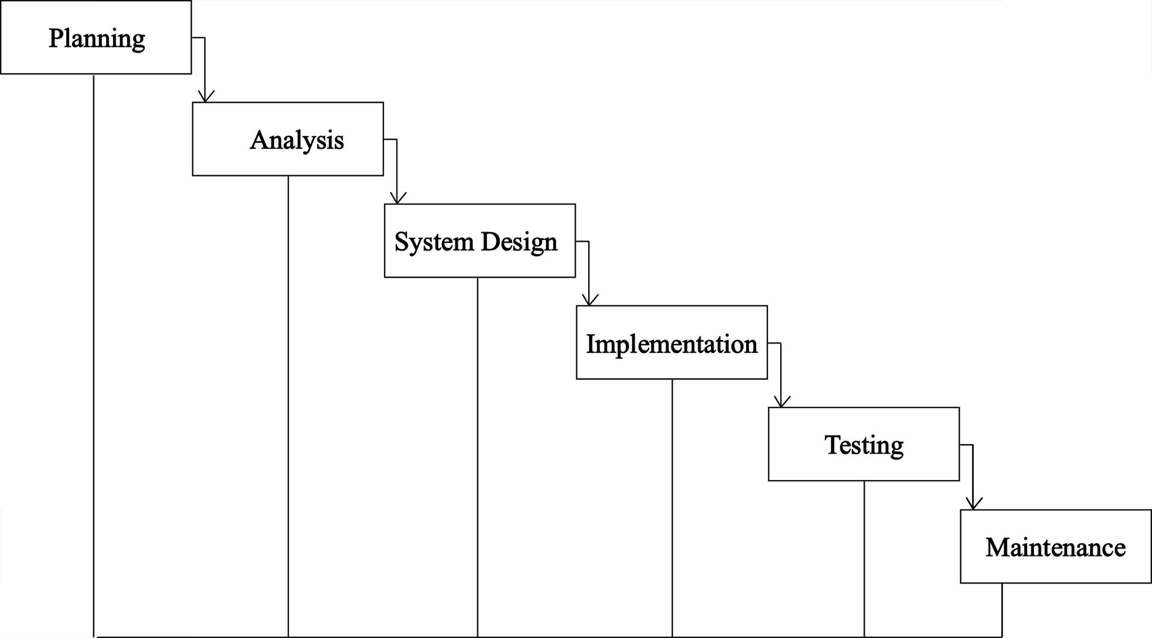
Figure 3.1 Iterative Waterfall Methodology

Requirements Analysis
In the requirement analysis phase, detailed specifications for core functionalities, including user registration, login, task management, user interaction with tasks, and the admin dashboard were identified, and user needs were collected and analysed to outline the project's scope.

System Design
Based on the requirements analysis, the system design phase involved creating detailed architectural and design specifications. User interfaces for various modules were wireframed, and the overall system architecture was mapped out.

Implementation
The implementation phase followed the design specifications closely, with the building the system in a series of iterations. Each iteration focused on a specific module or set of functionalities, such as user registration, task management, or the admin dashboard. This iterative approach allowed for incremental development, ensuring that each module was fully functional and tested before proceeding to the next.

Testing
Each iteration included a thorough testing phase, where individual modules were subjected to unit testing, integration testing, and system testing. Bugs and issues identified during testing were addressed in subsequent iterations, ensuring continuous improvement and refinement of the system. This iterative testing process enhanced the system's stability and reliability.

Deployment
After multiple iterations of development and testing, the system was deployed in a controlled environment. Feedback from initial users was collected and used to make final adjustments and improvements. The iterative nature of the waterfall methodology allowed for incremental rollouts and ensured that the system was robust and ready for broader deployment.

Maintenance
The final phase involves ongoing maintenance and support, where the we address any issues that arise, and implement enhancements based on user feedback. The iterative approach ensures that the system remains up-to-date and responsive to changing requirements and user needs.

System Analysis

Requirement Analysis
The functional and non-functional requirements for this system are as follows.
- Functional Requirements
- Users can sign up, log in, using JWT-based authentication.
- Two roles: Admin and User. Admins can manage users and assign tasks.
- Users can create, update, delete tasks. Admins can assign tasks to users.
- Tasks can be sorted based on title, due date, and priority.
- Users can update their own profiles.
- Admins can view all users, activate/deactivate users, and see global task stats.
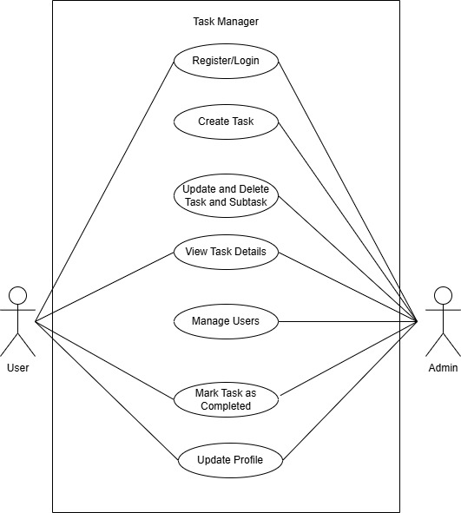
Figure 3.2: Use Case Diagram of the System

- Non-Functional Requirements
- Usability: Clean UI using TailwindCSS and HeadlessUI
- Performance: Single Page Application (SPA) for fast interaction
- Security: JWT for auth, RBAC enforced in both frontend & backend
- Responsiveness: UI adapts to different screen sizes

Feasibility Study
- Technical Feasibility
The system is built using the MERN stack, which consists of MongoDB for the NoSQL database, Express.js for backend server development, React for building a responsive frontend interface, and Node.js as the runtime environment. All of these are well-supported, robust technologies suited for scalable web applications. Additionally, Redux has been integrated for managing complex state across the frontend.
- Economic Feasibility
The entire system is developed using free and open-source technologies, including the MERN stack and development tools like Postman for testing.
- Operational Feasibility:
The system offers a clean and intuitive user interface designed with TailwindCSS and HeadlessUI. Users can easily navigate between dashboards, manage tasks, and update profiles. Admin users are provided with additional control functionalities such as user activation and task assignment, all streamlined within a unified dashboard.
- Schedule Feasibility:
The proposed system has the following the timeline below and was accomplished within the available timeframe.
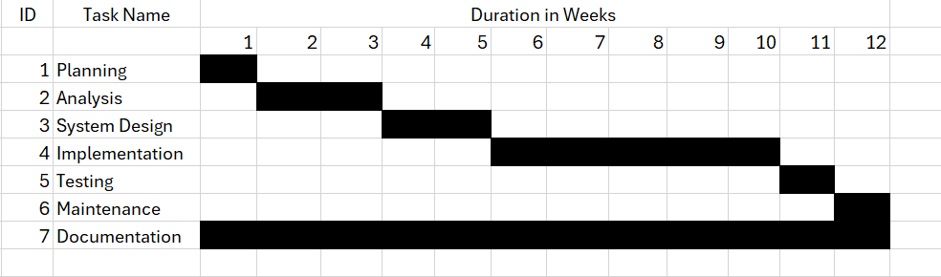
Figure 3.3: Gantt Chart of the System

Data Modelling

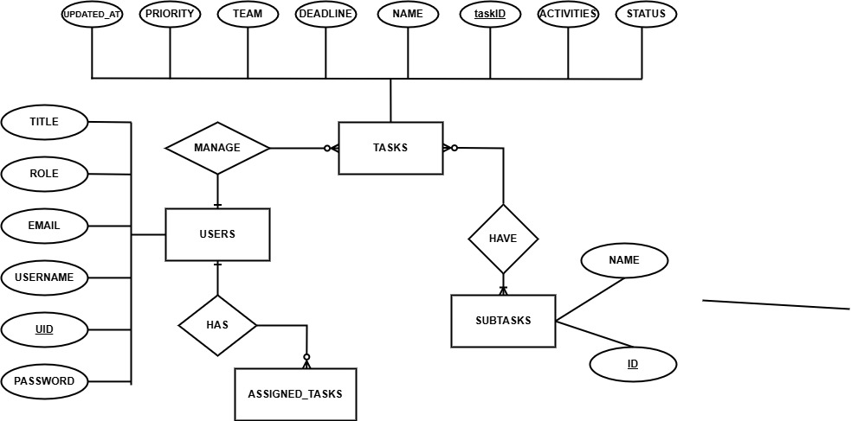
Figure 3.4: ER Diagram of the Task Management System

Process Modelling

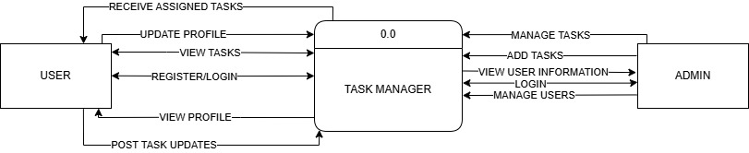
Figure 3.5: 0 Level DFD of the Task Management System

Figure 3.6: 1 Level DFD of the Task Management System

System Design

Architecture Design

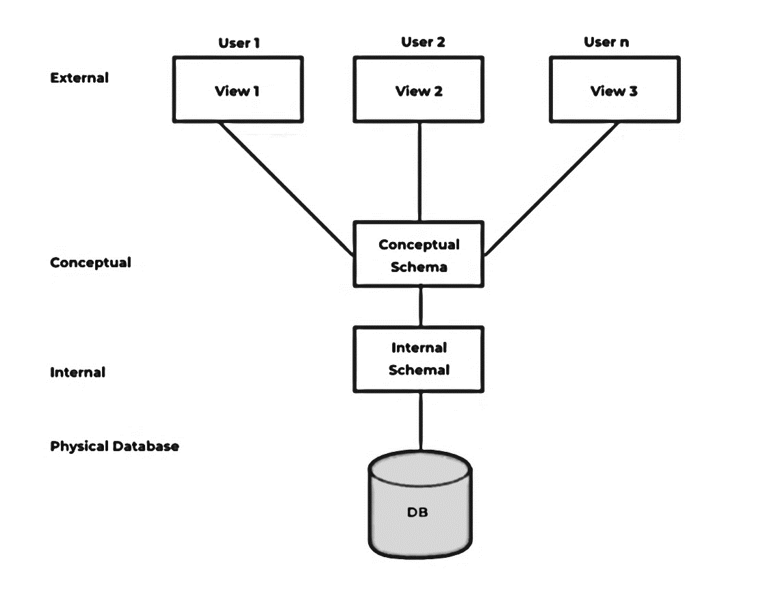
Figure 3.7: Architecture Design of the System

Database Schema Design
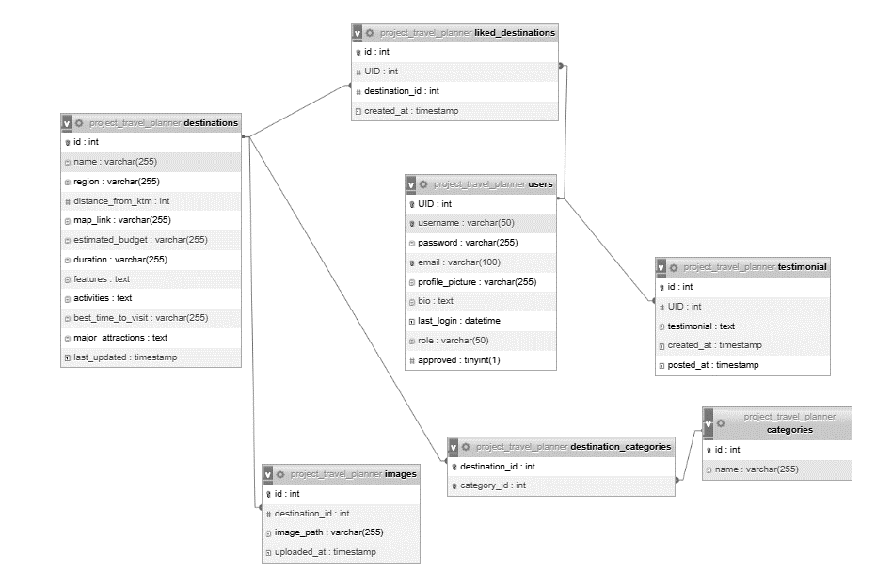
Figure 3.8: Database Schema Design of the System

Interface Design

Figure 3.9: Login Page Interface Design

Figure 3.10: Registration Page Interface Design

Algorithms Used
Sorting Tasks: Custom sort functions based on priority, title, or due date
RBAC Middleware: Auth middleware checks JWT and user role before allowing access to protected routes

Chapter: 4 Implementation and Testing

Implementation

Tools Used
- Programming Languages:
- Frontend: React.js, Redux Toolkit, Tailwind CSS, HeadlessUI
- Backend: Node.js, Express.js
- Database: MongoDB (with Mongoose)
- Authentication: JWT (JSON Web Tokens)
- Testing & API Debugging: Postman
- Version Control: Git, GitHub
- Styling and Markup:
- HTML: For structuring the web pages and content layout.
- CSS: For styling and designing the visual appearance of the platform to make it user-friendly and attractive.
- Code Editing:
- Visual Studio Code (VS Code): The integrated development environment (IDE) used for writing, editing, and debugging code efficiently.
- Documentation Tools:
- Draw.io: Tool used to create detailed diagrams and visual representations of the system architecture and workflows.
- MS-Word: Documentation tool used to compile and format the project documentation, ensuring a structured and professional presentation of the project's details.

Implementation Details of Modules
- Authentication Module:
Handles user registration, login, and JWT token generation. Auth middleware validates tokens and enforces RBAC by checking user roles (admin/user).
- User Management Module:
- Admins can view all users.
- Admins can activate/deactivate user accounts.
- Users can update their profiles.
- Task Management Module:
- Users can create, update, delete their tasks.
- Admins can assign tasks to users.
- Each task includes title, description, due date, priority, and status.
- Admin Dashboard Module:
- View user list with statuses and roles.
- Assign tasks to users.
- Monitor overall task statistics (e.g., total tasks, assigned/unassigned tasks).
- State Management (Redux):
- authSlice: Manages authentication state (token, current user info).
- userSlice: Manages list of users and individual user data.
- taskSlice: Manages task list, filtering, and sorting.

Testing
This section outlines the test cases for unit testing and system testing, ensuring the system functions correctly and meets the specified requirements.

Test Cases for Unit Testing
Unit testing focuses on individual components of the system to ensure each part functions correctly in isolation. Below are test cases for modules of the Task Management System .
User Registration Module
Table 4.1: Unit Testing for User Registration Module
Test Case ID | Test Description | Test Steps | Expected Result | Result
TC1 | Validate empty username field | 1. Navigate to the registration page  2. Leave the username field empty  3. Submit form | Error message: "Username cannot be empty" | Pass
TC2 | Validate empty password field | 1. Navigate to the registration page  2. Leave the password field empty  3. Submit form | Error message: "Password cannot be empty" | Pass
TC3 | Validate empty email field | 1. Navigate to the registration page  2. Leave the email field empty  3. Submit form | Error message: "Email cannot be empty" | Pass
TC4 | Validate password length and complexity | 1. Navigate to the registration page  2. Enter a password less than 8 characters  3. Submit form | Error message: "Password must be at least 8 characters long and contain a number and a special character" | Pass
TC5 | Validate username with special characters or numbers | 1. Navigate to the registration page  2. Enter a username with special characters or numbers  3. Submit form | Error message: "Only alphabets and whitespace are allowed for username" | Pass
TC6 | Validate password mismatch | 1. Navigate to the registration page  2. Enter a password  3. Enter a different password in the confirm password field  4. Submit form | Error message: "Passwords do not match" | Pass
Login Module
Table 4.2: Unit Testing for Login Module
Test Case ID | Test Description | Test Steps | Expected Result | Result
TC1 | Validate empty username field | 1. Navigate to the login page  2. Leave the username field empty  3. Submit form | Error message: "Username cannot be empty" | Pass
TC2 | Validate empty password field | 1. Navigate to the login page  2. Leave the password field empty  3. Submit form | Error message: "Password cannot be empty" | Pass
TC3 | Validate incorrect username/password | 1. Navigate to the login page  2. Enter incorrect username and password  3. Submit form | Error message: "Invalid username or password" | Pass
TC4 | Validate successful login for approved user | 1. Navigate to the login page  2. Enter valid username and password of an approved user  3. Submit form | Redirect to home page | Pass
TC5 | Validate login attempt for unapproved user | 1. Navigate to the login page  2. Enter valid username and password of an unapproved user  3. Submit form | Error message: "Your account is pending approval" | Pass

Destination Management Module
Table 4.3: Unit Testing for Destination Management Module
Test Case ID | Test Description | Test Steps | Expected Result | Result
TC1 | Validate adding a new destination | 1. Navigate to the add destination page  2. Fill in all required fields  3. Submit form | New destination is added and displayed in the destination list | Pass
TC2 | Validate empty destination name | 1. Navigate to the add destination page  2. Leave the name field empty  3. Submit form | Error message: "Destination name cannot be empty" | Pass
TC3 | Validate destination with existing name | 1. Navigate to the add destination page  2. Enter a destination name that already exists  3. Submit form | Error message: "Destination name already exists" | Pass
TC4 | Validate updating an existing destination | 1. Navigate to the destination list  2. Select a destination to edit  3. Update details  4. Submit form | Destination details are updated successfully | Pass
TC5 | Validate deleting a destination | 1. Navigate to the destination list  2. Select a destination to delete  3. Confirm deletion | Destination is removed from the destination list | Pass
User Interaction Module
Table 4.4: Unit Testing for User Registration Module
Test Case ID | Test Description | Test Steps | Expected Result | Result
TC1 | Validate saving a destination to user profile | 1. Navigate to a destination page  2. Click on ‘Like’ button | Destination is saved to user profile | Pass
TC2 | Validate viewing saved destinations in user profile | 1. Login as a user  2. Navigate to the user profile  3. View liked destinations | List of liked destinations is displayed | Pass
TC3 | Validate removing a saved destination from user profile | 1. Login as a user  2. Navigate to the user profile  3. Select a saved destination to remove  4. Confirm removal | Destination is removed from user profile | Fail

Test Cases for System Testing
System testing ensures the integrated system functions as expected. Below are the test cases covering key system functionalities.
Overall System Functionality
Table 4.5: System Testing for Overall System Functionality
Test Case ID | Test Description | Test Steps | Expected Result | Result
TC1 | Validate registration, approval, and login flow | 1. Register a new user  2. Admin approves the user  3. User logs in | User is registered, approved, and able to login successfully | Pass
TC2 | Validate destination addition, updating, and deletion flow | 1. Admin adds a new destination  2. Admin updates the destination  3. Admin deletes the destination | Destination is added, updated, and deleted successfully | Pass
TC3 | Validate user interaction with destinations | 1. User saves a destination  2. User views saved destinations  3. User removes a saved destination | User can save, view, and remove destinations as expected | Fail

Performance Testing
Table 4.6: System Testing for Performance
Test Case ID | Test Description | Test Steps | Expected Result | Result
TC1 | Validate system performance under load | 1. Simulate multiple users registering and logging in simultaneously | System handles concurrent registrations and logins without errors | Pass
TC2 | Validate response time for destination search | 1. Perform a destination search  2. Measure the response time | Search results are returned within acceptable time limits | Fail

Security Testing
Table 4.7: System Testing for Security
Test Case ID | Test Description | Test Steps | Expected Result | Result
TC1 | Validate SQL injection protection | 1. Attempt SQL injection during login and registration | System rejects malicious inputs and displays an error message | Pass
TC2 | Validate password encryption | 1. Register a new user  2. Check the database for stored password | Password is stored in encrypted (MD5) format | Pass

Chapter 5: Conclusion and Future Recommendations

Lesson Learnt / Outcome

Conclusion

Future Recommendations

Appendices
Index:

References

[1] | L. K. L. M. A. L. J. M. A. a. A. G. Y. Khaokaew, “Imagining Future Digital Assistants at Work,” in CHI Conference on Human Factors in Computing Systems (CHI ’23), Hamburg, Germany, 2023.
[2] | M. S. U. M. R. a. A. G. S. Shafiq, “TaskAllocator: A Recommendation Approach for Role-Based Task Allocation in Agile Teams,” IEEE Access, vol. 9, p. 11, 2021.

